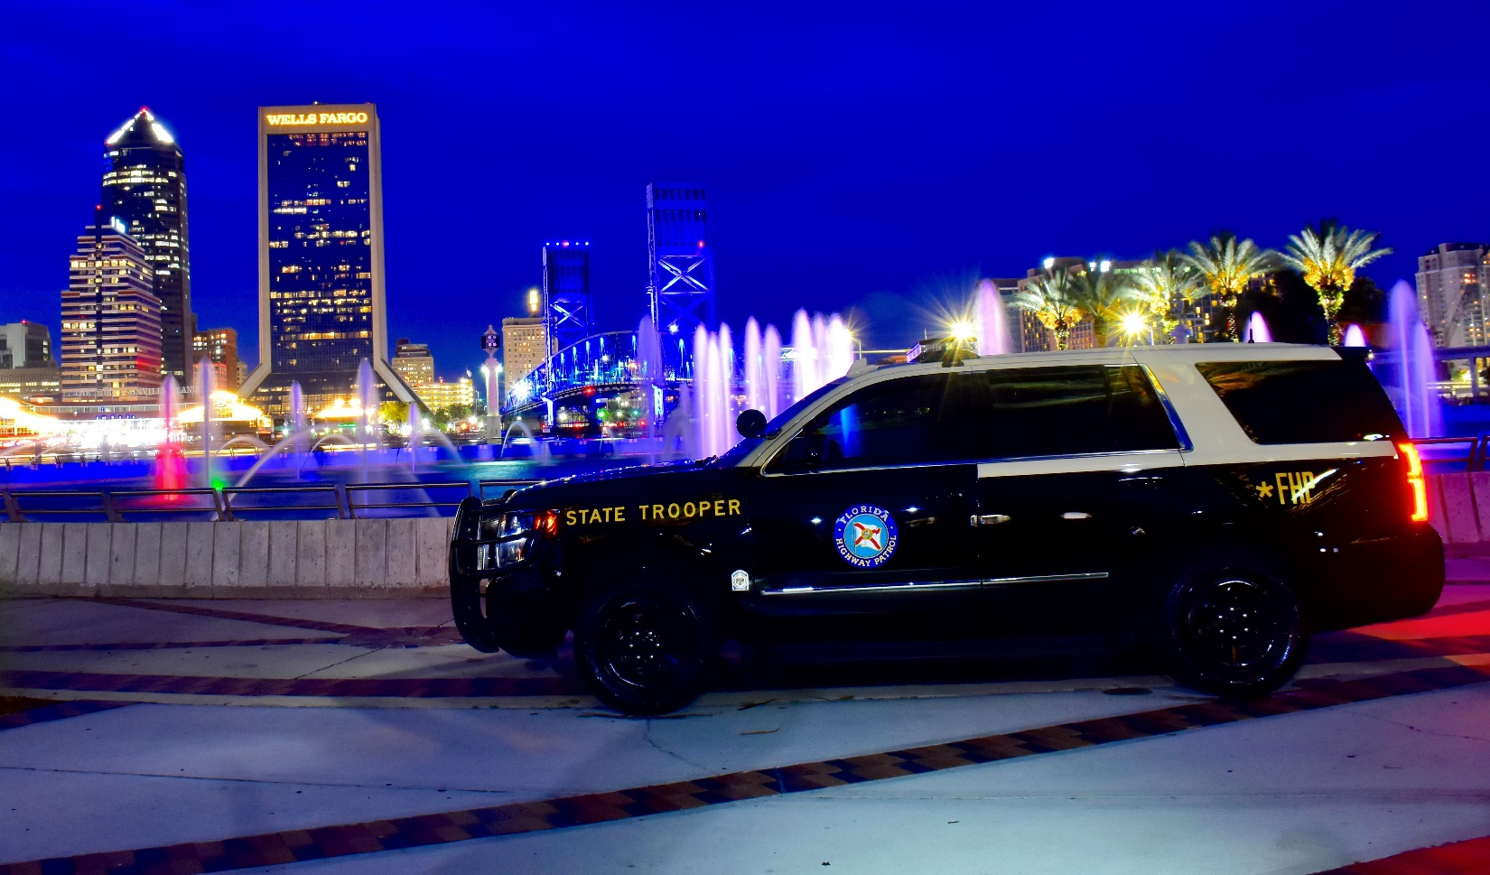
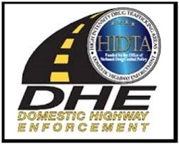
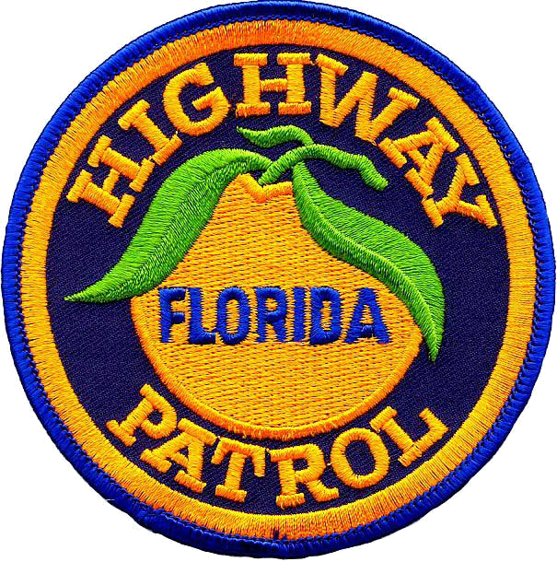

2019 Motor Vehicle Criminal
Interdiction Conference Agenda

Hyatt Regency
Orlando, Florida
July 29 – August 1, 2019

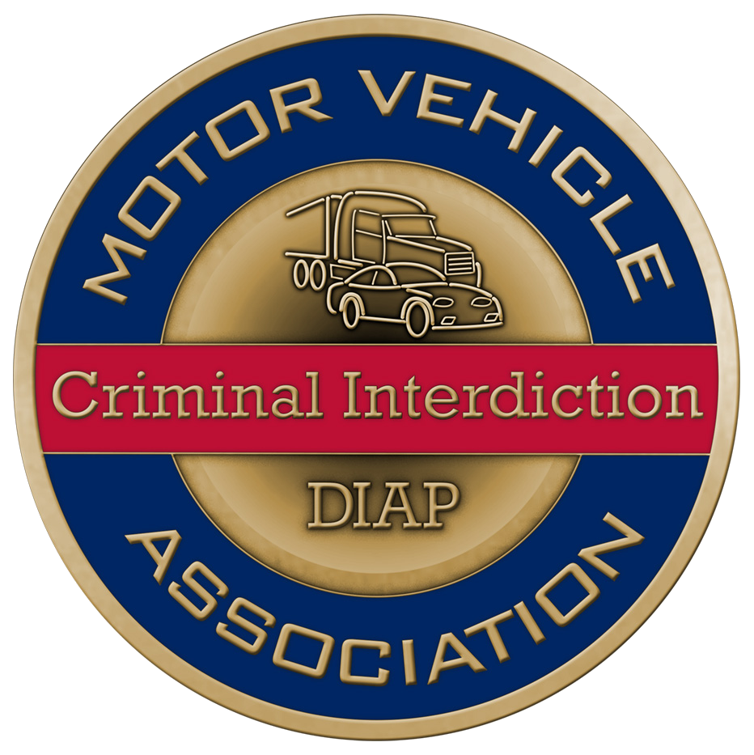
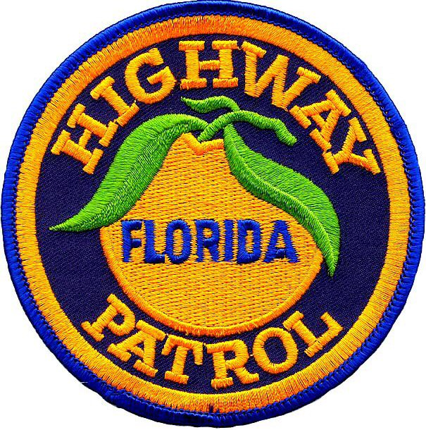

WELCOME

29th ANNUAL MOTOR VEHICLE
CRIMINAL INTERDICTION (MVCI-EPIC)
TRAINING, NETWORKING AND INTELLIGENCE SHARING CONFERENCE

Hyatt Regency
Orlando, Florida

Sunday, July 28, 2019

Time | Topic or Activity | Location | Presenter
1500 - 1900 | Early Registration | Challenger | MVCI/EPIC
1800 - 1900 | Mandatory Instructors Meeting | TBD | MVCI/EPIC
1800 - 2100 | HOSPITALITY

Monday, July 29, 2019

Time | Topic or Activity | Location | Presenter
0630 | Late Registration | Plaza G/H | Sponsors and Hosts
0800 | Call to Order | Plaza G/H | MVCI
0800 - 0840 | Opening Ceremonies/Remarks | Plaza G/H | Florida Highway Patrol
0840 - 0930 | Welcoming Remarks | Plaza G/H | MVCI/EPIC/DIAP/DHE
0930 - 0945 | MORNING BREAK
0945 - 1030 | Officer Involved Shooting – Story of How One Officer Survived | Plaza G/H | Brandon Howerton  Georgia State Patrol  Charles Chapeau  Georgia State Patrol
1030 - 1145 | Touchstone – Why What You Do Matters | Plaza G/H | Patrick Mead  Law Enforcement Lecturer
1145 - 1200 | Training Agenda Overview / Announcements | Plaza G/H | MVCI
1200 - 1300 | LUNCH ON YOUR OWN
1300 - 1315 | Drug Testing Equipment | Plaza G/H | 908 Devices
1315 - 1355 | Human Trafficking – How to Detect and What to Do | Plaza G/H | Kylla Lanier  Truckers Against Trafficking
1355 - 1455 | Legalized Marijuana  (What You Need to Know and How It Will Affect You) | Plaza G/H | Kenneth Stecker  Michigan Prosecuting Attorney’s Association
1455 - 1510 | AFTERNOON BREAK
1510 - 1650 | Inside the Cartels – Story of Being Imbedded with Mexican Law Enforcement | Plaza G/H | Craig Renaud  Director of Meth Storm:  Arkansas USA
1650 | Announcements – Raffles/Nights Entertainment Announcement | Plaza G/H | MVCI
1800 - 2100 | End of Training Session / Hospitality

Tuesday, July 30, 2019

Time | Topic or Activity | Location | Presenter
0800 - 0810 | Announcements | Plaza G/H | MVCI
0810 - 1000 | Convoy 101  Basic CMV Interdiction | Florida C | Chase Melder  Arkansas State Police  Mike Hinsperger  Ontario Provincial Police, Canada
 | Pipeline 101 - Basic Passenger Car Interdiction, Being Successful | Florida B | Manny Marquez  US DOT
 | Commercial Vehicle Interdiction to Include 4 CMV’s Containing Traps  (All Day – Limited Entry – Sign Up at Registration Only) | Plaza J | Ray Herndon  Regional Counter Drug
 | Hidden Compartment Detection  East Coast Style | Florida A | TJ Cullen  Trap Find
 | Roadside Interdiction, Intelligence, and Resources for Passenger and Commercial Vehicle Interdictions and Investigations | Plaza D | Trooper Mace Craft  Intelligence Analyst Darin Templeton  Arizona DPS /Arizona HIDTA
 | Interdicting Car Haulers – Everything You Need to Know | Plaza E | Chris Goodman  Arkansas State Police  Breck Williamson  Ohio State Patrol
 | Corridor Breakout – All East / West Routes | Plaza K | DHE Team  HIDTA/DHE
 | Hotel / Motel Investigations | Plaza I | Matt Wilson  Indiana State Police
 | EPIC Resource Brief | Plaza F | SA James Highsmith  EPIC
1000 - 1010 | MORNING BREAK
MORNING AGENDA CONTINUED ON NEXT PAGE

Tuesday, July 30, 2019 – CONT.

Time | Topic or Activity | Location | Presenter
1015 - 1200 | Convoy 101  Basic CMV Interdiction | Florida C | Chase Melder  Arkansas State Police  Mike Hinsperger  Ontario Provincial Police, Canada
 | Pipeline 101 - Basic Passenger Car Interdiction, Being Successful | Florida B | Manny Marquez  US DOT
 | Commercial Vehicle Interdiction to Include 4 CMV’s Containing Traps  (All Day – Limited Entry – Sign Up at Registration Only) | Plaza J | Ray Herndon  Regional Counter Drug
 | Hidden Compartment Detection  East Coast Style | Florida A | TJ Cullen  Trap Find
 | Roadside Interdiction, Intelligence, and Resources for Passenger and Commercial Vehicle Interdictions and Investigations | Plaza D | Trooper Mace Craft  Intelligence Analyst Darin Templeton  Arizona DPS /Arizona HIDTA
 | Interdicting Car Haulers – Everything You Need to Know | Plaza E | Chris Goodman  Arkansas State Police  Breck Williamson  Ohio State Patrol
 | Corridor Breakout – All East / West Routes | Plaza K | DHE Team  HIDTA/DHE
 | Hotel / Motel Investigations | Plaza I | Matt Wilson  Indiana State Police
 | EPIC Resource Brief | Plaza F | SA James Highsmith  EPIC
1200 - 1300 | LUNCH ON YOUR OWN
AFTERNOON AGENDA CONTINUED ON NEXT PAGE

Tuesday, July 30, 2019 – CONT.

Time | Topic or Activity | Location | Presenter
1300 - 1310 | Announcements | Plaza G/H | MVCI
1310 - 1445 | Supervising an Interdiction Team | Florida A | Dennis Overton  Arkansas State Police  Jose Patino  Michigan State Police  Richard Jankovski  Texas DPS
 | Whisper Stops – The Do’s and Don’ts | Florida B | Charles Chapeau  Georgia State Patrol  Tully Yount  Collin County Sheriff’s Office, TX
 | Commercial Vehicle Interdiction to Include 4 CMV’s Containing Traps  (All Day – Limited Entry – Sign Up at Registration Only) | Plaza J | Ray Herndon  Regional Counter Drug
 | Canadian Trends and Patterns Affecting the US | Florida C | Cory Kornicki  Royal Canadian Mounted Police
 | K-9 Training | Plaza D | Ricky Farley  Alabama Canine
 | Corridor Breakout – All East/West Routes | Plaza K | DHE Team  HIDTA/DHE
 | Concealment Trends | Plaza E | Rockey Rapert  Arkansas State Police  David Whitehead  Georgia State Patrol
1445 - 1500 | AFTERNOON BREAK
AFTERNOON AGENDA CONTINUED ON NEXT PAGE

Tuesday, July 30, 2019 – CONT.

Time | Topic or Activity | Location | Presenter
1500 - 1650 | Supervising an Interdiction Team | Florida A | Dennis Overton  Arkansas State Police  Jose Patino  Michigan State Police  Richard Jankovski  Texas DPS
 | Whisper Stops – The Do’s and Don’ts | Florida B | Charles Chapeau  Georgia State Patrol  Tully Yount  Collin County Sheriff’s Office, TX
 | Commercial Vehicle Interdiction to Include 4 CMV’s Containing Traps  (All Day – Limited Entry – Sign Up at Registration Only) | Plaza J | Ray Herndon  Regional Counter Drug
 | Canadian Trends and Patterns Affecting the US | Florida C | Cory Kornicki  Royal Canadian Mounted Police
 | K-9 Training | Plaza D | Ricky Farley  Alabama Canine
 | Corridor Breakout – All East/West Routes | Plaza K | DHE Team  HIDTA/DHE
 | Concealment Trends | Plaza E | Rockey Rapert  Arkansas State Police  David Whitehead  Georgia State Patrol
1650 | Raffle / Announcements | Plaza G/H | MVCI
1730 - 2100 | 2019 MOTOR VEHICLE CRIMINAL INTERDICTION AWARDS BANQUET

2019 MOTOR VEHICLE CRIMINAL INTERDICTION
AWARDS BANQUET
Hosted by the El Paso Intelligence Center/MVCI

July 30, 2019

Location: Plaza G/H

1730 - 1800 Intelligence Networking and Exchanging

1800 - 1815 Seating

1815 - 2100 Awards Banquet

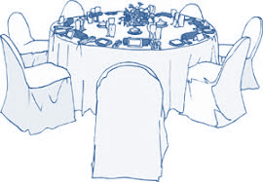

Wednesday, July 31, 2019

Time | Topic or Activity | Location | Presenter
0800 | Announcements | Plaza G/H | MVCI
0815 - 1000 | Street Survival | Plaza G/H | Jim Glennon  Caliber Press
1000 - 1015 | MORNING BREAK
1015 - 1200 | Street Survival - Continued | Plaza G/H | Jim Glennon  Caliber Press
1200 - 1300 | LUNCH ON YOUR OWN
1300 - 1445 | Street Survival | Plaza G/H | Jim Glennon  Caliber Press
1445 - 1500 | AFTERNOON BREAK
1500 - 1700 | Street Survival - Continued | Plaza G/H | Jim Glennon  Caliber Press
1800 - 2100 | END OF TRAINING SESSION / HOSPITALITY

Thursday, August 1, 2019

Time | Topic or Activity | Room | Presenter
0800 - 0810 | Announcements | Plaza G/H | MVCI
0810 - 1000 | Exploiting Open Source Intelligence Information During Road Side Investigations | Florida B | Jason Webber  NW3C
 | Hotel / Motel Investigations | Florida C | Matt Wilson  Indiana State Police
 | Roadside Interdiction, Intelligence, and Resources for Passenger and Commercial Vehicle Interdictions and Investigations | Plaza D | Trooper Mace Craft  Intelligence Analyst Darin Templeton  Arizona DPS/ Arizona HIDTA
 | Commercial Vehicle Interdiction to Include 4 CMV’s Containing Traps  (All Day – Limited Entry – Sign Up at Registration Only) | Plaza J | Ray Herndon  Regional Counter Drug
 | Supervising an Interdiction Team | Plaza K | Dennis Overton  Arkansas State Police  Jose Patino  Michigan State Police  Richard Jankovski  Texas DPS
 | Interdicting Car Haulers – Everything You Need to Know | Plaza E | Chris Goodman  Arkansas State Police  Breck Williamson  Ohio State Patrol
 | K-9 Training | Plaza I | Ricky Farley  Alabama Canine
 | Hidden Compartment Detection  East Coast Style | Florida A | TJ Cullen  Trap Find
1000 - 1010 | MORNING BREAK
MORNING AGENDA CONTINUED ON NEXT PAGE

Thursday, August 1, 2019 – CONT.

Time | Topic or Activity | Room | Presenter
1010 - 1200 | Exploiting Open Source Intelligence Information During Road Side Investigations | Florida B | Jason Webber  NW3C
 | Hotel / Motel Investigations | Florida C | Matt Wilson  Indiana State Police
 | Roadside Interdiction, Intelligence, and Resources for Passenger and Commercial Vehicle Interdictions and Investigations | Plaza D | Trooper Mace Craft  Intelligence Analyst Darin Templeton  Arizona DPS/ Arizona HIDTA
 | Commercial Vehicle Interdiction to Include 4 CMV’s Containing Traps  (All Day – Limited Entry – Sign Up at Registration Only) | Plaza J | Ray Herndon  Regional Counter Drug
 | Supervising an Interdiction Team | Plaza K | Dennis Overton  Arkansas State Police  Jose Patino  Michigan State Police  Richard Jankovski  Texas DPS
 | Interdicting Car Haulers – Everything You Need to Know | Plaza E | Chris Goodman  Arkansas State Police  Breck Williamson  Ohio State Patrol
 | K-9 Training | Plaza I | Ricky Farley  Alabama Canine
 | Hidden Compartment Detection  East Coast Style | Florida A | TJ Cullen  Trap Find
1200 - 1300 | LUNCH ON YOUR OWN
AFTERNOON AGENDA CONTINUED ON NEXT PAGE

Thursday, August 1, 2019 – CONT.

Time | Topic or Activity | Location | Presenter
1300 - 1310 | Raffle | Ballroom | MVCI
1310 - 1450 | Exploiting Open Source Intelligence Information during road side investigations | Florida B | Jason Webber  NW3C
 | Convoy 101  Basic CMV Interdiction | Florida C | Chase Melder  Arkansas State Police  Mike Hinsperger  Ontario Provincial Police, Canada
 | Pipeline 101 - Basic Passenger Car Interdiction, Being Successful | Plaza D | Manny Marquez  US DOT
 | Commercial Vehicle Interdiction to Include 4 CMV’s Containing Traps – CONT.  (All Day – Limited Entry – Sign Up at Registration Only) | Plaza J | Ray Herndon  Regional Counter Drug
 | Concealment Trends | Plaza E | Rockey Rapert  Arkansas State Police  David Whitehead  Georgia State Patrol
 | Canadian Trends and Patterns  Affecting the US | Plaza K | Cory Kornicki  Royal Canadian Mounted Police
 | Whisper Stops (The Do’s and Do Not’s) | Florida A | Charles Chapeau  Georgia State Patrol  Tully Yount  Collin County Sheriff’s Office, TX
 | EPIC Resource Brief | Plaza F | SA James Highsmith  EPIC
1450 - 1500 | AFTERNOON BREAK
AFTERNOON AGENDA CONTINUED ON NEXT PAGE

Thursday, August 1, 2019 – CONT.

Time | Topic or Activity | Location | Presenter
1500 - 1650 | Exploiting Open Source Intelligence Information during road side investigations | Florida B | Jason Webber  NW3C
 | Convoy 101  Basic CMV Interdiction | Florida C | Chase Melder  Arkansas State Police  Mike Hinsperger  Ontario Provincial Police, Canada
 | Pipeline 101 - Basic Passenger Car Interdiction, Being Successful | Plaza D | Manny Marquez  US DOT
 | Commercial Vehicle Interdiction to Include 4 CMV’s Containing Traps – CONT.  (All Day – Limited Entry – Sign Up at Registration Only) | Plaza J | Ray Herndon  Regional Counter Drug
 | Concealment Trends | Plaza E | Rockey Rapert  Arkansas State Police  David Whitehead  Georgia State Patrol
 | Canadian Trends and Patterns  Affecting the US | Plaza K | Cory Kornicki  Royal Canadian Mounted Police
 | Whisper Stops (The Do’s and Do Not’s) | Florida A | Charles Chapeau  Georgia State Patrol  Tully Yount  Collin County Sheriff’s Office, TX
 | EPIC Resource Brief | Plaza G/H | SA James Highsmith  EPIC
1650 | Announcements  FINAL RAFFLE | Plaza F | MVCI

SEE YOU NEXT YEAR

IN INDIANAPOLIS!

