Rylee Roman  # 11 | 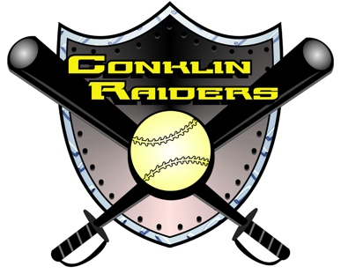ff | Class of 2021

PLAYER PROFILE
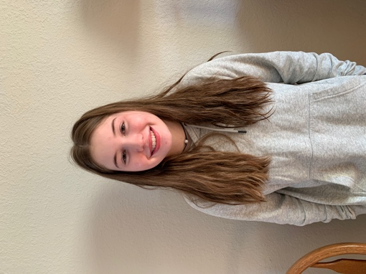 | Player:  Height:  Weight:  Positions:  Bats/Throws:  Parents:  Address | Rylee Roman  5’ 3”  115  P/2B/SS/CF  R/R  Joe Roman  Michele Roman  122 Lewis Road  Pine City, NY 14871 | High School:  Graduation:  GPA:  ACT:  Phone (C #1):  Phone (C #2):  Player / Parent Email: | Elmira High School  777 S Main Street  Elmira, NY 14904  (607) 735-3200  2021  4.0  21  (607) 873-4818  (607) 207-0319  ryroman11@gmail.com  jmroman2121@yahoo.com

SOFTBALL EXPERIENCE
Travel – Recreation – High School
High School
Spring 2018&2019  2017-Pres. | Elmira Express Varsity Softball Team  Conklin Raiders 16/18U Premier Softball | 2012-2014 | 10u NY Lady Rebels Travel Softball
2016-2017 | Conklin Raider 14u Futures Elite Softball | 2015 | Southport Cinderella 12u All-Star Team
Spring 2017 | Elmira Express JV Softball Team | 2013&2014 | Southport Cinderella 10u All-Star Team
2014-2016 | 12u NY Lady Rebels Travel Softball | 2011&2012 | Southport Cinderella 8u All-Star Team
Spring 2016 | Elmira Express Modified Softball Team | 2011- 2016 | Southport Cinderella Softball League

ACADEMIC & ATHLETIC ACCOMPLISHMENTS

2016 | USSSA Powerade Nationals in Syracuse NY Tournament Champions | 2019 | Elmira High School Varsity Volleyball
2016 | ASA Raider Rumble in Conklin NY  Tournament Champions | 2016 | Elmira High School JV Soccer
2016 | ASA Memorial Mayhem in Horseheads NY Tournament Champions | 2012-2016 | Soaring Capital Soccer Club
2019-present | National Honor Society Member | 2017, 2018 | Elmira High School JV Volleyball

SOFTBALL COACHES
Raiders 16u/18u Travel Ball Coach | Joe Roman (607) 731-6877 jmroman2121@yahoo.com
Raiders 14u Travel Ball Coach | Rich Wiggins (607) 765-6938 rich.wiggins@icloud.com
Elmira Express Varsity Coach | Rebecca Saggiomo (607) 857-3247 rsaggiomo@elmiracityschools.com
Pitching Coach | Dale Cook (607) 624-3142 popscook01@stny.rr.com

For Additional Information Please Contact: Bob Bates, (315) 521-8429, jbmpaving@yahoo.com

