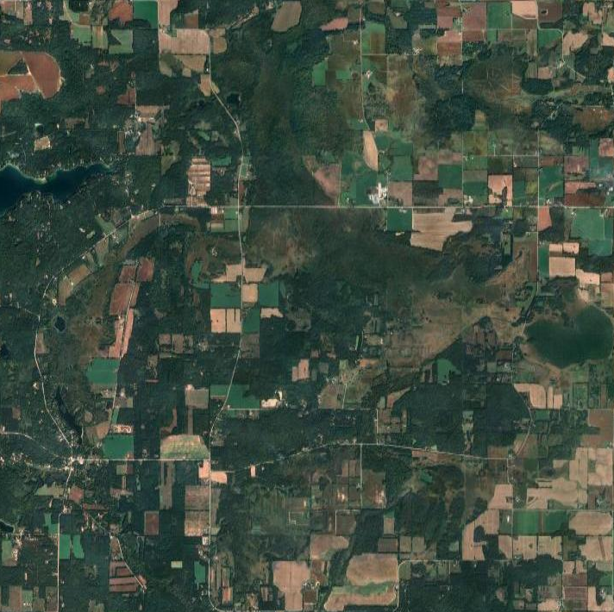
Appendix 8 - 2026

Town of Saxeville
Chapter 8
Land Use Goals and Objectives

June 1, 2026

8.1: Land Use Chapter Purpose and Contents

This element includes a summary of existing land use conditions and trends followed by a series of goals, objectives, and recommendations to guide the future development and redevelopment of public and private property in the Town of Saxeville. The element also contains an analysis of opportunities for redevelopment and existing or potential land use conflicts. It concludes with a twenty-year future land use plan.

8.2: Summary of Existing Conditions

The following section identifies a summary of existing land use conditions and trends for the Town of Saxeville as identified by the most recently available Statement of Assessment for the Town of Saxeville. A complete listing of existing resources information can be found in the Town of Saxeville Comprehensive Plan Volume Two: Existing Conditions Report.

Existing Land Use and Land Use Trends (Table 8.2026.1)

- The Town of Saxeville existing land use map was last updated in 2015.
- The Town of Saxeville encompasses approximately 23,328 acres. In 2025, about 11% of the total area is developed.
- Overall, woodland and undeveloped land account for 36% of the total land use, while agricultural makes up another 33%.
- According to publicly available Statements of Assessment from the Wisconsin Department of Revenue, residential acreage has decreased since 2017.

Table 8.2026.1
Statement of Assessment for Town of Saxeville
Source: Wisconsin Department of Revenue
 | 2017 | 2020 | 2025 | % change
Residential | 2833 | 2750 | 2625 | -1.2%
Commercial | 29 | 28 | 41 | 0.1%
Manufacturing | 0 | 0 | 0 | 0.0%
Agricultural | 7464 | 7626 | 7600 | 0.6%
Undeveloped | 3995 | 4031 | 4068 | 0.3%
Ag Forest | 1501 | 1554 | 1695 | 1.0%
Forest Lands | 2703 | 2595 | 2541 | -0.9%
Other | 183 | 184 | 195 | 0.1%
Total | 18708 | 18768 | 18765

Zoning
- The Town of Saxeville utilizes Waushara County Zoning.
- The predominant zoning district in the Town is “General Agriculture”.

Residential Density and Intensity

- Between 1990 and 2025, residential densities increased throughout the county, state, and the Town of Saxeville. During this time, residential densities increased by about 13.4% from 16.22 units per square mile to 18.4 units per square mile in the Town of Saxeville.
Source: US Census Data
- When comparing the number of residential properties to the amount of land classified as single-family (including farmsteads, duplexes, and mobile homes), a single-family intensity of less than 1 unit per acre was recorded for the Town in 2001 (610 units on 718.21 acres). In 2025, a single-family intensity of slightly more than 1 unit per acre was recorded for the Town (664 units on 646 acres). (Single Family + Farmstead)

Land Demand and Pricing
- According to Population and Housing Unit Counts from the U.S. Census, there was an overall increase of net housing units over the last 45 years. (Table 8.2026.2)
Source: https://www2.census.gov/programs-surveys/decennial/2000/data/phc/phc-3-51.pdf

Table 8.2026.2
Timeframe | Units per year
1980-1990 | 8.5
1990-2000 | 2.5
2000-2025 | 2.2

- Wisconsin Department of Revenue (DOR) annually reports equalized value by real estate class per municipality in Wisconsin. Overall, both the Town of Saxeville and Waushara County experienced increases in land value between 1998 and 2024. (Table 8.2026.3)

Table 8.2026.3
Year | Waushara County Increase | Town of Saxeville Increase
1998-2008 | 10.3% per year | 10.9% per year
2008-2024 | 4.2% per year | 3.1% per year
1998-2024 | 4.8% per year | 4.5% per year
Sources:
- https://public.tableau.com/app/profile/research.policy/viz/EqualizedValues/Dashboard1
- https://www.revenue.wi.gov/Pages/SLF/cotvc-08corate.aspx
- https://www.co.pepin.wi.us/vertical/sites/%7B379104F9-0DE8-498C-8406-82AD4E352E4A%7D/uploads/2024_Pepin_County_Statistical_Report.pdf
- https://search.library.wisc.edu/digital/A4K4QRBLSRUNJE8R/pages/A36JX5PWTTKTLW8R

- State of Wisconsin housing statistics provided by the Wisconsin Realtors Association show that median sale price in Waushara County increased from $122,000 in 2008 to $285,000 in 2025. This represents a 134% increase.
Source: https://www.wra.org/housingstatistics/

8.3: Opportunities for Redevelopment
Like many rural communities, the Town of Saxeville does not have its own downtown center where a variety of services are provided and opportunities to redevelop non-residential properties remain. Instead, the Town consists of a variety of residential homes and working farms. However, there is one active non-metallic mining operation within the Town which will offer long-term redevelopment opportunities. The Town coordinates with regional authorities to implement each quarry’s reclamation plans when productivity of the sites has ceased.

8.4: Existing or Potential Land Use Conflicts
Throughout the Town, there are single-family residences and small commercial operations. The only potential land use conflict is the one active quarry operation. These uses can produce noise and heavy-vehicle traffic.

8.5 Land Use Goals, Objectives, and Recommendations

The following section identifies goals, objectives, and recommendations to guide the future development and redevelopment of public and private property in the Town of Saxeville. The goals and objectives identify what should be accomplished, whereas the recommendations focus on identifying the action necessary to achieve the desired outcome.


Goal 8.1
Strengthen and enforce the existing county shoreland zoning ordinance.

Objectives

    - Encourage the preservation of open space, shorelands and scenic areas, which contribute to the rural character and quality of life in the Town.
    - Encourage the conservation of areas that are of natural resource, open space, and scenic significance.
    - Encourage buffer areas adjacent to designated areas to be preserved, such as lakes and other waterbodies.

Recommendations

- Shoreland protections shall be applied to all lands within 1000 feet of all navigable lakes and within 300 feet of rivers and streams.
- Support the existing county prohibition on pyramid lot arrangements to prevent pyramiding of homes around lakes.

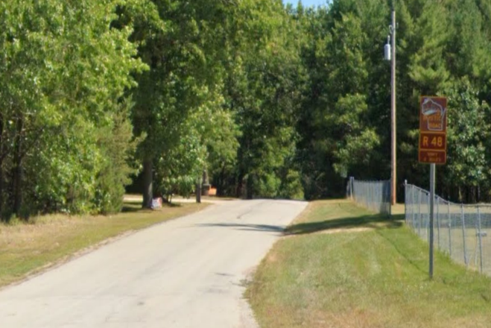
Goal 8.2
Conserve and protect the significant environmental, scenic, cultural, and historic resources of the Town.

Objectives

    - Ensure that rural and urban land uses are located, developed, and managed to minimize harmful impacts on the Town’s natural resources.
    - Encourage the preservation of open spaces and scenic areas, which contribute to the rural character and quality of life in the Town.
    - Encourage the conservation of areas that are of natural resource, open space, scenic, historical and archeological significance.

Recommendations

- Use DNR Stewardship funds for Town to acquire lands for protection.
- Recommend a woodland and/or prairie management plan for all subdivision plats. Such plans should identify any existing, unique stands of trees or prairie habitat and encourage woodlot and prairies preservation or mitigation to minimize the impacts of development.
- Encourage existing and future woodlot owners to utilize “best management practices” on their properties to preserve more native tree cover. Promote education about various state woodland and prairie management programs and services.

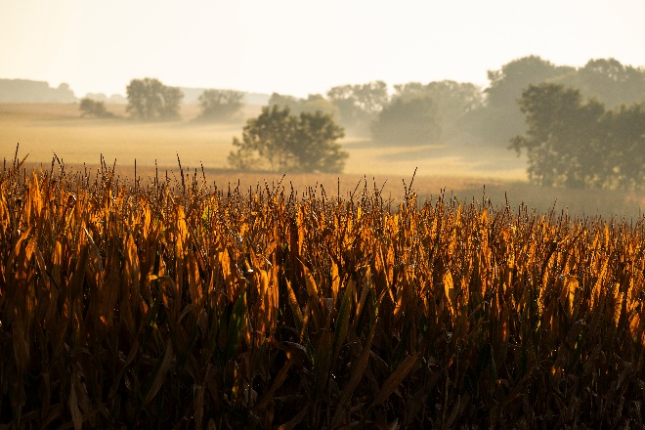
Goal 8.3
Preserve the unique and desirable qualities of the Town’s landscape that define its rural character.

Objectives

    - Address and eliminate unsightly properties and other elements generally regarded as eyesores.
    - Minimize the visual impact of non-farm residential development on the rural landscape.
    - Protect the visual integrity of important scenic features and/or vistas.
    - Encourage the County to adopt strict zoning laws regarding placement of data centers and similar uses to protect our sensitive water and energy resources.

Recommendations

- Require all platted subdivision of land to have approval of the Town Board before County plan approval is sought.
- All approvals to further subdivide any existing parcels must receive Town Board approval first.
- Ensure that any new land uses are located appropriately, as per the Proposed Land Use Map.
- Discourage the subdivision of viable farmland and forested land.
- Pursue a change in Town zoning from AG to AG-2, with the exception of the residential and commercial growth area.

The Future

8.6: Land Use Projections
Wisconsin statutes require comprehensive plans to include twenty-year projections for residential, commercial, industrial, and agricultural uses by five-year increment. A summary of future land use projections is listed below.
With an estimated decrease of 26 residentially assessed acres per year, the Town of Saxeville would likely experience a loss of 130 residential acres by 2050. Commercial increases are forecast to coincide with increases in residential density. (See Table 8.2026.4)

Future land use was calculated based on the trending change from 2017 to 2025.

Table 8.2026.4
Future Land Use Projections (in acres) for the Town of Saxeville
Original Data Source: Wisconsin Department of Administration
 | 2017 to 2025  Acreage Change per Year | 2025 | 2030 | 2035 | 2040 | 2045 | 2050
Residential | -26 | 2625 | 2599 | 2573 | 2547 | 2521 | 2495
Commercial | +2 | 41 | 43 | 44 | 46 | 47 | 49
Manufacturing/Industrial | 0 | 0 | 0 | 0 | 0 | 0 | 0
Agricultural | +17 | 7600 | 7617 | 7634 | 7651 | 7668 | 7685
Undeveloped | +9 | 4068 | 4077 | 4086 | 4095 | 4105 | 4114
Forested | +4 | 4236 | 4240 | 4244 | 4248 | 4252 | 4256

8.7: Future Land Use Map and Categories

The Town of Saxeville Future Land Use Map (Exhibit 8-2026-3) identifies one priority growth area immediately surrounding the intersection of County Road W and South County Road A. This is a
“Residential and Commercial Growth Area” and the intent of this area is to allow residential and commercial interests to develop land near or adjacent to these crossroads.

The following section describes the future land use categories utilized on the Future Land Use Map (Exhibit 8-2026-3.)

Future Land Use Categories
Agricultural/Natural
- The agricultural/natural district is established for areas in which agricultural and certain compatible low intensity uses are encouraged as the principal uses of land. It also includes areas where special protection is encouraged because of unique landscape, topographical features, wildlife, or historical value.

Residential
- The residential district includes land uses where the predominant use is housing. This includes large-lot residential development as well as more compact residential lots and mobile home parks.

Commercial
- The commercial district includes areas dedicated to the sale of goods or merchandise and office developments.

Residential and Commercial Growth Area
- Located at the crossroads of A and W, this area has been targeted as a residential and commercial growth area. The intent is to cluster residential and commercial uses near existing residential and commercial uses where highway access and utilities provision best meets the requirements of those uses.
Industrial:
- The industrial district is established in select areas to enable industrial activities when compatible with adjacent land uses. In Saxeville, industrial uses primarily include quarries.

Public/Institutional
- This district includes a range of public, social, and institutional uses. These uses are public or semi-public and are generally tax exempt. Specific uses include schools, libraries, parks, municipal buildings, health care facilities, places of worship, and transportation right-of-way corridors or other public lands.

Transportation
- This area incorporates the town’s roadway network.

Water Features
- These areas include lakes, streams, and other water bodies.

Environmentally Sensitive Areas
- These areas include land where special protection is encouraged because of unique landscape, topographical features, wildlife, or historical value. The district may include woodlands, wetlands, undeveloped shorelands, floodplains, groundwater recharge and discharge areas, and steeply sloped lands.

