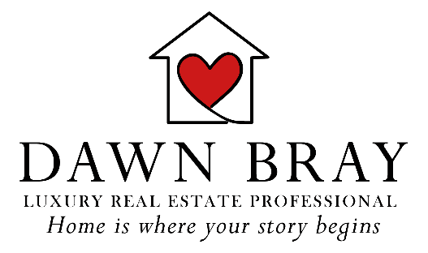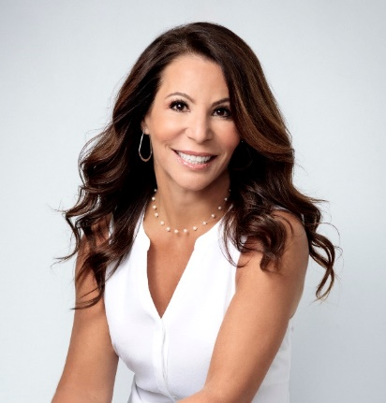

Introducing our first Gold Sponsor

If you live in WildBlue, you've probably encountered our exceptional neighbor Dawn Bray. Now, we're excited to introduce her as the very first WBCN Gold Sponsor. Together We Can talked with Dawn about her business, her mission, and what WBCN means to her.

WBCN: Dawn, please tell us about your company and your role.

Dawn: I have been a SWFL Luxury Real Estate agent since 2018. I began this second career when I originally joined my sister’s brokerage. I decided to branch out on my own, along with my daughter, a few years ago and joined the Luxury Division of Premiere Plus Realty. We really strive to meet the needs of our clients and make the process as easy and seamless as possible. I have a team that I can rely on, as well as a list of trusted vendors who we love to recommend to our clients. We truly enjoy connecting with our clients and feel so blessed to have experienced great success here in SW Florida and within our WildBlue community.

WBCN: How does becoming a WBCN Gold Sponsor fit into your company's values and mission?

Dawn: What I love most about being an agent in SW Florida, is helping others. Sometimes it’s helping them to find the perfect home, to assist them with selling their own home, or helping to connect them with the resources that they need. The reward for me is more intrinsic. I love knowing that I have made a positive difference in some way, and that is what WBCN is all about: helping to make an impactful difference in the lives of many. I truly wish I had more time to give (someday soon I will) but for now, I love knowing that my sponsorship is making an impact in some way.

WBCN: As a WildBlue neighbor and business leader in our community, what does WBCN mean for you personally?

Dawn: On a more personal note… one of the reasons I moved here permanently in 2018, was because my mother was diagnosed with Alzheimer’s at the early age of 62. We decided to relocate here so that I could help to support my father throughout the difficult journey. WBCN are committed to helping The Dubin Center, which is an organization that provides education and support to families when they really don’t know where to turn or how to handle such a difficult situation.

Additionally, having been an educator for 25 years prior to moving into the real estate industry, I have dealt with countless families who were struggling. I am thrilled that this organization is also committed to assisting a number of charities that focus on the well-being of children and families.

WBCN: Are there any other key messages you would like to convey?

Dawn: I am so proud to live in Wildblue and be a part of such a caring and generous community. The fact that this organization is in existence is a great testament to the values of our community. When touring the community with potential new owners, I strive to relay the welcoming nature of this special place. I truly love our community and am so blessed to live here.

I’d also like to convey a very sincere thank you too all of the members of the group. I’m so impressed with all that you’ve done so far, and super excited to see how it flourishes over the coming years.

