Spotlight on…Webmaster Tom Struble

In every edition, Together We Can will highlight a volunteer who helps lift us all. We are excited to shine the spotlight on our dedicated webmaster, Tom Struble, who has gone above and beyond to help bring our WBCN website to life. His commitment, patience and expertise have significantly enhanced our online presence, making it easier for our community to engage with our mission. You may see Tom walking down the street with his dog, Tessa, around Vista. Give him a wave and a thank you!

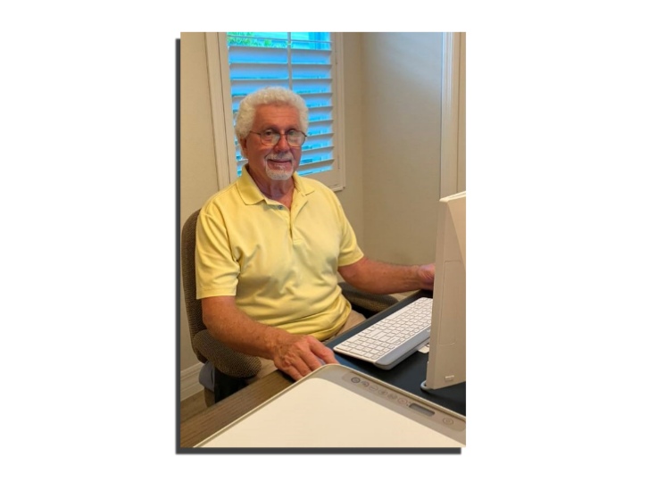
(P.S. And be sure to check out his/our beautiful website!)

Charity plays a vital role in fostering a healthy society, as it encourages individuals to treat one another with kindness and respect, no matter their background.
Tom Struble

Introducing our neighbor and yours, Tom Struble.

WBCN: Tom, thank you so much for your invaluable volunteer service. Please tell us about yourself.

Tom: I have been a member of the Vista WildBlue community for over three years. I am from Connecticut and moved to this area with my wife, Diane, and my Black Lab, Tessa. My wife and I are both retired teachers. I taught technology and was the Computer Coordinator for a public school system for 36 years. While in the public school system, I started developing websites. I worked with an upstart web design company and helped develop a content management web program. I used this program to build the district website and trained the administration, staff, and teachers on how to design and post school-related information. After retiring, I spent the next 15 years working at Southern Connecticut State University. In the first five years, I was a PC Technical Support Analyst managing Academic Computing. Later, I moved into management and ended my career as the Director of Facilities Operations Services.

My love for web design has not ended with retirement. I started my own company called IBuildWebsites4Free. This started me down the road of doing charitable deeds. I create websites for free to assist you or your small business in gaining digital recognition. You might lack the time, expertise, or resources to hire someone for website creation. Being retired, I have ample free time and a passion for designing websites that reflect your style.

WBCN: How did you get involved in WildBlue Charitable Neighbors?

Tom: My wife was talking with one of our neighbors, Shelly Wessler, who is a very active member of WBCN. My wife told Shelly that I build websites. Shelly approached me and within days, I heard from Debbie Nolan and Melissa Metzger about helping with the WBCN website. It has been a pleasure to work with a very passionate group of people.

WBCN: What do you like best about the work you’re doing?

Tom: Being part of a group that assists our neighbors is something I value. It's a wonderful way to contribute to society and make a positive difference in our community. Charity plays a vital role in fostering a healthy society, as it encourages individuals to treat one another with kindness and respect, no matter their background.

WBCN: What would you like the WildBlue community to know about WBCN?

Tom: WildBlue Charitable Neighbors has a place for everyone in our community to volunteer their time, skills, and to donate financially. The WBCN website was constructed to provide information on the PURPOSE, SERVICES, EVENTS, FINANCIALS, and LEGAL & POLICY COMPLIANCE. Being part of a group that assists our neighbors is something I value. It's a wonderful way to contribute to society and make a positive difference in our community.

WBCN: Tom, on behalf of all of us involved with WBCN, our neighbors and most importantly the beneficiaries of the organizations in Lee County whom we support, a big thank you for sharing your time and talents with us.

