Founders’ Corner
Together We Can Do More: Introducing WildBlue Charitable Neighbors

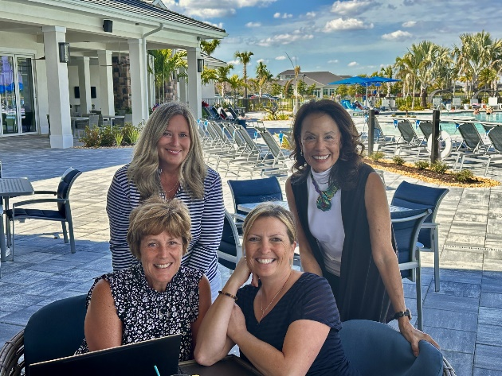

Let’s join together as neighbors, as friends, and as a family to build a better community for everyone.
(top) Vicki Hellenbrand, Debbie Nolan;(bottom) Maureen Humes, Melissa Metzger

A simple meeting during WildBlue golf scrambles has blossomed into something truly special. When Debbie Nolan and I met, we had no idea we were starting what would become a vital force for good in our community. From pickleball courts to Bible study groups, bingo nights to ladies' lunches, our community of neighbors has grown stronger—not just in friendship, but in purpose.

From north, south, east and west, we are all blessed to come together in this beautiful new community. But as we’ve settled in, we've also noticed something: not everyone shares the same opportunities. There are families, individuals, and animals right here in Lee County who need our help. This realization sparked the idea for action. That’s how WildBlue Charitable Neighbors (WBCN) was born. We became an official nonprofit on January 20, 2024, with a single goal in mind: to give back to the community that offers so much to us.

Laying the Foundation
Since that day, we’ve been working hard behind the scenes. Debbie and I, along with a dedicated team of 11 board members and 35 committee members, have spent countless hours on phone calls, Zoom meetings, and face-to-face discussions to ensure that WBCN is built on a solid foundation.

We started by surveying our neighbors to gather ideas and identify where our community could make the most impact. With those insights, our grants committee carefully vetted local charities, conducting onsite visits and reviewing grant applications to ensure that our efforts truly meet the needs of Lee County.

Our Mission: The Four Pillars of WBCN
We are proud to announce that WBCN is ready to launch its mission, serving Lee County through our four key pillars:
- Housing & Hunger – Helping individuals and families struggling with basic necessities
- Youth Education & Development – Providing support and resources for the next generation
- Senior Citizens & Veterans – Honoring those who paved the way and served our country
- Animal Welfare – Caring for the animals that bring so much joy into our lives

As we come together, united by the desire to give back, we are reminded of a powerful quote by William Blake: "No bird soars too high if he soars with his own wings." At WBCN, we believe that when we join together as neighbors, we can soar even higher—because together, we can do more.

Get Involved: Be Part of the Mission
We are excited to begin this journey with all of you, our WildBlue neighbors. Whether you’re interested in volunteering, donating, or simply spreading the word, your support will help us make a real difference right here in Lee County.
Want to stay up to date with WildBlue Charitable Neighbors?
- Check out the WildBlue Charitable Neighbors website (www.wildbluecharitableneighbors.org)
- While you’re on the website, enter your email address in Subscribe To Our Newsletter and click the Sign Up button.
- Follow WildBlue Charitable Neighbors on Facebook

