And the 2024 – 2025 grants go to….
WBCN is a 501(c)(3) non-profit corporation. Your donations help us fulfill our mission by extending a helping hand to local charities and non-profits in Lee County. But with so many needs in our area, how do we choose charities and non-profits we will support? Here’s the WBCN grant/gifting process we organized and followed.

- Ask the community
Several surveys were sent to the WildBlue community to determine what areas of need were most important to you and which specific non-profits we should consider. Survey results were compiled and analyzed.

- Identify priorities
Based on your input, we identified six areas of interest, or “pillars,” to consider. For WBCN’s initial efforts, we decided to concentrate on the four pillars with the highest level of interest from our neighbors – noted in bold.
- Hunger and Housing
- Youth Education and Development
- Animal Welfare
- Seniors and Veterans
- Women’s Resources
- Environment and Conservation

- Select charities
Within the four pillars of focus, the Grants Committee took your suggestions for specific charities and also researched many others on our own. Among other factors, the organizations selected for our first round of grants were chosen based on
- 501(c)(3) Lee County non-profit
- Site visit surveys
- Financial audits
- Current financial donor base

We fully vetted 16 worthy organizations, presented our findings to the Board. The Board voted to accept these top eight for the 2024-25 grants:
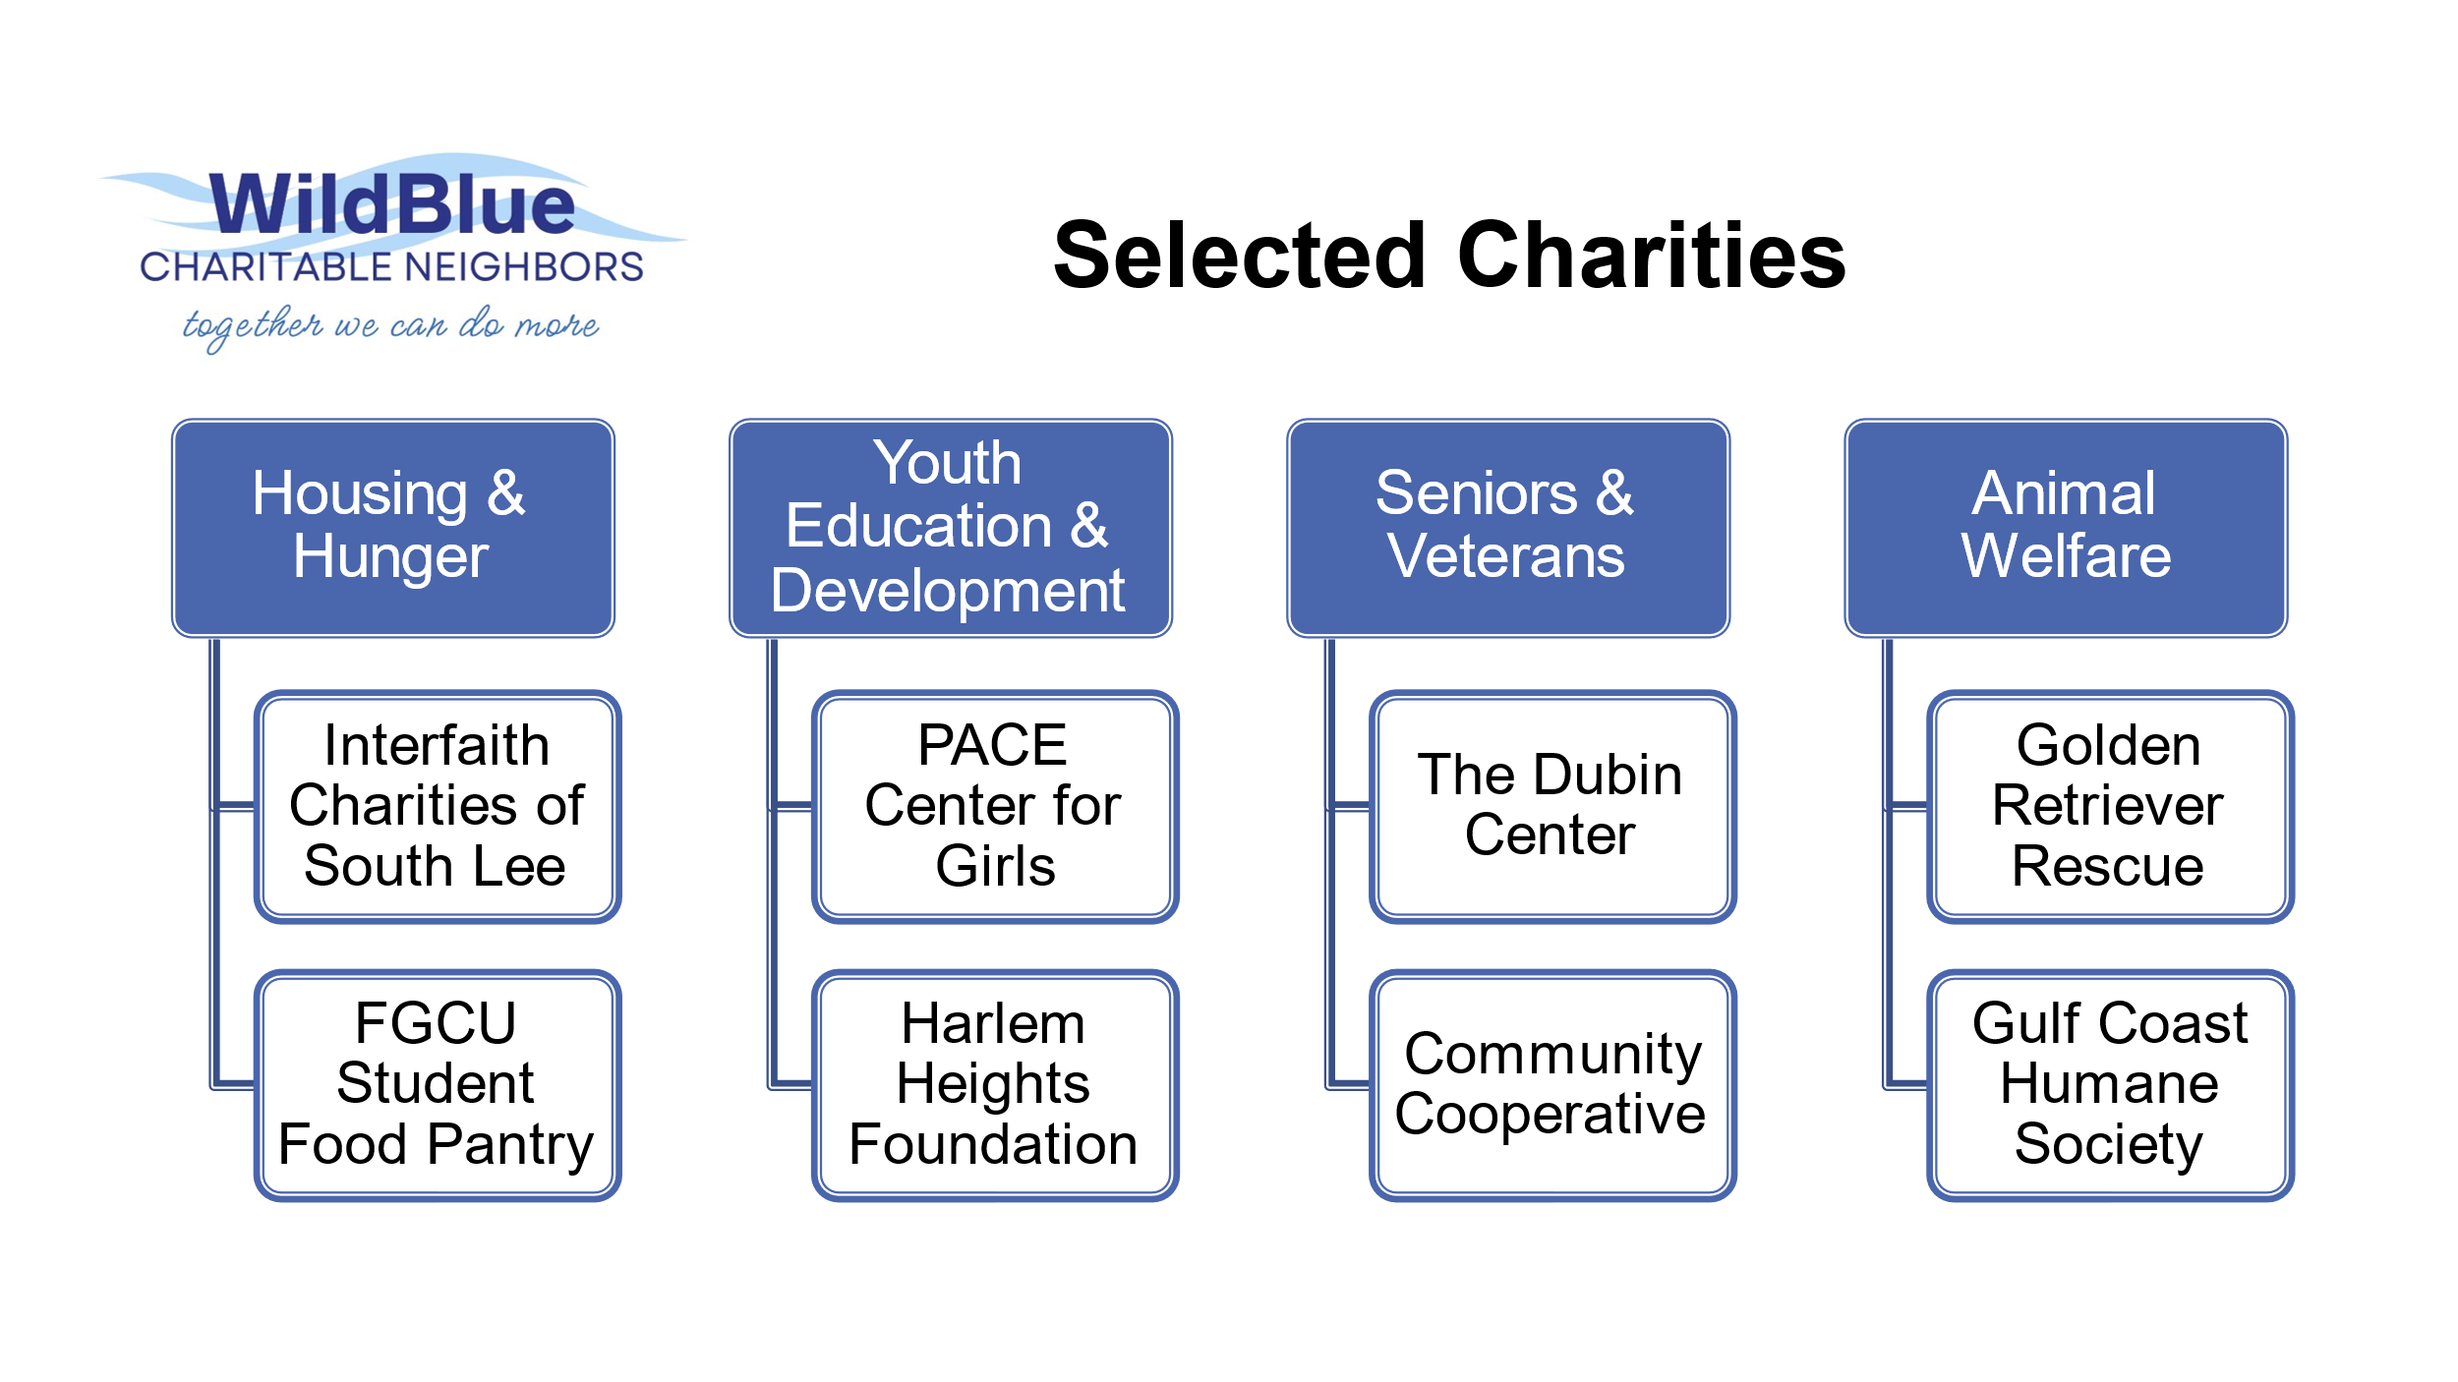
Learn more about these charities on our website at wildbluecharitableneighbors.org.

In the future, we will branch out to the other two pillars and the other organizations that are already vetted ready to be presented to our WildBlue community. Thank you for all of your support and financial gifts that will indeed make a huge impact to our partner agencies!

Can we count on your support?
Donate to support our eight amazing charities that do so much for so many in Lee County. Use the QR code below or send a check payable to WildBlue Charitable Neighbors to 13596 Blue Bay Circle, Ft. Myers, FL 33913.
Together we can do more!

