NEW: REGISTRATION QUESTION REPORT
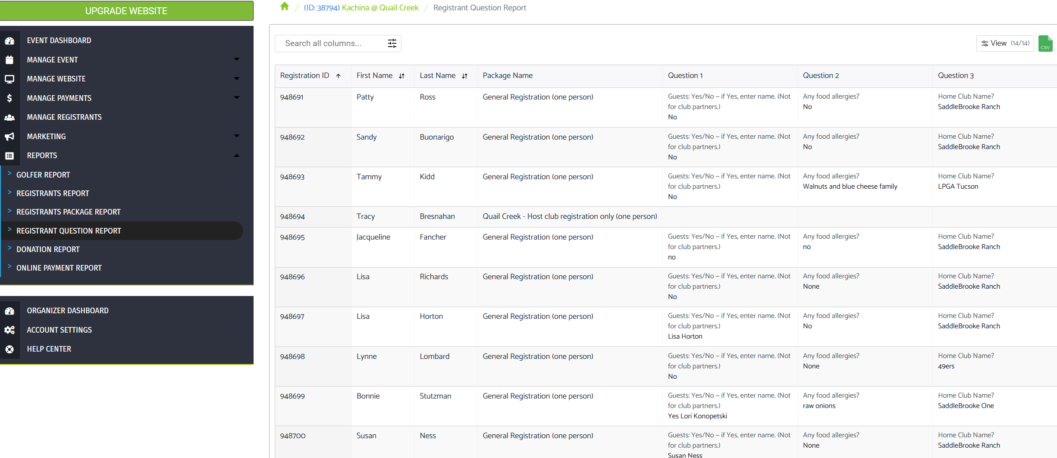
Select the information that you wish to export to CSV
- The number of questions may vary for each event.
- When using the host club’s standard package, all questions must match exactly with the General Registration form. Any mismatch will cause the final report to misalign.
- Example: If “Home Club” is omitted, the GHIN number will shift into the Home Club column, creating alignment errors in the report.
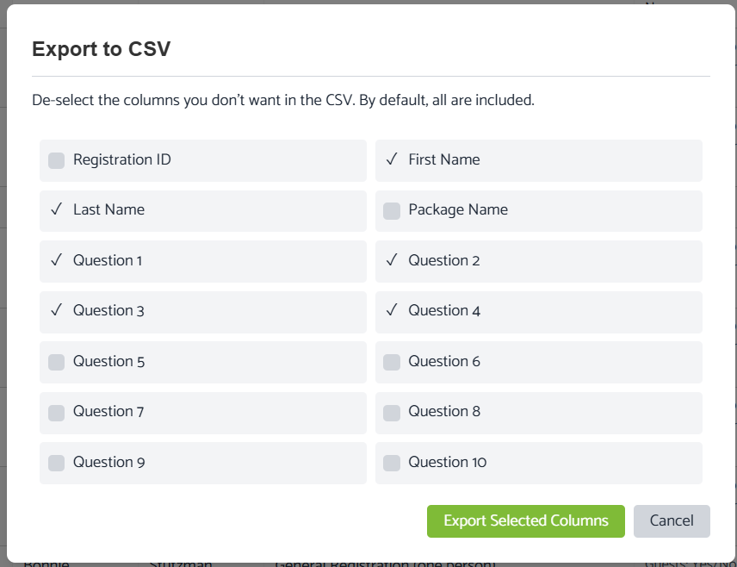
Not needed
Not needed
Home club
Guests etc..)
Food allergies
GHIN number
SAMPLE CVS Report – you will need to sort clubs into order
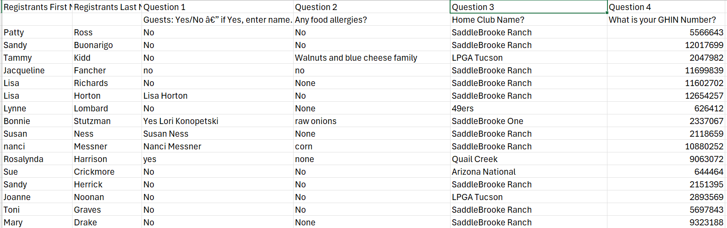
SAMPLE CVS Report with Host Club alignment issue
Note: Questions added after registration commenced new registrants do show GHIN numbers etc.
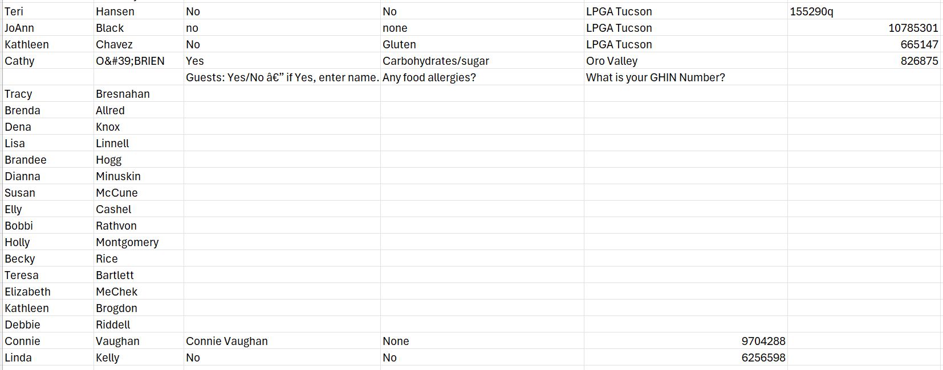

ADMINISTRATION
Setting up questions – check ASK REGISTRANT only (this avoids being asked to fill in golfer form – we only use Registration Report or Registration Questions Report.)
