Altar Server Handbook

Immaculate Conception Cathedral
Auchi, Auchi Diocese
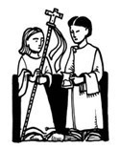
Welcome Altar Servers,

We thank you for responding to the call of the Holy Spirit to serve at Immaculate Conception Cathedral as an altar server. Serving at the Altar of God is to serve Jesus Himself. It is a privilege to be called and a responsibility to be present and ready to serve!
This booklet contains an overview of the ministry. Please keep it in a place at your home that you can review it, especially the first few times you will be serving at Mass.

Bro Martin Onyisi
Diocesan MC

Dear Parents,

As parents of Altar Servers, you are also an important part of our liturgy. Your role is to worship with your child and to support their commitment to our parish community by making sure that your child is present and on time to serve at Mass when scheduled. If you have a scheduling conflict, your responsibility is to arrange for a substitute Altar Server for that Mass.
Thank you for your family’s support and commitment.

Rev. Fr John Aligamhe
Cathedral Administrator

Responsibilities of Altar Servers

- Always pay attention to the priest and the deacon. You should be ready at any time during Mass to respond to them if they indicate they need your help or assistance.

- Always be here at least 15 minutes early if you are scheduled to serve.

- Memorize when your jobs and duties happen. Learn the order of Mass.

- Always check with the priest and/or deacon before Mass begins to see if there are any special instructions or reminders he needs to give you.

How to Serve in this Ministry with Reverence

  - Participate and look interested—you are visible to the congregation during Mass, so it is important not to look bored.
  - Keep your hands folded in ‘prayer’ posture when standing or kneeling unless you are holding something.
  - Walk slowly and deliberately—think ‘royalty’.
  - Dress up. We are gathering for a feast with our king.
Boys should wear dress pants and dress shoes. Girls should wear a dress, skirt, or dress pants with dressy, closed toe shoes. Please do not wear flip flops, sandals, or tennis shoes. Choose clothing that will not ‘scream’ through the alb (like neon).
  - Always find a substitute as soon as you know you cannot serve your scheduled Mass.

Scheduling

Altar Servers are scheduled according to their Mass preference whenever possible. There may be times when you are asked to serve at a Mass that you do not regularly attend. Please be generous with your time and schedule if this happens!

The schedule will be sent out in as a message every Saturday morning. Before the schedule is made, we will ask you to submit dates that you are unavailable for the week schedule.

We will schedule altar servers for Holy Days several weeks ahead of time.
There will be a schedule that goes out to see who is available.

Please review the schedule when you receive it to check the dates that you have been scheduled to serve.

If you are unable to serve for your scheduled Mass, please find someone who can substitute for you as soon as possible. If you become ill or have a
last minute emergency, please call the sacristan or president at the church so they can let the priest know that he will need to find a last-minute substitute.

It is helpful to come to Mass ready to serve, even if you are not scheduled.
Sometimes other servers may not be here and you may be the only server!
This means doing your best to be early, checking to see if you are needed, and wearing attire appropriate for altar serving.

We will be having an Altar Server Retreat each year.
Regular formation is important for all liturgical ministers.
Mass BEFORE MASS BEGINS…..
- Arrive AT LEAST 15 MINUTES before Mass begins
- Sign in on the Altar Server Schedule posted in the sacristy
- Vest in an Alb(Cassok) (check to make sure it is the correct length)
- Decide who will be FIRST SERVER and who will be SECOND SERVER
- Light altar candles with the small lighter/snuffer which is stored in the cabinet in the vesting sacristy.
- If there is a BAPTISM, make sure the Paschal Candle (by the baptismal font) is lit. If it is too tall for you to light ask the sacristan to help.

PROCESSION
- Gather at the entrance to the sanctuary with Father and Deacon/ Seminarian.• First Server will be the cross bearer who leads the procession.
- First Server begins processing while the piano/organ accompanist is playing the introduction to the opening hymn
- Second Server begins processing when First Server has reached the first brass circles on the carpet
- When arriving at the foot of the altar, the Cross Bearer goes to the right/Second Server goes to the left of the Priest. Facing the altar.
- Cross Bearer does not bow/Second Server bows with Priest
- Cross Bear takes cross to the back, places it in the stand and goes to his / her place by passing through the working sacristy.
- Second Server goes directly to his/her seat

BEGINNING OF MASS + PENITENTIAL RITE/GLORIA (Gloria does not happen during Advent or Lent)
- Second Server(MC) is book bearer and prepares to take the large red book (Roman Missal) to the Priest for the opening prayer.
- CUE: (No Gloria - Advent and Lent) “May Almighty God have mercy on us, forgive us our sins……” Let us pray
- CUE: (Gloria) Conclusion of the Gloria “Jesus Christ, with the Holy Spirit, in the glory of God the Father. Amen”
- Stand in front of Priest who will open Roman Missal and adjust the height.
- Return to your seat with the Roman Missal

PRAYER OF THE FAITHFUL
- CUE: When we say the prayer for the “sick and dying”
First Server gets the cruet with water from the small table in the back (credence table) .
Second Server gets ready to take Roman Missal to altar.
- At the end of the Prayer of the Faithful, Servers bring water cruet and red book (Roman Missal) to the altar
- Cruet is placed on the right corner of the altar. Father or deacon/Seminarian may move to the altar to accept the book. If Father remains at his seat, place the book on the altar a little to the right of center so that when the book is opened it is in the center of the altar.

PRESENTATION OF GIFTS
- CUE: Priest stands to accept the gifts brought in the Offertory Procession; both servers go with him to the foot of the altar.
- The First Server (MC) walks behind the Father and stands next to him on
Father’s left.
- The Second Server (Boat bearer) stands on Father’s right side.
- Father will accept the bread plate and wine pitcher and hand them to the servers who will proceed to the altar and place them on the altar.
- Then the Third server (Aux) presents to the priest a sprinkler containing HOLY WATER

WASHING OF HANDS BY PRIEST
- After placing the bread and the wine on the altar the Second Server goes to credence table in back of the altar to get the bowl and the towel and then returns to his/her place
- The First Server returns to his/ her place remaining standing until the
Second Server returns. Both servers then sit until Father approaches the altar at which time both servers then stand at the foot of the steps.
- During the offertory, Father will raise the hosts in the plate and then raise the chalice.
CUE: As Father lowers the chalice both servers go to the altar.
- The Second Server will carry the bowl and have the towel over his/her arm.
- First Server picks up cruet. When Father holds his fingers over the bowl, the First Server pours water over the priest’s fingers.

- First Server returns cruet to the credence table/Second Server empties water bowl in back sacristy and returns bowl and towel to the credence table.
- After the washing of hands, the priest and servers bow.
- Servers return to their place and stand. Servers kneel for the Eucharistic Prayer. Servers stand after the Great Amen.

RECEPTION OF HOLY COMMUNION
- Servers receive Holy Communion standing with the Extraordinary Ministers of Holy Communion and be seated in the chairs by the wall.
- Roman Missal needs to be taken from the altar either by the Deacon/ Lead Minister or Server during the reception of communion by the people. Just check to make sure it comes back to your chair area before communion is over. After communion is finished, return to seat.
CUE: During announcements First Server goes around the back to get the Cross for the Recession.
CUE: When you hear the final blessing, be ready to join Father at the foot of the altar for the recession.
CUE: When Father walks towards the altar to bow, Servers start walking to the foot of the altar. Stand facing the altar.
- When Father bows the Second server bows. The cross bearer does not bow.
- After Father bows , First Server with Cross immediately leads procession, followed by Second Server and Father/Deacon

PRAYER AFTER COMMUNION
CUE: The priest stands and says “let us pray”.
- The Server brings up the missal. 99 % of the time when the priest stands he will be saying the prayer after communion.
- Note: This may also be a time when the priest calls a speaker to come forward. Generally, he will say the prayer after the speaker has finished.

AFTER MASS
- Extinguish candles with large snuffer from the back sacristy.
- Return alb to closet. Place the hanger through the loop on the alb to prevent falling on the floor.

ALTAR SERVER VOCABULARY

Alb—the white robe that servers wear to celebrate Mass. It reminds you that you are baptized int Christ. The name for this robe comes from the Latin word for “white”.

Altar—the table where Mass is celebrated. Christ sacrifices his own Body and Blood here through His priest. The altar is also a symbol of Christ.

Ambo—also called ‘pulpit’ or ‘lectern’ - The bookstand where the priest or deacon proclaims the Gospel, the lectors proclaim the scripture readings, and the cantor proclaims the psalm. It has a microphone and is designed to hold the book of the Gospels at waist or chest level. There is a shelf underneath the book stand where the priest can keep his homily or other papers.

Aspergillum—Also called a holy water sprinkler. It has an end with holes on a handle that holds holy water for the priest to sprinkle on people to bless them.

Aspersorium ( Sprinkler)—the bucket for holy water.

Baptismal font ( Bowl)—the large basin that holds holy water, where people are baptized.

Blessed Sacrament—another name for the consecrated Host, which is the Body of Christ Himself.

Boat—a small metal container that holds the incense used for the thurible (also called censer). It has a cover and comes with a small spoon. It is usually either round, or shaped like a little boat (because the Church is the Barque (ship) of St. Peter, the vessel that carries us to Heaven)

Book bearer (MC)—the server who holds the Roman Missal or other books for the priest and deacon at Mass

Bow—a gesture of reverence given at Mass to the altar, the symbol of Jesus Christ, or to Christ as he is present in the priest. The bow made during the Mass to the altar is a “deep bow”, meaning that you keep your body straight, bow at the waist and bow your whole body down. The bow to the priest is a smaller bow.

Candle lighter—also called snuffer or extinguisher — used to light and extinguish candles. It has a long pole, and contains a long, retractable wick which goes inside it (called a taper. One side holds the wick, the other holds the bell shaped ‘snuffer’ to put the candles out.

Cassock—a long black robe worn by the priest as a mark and sign of his priestly state, or a seminarian as a reminder of what he is training for. (The priest will often wear a black suit instead of a cassock. ) This dates back hundreds of years to the Roman empire.

Chalice—the cup used to hold the wine that is transformed into the Precious Blood of Christ. The large, ornate one the priest uses at the consecration is called the ‘priest’s chalice’ and the smaller simpler ones to distribute to the people at Mass are called ‘side chalices.’ The priest’s chalice is usually made out of gold or silver, or some other precious metals, and it is beautifully crafted to remind us that what is inside is the most precious thing we have in this life: Christ’s own Blood.

Chasuble-the outer robe a priest wears, that fits over the top of his vestments like a poncho . Its color is symbolic of the mystery or liturgical season being celebrated (for example, red for martyr’s feast days, purple for Lent, white for Easter) It is a symbol of the charity of Christ.

Ciborium — a bowl or vessel with a lid that holds the hosts to the consecrated for Mass.

Collect-the prayer said at the beginning of Mass, where the prayers of all the people are “collected” and offered as Mass begins

Cincture—a long rope belt used for tying the alb at the waist.

Consecration-the time during the Mass that the priest, acting in the person of Christ, says a special prayer of blessing and thanksgiving and raises up the bread and wine. At this time, through the power of Christ working through him, the bread and wine are transformed. They are no longer bread and wine (even though they still look and taste like it), but they become the real Body and Blood of Jesus Christ.
Cope—a long cape, used in certain ceremonies outside Mass, including Eucharistic adoration and benediction.
Corporal—a rectangular piece of white cloth that is unfolded like a table cloth and placed on the center of the altar so that the crumbs and fragments of the Host are not lost.

Credence table — a table to either side of the altar where supplies are kept during the celebration of the Mass.

Crucifer—the server who carries the processional cross (Crucifix) at Mass

Crucifix—the image of Jesus crucified nailed to the Cross; a reminder of what the Mass is about when we enter into the mystery of Jesus’ suffering, death, and Resurrection, and we receive the fruits and merits of His Passion (suffering) as He sacrifices Himself as a victim to save us. There is a large Crucifix on the wall behind the altar, and also one the servers carry at Mass, called the “processional crucifix” or “processional Cross”

Cruets-these are the small glass bottles with caps (usually cross-shaped) to hold the water and wine used during the Mass.

Decanter—see flagon

Eucharistic Prayer—the main prayer of the Mass. It is a prayer of blessing and thanksgiving that the priest offers in the person of Christ the Head of the Body of the Church. He offers it to God the Father on behalf of all the people, those present at Mass as well as all those who have died.

Extraordinary minister of Holy Communion (EMHC) - lay people who are authorized by the Diocese to assist the priest and deacon in distributing the precious Body and Blood of Christ if there are too many people for the priest and deacon to do so alone.

Finger bowl—this is the small bowl used the catch the water when you are washing the priest’s hands.

Finger towel—the small towel the priest uses to dry his hands after they are washed after the presentation of the gifts.
Flagon—also called decanter or wine pitcher—a large pitcher containing wine to be consecrated. At Sunday Mass, it is carried up by members of the parish to the altar in the offertory procession, where the deacon or priest distribute it into chalices.

Genuflection—a gesture of reverence and love given to Our Lord in the Blessed Sacrament. When we genuflect, our body stays straight and we bend down our right knee to the floor.

Host—a piece of unleavened bread pressed flat and usually round (“unleavened” means there is yeast in it to make it rise. This reminds us of the Jewish Passover when they did not have time to wait for the bread to rise as they fled from Egypt). Hosts often have a cross stamped into tem, to remind us of Jesus’ Pachal mystery (His suffering , death, and Resurrection). This is the special bread used for consecration, which becomes Jesus’ own Body. These hosts are kept in a ciborium. Most of them are small, but the priest uses a larger one at Mass. The priest breaks his consecration host at the Agnus Dei (Lamb of God) prayer, reminding us how Jesus took bread and broke it to share among his disciples.

Humeral veil—a special long thin veil that goes over the shoulders of the priest before he gives benediction, or before he handles the Blessed Sacrament. It has hand pockets for him to place his hands inside it. It is a reminder that the blessing of benediction comes from Christ Himself in the Eucharist, and not from the priest.

Lectern—see Ambo

Lectionary—the book of Bible readings used at the Mass

Lector—the person from the congregation who read the Word of God during Mass

Mass—also called—Holy Communion or the Eucharist—The perfect prayer of the Church, in which we enter into Communion with Christ and with each other, and are united with all of the angels and saints in Heaven. The Mass is the sacrifice of Christ on Calvary, and through the power of Christ, we share in His Resurrection from the dead. We are closer to Heaven during the Mass than at any other time in our lives.

Missal—the book of prayers for the Mass the priest reads from. The one for Sunday Masses is a big, red book. Also called the Sacramentary or Roman Missal

Monstrance—a large, ornate tower shaped like a Cross and usually made of gold. Designed to hold the Blessed Sacrament (Host) in a see-through glass case, so we can see Our Lord in His sacramental form (truly there in what looks like bread). This ceremony is called “Adoration”. When the priest or deacon blesses us with Our Lord in the monstrance, that is called “Benediction”.

Nave—the main floor area of the church, where the people sit.

Offertory—See “Preparation of the Gifts”

Pall—(1) One pall is a stiff white square that goes over the top of the priest’s chalice and purificator to make sure that nothing gets into the Precious Blood (dust, etc). (2) a large rectangular white cloth that goes over a casket at a funeral. It is a reminder of the person’s baptism.
Preparation of the Gifts—also called “offertory” - the time of Mass when the altar is prepared to receive the gifts of the people: Bread and wine representing their work and their livelihood that they offer to God.

Procession—the line of people participating in a part of the Mass, moving to or from the altar. The entrance procession is at the beginning of Mass; the offertory procession is during the Mass, and the recessional is at the end of Mass.

Pulpit—see Ambo

Purificator—a tri-folded white rectangular cloth, with a tiny red embroidered cross. It is used to wipe the precious blood from the chalice, and to wipe crumbs of the Precious Body of Christ from the priest’s fingers.

Reverence the Altar—the action taken by the priest (and deacon) during the Mass to show love for Christ. The altar is a symbol of Christ’s presence. The priest will lean down at the beginning and end of Mass and kiss the altar where the consecration will take place.
Sacristan—the person who helps prepare the altar and the bread and wine for consecration

Sacristy—the room used to hold vessels and vestments (special clothes) used during the Mass, and used to prepare items for Mass. We have two: (1) the ‘vesting sacristy’ is the room where the priests and deacons put on their vestments before Mass (2) the ‘working sacristy’ is where the sacristan and EMHCs prepare the bread and wine for the Eucharist. The working sacristy is behind the altar.

Sanctuary—the area of the Church reserved for the sacrifice of the Mass, containing the altar, ambo, and the priest’s chair. It is traditionally raised three steps from the Nave, the place where the people sit in pews.

Species—the “form” under which the Blessed Sacrament is seen. A host is consecrated bread, and Precious Blood is consecrated wine.

Solemnity—also called “solemn feast day” - the highest ranking feast days (special days) of the Church.

Stole—the long scarf-shaped neck garment worn by the priest during Mass, confession, baptism, and other sacraments, symbolizing the authority that Christ has given Him to bring His Body and Blood present, to forgive sins in the name and person of Christ, and to baptize new members into the Church.

Surplice—the white top worn by a priest over his cassock. It symbolizes baptism.

Thurible—also called a censer—the metal container on a chain that holds burning charcoal and incense for Mass and other ceremonies.

Thrurifer—the server who carries the thurible

Your faithfulness and dedication are greatly appreciated. If you come to a point in your ministry life that being an altar server is no longer a ministry that you feel you can continue, please contact CASAN Auchi at Casanauchi.godaddysites.com and ask to have your name removed from the roster. If you have a change of address, email, or phone number, please let us know immediately. If you have any questions or concerns, please don't hesitate to call/ contact us.

Victor Egwuare
Diocesan President
CASAN
Auchi Diocese
09035572375

Martin Onyisi
Diocesan master of ceremonies (MC)
CASAN
Auchi Diocese martony0109@gmail.com, https://Martony.websites.co.in

All Thanks To Rev. John W. Swiztovic,
pastor of St Michael Catholic Church

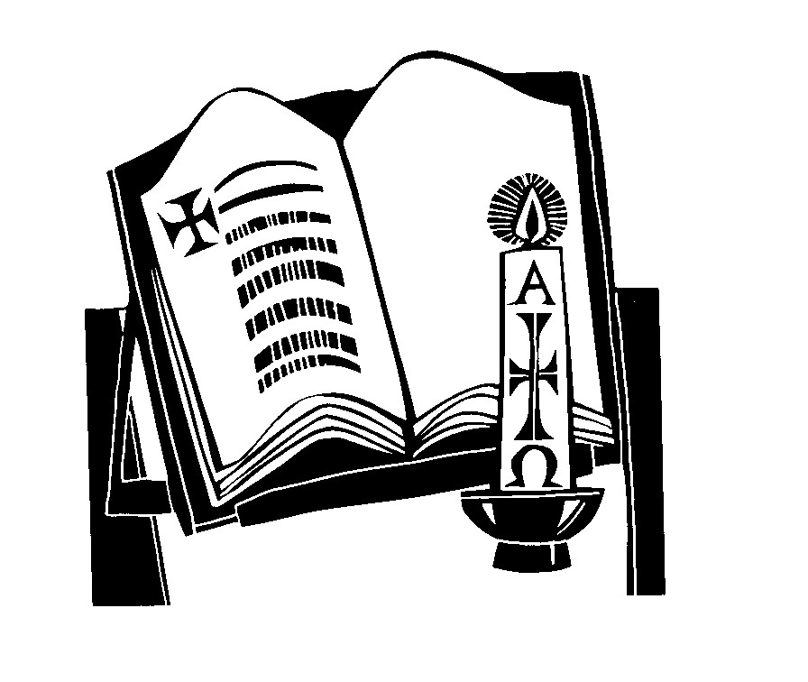

Prayer Before Serving Mass

Thank you, God, for calling me to serve
at your altar this day.
Help me to be calm and joyful, to remember everything
and to do my tasks well.
I ask this in Jesus’ name.
Amen

