ACADEMY GAME ANALYSIS
TEAM / AGE: COACH:
OPPONENT: SCORE:
ASSESSED BY:

DATE:
TEAM EVALUATION |  | FORMATION PLAYED:
TACTICAL |  | 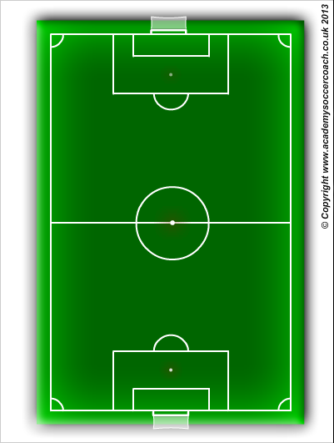
TECHNICAL
PHYSICAL
PSYCHOLOGICAL & Social
COACH EVALUATION
PRE GAME INSTRUCTION / WARM UP
HALF TIME INSTRUCTION
FULL TIME SUMMARY
IN GAME COACHING
 | OVR RATING: / 10
PARENT EVALUATION
GENERAL BEHAVIOUR

OVR RATING: / 10

