ET-01: Classic Historic Route with Simien Mountains
Duration = 6 days/ 7 nights
Route = Historic Route with Simien Mountains National Park
Transportation: - Bus and flight
Minimum group size= 1 PAX

Month | Tour Dates | 2022  Prices | Single room  Supplement
Jan | Jan 18 - Jan 24, 2026  (Timket Festival in Addis Ababa) | USD 1,467 | USD 247
Feb | Feb 9- Feb15, 2026 | USD 1,467 | USD 247
Mar | Mar 13- Mar 19, 2026 | USD 1,467 | USD 247
Apr | Apr 12- Apr 18, 2026  (Palm Sunday festival in Axum) | USD 1,467 | USD 247
May | May 15 – May 21, 2026 | USD 1,454 | USD 287
Jul | Jul 03 – Jul 9, 2026 | USD 1,426 | USD 212
Aug | Aug07 – Aug 12, 2026 | USD 1,426 | USD 212
Sep | Sep18 - Sep23,2025  (Meskel Festival in Addis Ababa) | USD 1,426 | USD 212
Oct | Oct 09 –Oct 15, 2025 | USD 1,467 | USD 232
Nov | Nov25 – Dec 01, 2025  (St Marry Axum Zion Festival in Lalibela) | USD 1,467 | USD 232
Dec | Dec09 – Dec 15,2025 | USD 1,467 | USD 232

Domestic airfare
= USD 325 per person, subject to change, if a client uses ET in the international flight
=USD 631 per person, subject to change, if a client uses other carrier different from ET

Itinerary

This itinerary is designed for travelers who want to visit the northern historical attractions but don’t have much time. Visitors will cover all the important sites in the Historic circuit by flying from one site to the other. It also includes a visit to the Simien Mountains National Park, which is the only natural site of the country that is registered by UNESCO as a world Heritage.

Day 1 – Arrival + Addis
Be welcomed by your guide on arrival at Addis Ababa Bole International Airport, and transfer in to your hotel.
O/N – triple e Hotel International or other Similar 3* Hotel

Day 2 – Fly Addis – Bahir Dar
Fly from Addis to Bahir Dar and visit the Blue Nile Falls before lunch. In the afternoon, have a boat trip on Ethiopia’s largest water body - Lake Tana (3,600 Km Sq) to visit the island monasteries of Ura Kidane Mihret (14th Century AD) and Azwa Mariam (14th Century AD).
O/N – jacaranda Hotel or similar
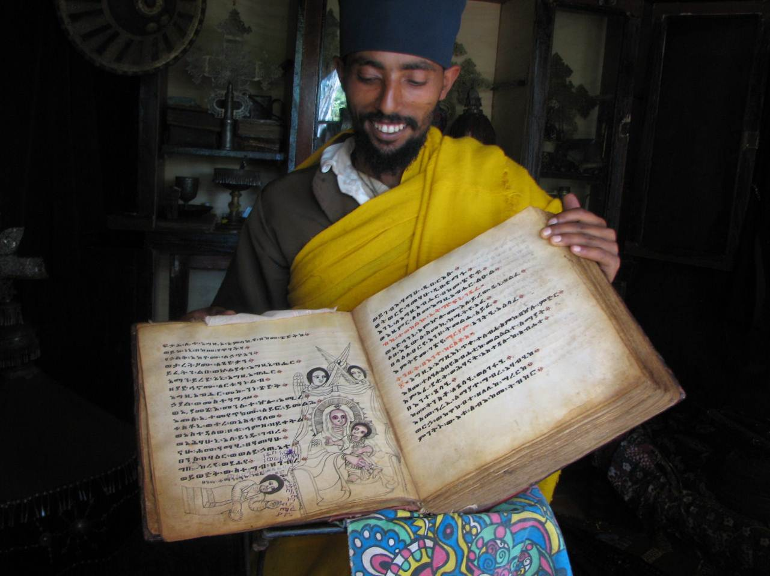

Day 3 – Drive Bahir Dar – Gondar
Drive from Bahir Dar to Gondar - the 17th century capital of Ethiopia. In the afternoon, visit the Imperial Castle Compound of Gondar (UNESCO World Heritage Site), the ‘Bath of Emperor Fasiladas’, the church of Quskuam Mariam (17th century AD), the residence of Empress Mintwab, and the church of Debre Birhan Sillassie which is famous for its wall and ceiling paintings.
O/N – Goha Hotel or similar

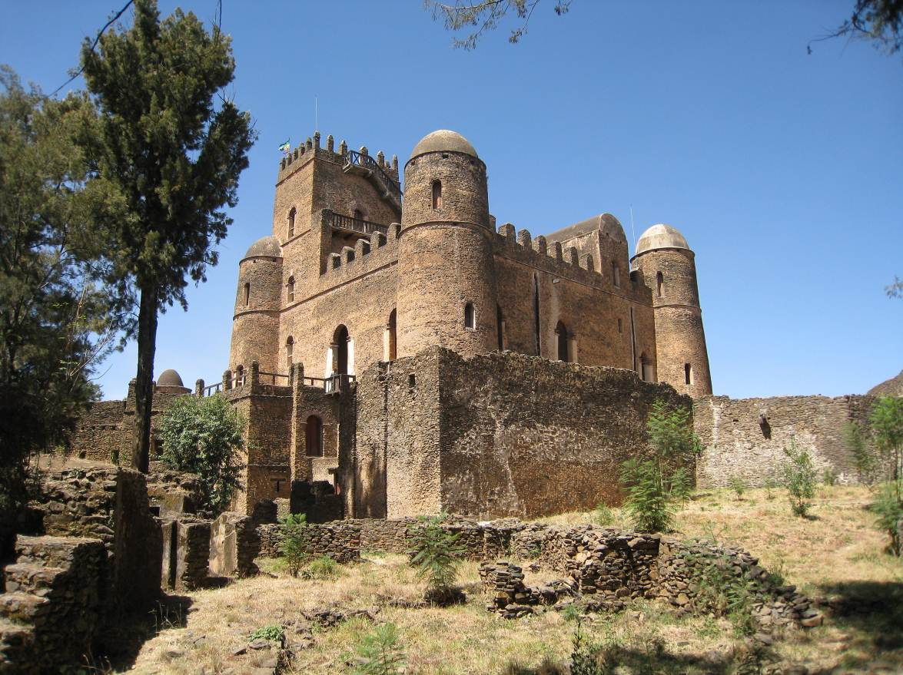

Day 4 – Drive Gondar – Simien Mountains National Park
Drive from Gondar to Debark (the headquarter of the Simien Mountain National Park), and proceed 36 km farther to the Simien Mountains (UNESCO World Heritage Site) to visit the endemic mammal of Ethiopia - the Gelada Baboon, and the breathtaking scenery of the Simien Mountains.
O/N – Goha Hotel

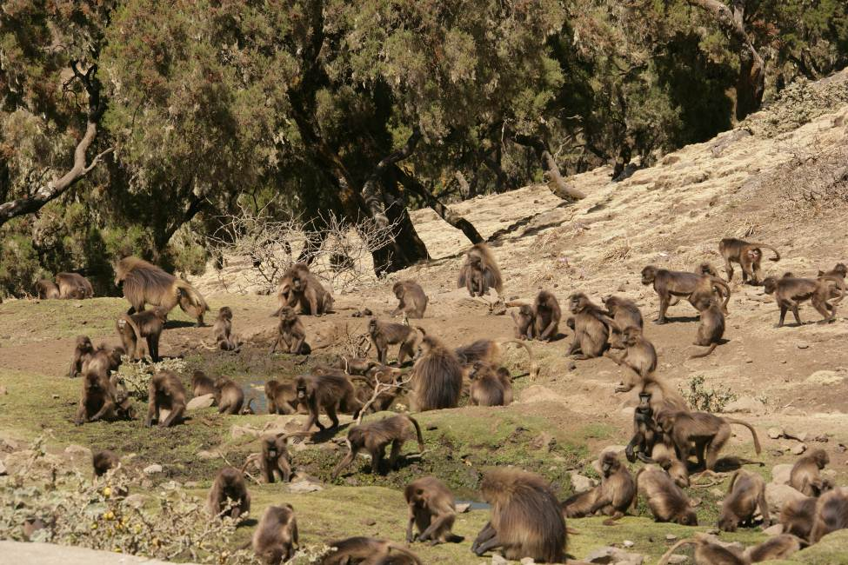

Day 5 – fly Gonder to Lalibela –

Fly to Lalibela on Ethiopian Airlines. Tour the magnificent rock-hewn churches, a UNESCO World Heritage site. This group of eleven monolithic churches were carved directly into the stone mountainside at least 800 years ago. This complex boasts the largest monolithic church in the world, a maze of passageways and tunnels, intricately carved reliefs, and fabulous examples of icon paintings.
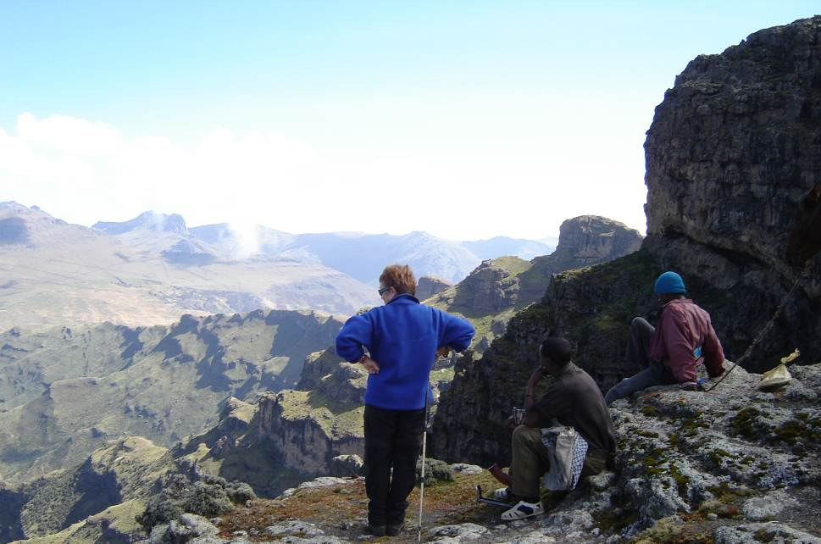

O/N – Mountain View Hotel or similar

Day 6 – Lalibela
In the morning, mule back ride to the hill top semi monolithic church of Asheton Mariam (13th century AD). Getting to the top of the hill rewards with great and unforgettable scenery of the area. In the afternoon, visit the remaining second and the third group of the churches of Lalibela.
O/N – Maribela Hotel or similar

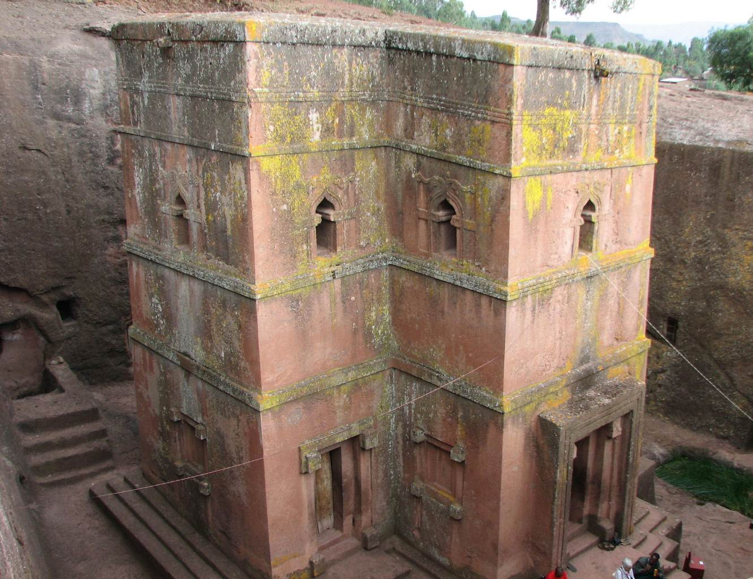

Day 7 – Lalibela – Addis + departure
Fly back to Addis and have a half-day city tour of Addis that includes visiting the National Archeological Museum of Addis Ababa, Merkato - the largest open-air market in Africa, and driving to Mt. Entoto (3,200 meters) to have a panoramic view of the capital.
In the evening, you will be invited a fare well dinner party at one of the best traditional restaurants of Addis to see the folkloric dances of the Ethiopian people and to taste the variety of meals of the Ethiopian people.
Departure

Price inclusive of: -
- Accommodation on a twin room sharing basis
- All meals out of Addis, and only breakfast in Addis
- All entrance fees
- Transfers
- Mule hire
- Boat rent at Lake Tana
- All ground transportations with fuel, and insurance
- Professional English speaking guide
- Portage fees
- All local guides
- Scouts
- Government tax

Price exclusive of:-
- International airfare
- Lunch and dinner in Addis
- Any alcoholic drinks
- Personal expense like souvenirs, laundry, etc
- Tips
- Any expense which is not stated in the ‘Included List’ above

