ET-07: Expedition to Danakil Depression
Duration = 3 days/ 2 nights
Route = Danakil Depression
Transportation: - 4x4 vehicles
Minimum group size= 1 pax

Month | Tour Dates | 2022 Prices | Single room supplement
sep | Sept.1-spet 27 2025 | USD 434
oct | Oct 1 –Oct 27 2025 | USD 434
Nov | Novomber 1 – November 29 2025 | USD 434
Dec | December 1 – December 28 2025 | USD 534
jan | January 1- January 29 2026 | USD 534
febr | Fubrary 1- fubrary 27 2026 | USD 534
march | March 1- March 28 2026 | USD 434
April | April 1- April 29 2026 | USD 434
May | May 1- May 29 2026 | USD 434
june | June 1- June 30 2026 | USD 434
julu | July 1- July 29 2026 | USD 434
Aug | August 1 – August 28 2026 | USD 434

Domestic airfare
= USD 120 per person, subject to change, if a client uses ET in the international flight

=USD 250 per person, subject to change, if a client uses other carrier different from ET

Itinerary

Day 01 : Addis Ababa – Fly To Semera Drive To Afdera-Volcano
Fly to Semera then we will drive to danakil Depressions ..We start an early drive to Lake Afdera . Leave after lunch, possibly at 01:30. After you pass several small hamlets scattered here and there in this desert land, Dodom is about 9.5km from Erta Ale and it takes about 1 hrs trekking. to the rim of the volcano, where we spend the night watching the dramatic action of the boiling lava. O/n camping on the mountain

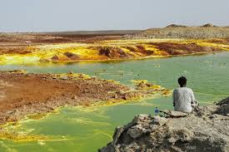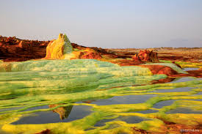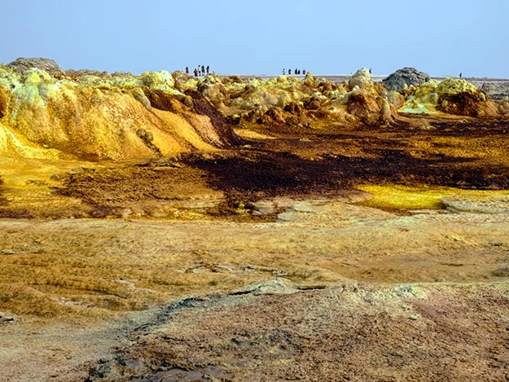
Day 02 ErtaAle-HamadEla-Dallol-Afdera
This day after an early breakfast we will drive to HamadEla . You will see lots of camel caravans and you will have the sunset look from the very shallow salt Lake Assale.
Morning tour Drive to Ragad (Asebo), You drive ahead to Dallol and visit the different landscapes formed by volcanic activity; Dallol + Lake Assale + salt canon, camel caravans, follow up camel caravans, and Drive to Lake Afdera
Overnight Camping in Lake Afdera

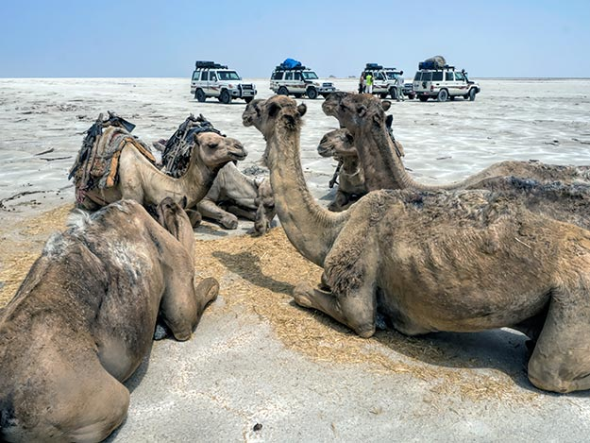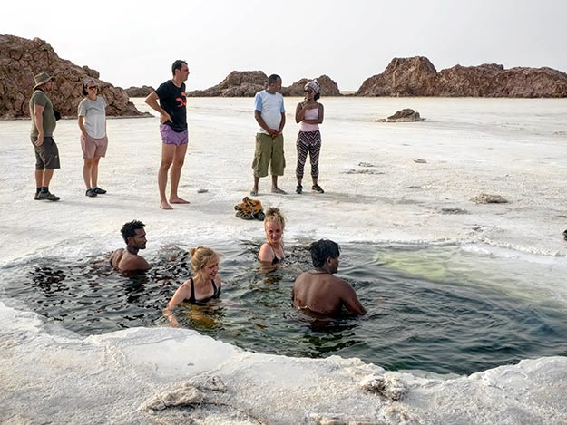
Day 03 Afdera-Semera
This day you may have another chance to see the beauty of the sunrise in lake Afdera then after breakfast, we will drive to the town of Semera and drop you at the airport for your departure
The price is depend on the group you will join
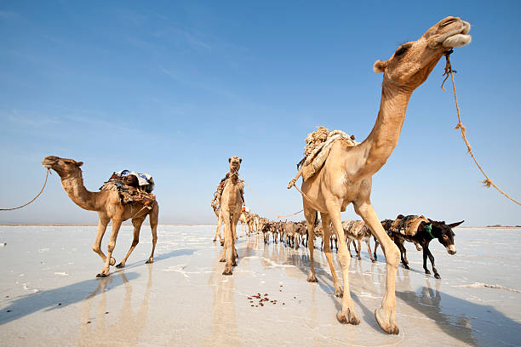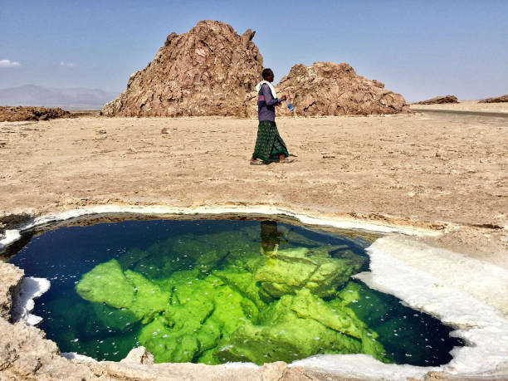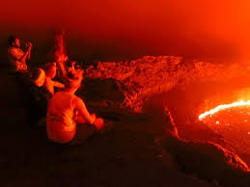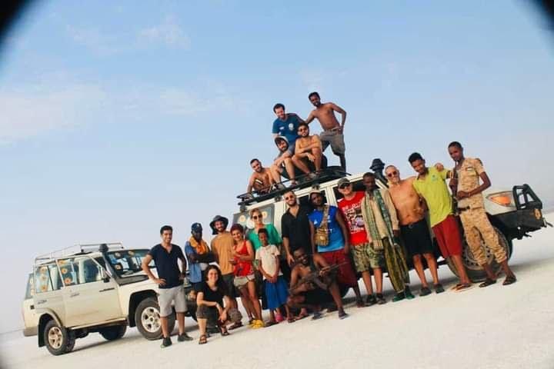

Included is:
· 4WD land cruisers with ac and 4 clients in one car
· all fuel expenses and drivers allowances
· All needed Entrance fees and licenses
· Accommodation and all meals throughout the tour
· Local guide service for the Afar region -Cooking, camping equipment
· Experienced cook throughout the whole tour

The price is inclusive of: -
- Accommodation on a twin room-sharing basic
- Three meals
- All entrance fees
- Transfers
- Two Air conditioned, and comfortable 4 X 4 Toyota Land Cruisers with fuel, insurance and drivers’ allowance
- Professional English speaking guide with all his expenses
- Camel Hire at Erta’ale
- Portage fees
- Professional Cook for the camping days
- First class camping gears
- All local guides
- Armed scouts
- Government tax

Price exclusive of: -
- Domestic flight
- Any alcoholic drinks
- Personal expense like souvenirs, laundry, etc
- Tips
- Any expense which is not stated in the ‘Included List’ above

