The Community Interpreter

*Professional Training for Community Interpreters*

“Great instructors, real life experiences, really help relate to our work.”

Join a field of passionate, committed professionals: become a community interpreter!

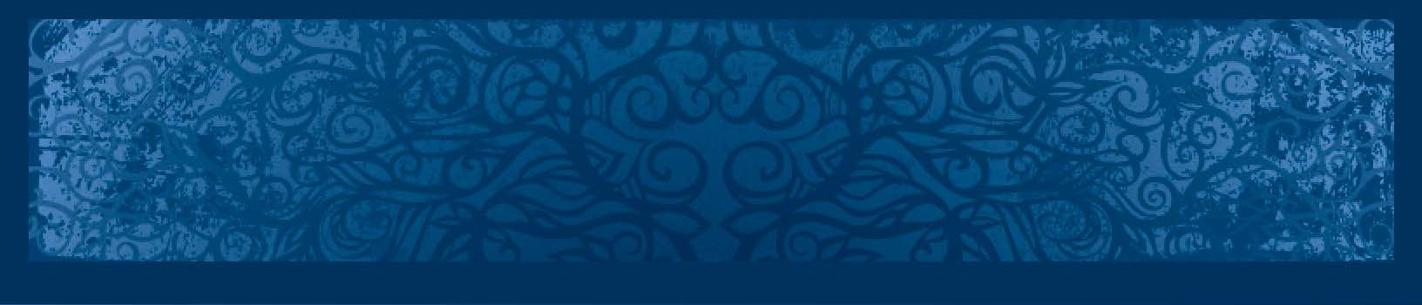

Community interpreting includes medical, educa- tional and social services interpreting. *It is one of the fastest-growing professions in the world.*

Cross-Cultural Communications (CCC) partners with 1World Translation & Transport (1WTT) to be your affordable home for **professional training and continuing education.**

To become a qualified interpreter in the field,

a 40-hour program is considered the minimum requirement.

CCC offers the finest such program in the world:

**The Community Interpreter®**.

***Grow. Engage. Transform.***

*Commit to excellence. We’ll get you there.*

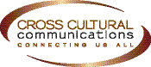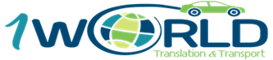

THE PROGRAM

The Community Interpreter® is a comprehensive 40-hour certificate program. It fills the prerequisite for national medical interpreting certification.

CCC’s program, The Community Interpreter®, is taught across the country. It is the leading national program.

*CCC has more than 140 licensed trainers in 28 U.S. states, DC, Guam, and six other countries*.

Sign up for The Community Interpreter® if you plan to launch or continue a career in:

* Medical Interpreting
* Educational Interpreting
* Social Services Interpreting HOW IT WORKS

The Community Interpreter® is an interactive, skills-based program. It’s never boring. It is also the most up-to- date program in the field. The sessions ground you in what you need to know to work as a professional interpreter.

The focus is on medical, school and government or nonprofit service settings. With this program, you receive a copy of the most comprehensive text- book and workbook in the field.

***The Community Interpreter*®/TCI 2019 Course Dates:**

*Facilitated by Linda De Santiago. All classes 9a-5p.* **$575. Language testing included.**

**April 29/May 6, 13, 20, 27** **(9a-6p) North Denver**

**June 24-28 (9a-6p) North Denver**

**September 23-27 (9a-6p) North Denver**

**Dec/Nov TBA- Can check our website-** [**www.oneworldtranslation.com**](http://www.oneworldtranslation.com)

 

PROGRAM CONTENT

MODULE 1: THE PROFESSION

* + An overview of medical and community interpreting today
  + National Ethics
  + How to assess your performance

MODULE 2: PROTOCOLS AND SKILLS

* + National Ethics
  + How to assess your performance

MODULE 3: STRATEGIC MEDIATION

* + How to make decisions
  + Intervention Skills
  + The Strategic Mediation Modal
  + Cultural Mediation

MODULE 4: PROFESSIONAL INDENTITY

* + Who are you? Where do you fit in?
  + Professional Practice
  + Introduction to Legal Interpreting
  + Terminology

MODULE 5: THE INTERPRETER’S ROLE

* + Managing your role
  + Advocacy
  + National Standards of Practice
  + Self-Care and Professional Development

**If you want a quality program that will prepare you for the *REAL* world of community interpreting, you have found it. The Community Interpreter® is for YOU.**

It is also exciting, fast-paced, and fun. **Sign up now!**

You can get much more information on our website, apply, and sign-up: [www.oneworldtranslation.com](http://www.oneworldtranslation.com/) Email us: [info@oneworldtranslation.com](mailto:info@oneworldtranslation.com)

 