Despairingly held, Moses and Susannah's faith was a thread leading them to find something positive.

Moses walks towards his wife, touching her left shoulder, “My lady, we should be happy to be blessed to have this roof over our heads and a warm fireplace to sustain us. All could be well since King Edward defied the French King Phillip, telling him he had no reign over Aquitaine. It is believed victory in 3 years for England.”

King Edward had inherited the Duchy of Aquitaine, and as Duke of Aquitaine, he was a vassal to Philip VI of France. Their relationship soured when Phillip aligned himself with Edward's enemy, King David II of Scotland. Edward, in turn, gave refuge to Robert of Artois, a French fugitive. When Edward refused to expel Robert of Artois from England, Phillip confiscated the Duchy of Aquitaine. Therefore, the 100-year war began as the Black Plague ravished the cities and villages.

“I do not know the affairs of the King," Susannah says with annoyance,” but I do know death awaits its victims." 'Those fighting for the King as their loved ones die from the plague.”

Moses and Susannah Coates bowed their heads and began to pray. “Please, God, protect us, have mercy, and we will do your will. Let it be known our lives will be committed to praise. We are weak and desperately want a future. God grant us…"

Suddenly, there was a loud knock on the door, startling Susannah. She lets out a soft scream.

Moses peers out from one of the windows and sees an elderly woman on a horse with two saddle bags hanging off the saddle. The woman wore a black hat with a dark scarf covering her face that flowed onto her back. Her eyes were wide and bright. From her appearance, she looked well off, perhaps from a court of some Duchy estate. Her riding apparel was well made, and she wore pants underneath a lady's mock, and a sizeable woolen coat covered her to her knees. Her eyebrows were thin, shaping the contour of her brow. She dismounted from the horse, holding the reigns, and knocking again while tying the reigns to the post. She continues to unhook a basket from the horse saddle. Moses yells, “What do you want."

The mysterious woman says, “Please help me, kind Sir. I don't want any money or food. I need your help.”

Susannah looks at Moses and shakes her head to disapprove. Moses Coates was a kind, helpful man. He was raised that way and didn’t feel any fear. He unlatches the door, removing a large plank wood jam from the posts. It was October 30th, 1357, on the verge of All Hallows Eve. As the door opens, a crisp, cold breeze flows into the room, blowing the candles and loose clothes on the spinning wheel. Susannah was sewing up a jacket for her husband. Moses gestures for the woman to enter.

Susannah says, "For lord's sake, close the door; there is a chill." Removing her jacket, the woman walks in and sits at a table, placing her coat over the chair beside her. She then places the large, covered basket on the tabletop.

Moses introduces, “Madam, I am Moses Coates, and this is my wife, Lady Susannah Coppock Coates."

The unexpected woman catches her breath and says, “It is such a fortunate pleasure to meet you at such an unfortunate time."

She seems to exhale and says, “The good lord has led me here before I must go to save my King, Edward, the Black Prince and his wife Joan, Countess of Kent, my niece, from a fate yet to be. I do not have much time, so I must not tally. Please, I must ask you a favor.”

Bewildered, Moses and Susannah Coates looked at each other, and something about the woman's pleas touched their hearts that night. Moses said, "I can help if your request is simple enough. “

The woman opens her basket, pulls out a small box, and opens the lid. “I must ask you to accept this gift. It is a box from Aquitaine. It was the possession of Eleanor, Queen of France, wife of King Louis VII, when she was 14.”

Moses and Susannah looked at the woman suspiciously. "Why, woman, would we take such an item of importance from you?” Moses inquired.

“I have no answer except to ask out of kindness that you will hold for me. If not, I cannot return. You are to pass this on to your son, and he is to pass it on to his and repeat until I can retrieve it."

Susannah Coates says, “Woman, I am confused but curious. What is in this Box.?”

The woman peers into the box, looks up, and says, my name is Margurite Maingoval de Wavrin. My husband died 7 years ago. I kept this box and the items within because it helped our lineage to provide protection and wealth to our descendants. However, I did not pass it on, but I will take some of what I have here and continue my journey to London. I must reach London before they conceive a child, an heir to them, to prevent the Plantagenets' demise.”

The House of Plantagenets was a royal house that originated in Anjou, France. The family held the English throne from 1154 with Henry II to 1485, when Richard III died in battle.

“I can foresee a future, a vision of things to come. If I can pass just a small piece of these items along in this box, it will help and protect my future descendant from a fate that may or may not happen.”

Moses says, “Madam Wavrin, I do not know what to say; it sounds like a dream."?

Madam Wavrin says, “It is like a dream. That is my ability to foretell or foresee, and if I can succeed, my descendant will survive a slow death that no one would wish upon another.”

The woman peers at Susannah with her dark black eyes, “Madam Coates, I see you are a sewer of threads."

Susannah looks at her spinning wheel and sewing materials and says, “Yes, Madam Wavrin, God gave me the ability to mend clothes and provide for our needs.”

“Ahh, I see." Madam Wavrin picks up some baby clothing and examines it closely. You have made such lovely baby clothes."

“Yes, I am expecting, and I sew these clothes in the hope for our child to survive this evil," Susannah tears up.

Madam Wavrin picks up a small spool of thread and a thimble; she says,” In this Box are 3 needles and 4 spools of thread along with two thimbles. Thread is wound into spools in one of two ways, Stacked Thread, or cross-wound thread. A stacked Thread is when the thread is parallel around the spool. The cross-wound thread forms an X around the spool. Initially, the box held 4 cross wound spools and 5 stacked thread spools. The cross-wound thread spools are the most consequential. These threads and items should not fall into the wrong hands. The souls who hold these items and have a heart of love will know and benefit from the powers of, but those whose hearts are cold and are false in their intentions will suffer and become afflicted with horrendous consequences.”

“Please hold on to these for me. You will be rewarded, and your future children and their children will be protected from death and misfortunes such as this awful, deadly Black Plague. In my vision, I can see one of your future descendants, Madam Coppock Coates, who will be saved by another Coates, who will be successful in their lives."

Susannah and Moses found the thought of falling ill with the Black Plague overwhelming. Puzzled, they agreed to take the box from the strange woman.

Susannah says, “Am I able to use the threads in my sewing of clothes for our child?”

The woman appeared shocked." No, madam. You may only use thread and needle to mend holes in socks, sew on buttons on a jacket, or sew a bow on a bonnet. But be free to use the threads. Do not waste, lose, or destroy any; keep them in a safe, protected place in your dwelling. Consider it an item to be passed down to your children, like an inheritance.”

“The threads have been in the possession of Queen Eleanor of Aquitaine. She got these threads from spiritual sorcerers in Anjou, France. They were known as the witches of Anjou. As the legend has it, the threads were entwined with threads sewed into the Shroud by Mary Madeline, who mended the cloth that covered our Lord Jesus as [He laid before He arose]. With each stitch Mary sewed, tears fell, and emotions soared. Mary thought, how could there be so many evil persons to want to kill her beloved Jesus. He had forgiven her sins and accepted her with love. How could this happen? Sorrow, anger, fear, and love were sewed stitch after stitch to cover her beloved Jesus.”

“Madam," said Moses,” I do not wish to dwell upon the witches, for I fear this plague has been conjured up, and God is punishing us. If these gifts can bring us hope and have that connection to our Lord, Jesus, then we will accept.”

Susannah and Moses agreed to accept the box.

The woman said, "Forgiveness is the most difficult act of love humans can do." Quoting a scripture, “Do unto others as you want done on to yourself." Madam Wavrin looks seriously,” There is also one more thing I must ask of you.” She gets up, walks outside, and brings in another large basket. She sits it down on the floor and closes the door. She opens the basket. A calico cat steps out of the basket and sits as the woman pets the cat. She says, “I need to ask that you take care of my cat. She is a sweet cat and companion. She can protect you from the rodents," please forgive me for this added request.

Moses begins to smile and laugh. “Well, Madam, I was not expecting a cat, but I like cats. They keep the rodents away, which would keep the rats at bay.”

Susannah says, “Now, I don't know about this cat. Is it safe to be around here? Some village folks thought cats caused the plague.”

Madam Wavrin, “No, Madam, the cats do not cause plague; the cat protects and boldly watches over. They are good creatures of God. Ancient Egypt glorified them as assistants to Kings and Queens. God did grant them nine lives.”

Moses pets the cat, which responds favorably to his gesture and rubs his leg while purring.

Moses, amused, “Cat sure likes me. “

The woman says, “So will you please I must go soon.”

Susannah says, “Yes, we will keep the cat. “

Susannah saw how Moses warmed up to the car, which relieved her.

Susannah asks, “What name does the cat answer to? “

The woman lifts the cat up and says, “Thread."

"A cat named Thread," says Susannah in surprise.

"Yes, and it is important to also know that in any inheritance when you pass these items onto your next of kin, demand that the pet cat that they must have to be named after the tools of the weaver," sternly said Madam Wavrin.

“Why should that be” concerned Moses inquires.

"The reason why is to remind one that they have sacred tools of the weaver that must be used in the darning holes in socks, mending a button on a jacket, and or a bow onto a bonnet," repeats Madam Wavrin. “Also remember, the Shroud that covered our Lord, before [He ascended into heaven.]”

“Now I must go, but I am taking with me two spools. There were originally nine spools; some selected individuals have them and know their power. You must follow my directions. Here is a thank you for your help as Madam Wavrin hands them a black velvet purse holding three gold coins.

Moses and Susannah are surprised by this gesture. They express more gratitude to Madam Wavrin, but she interrupts, “Please, I must go, and again, keep the promise.”

Both Susannah and Moses Coates agreed. Madam Wavrin mounted her horse and steered towards the road to London. As she prepared to gallop, her scarf had blown away from her head, and on the left back of her neck, one could see a birthmark revealed. The brown tannish mark was oval shaped at the top, but there was a flat line on the lower part. She adjusts the scarf to cover her neck. “Remember, I will be returning someday to retrieve my threads.” She hails her horse to gallop and gallop away she rode.

In the following year, the health and well-being of their lives improved. Thread, the cat seemed to adjust to their home and surrounding yard. Susannah would sew and weave her clothes as thread watched from a corner; her green eyes never strayed from watching. The following year, the couple had a son, Peter, who was not sick or ill. The couple were blessed to have 9 other children, each of whom was never ill or sick. Thread, one day, was found to have had kittens. Thread was an excellent mother cat and nurtured each of her 3 sets of litter during her 12-year lifetime. The kittens were paired off among the sons and daughters, and in each case, at least one out of each litter was named Thread or Threads. Some were given to a neighbor, but one son was the one who inherited the box holding the sacred items. Each son was told the story of how important it was to keep the promise made by their parents. They described Madam Wavrin to them and emphasized the importance of this inheritance. And they were good sons and obeyed the traditional promise as kept long ago. Being the first generation after their parents, these sons knew the ninth generation's deadline for this promise.

Benjamin Coates was born in 1380. He married Elizabeth Argyle in 1403. They kept the box in a secure, safe spot, and Elizabeth mended a few holes in Benjamin's socks. Benjamin had grown up with Threads as a pet and confidant. No illness or sickness came upon the couple, or their 3 children born to them during the 20 years of marriage, each passing at the ripe old age of 80. The same ritual was repeated with this generation. The box was kept safe and passed on, the promise was emphasized, and the threads were used to mend some holes in socks and buttons onto jackets. The items were passed on to the next generation.

Thomas Coates, born in 1426, was the son to receive the box containing the two spools of thread, the 3 needles, and the two thimbles. Thomas was also reared by his parents, along with a cat he named “Knits." He married Catherine Renfreushier in 1459. No one became ill and sick, wealth increased, and Catherine used the needle and threads to mend socks and a bonnet. The tradition continues, but somehow, the emphasis on the condition of having a cat around and named after a weaver's tools was ignored.

The couple only had one son, Peter Eaton Coates, born 1479 in Surrey, England. He was healthy, never sick as a child, and was told of the promise of keeping the inheritance of the box with instructions to use the thread to mend holes in socks and buttons onto jackets. He married Sarah Ann Deeley in 1510. She was able to mend some clothes with the needle and threads, but she noticed something extraordinary. When she would use the threads to mend socks and sew a bow onto a bonnet, it looked like the thread on the spool had increased. She was sure she had used a great deal of this thread, but it looked like she had not used any part of it. She had a cat called Seven. Seven, a cat with orange and black markings, always watched Sarah in the house. There was never any illness, no sickness, and wealth seemed to increase in their life. They had three children during their marriage. Two sons and one daughter. She named her daughter Seven More since her cat was named Seven. One day, at age 11, Seven More kicked the cat out of the house. “Get out' Seven More yelled at Seven the cat. The cat ran out quickly and turned to see if her threat was still in pursuit. Seven More had a mean disposition for a young girl. She went out to feed the horses in the barn. The cat she had thrown out of the house sat near a stone wall. The eyes of the cat were fixated upon the child as if stalking its prey. {music of the Omen}

Specifically, the eyes focused on the bright, shiny copper braid grasping the girl's long hair. As Seven More began to feed the horses in the stall, her bucket with apples toppled over. Instantly, she turned her back towards the horse. The sky was clear blue with the sun brightly shining. As Seven More moved to retrieve the apples, the hair braid reflected the sunlight, which spontaneously caught the eye of the horse. Without warning, the horse kicks up his hind leg, striking the unsuspecting girl in the head. She lingered for 3 days in a coma and died. It was a sad event, but life went on. The tradition and story of the promise to keep the box and items within in a safe place, using threads to only mend socks, bows on bonnets, and buttons on jackets, were passed on to the next generation. The information of having a cat and naming it after the weaver's tools was communicated to the families.

The son whose inheritance was the Box was John Peter Eaton Coates. Born in Surrey, England, in 1514, he married in 1527 Susan Metcalf. Again, the tradition continued by upholding the ancient promise of passing along this box and knowing the conditions of this item. John Peter Coates had a cat named Yarn. and it was always watching the couple as they went about their daily routines. Susan used a needle and thread to mend 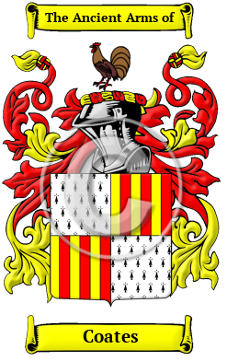socks and a button on a jacket. During this time, the Coates family arrived at nobility and decided to choose a symbol of their family’s motto, Bold and Watchful.

The cat Yarn displayed watchfulness, but John Peter chose a Rooster as the family emblem. It has been the emblem for the Coates family crest since then. No illness or sickness occurred in this family. They had 6 children during their marriage. Wealth increased, and health remained excellent. The couple seemed to know what could be and always seemed to be a few steps ahead of everyone else. Upon their deaths, the inheritance of the black box holding the sacred items, 3 needles, two spools, and two thimbles, had to go to one of their sons. However, at this time, numerous siblings had to be considered.

Having a cat as a confidant was becoming more daunting. Marmaduke Coates, born in 1552, married Mary Somner Skinner in 1572. He inherited the box with the three needles, two thimbles, and two spools of thread: one a stacked wound spool and the other a cross-wound spool.

Marmaduke and his wife had a few cats in their homestead. One cat they did name ‘Thread'. In 1607, wrote his will and was listed as being of Curry Rivel. The will mentions his wife, Mary, and sons, William, Thomas, and Henry. He had chosen Thomas as the heir to the sewing box. However, the other siblings were jealous of this will, and one day, Marmaduke found the wooden box had been disturbed. He discovered one of the needles missing from the box had been threaded by one of the spools. After questioning his children, no one would admit to pilfering through the box and the removal of one needle. This needle and thread eventually ended up with a Coates who settled in Ireland and 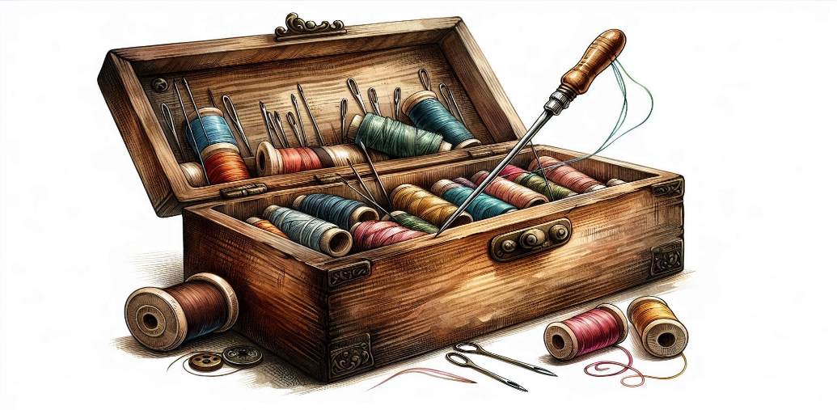Scotland. However, during its disappearance and eventual reappearance, many circumstances occurred.

The box was passed on to Thomas Marmaduke Coates, born in 1579 in Wiltshire, England. He married Lady Elizabeth Christina Jane Flood in 1610. The inheritance of this box and its contents were understood. As needed, Lady Flood sewed some buttons on Thomas’s jacket because in 1629, Thomas and his wife, along with other neighbors and relatives, had chosen to migrate to the Colonies. In 1620, the Mayflower brought the first pilgrims to Plymouth, Massachusetts. Some of which eventually married into the Coates families. The second voyage from London to Plymouth Colony on a ship called Abigail in 1635 carried 35 passengers, many of whom were from the Leiden Congregation that organized the first journey.