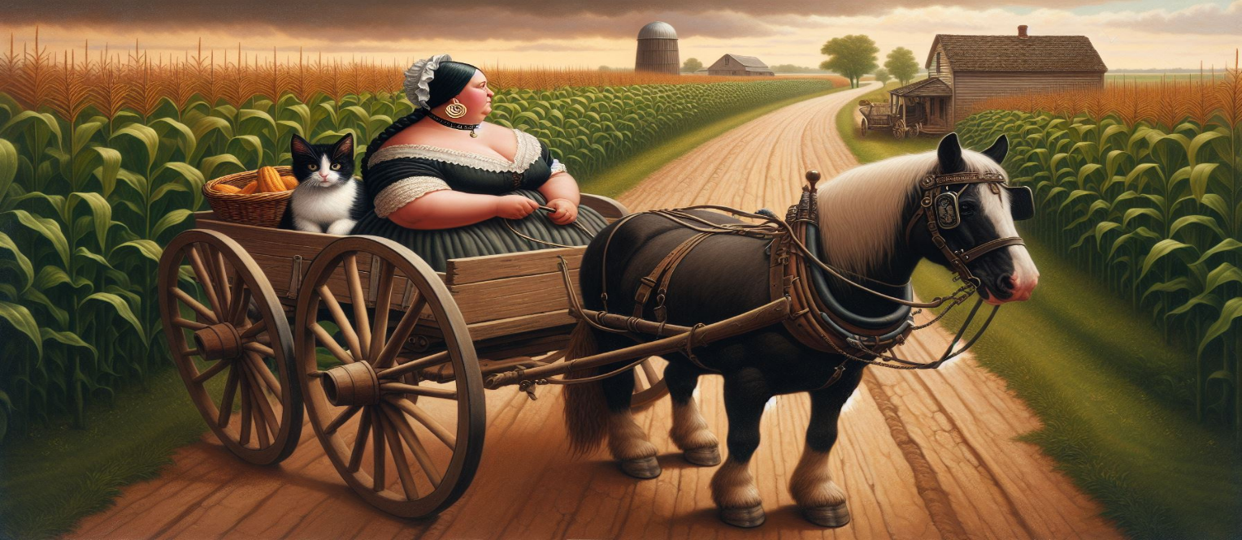

My husband’s half aunt, Eva Peoples (descendant of James Coats) married Edward Berndt, said, [‘yes, she also blacked her hair with ‘black cat’ stove polish. It was said she did this in remembrance of Axe, and she would repeat a story about crows. When she came upon the part in her story abouts a murder of crows, she would laugh when she would say, a murder of crows. She wore big hoop earrings”] Aunt Betty was known as a practical nurse and beloved by all in the area.

Chapter 4 - **Tëmahikànëtët AXE**

The Lenape, who are more commonly known today as the Delawares, were the first Indigenous tribe to meet the Europeans in the early 17th century. The Lenape traded furs for European-made goods.

“[The Moravians] had a mission,” Johnson said. “To come there to Christianize so-called heathens, so-called savages.”

The Moravians first arrived in this country in Savannah, GA, where they met resistance from the Cherokees, before moving north to Pennsylvania. The Delaware, who had previously encountered and traded with Europeans, trusted the Moravians.

“The Moravians and as well as the Quakers treated the Native Americans as equals,” Johnson said. “They did not attempt to exploit them and for those who wanted to become Christians, the Moravians were there to help.”

Many Delawares converted to Christianity thanks to the teachings of the Moravians.

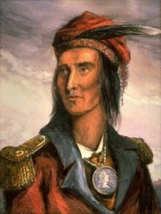According to Johnson, the Moravians taught the Delaware skills to succeed as Christians, but this forced the Delaware to abandon many of their traditions. In return, Delaware Indians showed the Quakers back in Sussex County New Jersey and the Moravians on Ohio territory, how to live off the land. A major part of the Delawares’ responsibilities was farming, taking care of livestock, hunting, and getting food. A great chief, Buckongahelas "Pachgantschihilas" Journeycake was a nationally renowned Lenape chief, councilor, and warrior.

He was active from the days of French and Indian War (Seven Years War) through the Northwest Indian Wars, after the United States achieved independence and settlers encroached on territory beyond the Appalachian Mountains and Ohio River. The chief led his Lenape band from Delaware westward, eventually to Muncie, Indiana. Buckongahelas was born in present day Delaware around 1720 to Lenape parents. British colonists called the people the Delaware after the river which was the heart of the territory. Great grandfather, William P Coats and his wife, Jane Hooey Couts had inherited and acquired land in this area in 1811. The Coates’ were Quakers and most of these Quakers treated the Lenape as equals and would often trade with them. Coates’ had a ferry at the Dingman’s Ferry in Pennsylvania across from Sussex County, New Jersey side. The Algonquian speaking Lenape lived throughout the mid-Atlantic area. Bucongahelas in the Lenape language means a “Giver of Presents.” He was also known as Pachganschihas and Pethnanalas meaning a “fulfiller” or “one who succeeds in all he undertakes.”

Buckongahelas married as a young man and started his family. Under pressure from the colonial settlers, he began to move his tribe westward towards the Ohio territory. Also, problems between the English and the Lenape began after William Penn’s death. Penn’s sons stripped Delaware of their land in the Walking Purchase. In 1737, Penn’s sons had allegedly found a lost treaty, which dated back to 1686, where the Lenape had promised to give land extending “as far as a man could walk in a day-and-a-half” to the settlers.

Penn’s sons hired “professional runners” to run – not walk – for a day-and-a-half, and these runners ended up acquiring 1,200 square miles of Lenape land in what many historians have called [“a land swindle.”](https://www.britannica.com/event/Walking-Purchase)

“In the end, they were swindled out of their land, and they lost everything from Philadelphia up to Jim Thorpe,” Johnson said.

Buckongonhelas was believed to have lived some time with his people in what is now Buckhannon in Upshur County West Virginia. His son, Mahonegon was killed there in June 1773 by Captain William White a native of Frederick County Virginia. Local legend states that the current Upshur County Courthouse was built upon the grave of Mahonegon. Local legend suggests Buckongonhelas took revenge on White after trailing his son’s killer for a period of nine years 1773-1782. Lenape legend says Buckongonhelas summoned the spirit of Misick and evoked any traditional healer to shape shift into his own image and conduct the revengeful death of Capt. White.

The captain was killed March 8, 1782, within sight of Bush Fort in the vicinity of the Buckhannon River. But historic documentation places Buckongonhelas in Ohio by 1781 as he was moving relocating his tribe west to escape the colonist’s encroachment and it just could not be him but the evoked spirit of a shape shifting medicine witch woman.

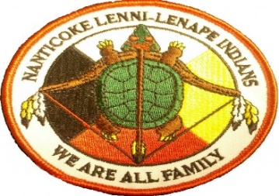During the American Revolutionary War Buckongonhelas led his followers against the Continentals. He had broken away from the neutral and pro-American Lenape led by White Eyes. White Eyes replaced Netawatwees of the Delaware Turtle clan. He was born in 1686. He eventually became the chief of the turtle clan of the Lenape Delaware in the Ohio country. The turtle represented the entire earth. As a chief of the turtle clan

Newcomer was the most powerful and influential member of the Lenape nation. He became chief of the turtle clan in 1757. In 1759, Netawarwees established Gekelmukpechunk, known as Newcomerstown to the White English settlers, this village was located east of Coshocton, Ohio and became an important Lenape village in the Ohio territory. Both during and after the French and Indian War, Netawatwees tried to form an alliance with the British. The British favored such alliances during the war, and afterwards to improve their involvement in the fur trade. The British failed to come to the Lenape aid in 1762 when a smallpox epidemic struck the Ohio territory. Chief Newcomer and his followers began to turn away from the British, Newcomer became a follower of Neolin a American Indian prophet who encouraged American Indians in the Ohio territory and regions were to forsake white customs and European goods. Neolin ideas also influenced Pontiac who led rebellions against the British beginning in 1763. The newcomer supported Pontiac’s actions. During the early 1770, Netawatwees welcomed the arrival of missionaries including David Zeisberger and John Heckewelder. The Moravian Church sent these men to convert the Ohio Lenape Indians to Christianity. The missionaries established several missions in the Ohio territory, including Gnadenhutten, Lichtenau, and Schoenbrun, Netawatwees hoped that the missionaries would help the Lenape Delaware overcome an epidemic that was passing through the population. The disease eventually ran its course. The Moravians remained in the Ohio territory and requested from the Lenape to disregard their customs and way of life and adopt the English way and customs. The Lenape became very divided with some adopting the Christianity and others refusing to do so. This was true to Netawatwees, who never converted to Christianity and his family as well. His own grandson, Killbuck resented his grandfather for allowing the Moravians to remain in the Ohio territory. The Lenape remained divided even after Netawaatwees death in 1776. White Eyes attempted to maintain peace, but Buckongonhelas **disapproved of White Eyes actions and was opposed to it. White Eyes,** named ***Koquethagechton*** (c. 1730 – 5 November 1778), was Chief [Sachem](https://en.wikipedia.org/wiki/Sachem)[[1]](https://en.wikipedia.org/wiki/White_Eyes#cite_note-1) of the [Lenape](https://en.wikipedia.org/wiki/Lenape) (Delaware) people in the [Ohio Country](https://en.wikipedia.org/wiki/Ohio_Country) during the era of the [American Revolution](https://en.wikipedia.org/wiki/American_Revolution). Sometimes known as George White Eyes, or Captain Grey Eyes al. Sir William, his given name in Lenape was rendered in many spelling variations in colonial records.[[2]](https://en.wikipedia.org/wiki/White_Eyes#cite_note-succession-2) By 1773 he was Speaker of the Delaware Head Council and known as one of the most important councilors.[[2]](https://en.wikipedia.org/wiki/White_Eyes#cite_note-succession-2) White Eyes was a war chief and a tireless mediator in turbulent times, negotiating the first Indian treaties with the fledgling [United States](https://en.wikipedia.org/wiki/United_States), and always working toward his ultimate goal of establishing a secure Indian territory. His assassination by an American militia officer is believed to have been covered up by United States officials.[[2]](https://en.wikipedia.org/wiki/White_Eyes#cite_note-succession-2)

After becoming a chief, White Eyes married Rachel Doddridge (d. 1788), a young English colonist who had been taken captive as a 5-year-old child during a Lenape raid and adopted into the Lenape people, becoming fully assimilated. They had at least one son, named George Morgan White Eyes.[[4]](https://en.wikipedia.org/wiki/White_Eyes#cite_note-princeton-4)

Rachel had been living with her father Philip Doddridge and family at a farm on [Chartier's Creek](https://en.wikipedia.org/wiki/Chartiers_Creek) near [Statler's Fort](https://en.wikipedia.org/w/index.php?title=Statler%27s_Fort&action=edit&redlink=1) (Washington County, Pennsylvania). Her cousin Philip Doddridge reported seeing her later as an adult at a trading post. Thoroughly assimilated by then, she was not interested in a reunion with her British relatives.[[5]](https://en.wikipedia.org/wiki/White_Eyes#cite_note-huff-5)

White Eyes established his own town, known by the colonists as White Eyes' Town, near the Lenape capital of [Coshocton, Ohio](https://en.wikipedia.org/wiki/Coshocton,_Ohio). By 1773 White Eyes served as Speaker of the [Delaware Head Council](https://en.wikipedia.org/w/index.php?title=Delaware_Head_Council&action=edit&redlink=1), an important position and indication of his high reputation in the tribe.[[2]](https://en.wikipedia.org/wiki/White_Eyes#cite_note-succession-2) In 1774, the Lenape Grand Council, an association of chiefs, named White Eyes as principal chief of the nation. In the early 1770s, violence on the frontier between whites and Indians threatened to escalate into open warfare. White Eyes unsuccessfully attempted to prevent what would become [Lord Dunmore's War](https://en.wikipedia.org/wiki/Lord_Dunmore%27s_War) in 1774, fought primarily between the [Shawnee](https://en.wikipedia.org/wiki/Shawnee) and [Virginia](https://en.wikipedia.org/wiki/Virginia) colonists. He served as a peace emissary between the two armies and helped negotiate a treaty to end the war. Years later, [George Morgan](https://en.wikipedia.org/wiki/George_Morgan_(merchant)), a US [Indian agent](https://en.wikipedia.org/wiki/Indian_agent), trader, and former close associate of White Eyes, wrote a letter to Congress claiming that the chief had been "treacherously put to death" by American [militia](https://en.wikipedia.org/wiki/Militia) in Michigan. Later documentation affirmed that White Eyes had been assassinated by an American militia officer on November 5, 1778.[[2]](https://en.wikipedia.org/wiki/White_Eyes#cite_note-succession-2) (Morgan had helped negotiate with Native Americans in the Fort Pitt area, so was closely involved in these matters.) He also wrote that the murder of White Eyes had been covered up to prevent Lenape from abandoning the revolutionaries. White Eyes' British-Lenape wife Rachel Doddridge was murdered by white men in 1788. Their [mixed-race](https://en.wikipedia.org/wiki/Mixed-race) son George Morgan White Eyes (1770?–1798) was cared for by the family friend George Morgan. Later he was educated at the College of New Jersey (later [Princeton University](https://en.wikipedia.org/wiki/Princeton_University)), where his tuition was paid by the [Continental Congress](https://en.wikipedia.org/wiki/Continental_Congress). He graduated in 1789.[[4]](https://en.wikipedia.org/wiki/White_Eyes#cite_note-princeton-4)

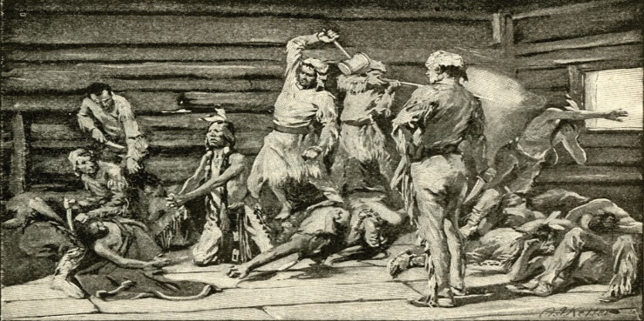Buckongonhelas took his tribe west to establish a town near the war chief Blue Jacket of the Shawnee. The two men became close allies. During these war years, a number of Lenape who had converted to Christianity were living in frontier villages run by Moravian missionaries. In April 1781, at the Ohio village of Gnadenhutten, Buckongonhelas warned the Lenape that an American militia from Pennsylvania was likely to execute any Indians in their path and would not pay attention to whether they were Christians. He urged the Lenape to please follow him further west away from the encroaching colonists. Moving westward “from the rising sun” the people could live where the land was good, and his warriors would protect them. The Delaware Lenape did not heed his words. John Heckewelder a Moravian missionary wrote in his account that Buckongonhelas oration to the Christian Indians was told, “with ease and an eloquence not to be imitated.”

He continued, “Eleven months after this speech was delivered by this prophetic chief, on March 8, 1772, ninety-six of these same Christian Indians about sixty of them women and children were murdered at the place where these very words had been spoken by the same men he had alluded to and in the same manner that he had described. A group of American militiamen rode out from Fort Pitt in western Pennsylvania and found the converted Delaware. Since Delaware had adopted Moravian ideals, they saw the militiamen as allies.

“[The militiamen] told them, ‘Come with us, we’ll protect you,’” Johnson said. “And, of course, [the Delaware] believed them.”

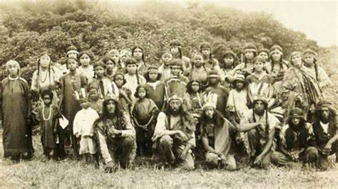The militiamen took a vote on whether to spare or kill the Delaware, and the latter was chosen. After the colonists told the Delaware that they were going to kill them, the Delaware prayed, and the next day, the Delaware converts were clubbed, hatched, and axed, to death, including men, women, and children, in an event called the Gnadenhutten Massacre. “The Moravian and the Delaware relationship didn’t end well for the Delawares,” Johnson said. “The Moravians were teaching and showing the Delawares that you live like us, you dress like us, and that you will be protected. They were killed by people that they trusted.”  After the Revolutionary War, the United States claimed the Ohio Country by right of conquest through its defeat of Great Britain. In the late 1780’s Buckongonhelas joined a Shawnee-led confederacy to try to repel the American settlers who had begun migrating west of the Appalachian Mountains using the Ohio River to penetrate the territory. The Western Confederacy brought together Miami, Potawatomi, Shawnee, Delaware, and other Native Nations fighting against U.S. encroachments. They won several battles against the Americans in the Northwest Indian Wars. Buckongonhelas led his warriors to win the most devesting military victory overachieved by Native Americans in the United States, in 1791, against General Arthur St. Clair who lost six hundred troops. Delaware described Buckongahelas as their own George Washington. Standing five feet ten inches tall, he was strong with powerful muscles and was said to resemble Bemjamin Franklin. Lenape, say he has the spirit of Mesingw/Mesink is the Lenape Mask Spirit, a powerful, sacred medicine spirit who maintains the balance of nature, appears to Lenape men in dreams, and is the focus of certain traditional Lenape religious rituals. Some people (especially non-Natives) have begun associating Mesingw with Bigfoot recently, but this is not a traditional view-- many Native American tribes do indeed have sasquatch/hairy man legends, but the Lenape Mask Spirit is not one of them. Mising is usually depicted as a supernatural face with one half colored red and the other half colored black. Mising is the protector of all animals of the forest but is most strongly associated with deer. Some Lenape people describe Mising as taking humanoid form as a tormented soul seeking to haunt those who mock enduring love. Misng at times is riding through the woods on the back of a deer, helping respectful hunters and punishing those who despoil the forest. Others have said he was able to summon Matanto. Folk lore says when his son was killed, he evoked and cursed by Matanto to get revenge, and when he heard that the Lenape Moravians were murdered, he summoned Matanto to get revenge. Matanto is the manëtu (spirit) of death. He was portrayed as a destructive, often evil being usually in opposition to [Ketanëtuwit](http://www.native-languages.org/kitanitowit.htm). Matanto is associated with bats, stinging insects, and poisonous plants, all of which he is said to have created. On August 20, 1794, Maj. Gen. Anthony Wayne led troops of the Legion of the United States from their fort at Roche de Bout. The left wing and flanking militia from Kentucky crossed the level but poorly drained land containing dense forest and underbrush. Hearing about that General George Washington had ordered “Mad” Major General Anthony Wayne to lead colonial militias to destroy the Lenape and the Confederation of Indians, Buckongahelas evoked the spirit of Mantanto and all medicine women who can shape shift to summon any tormented soul that maybe attached to Gen. Anthony Wayne to haunt and take revenge upon him. Buckongahaleas had the special ability to foretell, and he did see a tormented soul that had followed Gen Anthony Wayne to the Ohio territory. He had the vision come to him in his dream. He heard the name “Nancy” of which Gen Wayne had named his horse. Buckongahelas said, “I will send this tormented soul to enhance her revenge upon General Wayne and he will be made crazy in his head.” He saw a long black hair woman who was attached to Gen Wayne and was, so heart broken and sad, the spirit of this woman dominated the conscience of Anthony Wayne. Buckongahelas was hoping that this curse and spell would interfere with Gen Anthony Wayne’s ability to plan or conduct a battle. After a five-mile march, the mounted volunteers came upon a line of 1,100 Indian warriors from a confederation of Ohio and Great Lakes Indian tribes. The militia volunteers retreated around the legion's front guard. The front guard returned fire while retreating but eventually fled. The warriors vigorously pursued the soldiers of the front guard until a light infantry skirmish line forced the Indians to seek shelter amid timbers that had been felled a few years before by a tornado. The battle of Fallen Timbers was the ultimate battle of the Northwest Indian War. The legion's right wing was under heavy fire from the concealed warriors, who broke down to flank them from the river. The left flank of soldiers charged, inflicting heavy casualties on the Indians, and driving them from the field. Wayne's scouts tracked the Indians to the mouth of Swan Creek, but they were not engaged. After regrouping his troops, Wayne held his position into the afternoon. With no Indian counterattack, Wayne set up camp on high ground overlooking the foot of the rapids, within sight of Fort Miamis. In the following days Wayne's men returned to the battlefield to collect the wounded and equipment. Two officers and 15 to 17 soldiers were buried, but hard soil conditions deterred soldiers from burying more men. The entire legion marched back through the battlefield on August 23 as they returned to Roche de Bout. After the defeat, Buckongahelas ordered the traditional healers killed because they failed and were blamed for the smallpox outbreaks and the defeat at Fallen Timbers. The confederacy were finally defeated at the [Battle of Fallen Timbers](https://en.wikipedia.org/wiki/Battle_of_Fallen_Timbers) in 1794. The British failed to support the Indian confederacy after this battle, and Buckongahelas signed the [Treaty of Greenville](https://en.wikipedia.org/wiki/Treaty_of_Greenville) on August 3, 1795. By this treaty, his band and other Lenape ceded much land in [Pennsylvania](https://en.wikipedia.org/wiki/Pennsylvania) and [Ohio](https://en.wikipedia.org/wiki/Ohio) to the United States.[[6]](https://en.wikipedia.org/wiki/Buckongahelas#cite_note-White-6) At times, competing tribes tried to control the lands and villages, and it was not clear that the chiefs who signed the treaties had authority over the lands they were ceding.[[6]](https://en.wikipedia.org/wiki/Buckongahelas#cite_note-White-6)On June 7, 1803, Buckongahelas signed the [Treaty of Fort Wayne](https://en.wikipedia.org/wiki/Treaty_of_Fort_Wayne_(1803)) in [Indiana](https://en.wikipedia.org/wiki/Indiana); the US set new boundaries for the Lenape and other nations. They also ceded salt springs. Algonquian tribes ceded large land tracts to the United States. Lastly, he signed the [Treaty of Vincennes](https://en.wikipedia.org/wiki/Treaty_of_Vincennes) on August 18, 1804, in Vincennes, Indiana. The Lenape ceded lands between the Ohio and [Wabash](https://en.wikipedia.org/wiki/Wabash_River) rivers. The treaty helped open the Ohio and Indiana territories to European-American settlement. Not able to read and write, Buckongahelas made "X" signatures on the three treaties.[[6]](https://en.wikipedia.org/wiki/Buckongahelas#cite_note-White-6)Buckongahelas spent his final years living with his people on the [White River](https://en.wikipedia.org/wiki/White_River_(Indiana)) near present-day [Muncie, Indiana](https://en.wikipedia.org/wiki/Muncie,_Indiana). He died in May 1805 at the age of 85 from [smallpox](https://en.wikipedia.org/wiki/Smallpox) or [influenza](https://en.wikipedia.org/wiki/Influenza). The Indians always trusted and loved the men of peace. But although their friends could teach the Indians to plow and sow, to build houses and barns, to make tools and mend them, to sing and to pray, and to wear clothes and to lead decent and sober lives, they could not uproot all their old customs and superstitions. The superstition that seemed to last longest was the belief in witchcraft, which was indeed quite common among their white neighbors. All forms of sickness were treated as the effect of witchcraft by the Indians, and the afflicted were carried into the woods and left alone with none near them except the traditional healer whose business it was to expel the witch.

A suspected witch or wizard might be safely killed by any kinsman of the sufferer; and it is said that Indians were known to walk all the way from the Mississippi to the Ohio reservations to shoot down persons accused of witchcraft, and then return unmolested. In 1828, the Mingo chief Seneca John was put to death by two of his tribe members as ruthlessly as Leatherlips in 1812. He was accused of having bewitched chief Comstock, and though he protested, “I loved my brother Comstock better than the green earth. I stand upon; I would shed my blood, drop by drop, to bring him back to life,” yet he was sentenced to die, and Comstock’s brothers, Coonstick and Steel, conducted the sentence. Many local Native Americans thought the [epidemics](https://en.wikipedia.org/wiki/Epidemics) of fatal illnesses to be related to witchcraft, as their traditional remedies and medicine had no effect on the course of the diseases. They conducted a witch-hunt and executed several Lenape women suspected of witchcraft.However, they missed catching one other powerful spiritual witch traditional healer who had successfully summoned the tormented soul who was attached to General Anthony Wayne. Axe had used her skills in medicine and spirit evoking spells that she had learned and acquired from her upbringing. She had the spell set to Anthony Wayne destiny, “he will be punished as his tempter will show, a short wick, he will die before he arrives at his home. Throw his bones into a black caldron along with his horse. Boiled down to make candles, with short wicks as his anger, and he will be cast forever, as a lost soul searching for his bones.” Axe was able to converse with this ghostly spirit and discovered her name. Her name happened to be the name of Mad Anthony Wayne’s horse. General Wayne called his horse Nancy. It was a name Axe was familiar with and had believed to know this spirit’s family. The spirit was a woman, and she was soaked in water in her visions. She said her name was Nancy Coats. Axe heard the name in her vision and recalled the name of Elizabeth Aunt Betty and her brother, James. “Coats” she heard, and, in her mind, she recalled, and so Nancy Coats the spirit became attached to Axe, for the spirit yearned to be found by family. Axe attempted to disperse the spirit ghost but was unable to and allowed the spirit to roam around with her in the woods. The spirit did say she was a widow, and her first and only husband was Coates, but he had passed near Fort Ticonderoga. Axe just did not understand what was causing her to remain with Axe.

The spirit of Mrs. Nancy Coats was able to haunt Anthony Wayne in his dreams, but always would return to Axe. On December 15, 1796, Mad Anthony Wayne dies in Fort de la Presqu’il Erie, Pennsylvania. Axe recalls it was a very emotional day for the spirit of Nancy Coats. The spirit seemed to remain around the area, wandering around the hills of Guernsey and Tuscarawas Counties. Axe recalls asking Aunt Betty if she has a sister named Nancy. She did say yeas she does, but she is married to a Mr. Hartshorn, and she is referred to as Mrs. Hartshorn. The conditions of defeat and despair were the grounds for the rise of the Shawnee [prophet](https://en.wikipedia.org/wiki/Prophet) [*Tenskwatawa*](https://en.wikipedia.org/wiki/Tenskwatawa)*,* who promised renewed power for the American Indians against the European Americans. His brother [Tecumseh](https://en.wikipedia.org/wiki/Tecumseh) became an influential chief leading a new Indian confederacy against the Americans in the early 19th century. Some of the Lenape Indians survived this massacre by having been away on hunting or visiting relatives in other parts of Ohio during this event. Reports about the massacre indicate only one young boy had survived by hiding in a box. However, there was one fortunate infant soul that also survived by a miracle. After the deadly massacre, March 15, 1782, after the murderous militia men had departed back towards Pennsylvania, returning Lenape folks and local pioneers cautiously made their way to the site of the Moravian Indians. Some folks fainted upon seeing the bloodbath and remains of burnt family members. A missionary woman who was observing the horrendous carnage happened to hear a baby cry. She immediately attempted to locate the cry and in one cabin that was partially destroyed by fire, heard a faint whimper. Peering through the debris, she sees a body of a female woman with a hatchet in the back of her skull. She sees that she is lying next to a bloody blanket wrapped around a basket. The basket had an axe with a long handle embedded through the basket and into the wooden floor. Upon further examination, she removed the blood-soaked blanket and discovered an infant lying next to the sharp edge of the axe that had barely missed the head of the infant by inches. Before she was able to react, a group of Lenape women and men approached the site. The group all realized the situation and reacted by removing the infant. The missionary woman had written down her experience that day. She recalls the Lenape folks while holding the infant baby girl and saying, “she will be named Tëmahikàn, “AXE” so she will always know how her mother and family had been murdered. We will tell this story every year to our children so they will know how devils work and will never forget this most evil moment. Retributions will come by the creator.”

Axe ***tëmahikàn***. The Lenape folks who rescued her from the massacre site knew of her parents and family. They knew her mother had just birthed Axe four months ago, and her three siblings and her father were killed there as well. They knew that Axe’s mother had a brother who resided near Salt Fork creek and Coon run intersection, above Will’s creek and had a cabin there where he and his two wives reared seven sons.

As a child, she learned about her Lenape history and each year, the story along with a ceremony was repeated to commemorate the slaughter event. Her adopted mothers were traditional healers and had knowledge of plants, earth, and spirits. Some would refer to as spiritual guides or witches as white settlers would say. Being the only girl child of the family, at times she would spend her days along with her aunts’ sewing garments and making food as well as harvesting the crops. The women would teach her all the medicine rituals and all Lenape stories told in the tribe of old. Axe learned the spells and ceremonies of the customs of the Lenape. She tended to run with her new brothers when they would go on hunting expeditions. The area of land was vast with large first growth trees and thick underbrush as well as filled with wild animals such as bears, wolves, foxes, and bobcats. Danger did lurk through the hills, valleys, hollers, and such, from these wild beasts, and there were marauders consisting of Indians and drifters. Following a familiar hunting path, Axe and her seven brothers came upon a litter of bobcat cubs. As they watched the three cubs play, the hunting party were aware that if there are cubs there must be a mother cat. Just at that moment, a branch snaps and the cub’s instinct kicks in and they immediately ran towards a set of large oak trees on an obscured hill amongst the other hills in the forest. Curious, the boys and Axe slowly approached the oak trees and what they saw under the thick laurel brush and ferns was an opening between protruding rocks from the side of the hill. Nachgundin, the 17-year-old said, “I know of this place, my father and neighbor had told me it is called Wildcat Den.”