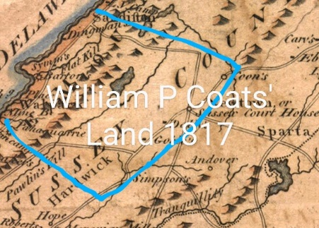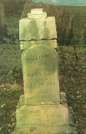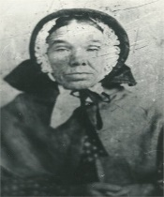Jane Jenny Hooey/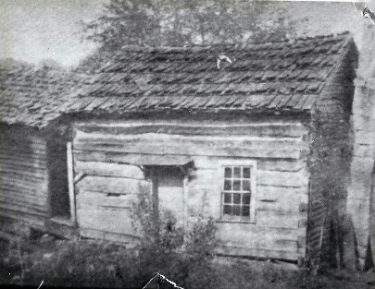

1783-Nov 25,1865 1781-1865

William and Jane Coats migrated from Sussex County, Newton, New Jersey

To Ohio with their seven children on April 26, 1817 upon selling 850 acres homestead. It took 3 months journey by Ox cart to arrive at their destination near “Newtown” later renamed Peoli. Mark Hooey, a brother of Jenny came along with his wife and children. Other step siblings of William went to Michigan around the same time. The other children ages were 12, Nancy; 11, Eleanor; 9, James;; 7, Ruth;; 7, Prudence & Cynthia 6 years. Isaac Coats was only 4 weeks old. “It would seem to me that Jane was a brave woman who had courage and the ability to cope with hard life to start a journey like that in an ox drawn covered wagons”, Said Charles Couts, 1939 in a handwritten letter recalling the stories he remembers as a child. The William P Coats’s family stopped at the “Old Tavern” owned by Ananias Randall. He offered them to rent a cabin until William could build one of his own. That house was located what was referred to as the Martin Hollingsworth farm. William started to begin his acquisition of land and purchased 160 acres of land costing $1.25 an acre. William with the help of others, cleared the land for his home and farm. The cabin was built as seen in the photo. The Coats’ lived here for a very long time. According to Charles Couts, nothing eventful happened until Isaac in June 1825 got himself lost in the woods. Isaac was a precious child to his parents and Jane his mother had taught him to read at age 4. The children began to grow up and as young adults, started to get married and build their own cabins near the area. The land was owned by William P and given to each child as they were married. Nancy Coats was the first to be married in the family. She married Joshua Hartshorn, a stone mason. The home they had was near a field called the Old Limestone Spring field. It was Isaac Beale’s cabin. This field had a very large old Popular tree that grew near the spring. North of this field was known as the old Chestnut tree stumps field. On the other side, was known as the Meadows, near Beale’s farm. Total acres there was about 160 acres that was given to William P. Couts Junior, because he stayed home until age 25 and helped his father. James Couts when he married to Rachel Wilson was given some acres near the old Hartwood cemetery. Nancy and James were the studious children and were well read. James began to study surveying and did work in the area. Charles recalls s story that as they were in the Ox Cart, their mother, Jane would have spelling bee contests. He recalled them being able to spell Coshocton. However, James spelled it incorrectly and Nancy had to correct his spelling. He also mentions in his handwritten letter, Jane telling the children, “Listen”, No one ever got into trouble by listening.” {**OHIO COUTS/COATS Progenitor Descendants are from the Couts children below. }**

|  |  |  |  |  |  |  |  |  |  |
| --- | --- | --- | --- | --- | --- | --- | --- | --- | --- |
| **Nancy M Coats**  1805-1860 | **Eleanor Couts**  1806-1860 | **James W. Coats**  1808-1850 | **Ruth Couts** 1810-1870 | **Prudence Couts** 1811-1893 | **Cynthia A. Couts** 1811-1894 | **William P Couts** Jr. 1813-1896 | **Jane Couts** 1815-1839 | ***Mary Jane 1816-1816*** | **Isaac Couts** 1817-1907 |
| **Charles Couts**  1819-1890 | **Elizabeth Betty Couts** 1821-1897 | **Mary Polly Couts**  1823-1899 | **Julia Couts**  1823-1904 | ***Daniel Couts***  ***1824-1824*** | ***Ruth Jane Couts***  ***1840-1842*** |  |  |  |  |

From what I observe, the Couts/Coats male descendants members are in our Facebook page, however, the female’s descendants are elusive. Perhaps we can locate and invite those descendants to join our Couts Family web site on Facebook* (Hartshorns/Caldwells/Ijams/Hagans/Kimballs/Stockers/Browning/Stewarts)