Greetings Couts/Coates families. There are many blessings we are thankful for and many dreams yet to be imagined and fulfilled as we approach a new year.

I wanted to expound upon our family history by focusing on the women or maternal lines of the Couts’ family. Why? Because most of our genes are from the maternal lineage of the women in our family tree. Most of our Scottish genes derives from the women on our maternal sides. Also, the maternal side is very interesting.

I will be submitting on occasion some of these findings and stories of the maternal lineages. The first focus is Martha Anne Parrish Postel.

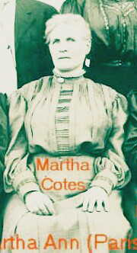She was born 1852 and died 1938. In 1852, Franklyn Pierce was elected president of the United States; Uncle Toms Cabin was published and California became the 31st state, She had one son with George Washington Gibbens.  John S. Couts Postel. { John S. Couts Postel chose to keep his mother's name}. She then married William Van Buren Couts and they had ten children together. She died on January 15, 1938, in Port Washington, Ohio, at the age of 85, and was buried in Newcomerstown, Ohio. In 1938, a loaf of bread cost is 9 cents. Gallon of gas is 10 cents. There was a disastrous hurricane that struck New England killing over 700 persons. The Germans initiated the killing of jews. Nylon was produced and Ballpoint pens were first made. Oil was discovered in Saudi Arabia. Franklyn Roosevelt was president.

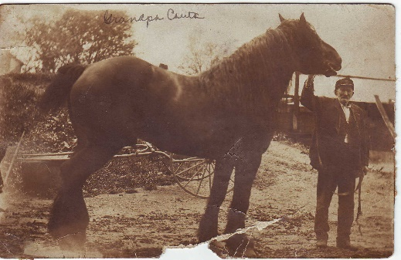

William Van Buren Couts (husband)

Here are a few of her ancestors, grandfathers and mothers who contributed to our existence. Their DNA runs in our veins. Their stories will inspire and intrigue your inner imaginations. Let me begin when the Ships came in, how each of our great grandfathers/ great grandmother came to America seeking freedom, life, liberty and the pursuits of happiness. It was rough and somehow, they survived. Resiliency is in Couts’ DNA.