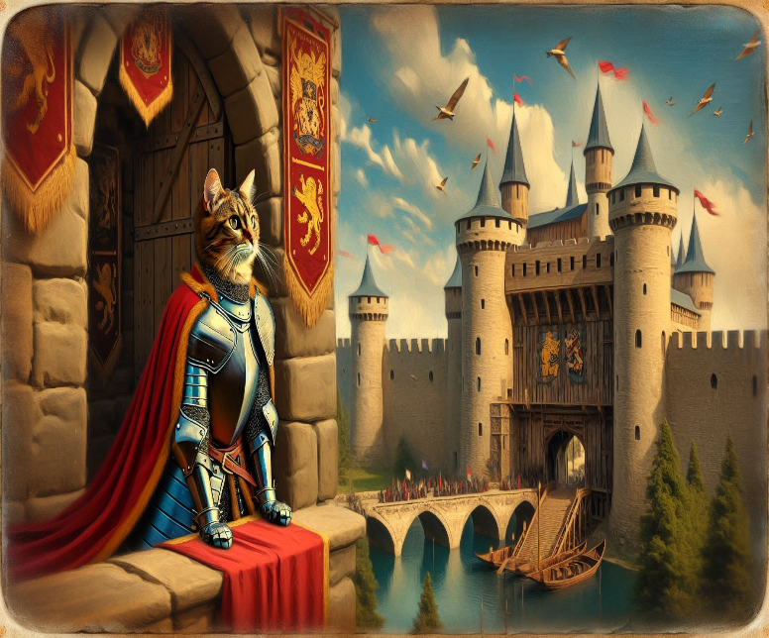
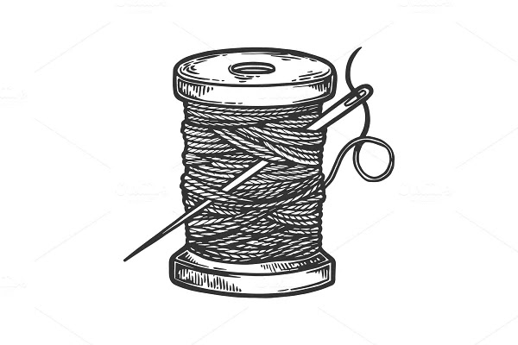
A Stitch in Time, Saves Nine
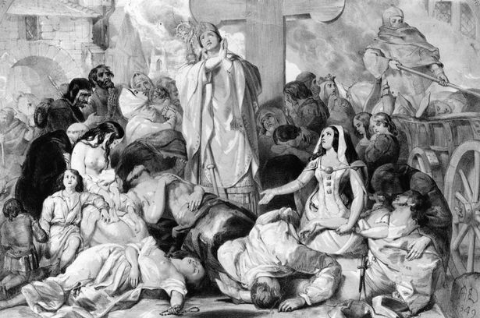

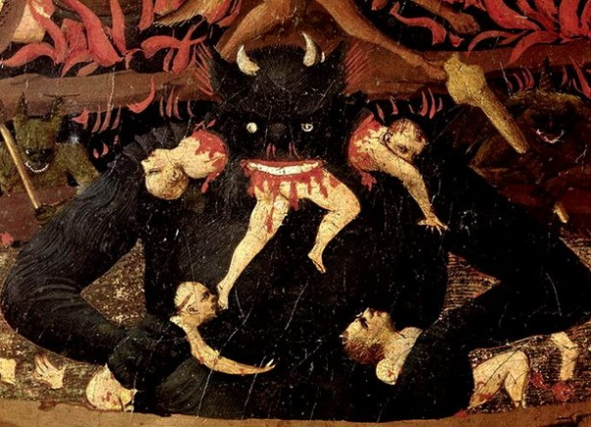
Sarum, Wiltshire, England 1321 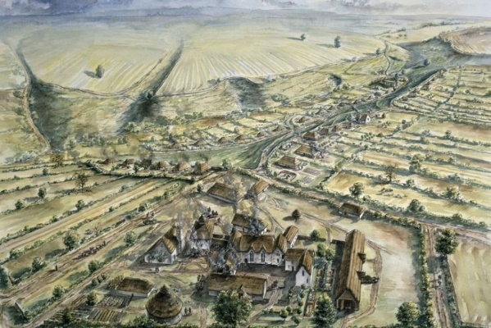

[Chapter 1] — Back Story
The story's backstory takes place a long time ago, in a period that decided the destiny of the Coates Family. In Medieval England, the Black Plague was to kill 1.5 million people out of an estimated total of 4 million people between 1321 and 1350. No medical knowledge existed in Medieval England; it was the Dark Ages. After 1350, the black plague was to strike England another 6 times by the disease. Understandably, peasants were terrified as the news of the Black Death was approaching their villages and towns. The Black Death is the name of a disease called the Bubonic plague, which was rampant during the Fourteenth Century. In fact, the Bubonic plague affected England more than once in the century, but its impact on English society from 1248 to 1350 was terrible. The Black Plague was caused by fleas carried by rats, which are common in towns and villages. The fleas but their victims literally injecting them with the disease. Death would come quickly for the weakest. The primarily illiterate populations initially believed that they needed to kill off the dogs and cats to stop the Black Plague, and about 40,000 dogs and 200,000 cats were killed by the English people. In the Middle Ages, cats were considered companions of sorcerers and witches. For this unfortunate and fatal reason, cats were tortured, and mass burned. Due to this superstition, entire feline populations were decimated throughout the Black Death. Ironically, the spread of the plague could have been contained if this prejudice towards cats had not existed! Felines would have helped to keep the rodents and their fleas in check. Cats kept their sacred oath to God to keep their eyes open, watchful, and helpful to humankind. For which were granted by God nine lives.
1357, in and around a village in Wiltshire, in Southwest England, there was a man and wife who offered comfort through an act of kindness promised who held their faith in God, and by happenchance, received a powerful thread pulled through an eye of a needle will be passed along for generations that will provide protection and comfort to those who have possession of it. It is linked to the blood of the soul who owns it, and if certain conditions are met, it will give the ability to foresee the future, to watch from afar, and to become aware of the spirits of lost souls. Along with it comes some unfortunate fate that could be avoided by simply understanding a gift. The possession of a cat and holding on to faith that through God, anything is possible. If not, these are bound together in one’s presence at the Right time and moment; nasty afflictions befall you and can only pass on

to the 9th generation of each chosen one. The unfortunate fate was a slow death that comes with a warning of a reburial. If no heed is done and time is wasted, the thread will not hold, and death and misfortunes will result. On the other hand, if conditions are held, blessings will be abundant.
Moses Coates was 25 when he married 22-year-old Susannah Coppock in 1356. The Black Plague was just raging in the surrounding lands. The newlyweds felt fearful of becoming victims of the plague after watching and seeing horrible deaths in their own families and neighbors around the village. It was a cold, dark October, and All Hallows Eve was approaching. Cries and screams are heard from a neighbor’s home, and horses are listened to, hauling away the dead. Imagine the fear running through the minds of the surviving souls so far. Having to watch your loved ones die and then their bodies thrown into carts to be hauled away to a burning pit of those who fell deadly ill from the plague. The famine at the beginning of the century, the vast wars in France, and the following plague spread fear across Christendom.
The Bible prophesied that the world's population would be culled by the four horsemen of the apocalypse: war, famine, pestilence, and death. For 14th-century people, the prophecy was becoming a reality, and the world's end was fast approaching.
Various paintings depict extreme and apocalyptic visions of the four horsemen, hell, and personifications of death and pestilence throughout the period. Effigies became skeletal; instead of displaying the dead in their grandeur, they showed them as decaying bodies, known as Cadaver Tombs.
It was an epidemic feeling that mortality was even more fragile than it had been before. Geoffrey the Baker, also known as Walter of Swinbrook, an English chronicler, wrote the Chronicon Angelate, recording English events from 1303 to 1360. "It {the plague} first began in the towns and ports joining on the seacoasts, in Dorsetshire, where, as in other counties, it made the country entirely void of inhabitants so that almost none were left alive.
"But at length, it came to Gloucester, yea even to Oxford and to London, and finally it spread over all England and so wasted the people that scarce the tenth person of any sort was left alive."
In early 1349, a second pandemic spread when ships arrived in the Humber. From there, it struck the north hard, moving into York by May and the northwest by mid-summer.
It had taken 500 days for the disease to cover England. In fact, it was so infectious that John Clyne, a monk at an Irish friary, described in his records how those who touched or spent time with the dying became sick soon after.
As he put it: "One day people were in high health, and the next day dead and buried."
In fact, Clyne was so convinced by the mass feeling of an apocalyptic end that the chronicler claimed that he was only writing, "So that what I have written shall not perish together with the writer, and this work shall not be destroyed, I leave my parchment to be continued, if someone of Adam's race may survive the death and wish to continue the work I have begun."
He honestly believed that the plague would consume him and was, in turn, consumed by the need to record the happenings around him for future people to read and understand. The plague would have been a horrible ordeal to face.
Swelling buboes, like giant boils, poured on the groin, neck, and armpit, oozing puss, and bleeding. If they swelled to a size that they popped, the victim tended to survive, and Medieval physicians drained them or tried bursting them using a hot poker.
The poet Giovanni Boccaccio wrote several accounts of the Black Death and its symptoms when it first reached Italy. He described the buboes as growing to the size of apples and claimed that the buboes were followed by the spreading of black spots over the body.
"The form of the malady began to change, black spots or livid making their appearance in many cases on the arm or the thigh or elsewhere, now few and large, now minute and numerous."
From there, the disease was considered near fatal; fever and vomiting followed, with victims coughing up blood. They would die within the week, sometimes as quickly as 48 hours.
Understandably, treatments were primitive. Bloodletting and sweating were the only two methods that targeted the disease, and they were as simple as described.
Physicians would bleed one side of the body, hoping to drain the blood from the buboes or use medicines and herbs to cause sweating. If neither method worked, the physician had little but prayers and a desire to give the victim strength. The disease could be beaten if the victim's immune system was strong enough to keep them alive for a week.
A medicine containing horse hoof, mercury, tin, and flowers was used to help conserve the strength of the diseased, but it would have likely poisoned them.
Another remedy consisted of powdered crab eyes, claws, and roots served with jellied vipers covered in gold leaf. Again, these did nothing or were harmful. They were also expensive due to the gold leaf.
As people died in their droves, even the most religious and God-fearing did not dare touch the dead; bodies were dumped in mass graves as plague pits sprung up across England.
The population was hit so hard that many villages shrunk or simply disappeared.
Hundreds of settlements were lost across England, with the more disparate populations in Cumbria, Lancashire, and Yorkshire being hit the hardest. This happened in the village of Wiltshire, where our ancestors experienced it.
“Please, my lady, Susannah, stop looking out the window at those poor souls," says Moses Coates cautiously. "Those bandits will see that we are living comfortably and will try to cut our throats for what money we may have. If they have the plague, we will be infected.”
Susannah Coppock stared into the warm fire in the hearth. Her skin was pale, and her eyes appeared watery,
She speaks as if she is in a hypnotic trance, peering into the fire, "I fear we may be victims of the plague, and I feel hopeless."
Moses and Susannah had many desperate moments, questioning their faith and wondering whether life would improve or suffering, and fear would dominate their lives. Imagine the hopeless feeling embedded deeply into their hearts; their souls were awakened, questioning the dangers ahead. Death surrounded the countryside, and marauding soldiers and bandits would often be threats.

