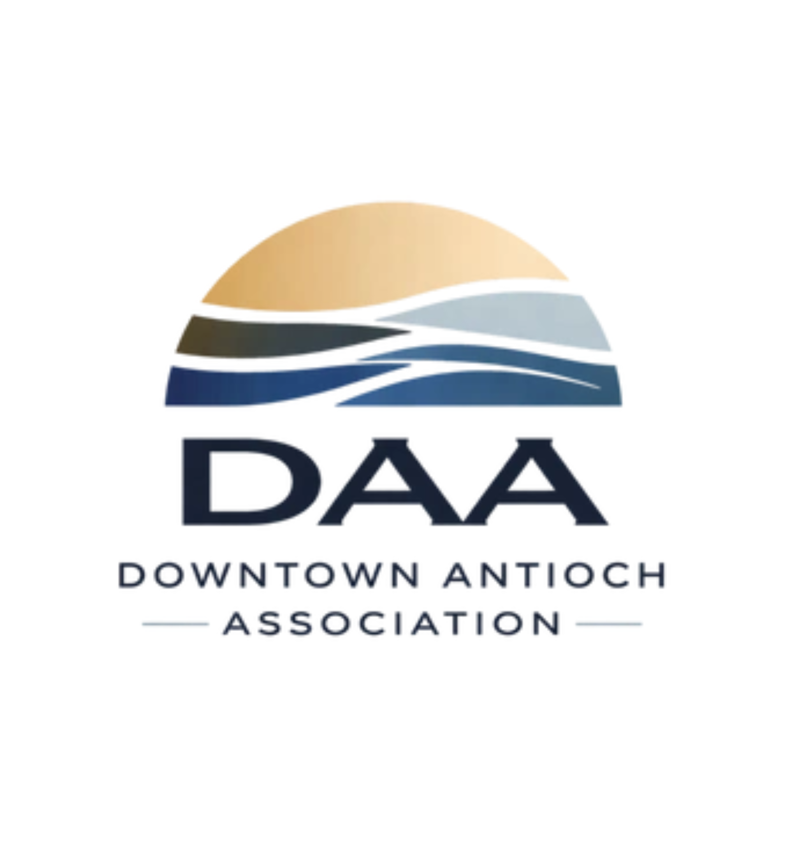
Meeting Notes
July 22, 2026
Unwind & Discover Your Inner Light
Led by Debbie Blaisure, DAA President

Opening Remarks
Debbie Blaisure, DAA President, opened the meeting noting the tight agenda for the evening, as the venue had a class scheduled at 7:30pm. She thanked Aaron, Desi, and Kim for hosting, and for their hard work on the Fourth of July celebration. This year's event was one of the best in recent years, featuring fireworks, a parade, a kid zone, and live music. Debbie credited Shahad and the Parks and Recreation team for the smooth collaboration.
Debbie read a message from Mayor Ron Bernal, who was unable to attend due to hosting Mayor Kiyono and his assistant Mr. Imaizumi from Antioch's sister city, Chichibu, as part of the sister city program. In his message, Mayor Bernal expressed appreciation for the DAA's work on downtown revitalization and acknowledged the ongoing challenge of homelessness in Antioch. He noted that the City Council will vote this Tuesday (July 28th) on a resolution regarding permanent supportive housing at the Antioch Inn (formerly Comfort Inn) for 85 homeless individuals from throughout Contra Costa County with mental health issues. This proposal has generated community discussion, with some supporting it and others raising concerns about cost or location. The Mayor encouraged community members to make their voices heard by attending or calling into the city council meeting, which starts at 7:00pm and is being conducted in hybrid format (in-person and remote options available).
The June meeting had been skipped to allow the community to attend a special city council meeting about proposed $5 million budget cuts. That meeting proved important, as the city ultimately decided to keep the Fourth of July celebration and other key programs in the budget. Debbie emphasized the value of attending city council meetings in person when possible, as they offer opportunities to learn about issues affecting downtown and to make public comment.

Promoting Downtown: Positive Action
Debbie addressed the negativity appearing online about downtown, noting she has received many emails, texts, and calls from community members concerned about negative posts. Her message was clear: the DAA will maintain a positive stance and will not engage with negative commentary. She encouraged members to post on their own channels instead, since those spreading negativity are monetizing engagement for their own benefit. The best response is to share positive news about downtown, cross-promote local businesses, and highlight the many events and new openings happening right now. As Debbie pointed out, the DAA's social media alone reaches 30,000 views with only 200 followers, proving that people are paying attention and looking for information about downtown.
The core mission of the DAA is to bring people downtown and into the businesses. While events draw foot traffic, they only succeed when businesses actively promote themselves and collaborate with each other. Debbie urged members to send their specials, promos, and announcements to downtownantiochassociation@gmail.com so the DAA can amplify them. Cross-promotion across social media, email lists, and personal networks is essential to making downtown visible and appealing.

Website, Marketing & Leadership
The DAA website, AntiochDAA.com, is now live and accepting memberships and sponsorships. The rebranding effort is complete, with a new logo and unified social media presence across all platforms. Jessica Wendland and Christin Zamora serve as marketing and media leads, supported by Beverly Knight (Empower Antioch) who manages social media content and photography. The website serves as the central hub for event information, membership details, and community updates.
The DAA leadership structure remains stable, with the events committee expanded to include Dominique Coleman, Nicole Holmes, Monique Griffin, Erin Green-Astone, Lola Piilani, Gladys Torres, and Erin Pina. The mission remains focused: bring people downtown and into the businesses.

Public Safety & Community Engagement
Sergeant Fashner shared an update on APD initiatives, including efforts to expand hiring and establish clear priorities for call response. The department is actively recruiting new officers to strengthen capacity and response times. APD has also identified call priority areas to ensure resources go to the highest-impact issues. Sgt. Fashner emphasized the importance of coordinating with community partners like the DAA to address downtown concerns effectively.
APD continues to collect backpack donations at the station and through an Amazon Wish List, supporting students as the school year approaches. This effort will continue through the start of school. The Business Watch program and SeeClickFix app remain active tools for reporting non-emergency issues. LemonTree is coordinating National Night Out with APD on August 4th at G Street, and community members are encouraged to attend and engage with officers. For downtown concerns, contact Debbie who will document and share issues with APD. Emergency situations should be reported to 911.

Economic Development & City Planning
Kevin Scudero presented updates on economic development initiatives affecting downtown. The DAA provided its 5-year plan to the City for review alongside the Downtown Specific Plan currently being developed. There has been no discussion to date about a potential datacenter in Antioch, despite some speculation in the community. Kevin reiterated the City's support for the DAA's mission and collaborative approach to downtown revitalization.
The City is requesting that the DAA and local businesses complete a security survey to identify safety concerns and opportunities for improvement. Kevin also shared information about available grant and sponsorship opportunities in areas including community development, health, youth services, arts, and beautification. Volunteers with grant writing experience are needed to help pursue these funding sources. For businesses interested in the security survey or grant opportunities, contact Kevin or reach out through the DAA.

Partnerships & Collaborations
The DAA continues to work with key community partners to strengthen downtown. The Antioch Chamber of Commerce is promoting new videos and business spotlights. El Campanil Theatre has upcoming shows scheduled. The ABC Antioch Business Collaborative partnership continues, though the contract comes up for renewal in November. The Farmer's Market is updating signage and exploring community lunch programming on 3rd Street. Team Jesus Outreach Ministries provides a weekly Thursday food giveaway at Rivertown Treasure Chest, supporting residents in need.
The DAA is piloting a new partnership model: when community groups or event organizers have an idea but lack the expertise to execute it, the DAA can help navigate permits, logistics, security, insurance, and vendor coordination. In exchange, the DAA would receive a percentage of revenue or sponsorship. This model is already in motion with several upcoming events and represents an opportunity for the DAA to expand its impact while supporting community-led initiatives.

Upcoming Events
The DAA has a full calendar of events planned for the remainder of summer and fall. Several deserve special mention:
The Single City Series poetry event series launches this Saturday, July 25th, with 12 shows across 12 different venues in the city, featuring 24 poets. This initiative serves as both an economic driver for participating businesses and an exposure opportunity for poets. Light drinks, snacks, and live poetry will be featured at each location. Jose Cardone is coordinating the series and welcomes additional venues and poets. Five more locations are still needed to complete the full series.
July 29th through August 4th, the DAA will hold a fundraising auction. Approximately 50 items are needed from local businesses, sponsors, and community members. Raffle items, gift baskets, and donated goods can be sent to the DAA or dropped off at downtown locations. This auction will help fund DAA programming and events.
July 31st features multiple events: Christmas in July (11am-6pm at Timeless Elegance on G Street), Lunch Series: Chili (11am-2pm at Royal Banquet), and Books Bedazzled (6-8pm at Twisted Lovers Book Store).
August 1st marks the LemonTree Grand Opening on G Street, with the DAA and Chamber of Commerce promoting and celebrating. August 4th is National Night Out at G Street with APD. August 7th continues the First Friday Car Shows in partnership with Carlos Tacos.
October 24th is Hot Rods for Paws, a 12-year fundraiser now in its tradition of supporting local animal rescue. Erin has coordinated this event for 12 years, and the DAA is stepping in to help with logistics, volunteer coordination, vendors, and kids' programming. The event features cars, trunk-or-treating, contests, games, and vendors across the city. Jessica and Debbie have committed to expanding the kids' zone by partnering with Pastor Jared to add activities and fun for families.
A full calendar of events is available on AntiochDAA.com and is updated monthly as new events are confirmed.

Action Items for Businesses & Community
- Sign up for DAA membership or sponsorship on AntiochDAA.com
- Send your specials, promos, and announcements to downtownantiochassociation@gmail.com for promotion
- Attend City Council meetings on 2nd and 4th Tuesdays at 7:00pm to stay informed and make public comment
- If interested in the homelessness/permanent supportive housing discussion, attend or call into the City Council meeting on Tuesday, July 28th at 7:00pm (hybrid format available)
- Donate raffle, auction, or basket items for the July 29–Aug 4 fundraising auction (need ~50 items)
- Complete the security survey when distributed by the City
- Contact Debbie if you can host a future DAA meeting for 30–40 people
- Share DAA posts and downtown events on your own social media channels
- Volunteer for event day support, grant writing, or other DAA initiatives

Contact Information
Debbie Blaisure, DAA President
510-909-4618
downtownantiochassociation@gmail.com

We need all business and resident support and feedback to succeed. Our strength is in collaboration, visibility, and lifting up each other's work.

