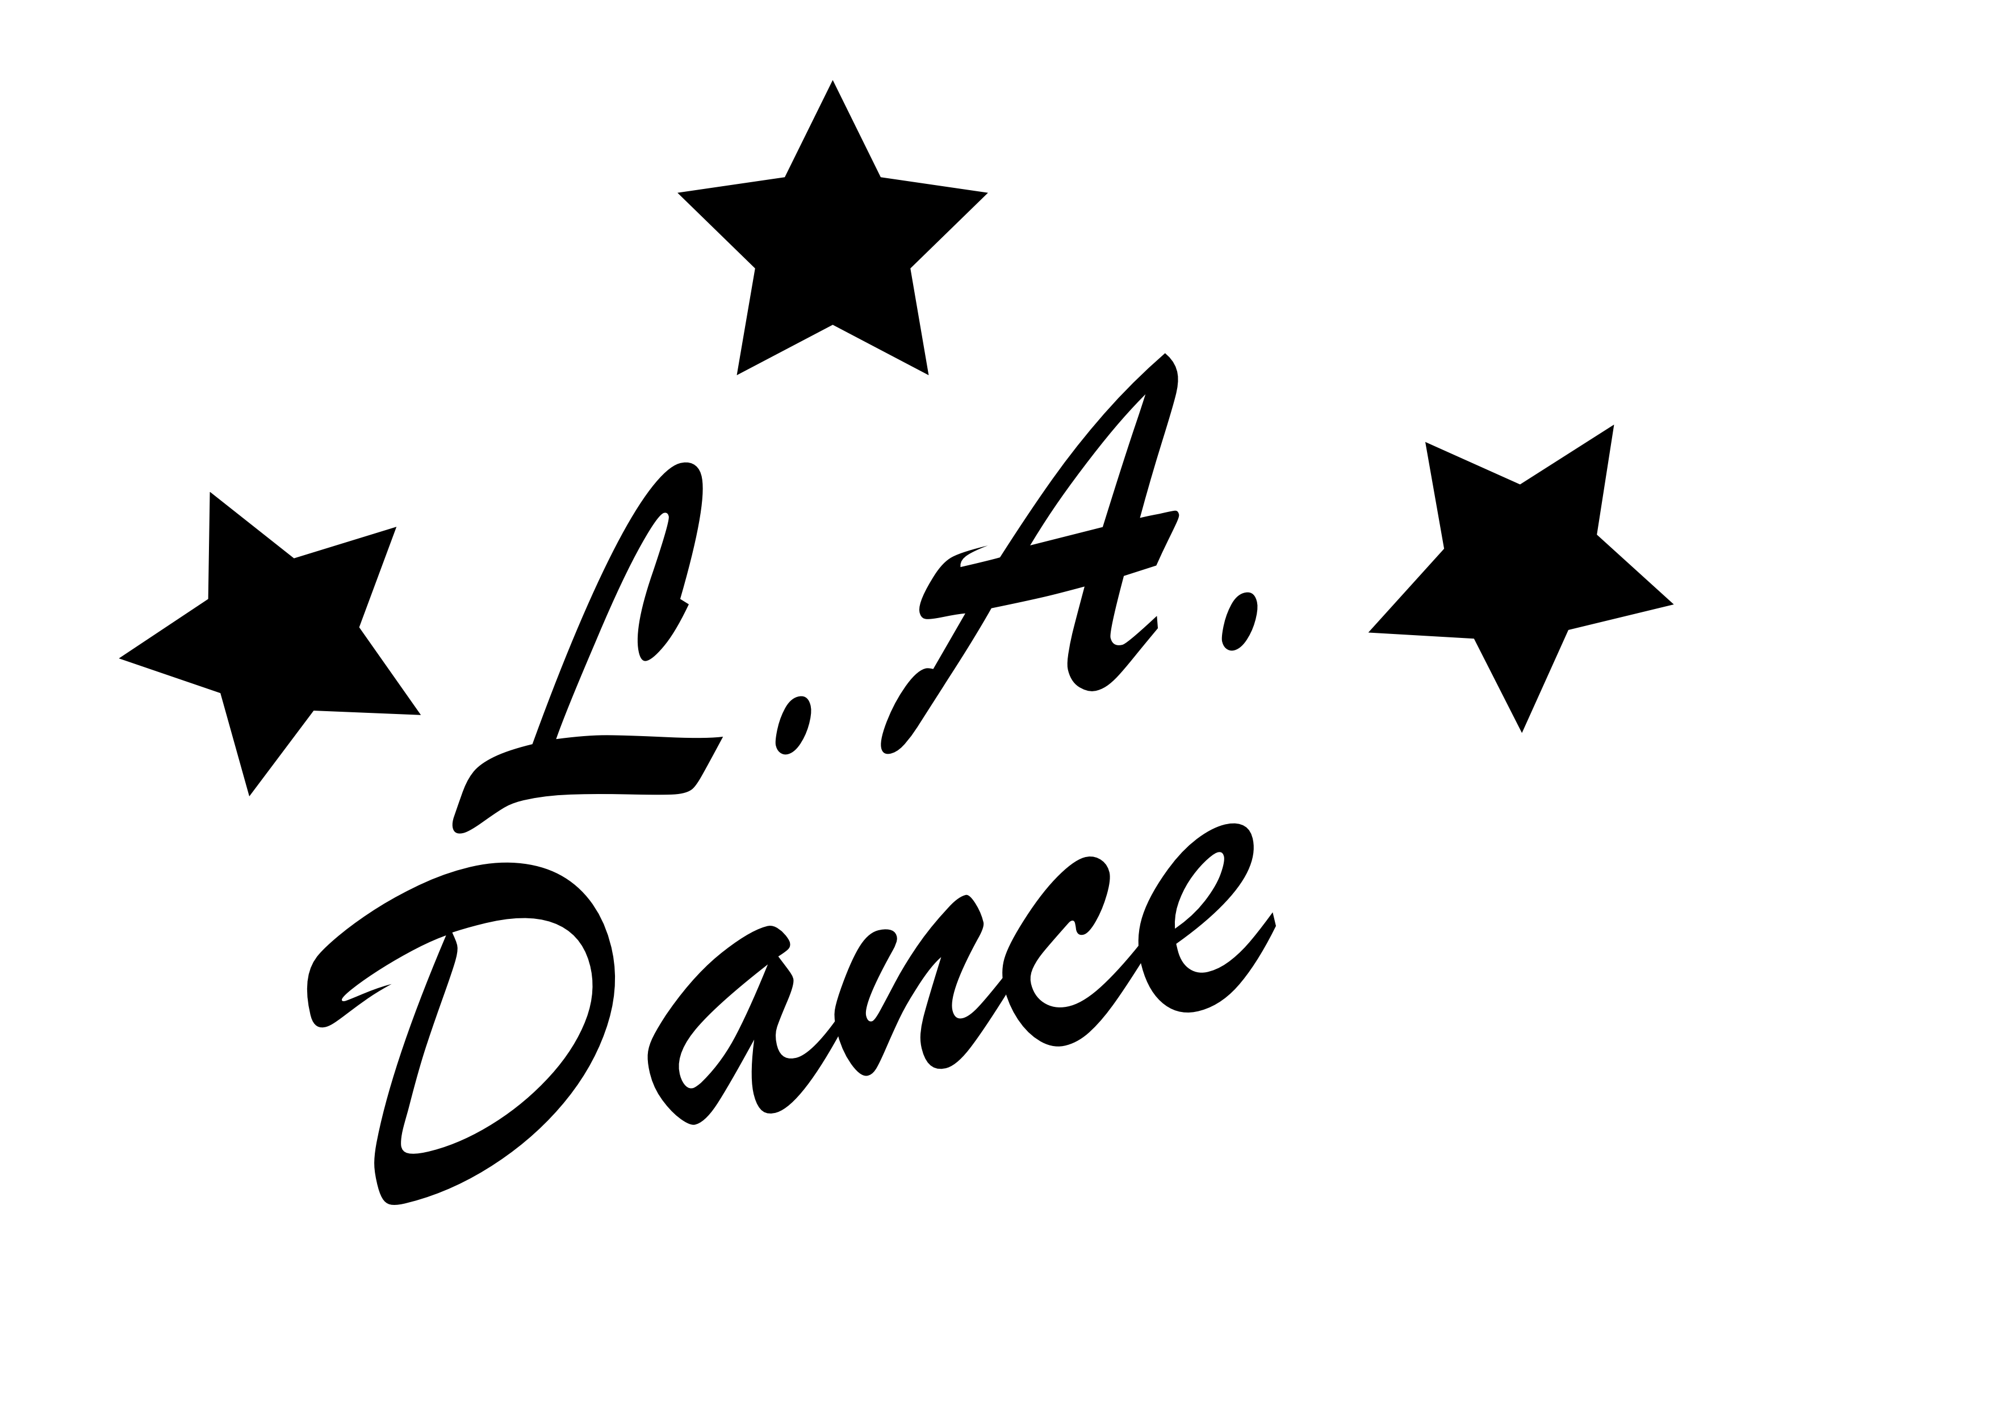
ACCIDENT WAIVER AND RELEASE OF LIABILITY FORM
L.A. Dance (Lora’s Academy of Dance, LLC.)
PLEASE PRINT
You must fill out form completely or processing will be delayed.
DATE: ____________________, 20____
Participant's Full Name (1) ________________________________________________Date of Birth__________
Participant's Full Name (2) ____________________________________________________________Date of Birth__________
Participant's Full Name (3) ________________________________________________Date of Birth__________
Parent's Full Name___________________________________________________________________
Address_________________________________________________City___________ State________ Zip______
Home Phone_______________________________________________________________________
Emergency Name Phone_____________________________________________________________

I HEREBY ASSUME ALL OF THE RISKS OF PARTICIPATING IN THIS ACTIVITY OR EVENT, including by way of example and not limitation, any risks that may arise from negligence or carelessness on the part of the persons or entities being released, from dangerous or defective equipment or property owned, maintained, or controlled by them, or because of their possible liability without fault.
I certify that I am physically fit, have sufficiently prepared or trained for participation in the activity or event, and have not been advised to not participate by a qualified medical professional. I certify that there are no health-related reasons or problems which
preclude my participation in this activity or event.
I acknowledge that this Accident Waiver and Release of Liability Form will be used by the event holders, sponsors, and organizers of the activity or event in which I may participate, and that it will govern my actions and responsibilities at said activity or event. In consideration of my application and permitting me to participate in this event, I hereby take action for myself, my executors, administrators, heirs, next of kin, successors, and assigns as follows:
I HEREBY WAIVE, RELEASE, AND DISCHARGE Lora’s Academy of Dance, LLC. (DBA L.A. Dance) and all divisions thereof of any and all liability and responsibility for injuries, sickness, pandemics, accidents, natural disasters and/or acts of God incurred during participation in and/or instruction of camps, intensives, private instruction, choreography or any activity I may participate.
I WAIVE, RELEASE, AND DISCHARGE from any and all liability, including but not limited to, liability arising from the negligence or fault of the entities or persons released, for my death, disability, personal injury, property damage, property theft, or actions of any
kind which may hereafter occur to me including my traveling to and from this event, THE FOLLOWING ENTITIES OR PERSONS: Lora’s Academy of Dance, LLC. (DBA L.A. Dance) and/or their directors, officers, managers, employees, volunteers, representatives, and agents, the activity or event holders, activity or event sponsors, activity or event volunteers;
I INDEMNIFY, HOLD HARMLESS, AND PROMISE NOT TO SUE the entities or persons mentioned in this waiver, release and registration form from any and all liabilities or claims made as a result of participation in this activity or event, whether caused by the negligence of release or otherwise.
The accident waiver and release of liability shall be construed broadly to provide a release and waiver to the maximum extent permissible under applicable law.
I CERTIFY THAT I HAVE READ THIS DOCUMENT, AND I FULLY UNDERSTAND ITS CONTENT. I AM AWARE THAT
THIS IS A RELEASE OF LIABILITY AND A CONTRACT AND I SIGN IT OF MY OWN FREE WILL.
Print Participant’s Name (1) ______________________________________________________
Participant’s Signature (if under 18 yrs old, Parent or guardian must also sign below)_______________________________
Print Participant’s Name (2) ______________________________________________________
Participant’s Signature (if under 18 yrs old, Parent or guardian must also sign below)_______________________________
Print Participant’s Name (3) ______________________________________________________
Participant’s Signature (if under 18 yrs old, Parent or guardian must also sign below)_______________________________
PARENT / GUARDIAN WAIVER FOR MINORS (Only if student is under 18 years old)
The undersigned parent and/or natural guardian does hereby represent that he/she is, in fact, acting in such capacity, has consented to his/her child or ward’s participation in the activity or event, and has agreed individually and on behalf of the child or ward, to the terms of the accident waiver and release of liability set forth above. The undersigned parent or guardian further agrees to save and hold harmless and indemnify each and all of the parties referred to above from all liability, loss, cost, claim, or damage whatsoever which may be imposed upon said parties because of any defect in or lack of such capacity to so act and release said parties on behalf of
the minor and the parents or legal guardian.

Signature of Parent or Guardian _________________________________________________

