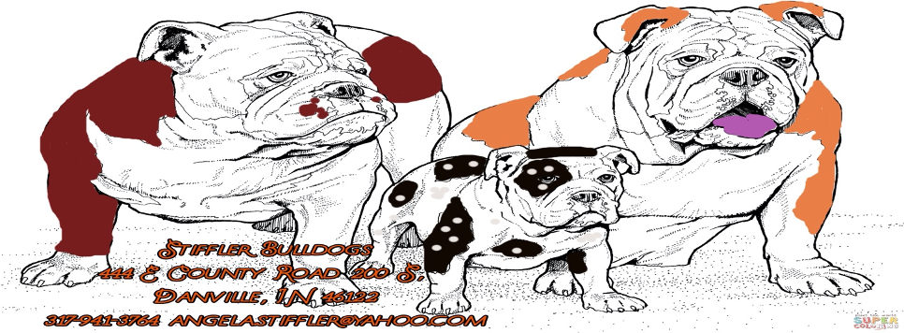
BREEDING RIGHTS AGREEMENT CONTRACT
Extension to Purchase Contract

Date: _________________

The following is a contract and Breeding agreement for an English Bulldog puppy produced by Stiffler Bulldogs.

Breeder agrees herewith to sell to:

(NAME)_________________________________,(Address)___________________________________,

(City)____________________________, (State)_______________ (Zip)____________,

(Phone)__________________, (Email)______________________________________

One puppy described below:

The Sire of this puppy is: ____________________________________
The Dam of this puppy is: ___________________________________
Registration Name: _____________________________________________________

Temporary Registration #: ______________________________________________

Microchip #: _____________________________________

This puppy’s coat color and markings are: _______________________________

D.O.B: ______________________ The sex of this puppy is: M or F (Circle One)
Puppy price is $ __________ USD Price of transport (if applicable) $ __________ USD

TOTAL PRICE: $____________________ USD

Contract Type: Breeding Rights/Stud

I _____________________________ understand that said dog is a Carrier of HU and will be tested for DM and CMR1 and breeder will contact me with the results when she gets them back.

Buyer Agrees to the following terms:

____________ I have received a copy of said puppies HU results.

____________ I understand that when Breeder receives the results for said puppies DM and CMR1, the Breeder will send me copies of those results when they get them.

____________ I will NOT stud said puppy out to any Purebred English Bulldog Female that has not been tested for DM, CMR1, and HU and results aren’t CLEAR. The results for those tests must be CLEAR.

___________ I will ONLY stud said puppy out to an AKC Purebred English Bulldog, no breeding mutts.

__________ I will have a stud contract with anyone that wants to use said puppy as a stud.

__________ I will have his sperm checked at or around age 1 year and again at age 2 to make sure said puppy’s sperm is good to use.

_________ I will get said dog OFA certified for hip (score good or better) and elbow (score normal) at age 2

_________ I have received a copy of the recommended Bulldog test.

________ I understand that if I violate any of these terms that I can lose ownership of said puppy.

This is a legal, binding contract between SELLER and BUYER and can only be changed by amendment dated and signed by both SELLER and BUYER.

Buyers Signature and date

Breeders Signature and date

BULLDOG RECOMMENDED TESTING
OFA-CHIC Health Testing Requirements
The OFA, working with the breed's parent club, recommends the following basic health screening tests for all breeding stock. Dogs meeting these basic health screening requirements will be issued Canine Health Information Center (CHIC) numbers. For CHIC certification, all results do not need to be normal, but they must all be in the public domain so that responsible breeders can make more informed breeding decisions. For potential puppy buyers, CHIC certification is a good indicator the breeder responsibly factors good health into their selection criteria. The breed specific list below represents the basic health screening recommendations. It is not all encompassing. There may be other health screening tests appropriate for this breed. And, there may be other health concerns for which there is no commonly accepted screening protocol available.

- Patellar Luxation
OFA evaluation, minimum age 1 year ➚
- Cardiac Evaluation (One of the following)
Congenital Cardiac Exam, exam by Boarded Cardiologist using echo preferred — but not required. ➚
Advanced Cardiac Exam ➚
- Tracheal Hypoplasia
OFA radiographic evaluation for Tracheal Hypoplasia. ➚
- Eye Examination- after the age of 24 months (Optional)
Results registered with OFA ➚
- Hip Dysplasia (Optional)
OFA Evaluation ➚
- Elbow Dysplasia (Optional)
OFA Evaluation ➚
- Autoimmune thyroiditis (Optional)
OFA evaluation from an approved laboratory ➚
- Congenital Deafness (Optional)
OFA evaluation based on BAER test ➚
- HYPERURICOSURIA (Optional)
HYPERURICOSURIA(HU) - DNA based test from an approved laboratory ➚
Notes
In addition to the breed specific requirements above, a CHIC requirement across all participating breeds is that the dog must be permanently identified via microchip or tattoo in order to qualify for a CHIC number.
CHIC numbers generate automatically within 1 to 2 weeks after all the required test results have been registered with the OFA.
For dogs residing outside the US or Canada, owners may submit their country's equivalent health screening results for listing on the OFA website. These requests are reviewed on a case by case basis and fees apply. Once these results have been recorded with the OFA, owners may request CHIC numbers if they've met all the CHIC requirements through regular registrations or international equivalents. These requests are handled on a case by case basis.
Other Recommended Test
HU- Which is listed above
CMR1- canine multifocal retinopathy
DM- Degenerative Myelopathy

