STIFFLER
BULLDOGS

Puppy Pack

• Sales Contract
• Endorsement Contract
• 3 Generations Pedigree
•Puppy Information Sheet
• Breed Profile
• Puppy Care Guidance
• Contact Details
•Kennel Club Registration
Document
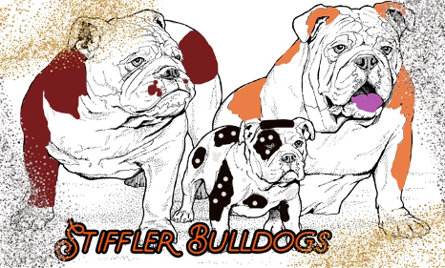

TABLE OF CONTENT

PAGE(s) # Content

1 Outline of What is in Packet
2 Table of Content
3 Congratulations on Your New Puppy
4 Puppy Information Sheet
5 Copy of 3 Generation Pedigree
6 English Bulldog Profile
7-9 Diet
10 Exercise and Playing
11 Socialization
12-13 Training
14-15 Crate Training
16 Grooming
17 Worming
18 Vaccinations
19-20 Breeders Notes
21 Recommended Reading/ Useful Web Links
22 Breeders Contact Information

CONGRATULATIONS ON YOUR NEW PUPPY

Congratulations on your new puppy! I hope he/she grows to be a fantastic companion for
you. Bringing a new puppy into the home can be a daunting decision to make but with the
correct training, time and dedication it can also be a fantastic decision!

I have compiled this puppy pack to provide you with guidance on raising your puppy
throughout the first year of its life. Even if we have owned dogs our whole lives, it is often
the puppy stage that we forget so it is always good to refresh your knowledge on caring for
your latest addition!

In this pack, I have included information on:

• Feeding & Diet • Exercise & Playing
• Socialization • Training
• Grooming • Worming
• Vaccinations

Please read the enclosed information and if you have any questions, please do not hesitate to
contact me by phone or email and I will do my best to answer your questions!

A few tips to remember for the first few days:

• Your puppy may seem anxious and confused of its new home and surroundings having spent its whole life up to this point with its mum and siblings. A few days, with love and patience on your part, the transition will be smooth.

• After bringing your puppy home, you may notice their stool becomes soft or loose. This can be due to stress related with changes in food, water and environment. The stools will normally go back to being firm again in a few days. If not, contact your vet.

• Have plenty of chew toys on hand –by providing proper training and chew toys they are less likely to direct chewing to inappropriate items (such as shoes). After all, chewing and playtime are part of a normal puppy’s growth and development.

• It is not advisable to take your new pup to areas where there are likely to have been other dogs until after their second vaccination as per veterinary advice.

• Make sure that all new encounters that your puppy has are positive as these will shape their behavior for the rest of their lives. It’s better to go slow and assure your puppy is not frightened than to rush and force your pup to meet new things and people.

Good Luck and Have Fun! Please keep me updated with news and photos on how you are getting along!

Angela Stiffler

Puppy Information Sheet
Kennel Name: Stiffler Bulldogs
Breeders Name: Erik and Angela Stiffler
Kennel Address: 444 E County Road 200 S
Danville, IN 46122
Tel No: 317-941-3764
Email: angela.stiffler@yahoo.com
Website: http://stifflerbulldogs.godaddysites.com/

AKC Registered Name:
AKC Registration Number:
Breed: English Bulldog
Color:
DOB:
Sex:
Microchip Number:

Sire’s Name:
Color:
Dam’s Name:
Color:

Weight Record
Birth | 1 Week | 2 Week | 3 Week | 4 Week | 5 Week | 6 Week | 7 Week | 8 Week | 9 Week

Worming History | Medication |  |  | Information
Date | Brand Name | Description | Dosage | Worms Found  Y/N | Date Next Treatment Due

Next wormer is due: .
Please contact your vet to obtain a suitable wormer for your puppy’s weight.

This puppy was examined by the following veterinarian:

Name:
Surgery:

Extra Notes:

Date of Examination:
Tel No:

Copy of the puppies generations

English Bulldog Profile

As a breed, English Bulldogs fall under the Non-Sporting group. A very compassionate but stubborn breed, they are found in mostly home environments. English Bulldogs strive as companion pets, as well as a protector of their family, and they enjoy their time in the show ring as well!

Average Food Cost: $10–20 a week
Feeding Requirements: English Bulldogs can be fussy eaters so care must be taken to watch their weight. I personally feed our puppies and adults Royal Canin Bulldog.

Other Expenses: Puppies generally cost around $1500-4000. This is a relatively healthy breed but can have some health issues, so vets’ bills could be a little high. However, it is always a good idea to have pet insurance for unexpected events.

Lifespan: 8-10 years
Average litter size– 5 Pups

English Bulldogs are medium sized dog and can come in several different colors –Brindle (subtle "tiger stripe" effect), piebald, solid red, fawn or white which are standard colors, but you also have chocolate, and merle.
Height | Lower | Upper
Sire | 15 | 18
Dam | 14 | 16

Weight | Lower | Upper
Sire | 45 | 60
Dam | 40 | 50

Energy | Laid Back
Exercise (adult) | 20-40 minutes/day
Suitability as Guard Dog | Moderate
Tendency to Bark | Low
Ease of Transport | High
Level of Aggression | Low
Compatibility with other Animals | Yes
Suitability for Children | Yes
Coat Length | Short
Grooming Requirement | Moderate- 2-3 x’s week brushing
Shedding | Regularly

General Character and Temperament

This breed really fills all the requirements for a family pet. They are friendly, good natured dogs who offer affection to all those they meet. They are not very adaptable dogs and are very social. With correct training, they bond well with children and are extremely loyal. They will sometimes bark to draw attention to strangers but will greet them with a wagging tail.

Grooming

Coats are very easy to maintain – a brush 2-3 x’s a week for about 10 mins with more attention during molting is sufficient as the coat is thin and dense with a weather resistant undercoat. Baths should only be done when required. Clean the tail pocket and wrinkles at least once a day.
Diet

Little and often

Like all infants, puppies grow very rapidly and so require a specially formulated diet to aid their physical
development. A high-quality growth food is recommended and needs to be fed at evenly spaced intervals to
avoid over stretching your puppy’s small stomach.

The most suitable diet should be easily digested and produce dark brown, firm, formed stools. If your puppy
produces soft or light stools or has wind or diarrhea, then the diet may not suit your puppy or it might have
some kind of digestive problem or infection. If the condition persists for more than 2 days, consult your vet for
advice.

Please remember that stability in the diet will help maintain good digestion. Any change in diet should be
made very gradually over at least a week to avoid upset, we do over month and you should try a new diet for at least 10 days before making any further changes.

If your puppy develops the runs (it can happen with the change of residence and also differences in local
water) –give him/her some boiled white rice with chicken or tuna for 24 hours or a TBS of 100% pumpkin 3 x’s a day for 1 day to allow his/her tummy to settle.

Typical Feeding Guide

Start your puppy off on four meals daily –make sure to space these out throughout the day and give the last
meal close to bedtime as this can help them settle. Ideally a young puppy should go at least 4 hours between
meals. Typical feeding times would be:

6:00 AM
12:00 PM Midday
4:00 PM
8:00 PM
+ Possibly a small snack just before bed

However, these feeding times can be altered to suit your personal schedule. Times are not set but it is best to
be within an hour of regular times to set a schedule for the puppy.

It is better not to leave food down and not to change your puppy’s food regularly as this could cause havoc with its digestion and toilet training regime. However, make sure that water is always available to your puppy, so never take its water bowl away. Do not leave food down overnight as it will be detrimental on toilet training.

Reduce this feeding to three meals a day at roughly 12 weeks and then 2 meals a day by six months.

It is very important not to make a fuss over food. Puppies will learn that not eating food will get them coaxing,
cuddles and alternative ‘treats’ and will then continue to be fussy throughout its life.

Quantities

The quantity of food should be approximately the same for each meal. Puppies can be greedy or picky with their food so it can sometimes be difficult to gauge how much to give them. Care should be taken not to over or underfeed your puppy. Puppies can often appear ‘chubby’, particularly after they have eaten, but under normal circumstances they should have a defined ‘waist’. If in any doubt about your puppy’s weight or diet, consult your vet when you next visit for a puppy check-up. Follow directions on your food bag or consult your vet.

Dry complete foods

There is a wide range of dry complete foods on the market and the quality varies widely. To get the best out of your puppy’s development choose a food specially designed for puppies. If your puppy does not seem to like eating dry complete and this is what you wish to feed, you can try soaking the food in a little warm water to soften it, or mix in a little tinned puppy food, gradually reducing the quantity until your puppy is fully weaned and accepts dry complete.

Semi-moist, pouch and tinned foods

As with complete dry foods, semi-moist, pouch, and tinned foods can vary in quality. Again, choose a good quality diet which is easily digestible, nutritionally complete and does not require additional foods to be added to it. As before it is best to avoid changes in your puppy’s diet- so if you find a product that works for your puppy, stick to it.

Treats

Giving treats is a good way to reward your dog during training and encourage the behavior you want. There are a wide variety of prepared and natural treats on the market which vary hugely in quality. Some commercial treats have lots of sugar, colorings, milk products and fat in them, so always check the ingredients label. Good quality prepared treats have been developed with dogs’ dietary needs in mind.

However, all treats should be given sparingly, and never comprise more than 15% of your puppy’s total calorie intake. If you use treats regularly, reduce the amount of main meal food your dog is receiving in order to avoid obesity. Some chew treats have proven ability to help prevent dental diseases, but again check the label to ensure you are getting a genuine product.

Feeding tips

• Clean fresh water should always be available.
• Do not refill half empty bowls but ensure that fresh food is always provided at each mealtime. This is
particularly true in the hot weather when food left in bowls can attract flies and other insects.
• Half full cans of dog food should be kept covered in the fridge.
• It is better to stick to one variety of complete puppy food, so you don’t need to add anything to the diet. Always remember that over-supplementing can be harmful to your puppy.
• As long as your puppy is not showing any growth or digestive problems, resist the temptation to change its diet or offer it a range of foods, as you may turn your puppy into a fussy eater.
• Never change your puppy’s diet abruptly (unless under the direction of your vet). If you want to change its diet, do it gradually over a period of a few days to a week or longer if necessary.
• Avoid feeding your puppy before travelling in the car, as this can encourage car sickness.
• Do not feed your puppy an hour before or after exercise or play, as this could lead to stomach dilation which is a life-threatening condition requiring immediate veterinary intervention.
• Leave your puppy in peace while it is eating from its bowl. Taking the bowl away while it is eating causes anxiety, and this can lead to food aggression. If you want to be sure that your puppy is comfortable with you approaching it during mealtimes, add a little food to the bowl while it is eating, so it sees you as an asset, rather than a threat.
• Never feed your dog from the table or your plate, as this encourages drooling and attention seeking behaviors, such as begging and barking.

Foods to Avoid
When bringing a new puppy into the home, it is vital to remember that puppies are inquisitive creatures and
are likely to eat anything that they come across. The canine body and digestive system are very different from
our own so foods that are safe for us can prove toxic to a dog. Below is a list of food to avoid, and if your pup
does consume it by accident, contact the vet immediately.
• Raw Bread Dough–Bread dough made with live yeast can be hazardous if ingested by dogs. The warm, moist environment allows the yeast to multiply causing the stomach to expand. As yeast multiplies, alcohol is also produced which can lead to intoxication.
• Chocolate & Coffee–Contains Theobromine & caffeine. It can be found in most products containing any form of chocolate, including cocoa powder and cocoa shell-based products. General rule of thumb for chocolate–the darker it is, the more toxic it is.
• Alcohol –Dogs are far more sensitive to alcohol than humans. Ingesting small amount of alcohol can cause significant intoxication.
• Grapes & Raisins–Grapes and raisins have been associated with kidney failure in dogs. Toxins can take up to 12 hours to become apparent.
• Hops–Cultivated hops used for brewing beer are associated with life-threatening signs in dogs. Both fresh and spent (cooked) hops are dangerous.
• Macadamia Nuts–Unlikely to be fatal but can cause very uncomfortable symptoms for up to 48 hours.
• Moldy Foods–Some molds produce toxins called tremorgenic mycotoxins which can cause serious problems if ingested. As it’s not possible to determine which molds produce this, extra care must be taken to remove anything growing mold from your dog’s environment such as fallen fruits or nuts.
• Onions & Garlic–All close members of the onion family contain compounds that cause damage to the red blood cells. Rule of thumb is ‘the stronger it is, the more toxic it is’ –garlic is more toxic that onion based on weight.
• Xylitol–Xylitol is a calorie free sweetener widely used in products such as sugar free gum. It can lead to a rapid and severe drop in blood sugar levels if consumed.
• Cooked Bones–cooked bones can easily splinter when chewed. These splinters can then become stuck in the intestines. This includes pieces of fish that may contain bones. Raw bones are much better and are good for the teeth.
• Mushrooms –Just like with humans, lots of wild mushrooms can be poisonous so be extra vigilant when out on walks where mushrooms may grow.

Quantity
Our adult dogs are fed on Royal Canin Bulldog and our puppies will typically be reared on this as well. Please see below for quantities that should be fed.

Puppy Food
Expected weight of Dog When Adult | Age (Months)  Grams per day
 | 1-2 | 3 | 4 | 5 | 6 | 6-10 | 10-12 | 12-18
1-5kg | 30-75 | 40-90 | 45-95 | 45-95 | Adult | adult | Adult | Adult
5-10kg | 75-130 | 90-155 | 95-165 | 90-165 | 160-265 | 155-260 | Adult | Adult
10-20kg | 130-200 | 155-255 | 165-275 | 165-275 | 160-265 | 155-260 | Adult | Adult
20-40kg | 200-295 | 255-405 | 275-450 | 275-460 | 265-450 | 260-445 | 250-425 | Adult
40kg+ | 295+ | 405+ | 450+ | 460+ | 450+ | 445+ | 425+ | 410+

Adult Food
Weight of Dog | Grams per Day
15-25kg | 195-295
25-35kg | 295-395
35-45kg | 395-480
45kg+ | 480+
Exercise & Playing

Small beginnings

English Bulldogs can be prone to joint problems. However, although Hip and Elbow Dysplasia is inherited it can also be caused my environmental factors such as weight and exercise. Puppies need much less exercise than adult dogs and over exercise can cause damage to their joints.

There are steps you can take to further protect your puppy’s joint, particularly during the first year of their life when their bones are still soft

• On lead walks should be limited to around 5 minutes for every month of their lives up to 12 months of age, e.g. at 3 months, 15 minutes. At 6 months, 30 minutes. Do not take this to mean your puppy cannot go out–your puppy should be out and socializing from the minute your vet gives you the go ahead. Take him/her to supermarkets, pet shops, playground, friends’ houses with pets & children. Your puppy could easily be out for an hour or more yet only have a 10-minute walk.
• Do not allow your puppy to use stairs unless completely unavoidable, a well fitted baby gate can be useful here. If it is essential for your puppy to use stairs, train them to use them sensibly by walking with them and using a lead to start off.
• Try to discourage them from jumping on and off the furniture–this can place additional pressure in particular on the elbows.
• If you have older dogs or bigger dogs, avoid too much play and make sure you have areas where both puppy and older/bigger dog(s) can go for some rest. Avoid leaving them alone together until you are comfortable that the puppy will not be hurt in any way.

All dogs require regular exercise to remain fit and prevent them from becoming overweight, which may also lead to health problems. You should remember however, that exercise needs to be introduced gradually, and that a young puppy will not have the same exercise requirement as an adult dog. The duration and frequency of exercise should remain consistent and any increases should be gradual. For the majority of dogs, exercise is an important part of their life and so they will take as much as you can give. A dog will also enjoy play, whether with you or on its own, and so toys play an important part in a dog's life.

Playing with your Puppy

English Bulldogs can become bored very quickly and this often leads to destructiveness including chewing and digging. Playing with toys and training are a fantastic way to wear them out mentally while putting minimal stress on their bones and joints.

There are a wide variety of toys available to use. It is best to experiment and see what toys your pup finds most exciting.

Socialization

Socialization is a vital component in rearing your puppy. The more different experiences that your puppy is exposed to the better it is for the pup. Socializing helps you to teach your puppy how it is to behave in certain situations.

We have started the process of socializing as much as possible without exposing the pup to the outside world before it has completed its vaccinations. After the vaccinations are complete, you can continue the work. However, during this time –there are also a number of CD’s available that you can use to accustom your puppy to lots of different sounds.

In this pack, I have included an individual puppy socialization record made using the Kennel Club Puppy Plan - www.thepuppyplan.com.

Places to go:

• Veterinary Practice • Kennels
• Groomers • Friends’ houses
• Pubs • Schools/Recreation Area
• Roadside • Public Transport
• Lifts • Markets

People and Animals to meet:
• Men • Women
• Young Children/Babies • Elderly People
• Disabled/Infirm • Confident/Loud People
• Delivery People • People with Glasses
• People with Beards • Wheelchairs/Bikes/Prams
• Veterinary Staff/Uniforms • Other Dogs
• Cats • Domestic Pets
• Livestock

Things to Encounter:

• Vacuum Cleaner • Washing Machine
• Tumble Dryer • Hair Dryer
• Vehicles • Children’s toys
• Being Alone

Activities to Accept:

• Walking on Lead • Medical Examination
• Grooming/Bathing

Training

Toilet Training

Toilet training is obviously a crucial part of your puppy’s early learning. Getting it right is relatively simple and will make those first weeks so much more enjoyable for you both. However, like all things, bad habits learnt early on can lead to problems that may take weeks or even months to resolve.

Initially, you will have to build your daily routine around your puppy’s needs. Fortunately, these are quite predictable when they are very young, and with careful supervision you should quickly establish when it is the right time to go outside and minimize any accidents.

• Puppies should be taken outside regularly starting off about every hour and then gradually
lengthening the time.
• They will also usually need to be taken outside first thing in the morning, last thing at night, after each meal, waking from a nap, and after any exercise, play or excitement
• At least once during the night –at this age your puppy cannot be expected to be clean through the night and nighttime accidents can be detrimental to training. For this night toilet stop, simply take them out to the toilet, praise them for going and then return them to their sleeping are. Do not play with the pup or give it any food as this will encourage the pup to wake up during the night.

Always go with your puppy into the garden and establish a regular spot. Puppies are creatures of habit, so as long as you introduce the garden to the puppy as its toilet area early on, you should be able to avoid most accidents. Decide on a cue word or phrase to use when the puppy is actually going to the toilet, so that the puppy will start to associate the word with the action and should learn to go on command. By accompanying your puppy into the garden each time, you will be there to attach cue words and praise to any successful actions.

If toilet training is not going quite as well as planned, some common reasons for why your puppy is struggling are as follows:

Training

• Punishing your puppy for accidents indoors may make it scared of going to the toilet in front of you –even outside
• Expecting your puppy to tell you when it needs to go to the toilet is unrealistic. It is far better to go outside at regular intervals
• Leaving the back door or outside access open for your puppy to come and go as it pleases can
cause confusion –particularly when that access is closed
• Do not leave your puppy too long on its own so that it is forced to go indoors
• Leaving your puppy alone in the garden means that you are not there to praise and reward, or to reinforce the idea that the garden is the correct place to go
• Try to avoid using the words “good boy/girl” when your puppy is going to the toilet -you don’t want your puppy going to the toilet every time it is praised
• Puppies can exhibit submissive or excitable urination when greeting you on your return home. Toning
down greetings can help prevent your puppy from becoming overexcited
• Young puppies will not be able to go through the night without needing to go to the toilet. If they do wake you up, it really is worth getting up to let them out

Environment

• Being surrounded by lots of absorbent or grass-like surfaces, such as rugs and carpets, may confuse
your puppy
• Ammonia based cleaning products used around the house can smell like urine to your puppy, and
lead to unwanted accidents
• If your puppy does have an accident inside, the scent will still be apparent to the puppy for a long time afterwards, even if you have thoroughly disinfected the area. Specialist cleaning products specifically designed to mask the odor are available

Beyond the garden, many owners can be disappointed that their young puppy does not initially toilet when first venturing out on walks. Often, your puppy will only relieve itself the second you get home. This is because the puppy has not yet associated going out for a walk as an opportunity to go to the toilet, so will wait until they return home to their garden, which they know is a good place to go. To break this habit, get up a little earlier in the morning (when you have plenty of time) and take your puppy out on a walk before it has had a chance to visit its usual spot. Stay out with your puppy for a reasonable length of time until it has been to the toilet, and then give plenty of praise. If you are not successful, make sure the puppy is whisked into the garden to relieve itself or you will run the risk of a large puddle indoors!

Remember, patience and consistency is key. All puppies take different amounts of time to learn, so don’t worry if your puppy seems to be taking longer to get the hang of things. Your patience will pay off and you will
both get there in the end.

A trained dog is a happy dog
Housetraining aside, every puppy also needs to be taught good manners and have constructive lessons in basic control and social interaction. This includes:
• Responding to its name
• Learning how to greet and behave politely around other people and dogs
• To come back when called
• To walk nicely on the lead
• To sit down and stay on command
• To allow itself to be groomed and examined by you and your vet

Dog training classes
Most owners can benefit from attending good training classes, and training in the company of other dogs is
very useful, because of the realistic distractions it involves. Ideally, you should start your classes as soon as
your puppy’s vaccinations are complete, but classes can be invaluable for older dogs too.

There are lots of schools of thought on dog training and it is naturally important that you find a class and training Instructors with the right approach for you and your puppy. You can find training classes by doing a search to find a training class near you. You can also ask your vet and other dog owners for recommendations. Dog training can be lots of fun and very rewarding. After all, a trained dog is a happy dog, and a happy dog makes for a happy owner too.

The Kennel Club Good Citizen Dog Scheme
The Kennel Club Good Citizen Dog is the largest dog training program and has been introduced to assist owners in training their dogs to be obedient in everyday situations. It’s simple but effective dog training techniques encompass all the skills necessary for a happy and rewarding partnership with your dog. AKC includes the 4 levels of Canine Good Citizen program: AKC S.T.A.R Puppy, Canine Good Citizen, AKC Community Canine, and AKC Urban CGC. Each level is designed to further develop an owner’s understanding of training, while building a dog’s confidence and levels of obedience. Visit their website at https://www.akc.org/products-services/training-programs/canine-good-citizen/
Crate Training

Some new owners are against the thought of using a crate for their puppy. A crate can be a very useful tool
for housetraining, and if made pleasant with toys and blankets, they quickly regard it as a safe place & their
own little home.

If you are looking to crate train–consider buying a crate of 36” or 42”.

It is likely that your puppy will cry for the first few nights in its new home -this is completely normal as it is
their first time away from their mum and littermates.

How to Crate Train
Acquaint your puppy with his new home simply start from early puppyhood and have your puppy sleep and
rest in his home. Almost without trying, he will train himself to seek security and comfort inside his little "dog
room."
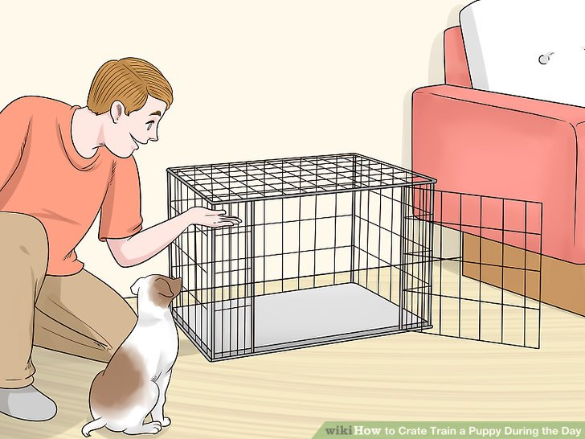

Encourage your puppy to go into his home on his own. If necessary, toss a little treat in the home. DO NOT
FORCE HIM! He may quickly back out or be shy, but that is normal. Just take it slowly. At first, do not close the
door on him; let him go in and out on his own. Once he is happy and unafraid of his new home, simply restrain
him at the door with your hand. Make him stay in the home for a few minutes, then gradually increase the time and be sure to praise him!
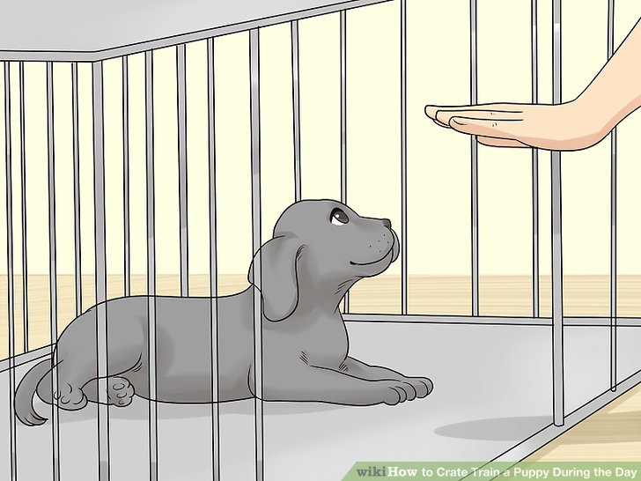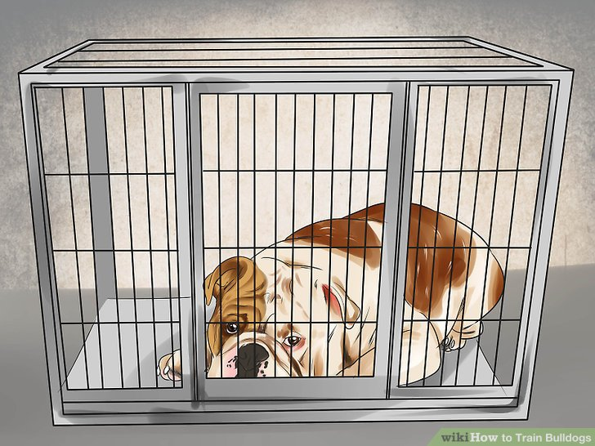

Once he is comfortable with this, (probably a few hours or days of short training sessions) simply restrain him at the door with the door—again praising him lavishly. Soon he will be secure in his home with the door closed. Slowly you can get further and further away from him, always praising his accepting behavior. Eventually, the pup will sit quietly and sleep in his home with the door closed.

Why to Crate Train Your Puppy?

Dogs in the wild live in a den, which provides protection and a great deal of psychological satisfaction. All dogs, therefore, have a strong natural tendency to seek out this type of shelter.

When you use a crate, you give your puppy a place to feel secure...something to get his back up against. He will not feel isolated because the pet home provides essential visibility & ventilation. Just like a baby in a playpen.

You will also be taking advantage of his natural instinct to keep his home clean; therefore, when he has to “go” he will try to hold it until you can take him outside to the proper area.

This will teach him a schedule and help him eliminate accidents.

With a crate, your puppy will have fewer behavioral problems like excessive barking and chewing.

Some of the DO's and DON'T’s of Crate Training

Do buy a crate large enough for your dog when he grows up. However, if the home is too big when your pup is
small, he may eliminate in one corner, and then go to another corner to sleep. This can sometimes be remedied by blocking of half of the crate.

Do get your pup used to his new home gradually. Do provide soft, washable bedding in the home so that it is comfortable and warm. Make the inside of the home as cozy as you can. Keep it clean and free of fleas.

Do supervise your pup anytime he is free in your home. Supervision is what allows you to direct behavior. Chewing, elimination, barking, and all other behaviors are all dependent on your direction. If allowed to be unsupervised, he will begin to direct his own behavior and schedule.

Do not put “housebreaking pads” or newspaper in your pet’s home. We are trying to take advantage of the pup’s natural instinct NOT to go in his home. Do not let your new pup roam through your house unsupervised.
Keep an eye on him so that when he sniffs and circles (an indication he is about to go) you can quickly and
gently guide him to the door and outside.

Do not force your new pup into the home for the first time. Plan on taking plenty of quality time with him the
first few days to get him accustomed to his new surroundings. Do not punish your pup by putting or forcing
him into his home. Your pup’s home should be his secure place; it should not be associated with punishment,
fear, or anything negative.
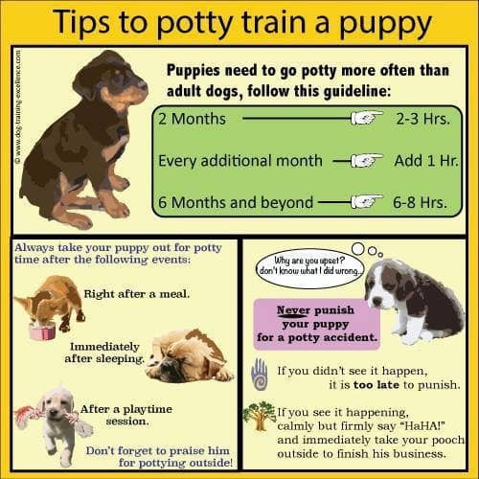
Grooming
Reasons for grooming –Remember ‘CHAIR’

Cleanliness– keeping your dog’s coat clean by removing dirt and dead hair helps encourage new hair growth, and reduces the amount of hair deposited on household furniture

Health–grooming helps to stimulate new coat growth, and prevents the formation of knots or matting which may lead to skin irritation

Appearance–most owners take a pride in their dogs looking smart, and regular grooming will certainly help your puppy to look its best

Inspection–regular grooming is also a great way to check for parasites, or any suspicious lumps and bumps

Relationship–grooming is part of dog’s socialization activities. Regular grooming helps create a bond between you and your puppy and accustoms your puppy to being handled.

Getting started

Start the grooming experience at an early age as part of your puppy’s socialization program and
routines. Keep the sessions short to start off with –just a couple of minutes, gradually increasing the time spent on the table. Always make the experience positive, rewarding with praise and suitable treats. Any struggling should be dealt with firmly but kindly, as your puppy may be frustrated, mischievous or even afraid.

Build up the experience and your puppy will come to accept the grooming routine. This will help with other activities such as veterinary visits. Finish the grooming if your puppy shows signs of getting bored or tired, so that each session ends on a positive note.

Care of ears, nails and eyes

• Regularly check your puppy’s ears to see if they are clean. You can remove excess dirt from the inside of the ear flap with damp cotton wool. Never probe inside the ear as you may perforate the ear drum.
• If nails are excessively long removing the tip of the claw, taking care not to cut the quick or blood vessel.
• If needed clean the eyes with clean, damp cotton wool using a separate piece for each eye.

External Parasites

A parasite is something that lives on another animal (the host) and gets its nourishment from the host. If left unchecked, the parasite causes disease. The most common external parasites found on dogs are fleas and ticks.
• Excessive scratching and self-biting can be symptoms of flea infestation. Even if no fleas are to be seen the presence of shiny black specks like coal dust (flea excreta) is a sure indication of the presence of fleas
• Ticks can be 3 to 4mm in length. They attach themselves to other animals in order to have a blood meal.

Other skin problems
• Ringworm is a fungal disease, affecting the skin, nails and hair. Circular lesions appear causing hair loss, which become scaly and crusty. Ringworm is contagious.
• Dermatitis causes irritation, hair loss and inflammation and is a result of sensitivity to the environment.
• Alopecia can range from a thinning of hair to total hair loss and can be caused by a number of factors such as skin parasites, hormonal imbalance, infections, stress or poor nutrition. Seek veterinary advice for any skin problems.
Worming

Worming your dog throughout its lifetime is important, and you should talk to your vet about a suitable worming program for your puppy at the earliest opportunity. Regular worming not only protects your dog’s health but helps to prevent the spread of infection and potentially hazardous health risks to other animals and humans too. Worm infections carried by your dog do not always display obvious symptoms, so a treatment schedule is vital.

Signs aren't always obvious- Dogs can appear healthy even when they have worm infections. Detecting an infection can be tricky, particularly as worm eggs are too small to be easily visible in your pet's feces. In addition, your dog may be more at risk from some worm infections than others depending on where you live.
It is therefore extremely important to keep your dog’s treatment regular and up to date.

General signs to look for include:
• The presence of visible worm segments that could stick to your dog's bottom and become itchy. This can cause dogs to “scoot”, whereby they drag their bottoms along the ground with their back legs.
• Weight loss
• Vomiting
• Diarrhea
• A dull, lifeless coat
• A change in appetite (it may be either increased or decreased depending on the worms present)
• A lack of energy
• A pot-bellied appearance (most commonly seen in puppies)
• Breathing difficulties and coughing
You should seek advice from your vet if you see any of the above signs in your dog. Your vet will be able to
investigate the problem and provide appropriate advice and treatment.

How Often Should You Worm?
All animals are at risk from acquiring worm infections. However, some animals will be at higher risk than others depending on factors such as their lifestyle and area in which you live. Children are at increased risk of disease from worms; if you have a young family or your dog often comes into contact with children, you should pay particular attention to regular worming.

There are also many other practical things you can do to help prevent the spread of worm infections among
your pets and family. These are as follows:
• 'Poop scooping' -make sure you pick up your dog's feces immediately on a walk and remove it from the lawn or surrounding outdoor environment daily-bag it, and put it in designated poop bins
• Ensure you and your children wash your hands after handling / stroking your dog
• Wash all food including fruit and vegetables before eating them
• Don't allow children to put dirt in their mouths
• Throw away any food dropped on the floor / ground rather than eating it
• Cover children's sandpits when not in use

Travelling Pets-There are specific parasitic worms to which your pet may be exposed to on visiting countries
outside the USA. Two notable worms are Heartworm, transmitted by a mosquito bite, which could be fatal in your dog if not prevented, and one type of Tapeworm, which can cause serious and fatal disease in people. If you are intending to travel with your dog, you should talk to your vet in plenty of time to establish the best worming regime to ensure the protection of both your dog's health and that of your family. For further information about what you need to do before, during, and after travel abroad with your dog, refer to the Pet Travel Scheme guidelines or contact your travel agent.
Vaccinations
There are a number of infectious diseases that dogs are susceptible to throughout their life. Some of these diseases are life threatening and young puppies are particularly vulnerable, so It is important that your puppy is vaccinated against them at a young age. Further vaccination is essential to ensure that your puppy continues to be healthy and happy throughout its entire life.

First vaccinations
First vaccinations can be given from approximately eight weeks of age, although this can vary depending on the normal practice of your vet. Four main infectious diseases are vaccinated against: Canine Distemper, Hepatitis, Parvovirus and Leptospirosis.

All of these diseases can be fatal so after its first course of vaccinations, your puppy will need booster vaccinations according to your vet’s advice.

Once a puppy is vaccinated, the vet will issue a vaccination certificate showing a record of exactly when the puppy was vaccinated, and which product was used. This should be kept safe as you may need to show them at boarding kennels, dog-training classes or if you take your dog abroad. It is also useful should you change your vet and he may recommend a slightly different regime, and it will be useful to see what vaccination your puppy has had in the past.

Until your puppy is fully vaccinated, you should not take it anywhere where it might come into contact with dogs or ground that may be infected. However, puppies are most receptive to new environments and situations at this age, so keeping them confined to your house and garden can be counterproductive. In order to continue your puppy’s socialization program during these important first weeks at home, you should take your puppy out to different places in your arms or the car to get it used to different situations and noises, as well as letting it meet new people.

Does vaccination have any side effects?
Anybody who has ever been vaccinated knows that it can occasionally make you feel quite feverish and poorly for a short while. Whilst this effect is not pleasant, it is a sign that the vaccine is stimulating the body’s disease defenses. The perfect vaccine would not cause those effects, but not all vaccines are perfect, although safety is paramount in the licensing of vaccines. Exceptionally there can very occasionally be more severe side effects, but they are so rare that the benefits obtained with vaccination far outweighs the risks. If you are concerned about any possible side effects, discuss this with your vet prior to the vaccine being administered to your puppy.

How frequently should vaccines be used?
Vaccination plays a very important role in the control of infectious diseases. While it is recognized that adverse reactions such as an allergic response or a lack of efficacy may occasionally occur, an analysis of the overall benefits and risks strongly supports the continued use of vaccination. Vets should make a thorough assessment of the benefits and risks on an individual case basis and discuss them with clients when deciding the timing of vaccination, and the use of particular vaccines. Recent trends in data mean that many products now indicate duration of immunity of 3-4 years for canine distemper, parvovirus and adenovirus after completing the primary vaccination schedule and the subsequent booster in minimum age puppies. However, some veterinary surgeons may also take into account the World Small Animal Veterinary Association (WSAVA) Guidelines by, for example, giving a full first annual booster before applying the extended duration of immunity claims, or by delaying the second vaccination until the animal is at least 12 weeks of age in some high risk areas or where levels of maternally derived antibodies are expected to be high.

What are the benefits of vaccinating dogs?
There is no doubt that the use of vaccination has been of huge benefit to our pets by bringing some very unpleasant diseases under control the use of ‘combination’ or ‘multivalent’ vaccines (where several different vaccines are given together) has transformed the control of many diseases of dogs and cats. Virus diseases such as canine distemper, adenoviruses (viral hepatitis) and canine parvovirus used to be scourges. The development of vaccines and their widespread use has brought the diseases in question under control. The way in which vaccines have been used in dogs is rather different to the way in which they have been used in farm animals. The difference is that whereas in farm animals the aim is to prevent the spread of disease and to protect the herd, in the dog and cat itis the individual animal that vaccine is being used to protect. However, the uptake of vaccination by responsible dog and cat owners who wish to prevent their pet from catching certain diseases has been so great that it has reduced the amount of such disease seen by vets. It has produced some ‘herd immunity’. Prevention is better than cure, especially with diseases such as distemper and parvovirus where if the animal survives it is often left with permanent damage of some kind.
Breeders Notes
If your breed has specific socialization requirements, details of these will be included below:

Exercise Requirements:
Age of Puppy | Duration of Exercise Required(per walk) | Number of Walks  (per day) | Total Amount of Exercise(per day)
3-4 months
4-6 months
6-9 months
9-12 months
1 year +

Your Puppy’s Current Diet:
Number of Meals  (per day) | Current Meal Times | Type of Food Given | Quantity  (per meal)

Future Feeding Recommendations:
Age of Puppy | Number of Meals(per day) | Type of Food | Quantity(per meal)

Deworming Schedule:
Date Wormed | Product Used | Amount Given
Date next treatment due:

Vaccination History:
Vaccination Given | Age of Puppy | Date Administered
1st
2nd
Next Vaccination Due:
Please seek the advice of your puppy’s veterinary surgeon for information on future vaccinations.
There are 5 categories of coat type:

Coat Type | How Often | Breed Examples | Suggested Equipment
Double coats– a dense coat with soft undercoat concealed by a long topcoat | Approximately 30-40 minutes once a week to prevent heavy shedding | • Lhasa Apso  • Old English Sheepdog  • Shih Tzu  • Tibetan Terrier  • Bearded Collie | • Slicker brush  • Pin brush  • Wide toothed comb
Silky Coats– as its title describes, a silky texture not necessarily with coat length | Approximately 20-40 minutes once a week  to prevent heavy shedding | • Afghan Hound  • Maltese  • Yorkshire Terrier | • Bristle brush  • Pin brush  • Wide toothed comb  • De-shedder tool  •Rubber palm brush
Smooth Coats– short and tight to the body. Very low maintenance. Grooming achieved by removing the dead coat to leave a glossy finish | Approximately 10 minutes once a week  to prevent heavy shedding | • Boxer  • Weimaraner  • Staffordshire Bull Terrier  • Dobermann  • Labrador Retriever  • English Bulldogs | • Massage mitt  • Bristle brush  • Cloth
Wire coat– these coats have a course, harsh topcoat with a soft undercoat | Approximately 30 minutes once a week to prevent heavy shedding  And matts and tangles forming | • West Highland White Terrier  • Wire Fox  • Border Terrier  • Scottish Terrier  • Schnauzer | • Slicker brush  • Terrier pad  • Wide/narrow toothed comb
Wool coat – dense, bouncy coat requiring great care. A coat of high maintenance which requires specific drying techniques and trimming styles | Approximately 40  minutes twice a week to prevent matts and tangles forming | • Poodles  • Bichon Frise | • Slicker brush  • Wide/narrow toothed comb

Your Puppies Grooming Requirements:
Coat Type  (e.g. wire, double) | Amount of Grooming Required | Suggested Grooming Equipment
Additional Information:

Recommended Reading

- The Perfect Puppy – Gwen Bailey
- How to Train a Super dog – Gwen Bailey
- The Complete Guide to English Bulldogs: How to Find, Train, Feed, and Love your new Bulldog Puppy- David Anderson
- Brain Games For Dogs – Claire Arrowsmith
- RSPCA Complete Dog Care Manual –Bruce Fogle
- Dog: The Definitive Guide for Dog Owners– Bruce Fogle

Useful Web Links
- Our Website– www.stifflerbulldogs.godaddysites.com
- Champdogs- http://www.champdogs.co.uk/breeder/35318
- The Kennel Club- https://www.akc.org
- English Bulldogs Forums– http://englishbulldognews.com
- Kennel Club Insurance- https://www.petinsurancereview.com/insurers/aks-pet-insurance
- English Bulldog Health Information– http://www.englishbulldoginformation.org/english-bulldog-health/

Contact Information

Name: Angela Stiffler
Address: 444 E County Road 200 S
Danville, IN 46122
Telephone: 317-941-3764
Email: angela.stiffler@yahoo.com
FB Page: Stiffler Bulldogs
FB Group: Stiffler Bulldogs Families (Private)

