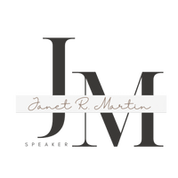
- Name of organization:
- Date and time of presentation:
- Is the presentation in person, virtual or hybrid?
- Composition of audience and number expected to attend.
- Length of presentation:
- Is there a theme:
- Organization mission statement:
- Objectives of this meeting:
- Current concerns/problems/challenges facing your group:
- Any sensitive areas to be avoided:
- Unique features of your organization
- What will be taking place immediately before/after our program:
- Who can be contacted in case of an emergency or problem immediately
prior to the event?
- What other key people will be in the audience:
- In case of emergency during program, how to handle:
15. What else should I know about your organization that would make this
program more meaningful.

Janet Martin
Janet Martin Speaks
Janet@janetmartinspeaks.com
(417)593-0747

