From City West:
We are excited to announce that high-speed fibre optic internet construction has started on Hornby Island!
You might see our build contractor, Summit Earth, in your neighbourhood. We want to clarify the details of our project and give an official update from CityWest.
The team at Summit has just recently broken ground on construction and has made tremendous progress in completing a large section of underground work in the first phase of our build on the island's west side. We expect crews to continue building with this momentum as they progress in phase 1 and simultaneously begin some preliminary work in the second phase of our build in the north section of the island.
Property owners may see fibre-optic drop connections being placed in the coming weeks on the west side of Hornby Island. To keep this project within budget and scope, CityWest will provide a drop of up to 80 metres for property owners who have signed up with CityWest. If your home or business is more than 80 metres from the road, one of our team members will contact you to discuss the cost of your drop before performing any work on your property.
While the initial progress for our Hornby build is excellent, we are still waiting for a launch date for services at this time. The community will be launched in a phased approach,with customers coming online as we build throughout the island. There are also still network commissioning and activation activities that must be completed with the Connected Coast landing, which is the backbone for providing services on Hornby.
Our team will provide updates as we progress with building our fibre-optic network. 2023 will be an exciting year, and we look forward to bringing Hornby Island a superior customer experience for many years to come. We are your partner in this exciting project.

Customer Journey

When we expand to a new community, many steps are involved to ensure that we provide our new customers with the best possible experience. The customer journey explains the steps that are involved i in launching CityWest services. Click the image or link below to learn more.
When we expand to a new community, many steps are involved to ensure that we provide our new customers with the best possible experience. This page explains the different steps involved in launch a new CityWest community.
F.M.I.: https://www.citywest.ca/customer-journey

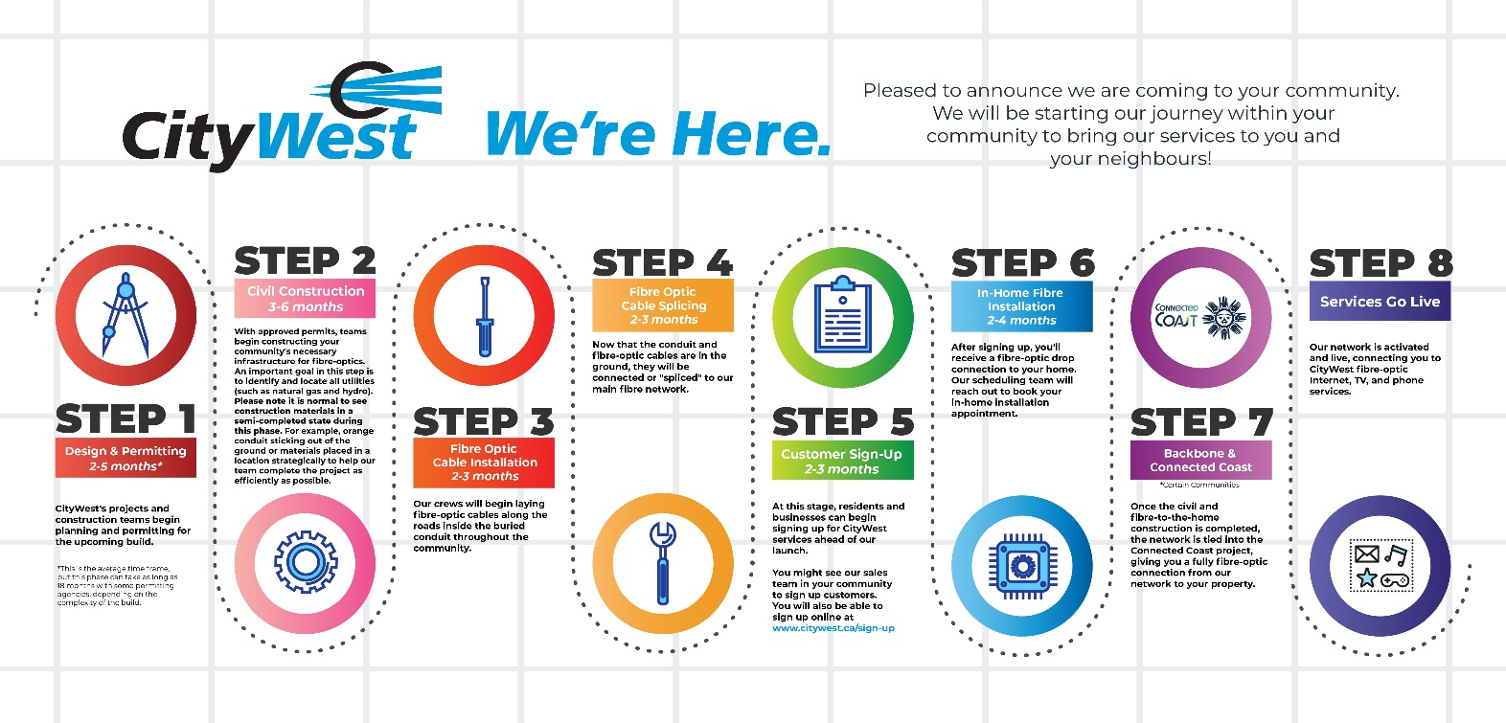

Hornby Island is currently on Step 2, which is civil construction.

Step 2 - Civil Construction

Estimated timeframe for Civil Construction: 3-6 months.

With approved permits, teams begin constructing your community's necessary infrastructure for fibre-optics. An important goal in this step is to identify and locate all utilities (such as natural gas and hydro). Please note that it is normal to temporarily see construction materials in a semi-completed state during this phase. For example, orange conduit may be visibly sticking out of the ground, or construction materials may be placed in a location strategically to help our team complete the project as efficiently as possible

