An Update on Fibre-Optic Connections on Denman and Hornby Islands

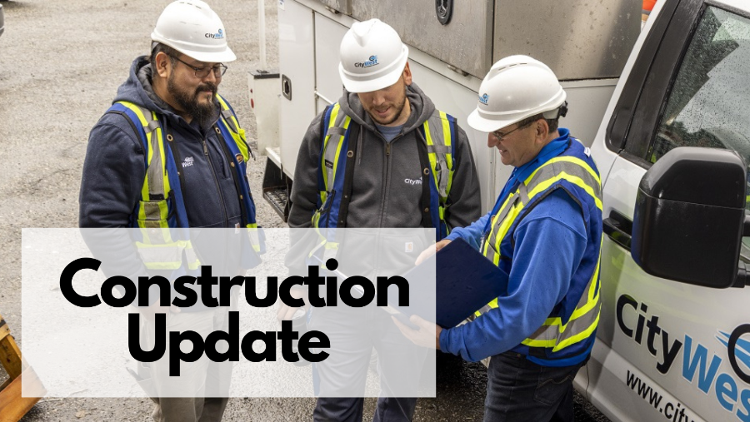
April 14, 2023 City West newsletter
Recently, CityWest announced a change to our construction and connectivity plans for Denman and Hornby Island. Our construction strategy must change slightly to keep these projects within reasonable cost and scope.
Crews will be bringing fibre-optic connectivity to the edge of every eligible property. For those people that sign up for our services, CityWest will still bring a free fibre-optic connection to every eligible home and business at no cost to the owner, up to 80 metres. CityWest was funded to provide a maximum of 30 metres of fibre-optic cabling to an eligible property. CityWest of our own investment, has increased our financial contribution to ensure better connectivity to residents and businesses, to increase the firbre-optic connection to 80 metres.
What does this mean to you? For those eligible residents and businesses at 80 metres or less, there is no cost to you. For any eligible property over 80 metres from the road, the property owner would be charged, at cost, $5 per additional metre. This pricing is our base cost, meaning we are not passing on any other fees or charges for the construction onto you.
If your property is over 80 metres from the road, one of our team members will speak with you before any work is done on your property. We will ensure that you agree to any additional charge to connect your property, find the best route for the fibre-optic cabling, and discuss the options available to pay for your connection (either as a one-time fee, or an agreement over an installment period of time, at zero interest).
We are looking forward to bringing Denman and Hornby Islands a superior service and customer experience for many years to come. We are your partner in these exciting projects.

