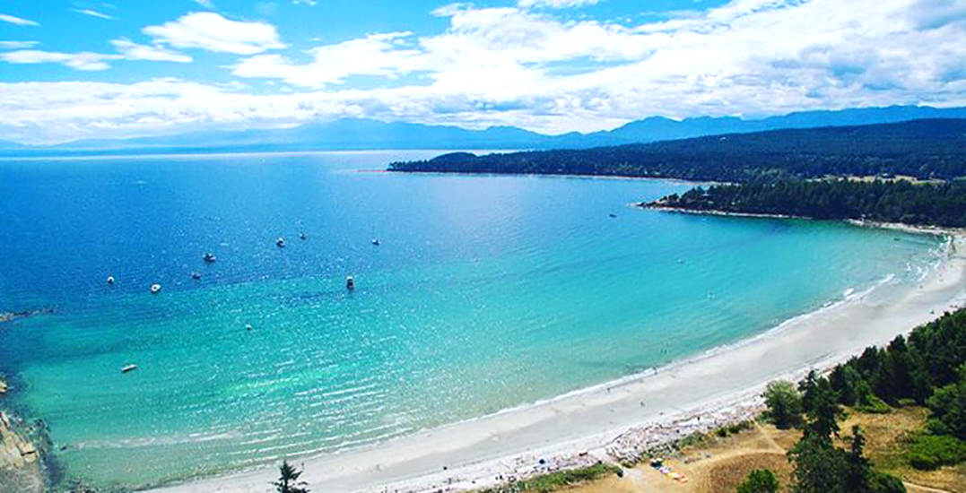
Part Two of the Two-Part
Digital Roadmap & Implementation Plan

Denman and Hornby
Broadband
Feasibility
Study

Prepared for:
Hornby Island Community Economic Enhancement Corporation
(HICEEC)
&
Denman Island Residents Association
(DIRA)
December 2019

Document Control Sheet

For Revisions and Proposed Changes Contract:
Dereck Wong
dwong@baylinknetworks.com
[+1] 778-388-2879
Issue | Date | Reason
0.1 | December 20, 2019 | 1st Internal Draft
0.2 | December 22, 2019 | 2nd Internal Draft
0.3 | January 09, 2020 | 3rd Internal Draft
1.0 | January 10, 2020 | Draft Report to DIRA & HICEECE
1.1 | January 13, 2020 | 4th Draft Review
1.2 | January 14, 2020 | 5th Draft Review
2.0 | January 17, 2020 | Revision Report to DIRA & HICEECE

Table of Acronyms

Acronym | Description
ACAD | AutoCAD
CDC | Community Development Company
CO | Central Office
CRTC | Canadian Radio-television and Telecommunications Commission
DHCP | Denman Hornby Connectivity Project
DIRA | Denman Island Residents Association
FDH | Fibre Distribution Hub
FTTP | Fibre to the Premise
GIS | Geographic Information System
GLB | Ground Level Box
GPON | Gigabit Passive Optical Network
HICEEC | Hornby Island Community Economic Enhancement Corporation
ISP | Internet Service Provider
MoTi | Ministry of Transportation and Infrastructure
MTTR | Mean time to Repair
NIU | Network Interface Unit
NOC | Network Operations Center
ODN | Optical Distribution Network
OLT | Optical Line Terminal
ONT | Optical Network Terminal
OSP | Outside Plant
OTDR | Optical Time-Domain Reflectometer
PON | Passive Optical Network
POP | Point of Presence
SLL | Shore Landing Location
USN | Undersea Network

Table of contents

Document Control Sheet i
Table of Acronyms ii
Executive Summary – Overarching Volumes 1 and 2 1
Objectives of the Feasibility Study 7
1.0 Introductions 8
2.0 Project Background 10
Overview of System 10
Scope of Work 10
Methodology 12
Site Visits 14
Cable Route Development Study 15
3.0 System Design 17
System Overview 17
Top Level Requirements 21
System Design 22
4.0 Maintenance 29
5.0 Project Permitting and Environmental Assessments 30
Land Based Network 30
Undersea Network Sections 31
6.0 Risk Assessment and Project Planning 32
Preliminary Risk Analysis Considerations 32
Installation 35
System Operation and Maintenance Failures 36
Timely Project Completion 36
7.0 Cost Analysis 42
Construction Budget 42
Operating Budget 42
Revenue and Profit Details 43
8.0 Ownership Options 44
Option 1 - Builder/Owner/Operator 44
Option 2 - Owner/Operator – Contracted out build cost 46
Option 3 – The Owner is the Denman/Hornby Community Development Company 48
Option 4 – Telus is the Owner/Operator – Contracted out build cost 48
9.0 Conclusions and Recommendations 51

Executive Summary – Overarching Volumes 1 and 2

This paper develops a strategic intervention to improve the digital connectivity of the under-served communities of Denman Island and Hornby Island.
This project to improve connectivity emerged because of the deep dis-satisfaction with inadequate broadband services on these neighbouring islands in the Salish Sea, part of the Comox Valley Regional District. The substandard internet service on these islands is based on obsolete ADSL technology that is uneconomic to upgrade. The community will have to either partner with an experienced service provider to replace the ADSL with modern telecommunications infrastructure or build this itself.
Over the last 18 months committees formed on each island, then joined forces to engage the entire community in an intensive consultation process. The committees set out to better understand local connectivity possibilities and better inform the community. They learned of the connectivity guidance and funding available from British Columbia’s Information Communication Technologies Directorate and the federal Broadband Fund, and determined to seek their assistance. British Columbia’s Connected Communities program dernes a “connected community” as:
“Applies a digital mindset to reimagine itself in today’s interconnected world. Digitally empowered connected communities purposefully integrate technology into all aspects of community development to improve livability, workability and sustainability, while leverage existing resources in new ways to achieve greater economic, social and environmental outcomes.”
The Ministry has depicted the route to connectivity in the following graph:
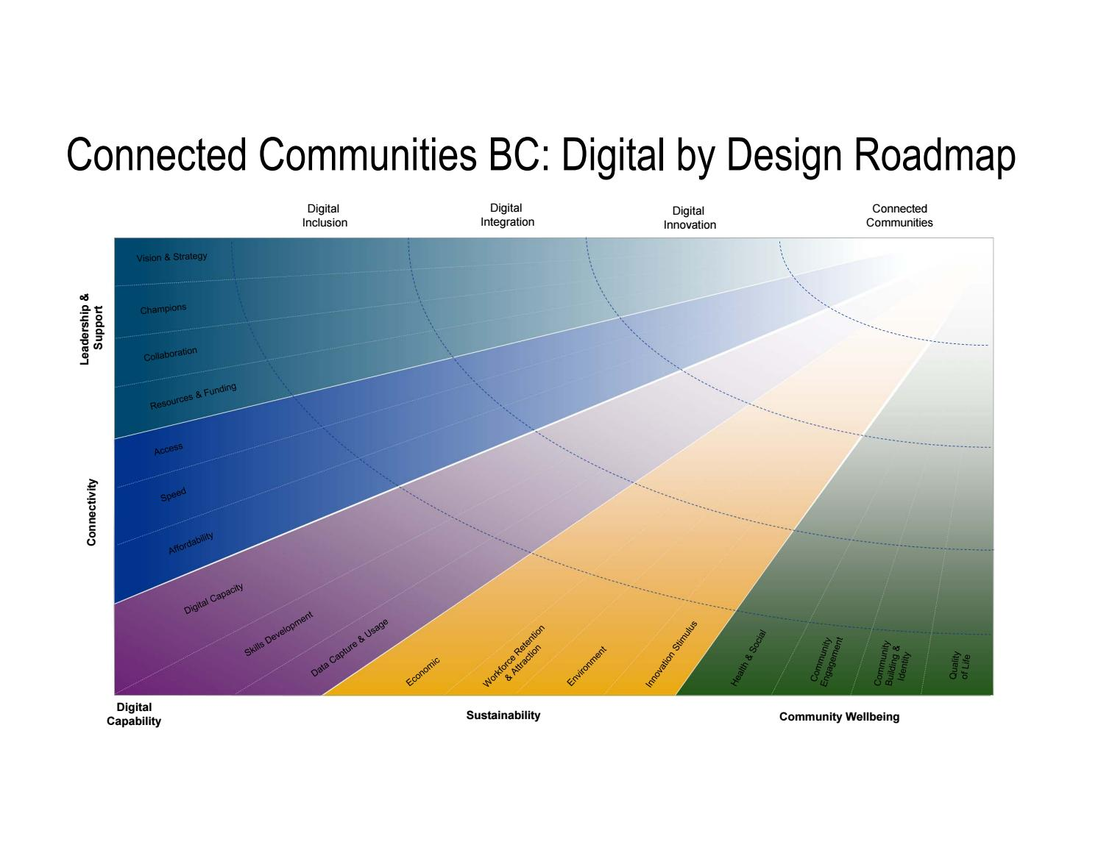
With guidance provided by the Ministry of Citizen’s Services in direct communications and in this definition and chart, the Denman and Hornby community has considered all aspects of the route to digital connectivity. This examination is presented in our attached, comprehensive, two-part report. Surveys were conducted with unusually high response rates, documenting the inadequacy of the internet in the community, disclosing problems this causes for individuals, groups and the economy, and demonstrating the many aspirations within the islands for a better future with advanced digital connectivity. Funding was obtained from ICET, NDIT, Denman Works and HICEEC which allowed the committees to hire experienced telecommunications expertise and develop a Digital Roadmap, Implementation and Business Plan.

The Current Situation
The rural, remote communities of Denman and Hornby need strong connectivity. Their populations (Denman – 1,165; Hornby 1,016) are growing faster than the BC average, raising the need for services. They have key groups with particular requirements for good quality, reliable broadband (seniors, school-age children, businesses). Seasonal residents are of central importance to the economy of these islands, this sector has critical needs for strong internet. Better connectivity is closely linked to objectives for improvement in public safety and services, for the expansion of individual firms, shops and studios, and for enabling skilled residents to build their vocations from home.
Through its two surveys, the committees learned of the depth of the internet problems on the two islands, and the dimensions of the market for improved service. Both surveys attained response rates exceeding 30 percent. They found no islanders receiving broadband at the level of service established by the federal government as a standard (that all Canadians should have broadband providing a minimum download speed of 50 Mbps and an upload speed of 10 Mbps). Speed testing from the surveys revealed that on each island, over 95 percent of respondents recorded download speeds below 25 percent, and nearly one-half were below 6 percent.
- On Hornby, with 560 occupied households:
  - 127 of 229 survey respondents use the internet for business, and 79 percent say it is inadequate to conduct their business effectively;
  - 54 percent of respondents include seniors, who are major internet users for social, health, business and entertainment purposes;
  - 22 percent include school-age children, and none are satisfied that their internet supports children’s education as a study and research tool. Ninety-five percent report speeds below 15 Mbps.
  - 25 percent are primarily seasonal residents, and one-half said poor internet stops them from becoming full-time residents or spending more time on the island.

- On Denman, with 592 occupied households:
  - 135 of 198 survey respondents involved seniors, and 40 percent of them say the internet is inadequate;
  - 16 percent of respondents include school-age children, and 82 percent are not satisfied with their internet service;
  - 10 percent are primarily seasonal, and 79 percent of them are dis-satisfied with the internet;
  - All business respondents are dis-satisfied with their internet;
The committees informed the community of these findings and began discussions of potentials for improvement. Articles and letters were published in the locally-popular weekly newspapers and three widely-used local Facebook groups. Individual mini-interviews were conducted with all institutions and most businesses in the community to learn of their needs and aspirations concerning connectivity. Other consultation measures included radio interviews and presentations at well-attended public events. The main events were two public Open Houses (each drawing over 70 attendees) and four other public meetings (each drawing over 30).
Three other key findings emerged from this extensive consultation:
- The community is proud of its attentiveness to the environment. It sees improved connectivity as means of replacing travel, which would reduce its carbon footprint as well as lowering its expenditure on travel;
- The community has a vision of universal Fibre to the Premise (FTTP) on both islands advancing the social and economic lives, health, safety and enjoyment of all residents;
- The community is deeply concerned about electro-magnetic frequencies emitted by wireless devices, and is prepared to expend more to obtain FTTP service. The interest in obtaining improved cellular service was discussed, but is not as strong a concern as the interest in FTTP.
The surveys and consultation process have developed the communities’ objectives and identified the market for better broadband. All of these factual components and process findings contribute to a strategic plan to improve Denman/Hornby connectivity.

Design of an Improved System
The technical assessment of the situation is contained in the Feasibility Study, including a design to build an appropriate fibre-optic network and a study of the financial feasibility of approaches to the realization of this construction design. This research was undertaken by Baylink Networks which designed, costed and assessed likely business plans for a broadband network that would efficiently meet the communities’ current and future needs.
Baylink developed a network plan for universal coverage linking the islands’ 1600 homes and businesses. The plan development included a detailed study using large-scale Google Earth digital mapping plus ground truthing, considerable reference to other projects, specialist suppliers and contractors, many regulators, and the development of multiple spreadsheets that created and tested several construction/business alternatives.
The network design contains two main components, Backbone or Backhaul, and Last Mile or Fibre to the Home.
- Two methods of securing backbone are presented: purchasing from Telus at the Denman Island CO; or purchasing from Shaw at Buckley Bay and then bringing it by submarine cable to this CO. Telus’ very high quote for selling the capacity made the more complicated Vancouver Island purchase more economic.
- From this CO high-count fibre optic cable would go southeast across Denman Island to make another submarine crossing near Gravelly Bay to Hornby Island. On Hornby the cabling would extend to a second CO near the Co-op store. These COs or POPs, would have minimum capacity of 10 Gbps, capable of expansion to serve all needs for several generations.
- Two methods of building the Last Mile were considered, aerial (involving 2079 poles and 137 kms of backbone routing) and underground (requiring three crews each installing about 200 metres per day). Many implications of both methods were assessed, including timings, regulatory processes and ongoing maintenance.
- Two technical systems for the FTTP connectivity were examined, Passive Optical Network and Active Ethernet System. Either would accommodate multiple applications simultaneously (internet, telephone, television, other).
- Permitting, construction, maintenance and servicing requirements (involving time, staff, equipment and modalities) were all examined in detail and incorporated in spreadsheets and Gantt charts as part of the analysis of feasibility and viability.
Underground deployment and a PON network were recommended because of community characteristics (although an ethernet hybrid might be considered in a few sectors).
- Total construction costs are estimated at $10.289 M.
- Once constructed, monthly operating costs (gateway, staff and overhead, maintenance and equipment, insurance, others) would sum to $58,116.40
- This valuable broadband network design would be profitable to operate. Estimated monthly revenue would range from a conservative $77,000 (1,100 subscribers averaging $70 fees) to an aggressive $154,000 (1,400 subscribers averaging $110 fees).

Alternative Plans
Assessments were made of financial implications for four alternative modes of organizing the implementation/ownership of the proposed underground fibre broadband network. The implementation/ownership models all involve Denman/Hornby participating with the “owner” in securing government funding of 75% of project costs, and this would require active island involvement in the project construction/start-up for approximately three years. The models are:
- Owner builds and operates, in some kind of relationship to Denman/Hornby group;
- Owner operates, but hires out the construction. Has some kind of relationship to Denman/Hornby group;
- Owner is a community development corporation, successor to Denman/Hornby group. Owner is in a joint venture with a builder/owner/operator (as in 1. above), receiving 10% of profits above a threshold and 10% of any sale proceeds, and with a specific arrangement that it could influence rates and service levels,
- Owner and operator would be Telus, and the network would be to its design, primarily aerial on existing poles, with a Telus-defined project cost of $11,565,000. Denman/Hornby (with CVRD assistance) would make a significant contribution to the actual build costs (perhaps $300 -500,000), and would partner with Telus in applying for government funding.
It was observed that in all models except 4.(Telus), Denman/Hornby would have an ongoing critical role requiring managerial/financial skill and perhaps involving liability.

Conclusion
Denman and Hornby Islands need better internet and want to develop their community with better connectivity. The islands’ committees have conducted an intensive, thorough consultation process that developed these findings in depth and helped inform the community. All of these factors are described in detail in Part One of this comprehensive report, inspired by British Columbia’s “digital roadmap” model.
Part Two of this report is an examination of the feasibility of building a broadband network on Denman and Hornby that would meet the community’s needs, and provide the capacity to serve all aspirations for their future. The examination was conducted by Baylink Networks, an experienced telecommunications engineering firm, under a contract made possible by grants obtained from ICET, NDIT, Denman Works and HICEEC.
A quality, low-maintenance, underground fibre optic network that would meet and exceed the bandwidth needs of the community for the foreseeable future, can be built on the Islands. It would serve every home/business on the islands with fibre optics (no wireless infrastructure), and can supply internet, phone, TV and any other telecommunications services. It could be built for a total construction/installation budget of $10,289,668.

It would be possible to construct an aerial network less expensively, but because of known risks associated with implementation and costs, aerial infrastructure is only viable, financially, for Telus.
The construction and start-up of a high-capacity fibre-optic network service is greatly needed on Denman and Hornby Islands, and this will require a complicated, lengthy, and expensive project.

The feasibility report is structured as follows:
Executive Summary – provides an outline to the content of the report;
Section 1.0: Introduction – outlines what the project entails;
Section 2.0: Project Background –provides an overview of both Denman and Hornby current broadband availability;
Section 3.0: System Design – outlines a high-level network design and other options;
Section 4.0: Operations and Maintenance – provides the required operation and maintenance of an access network;
Section 5.0: Project Permitting and Environmental Assessments – provides example of the permitting process and contracts required;
Section 6.0: Risk Assessment and Project Planning – outlines the potential project risk of building a fibre to the premise network;
Section 7.0: Cost Analysis – provides a cost estimate for the proposed network;
Section 8.0: Ownership Options – describes different options of owning and operating the system;
Section 9.0: Conclusions and Recommendations – outlines closing comments and recommendations for this network.

Objectives of the Feasibility Study

In February of 2019, Hornby Island Community Economic Enhancement Corporation (HICEEC) and Denman Island Residents Association (DIRA) entered discussions with Baylink Networks (BN) regarding development of a Digital Road Map and Execution Plan for the islands. In September of 2019, BN was contracted to complete this study investigating how to bring a Fibre-to-the-Premise (FTTP) network to both Denman and Hornby Islands. Various options are available for a region of this size and density. The early sections of the study review why a fibre system is important and the existing market conditions, while subsequent sections address network designs, organizational structures, cost estimates and financial analyses. The end objective is to recommend a project design and estimated costs to construct and operate a quality FTTP system. A key objective is to deliver a Digital Roadmap and Implementation/Business Plan which meets the criteria defined by senior governments to whom applications for project funding will be filed. This study is intended to be used for grant application, survey and construction planning, budget and economic modelling and hazard identification and risk management for the eventual construction of such a cable system to serve the telecommunication needs of the islands for the foreseeable future.

1.0 Introductions

Connectivity is the ability to affordably access quality internet services that citizens need to fully participate in the growing digital economy. Responding to a global transition to knowledge-based economies, governments at all levels have identified access to information communication technologies as a cornerstone to support future sustainable economic development and serve as a cornerstone to maintain a high standard of living and quality of life. The definition of broadband has evolved rapidly over the past five years as governments and regulatory bodies have closely examined the service characteristics of internet services that allow consumers and businesses to take advantage of these services.
Residents and businesses continue to have increased dependency on reliable high-speed connectivity. In December 15, 2016, the Canadian Radio and Telecommunications Commission (CRTC) established that broadband internet was a basic service and set target service objectives of (50 Mb/s download and 10 Mb/s upload) to be available in 90% of Canadian premises by 2021. Reliance on internet-based services for both residential and commercial customers continues to grow as internet-based communications, entertainment, computing applications and services expand. As shown below on CRTC’s mapping, Denman and Hornby Islands are both eligible for the federal and provincial funding programs.

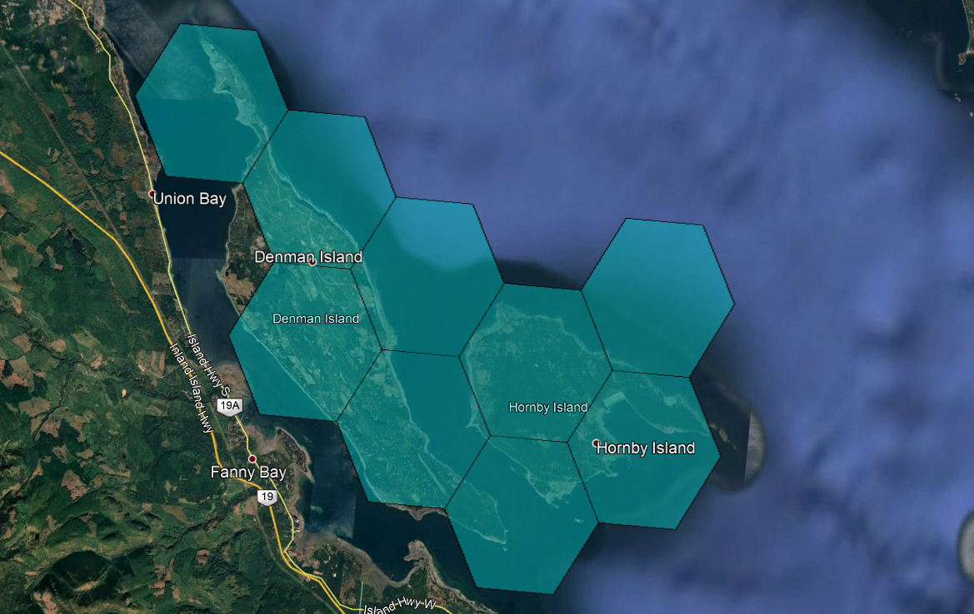
N
Legend
Non 50/10 Hexagon
CRTC Eligible Locations

Some benefits of access to high-speed internet include:
Building the economy
Responding to climate change
Delivering health services
Providing education
Ensure public safety
While public policy objectives now include making broadband available to most Canadians, the reality for residents in many rural and remote areas is that such quality services are still not available or adequate, and solutions to remedy that situation are not readily apparent. Hornby and Denman Islands will need to work towards ensuring that broadband services on both islands keep pace to continue to attract residents, visitors, and businesses which will allow for sustainable growth and diversification.
Hornby and Denman Islands are studying the feasibility of a complete last-mile fibre optic system connecting the islands back to long haul fibre back on the mainland. Over 1600 homes and business will be served by this system. The planned system will link the regions with connectivity to existing terrestrial or planned subsea broadband fibre optic infrastructure.

2.0 Project Background

Overview of System
Baylink Networks was selected by the Denman Hornby Connectivity Project (DHCP) to provide community consultations, network design, site visit and feasibility study to provide evidence of support for the proposed backhaul and last-mile fibre build.
The study supports a proposed backhaul and last-mile fibre build for DHCP. DHCP is a planned fibre cable system with six fibre distribution hub in the 2 communities on both island regions. The DHCP fibre cable system has an initial Ready For Service (RFS) of late 2021 which is approximately 22 months after funding approvals. This study has a budgetary level pricing estimate for a turnkey telecommunication cable construction company. A significant part of the study was concentrated on the technical design and feasibility of the terrestrial installation of the fibre cable and two associated submarine backhaul systems, with landings in each of the specified regions to connect to pre-existing network endpoints at Buckley Bay on Vancouver Island.
The planned, 308km DHCP system will link approximately 1,600 homes on both islands with connectivity to either existing or planned submarine broadband fibre optic infrastructure on Vancouver Island. The basic system is a main trunk fibre cable coming from Vancouver Island then reaching Denman Island central office where it spurs to each community.

Scope of Work
The study incorporates all activities necessary to evaluate the potential network and provides Denman and Hornby island with the information required to move ahead with the project; effectively delineating both technical and commercial risk; and options to successfully operate the system to meet or exceed capacity and/or revenue targets.

The study provides a report with possible business plan options to be considered.
Main inclusions are listed below:
Community Engagement
Route Deployment Analysis
Choice of Technologies
3rd Party Options
High Level Engineering and Design Plans
Market Analysis
Estimate Construction Costs
Ideal Operational Models and Cost
Risk Management
The final deliverables are:
- To prepare a digital roadmap for the two islands that addresses federal and provincial requirements for broadband funding;
- To examine the broadband situation and the detailed physical environment on the two islands and produce a technical implementation plan and appropriate business plan to bring quality connectivity to the islands, to at least the federal 50/10 standard, and including consideration of at least three ownership structural options;
- To conduct a thorough community consultation that informs the communities on both islands about their broadband situations, explores needs and aspirations for improvement, discusses options for improvement, develops a consensus and identifies support and opposition;
- To provide a thorough, integrated final report for the project.

Methodology
The study incorporates all activities necessary to design and evaluate the fibre build on both Denman and Hornby Islands.
The timeline and key activities for each stage were identified and are shown below:
September | Project Start-Up  DIIC and HICEEC to develop consultation plan, develop survey(s), develop consultation paper, develop communications plan for the consultation process  BN to undertake an in-depth desktop analysis/production to a first draft stage of digital roadmap (including DIIC and HICEEC as needed)
October | Main Project Development  DIIC and HICEEC to complete survey, consultation planning and communications activities including widespread distribution of consultation paper, preparation for coordinated public open house consultations on both islands. Open houses to include: displays (by BN, Telus, others); speakers (DIIC/HICEEC, BN, Telus, Networks BC, Island Health, others); survey/poll material directed to developing consensus and identifying opposition. BN to provide technical support  BN to continue roadmap and implementation/business plan production covering at least three structural options identified by DIIC/HICEEC, with site examinations, preparation for participation in consultation
November | Public Consultation  DIIC/HICEEC and BN to hold public, open house consultations on each island, conduct post-consultation reviews, move to either: consolidation of all material into draft final report; OR review problems uncovered in public consultation, revise and perform additional work including additional consultation if necessary, then draft final report
December | Project Finalization  DIIC/HICEEC and BN to complete draft final report which integrates the consultation, digital roadmap and implementation plan, circulate the draft(s) for review, and finalize. The final report will be under BN covers  Close-out of project, final accounting

Based on this plan, a five-phase approach was adopted:
- Phase 1: Data Gathering
- Phase 2: Data Assimilation and Consolidation
- Phase 3: High Level System/Service Requirements Design
- Phase 4: Complete Last-Mile Fibre System Design
- Phase 5: Report Delivery and Recommendations

The current existing state of broadband on both islands was reviewed and analyzed and the need for an upgrade to the existing system confirmed. This was further confirmed through the community consultation process. All existing and potential sites, routes, point of presences (POPs) and vaults on both islands were reviewed in accordance with industry standards. The objective of the site visits was to determine the suitability and collect data necessary for conceptual design and reporting. Based on the collected data, the final fibre design was prepared. It is a thorough and accurate fibre rollout plan. This represents a significant portion of a ready for construction telecommunications project. An initial route plan and review produced a series of alternative initial route plans.
A high-level review of the regulatory and permitting requirements for the system summarizes the requirements for the project and estimated timeframes to complete those requirements for the proposed system.
The project system costs have been estimated to a ± 20% range of accuracy utilizing an experienced-based cost estimating system. The costs of permitting, outsourced engineering and project management services, and system supply, installation/construction costs for fibre systems. The collected data was analyzed to identify project risks, enabling evaluation and risk elimination related to the system. The data collected and analyzed is based on experience and a variety of public, commercial and scientific sources to best analyze and project market conditions and cost.

Site Visits
Site surveys were conducted on Hornby and Denman Islands in the fall of 2019. Site visit reporting was completed, and the data collected was compiled and presented. The site visit report assessed the suitability of the landing sites and confirmed the ability to construct terrestrial infrastructure that reaches the landing sites and all homes and business. Any concerns with the nature of the landings, terrain, environment, local issues, etc., were noted. The Site Visit Report serves as a reference for the Route Development Study and permitting activity.

Cable Route Development Study
The following map and table below outline a list/data of all possible fibre distribution hubs (FDH) that will potentially be part of the network. The Shore Landing Locations (SLLs) that connect both islands and the main feeder line on Vancouver Island and their approximate coordinates of locations are provided. A detailed Cable Route Development Study was produced to provide a cable route and installation methodology of sufficient accuracy to produce a cost estimate for the system within the ± 20%. The study involved a thorough review of all available public domain data and the survey data, drawings, maps, plans photographs, and reports that were made available to produce a Cable Route Development Study report. The Cable Route Development Study optimized the cable type, route, and installation methodology by ensuring the physical security of the system from natural and man-made hazards through route selection, slack allocation, cable type (including armor) choice, and the use of industry-standard cable burial and protection practices.
 | Item | Longitude | Latitude
Denman | FDH 1 | -124.7617047 | 49.49804883
 | FDH 2 | -124.7400942 | 49.49710515
 | FDH 3 | -124.7318375 | 49.50316526
 | FDH 4 | -124.8173665 | 49.53592643
 | FDH 5 | -124.7661418 | 49.54176189
 | FDH 6 | -124.8310926 | 49.55818643
 | C/O | -124.8173626 | 49.53588354
Hornby | FDH 1 | -124.7041319 | 49.51670604
 | FDH 2 | -124.6877014 | 49.53954379
 | FDH 3 | -124.6698289 | 49.54850676
 | FDH 4 | -124.648329 | 49.52572584
 | FDH 5 | -124.6168112 | 49.52905605
 | FDH 6 | -124.641287 | 49.50600062
 | C/O | -124.6483282 | 49.52569673
Undersea | usn-glb 1 | -124.7030735 | 49.51131005
 | usn-glb 2 | -124.7081138 | 49.49342982
 | usn-glb 3 | -124.8495562 | 49.52457414
 | usn-glb 4 | -124.8204126 | 49.53453897

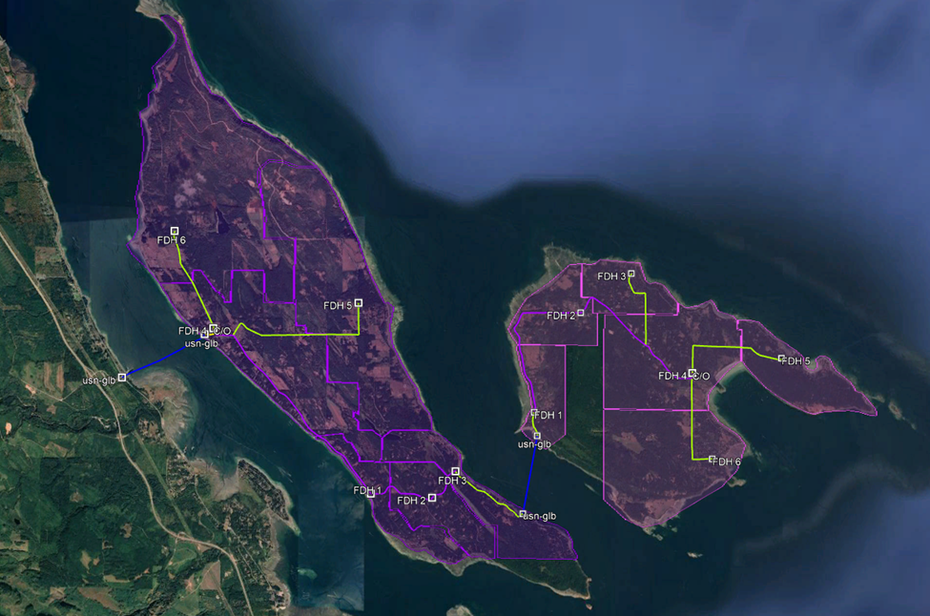
Legend
Undersea Backhaul
Terrestrial Backhaul
Fibre Distribution Hubs
N
Hornby and Denman Fibre Distribution Network

3.0 System Design

System Overview
The planned, 308km system will link 1,600 homes on both Denman and Hornby Island with connectivity to existing or planned submarine broadband fibre optic infrastructure on Vancouver Island. The basic system is a main trunk fibre cable coming from Vancouver Island then reaching Denman Island central office where it spurs to each community. There will be 12 fibre pairs (24 fibres) in the trunk cable. The trunk cable will continue off Denman Island Central Office and travel towards (Gravelly Bay ferry terminal) south-east of the island, where it becomes a submarine cable joining the two islands. Once on Hornby Island, the trunk cable will make its way towards the Hornby Island Central Office as shown on the previous map. One pair will be used for traffic to each central office, the remaining pairs are spares for future backhaul and expansion. Throughout the system design, additional vaults and points of presence (POP) are included for future expansion/homes. The fibre design system is based upon current fibre systems carrying multiple optical wavelengths (λs), (e.g. 100 λs x 10Gbps). Each community fibre distribution hub (FDH) would be provided with sets of wavelengths. Most of the FDH’s have relatively small populations, (ie, several hundred people). At this time, no community is forecasted to need more than 2Gbps of traffic for the foreseeable future.
This section also examines the engineering considerations and the implementation requirements that must be considered with respect to the general feasibility of constructing this fibre optic network on the islands.
The construction phase of any fibre optic network is often the single most costly capital expense for the entire project. Thus, it is essential to have accurate planning and engineering in order to minimize risk while ensuring that the end product will support current and future requirements.
Aerial
Aerial construction consists of installing the supporting strand, lashing fibre optic cable to the strand, splicing the fibre optic cable, distribution center placement and activation testing of the outside plant installation. Before any construction can be done on the existing pole infrastructure, make-ready work must be completed. The make-ready work consists of preforming aerial attachment (other fibre, telephone, and cable) relocation, sometimes pole extension or replacement. It must be done to ensure minimum clearance codes are met. Aerial make-ready costs are typically about $12,500 per kilometer excluding the incremental aerial construction material cost (fibre cable, splice enclosures, fibre taps for individual subscriber drop connects, strand, and pole attachment hardware). The make-ready costs only include the cost to make the poles ready for construction, this excludes any material and labour costs to put up new fibre cable.
Below is a map of the potential aerial design based on existing pole infrastructure on both Hornby and Denman Islands.

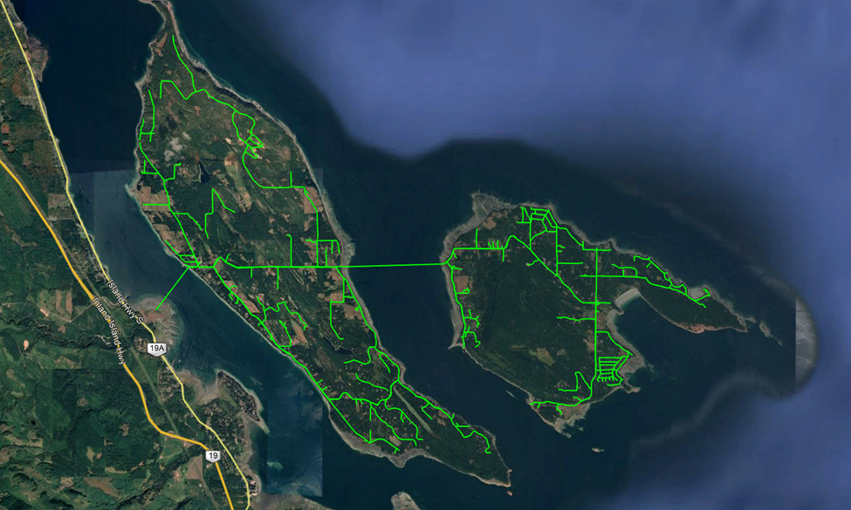
Legend
Aerial Design
N
Hornby and Denman Aerial Design

Underground
Underground construction can be accomplished in many ways. The following are the predominant methods of construction for underground outside plant installation.
- Plowing: If a cable route is unpaved, an ideal method of construction is the use of a vibratory plow to insert the cable into the ground. A cable plow has a vibrating blade that feeds cable or conduit down its chute into the ground. An advantage of using a plow is not having to backfill any trench or holes as material is not removed from the ground. In a single step, the plow generally opens a narrow trench, places the conduit or cable and closes the trench. Plowing is the most productive method of the three methods. It is ideal for direct burial of cable or small amount of flexible conduit but is not suitable for large numbers of conduits in one pass.

- Trenching: When paved areas are encountered and cannot be plowed, trenching may be required. Trenching is a technique where a blade is used to cut or dig out a section of the ground and then backfilled after the conduit or cable is placed. It will first be cut and trenched, then cable placed, back filled, then patched. This method is suitable for installing large amounts of cable or conduit in a fibre route section. However, the drawback of this method is the need to backfill and repair road conditions. Trenching can also leave permanent cosmetic and/or structural damage to right of ways or roadways.
- Directional Boring: Sometimes, pavement cuts are not allowed in certain sections and it may necessary to bore under the asphalt. There are different techniques for boring including the use of auger, water pressure, and pneumatic devices. Each method requires a pit to be dug on each side of the section to be drilled. The boring device is placed on one side of the pit and bores its way to the other open pit creating a pathway underground. Upon reaching the other pit, the cable or conduit is attached and pulled back through the same hole on retraction.

Underground construction costs can vary significantly depending up the construction methodology used and ground surface conditions. While the direct material costs for the underground construction are very similar with that of aerial construction, the labour and equipment costs are generally greater. The costs for underground construction can range from $15,000 to $150,000 per kilometer with the higher end being in dense urban areas. However, due to the lower density of both islands compared to that of an urban environment, the cost will be lower due to not having to deal with many concrete sidewalks or asphalted streets. Another advantage on the islands is the lack of constant traffic reducing the need for heavy traffic control. The estimated average for both islands is approximately $20,000 per kilometer mostly done with plowing and including some sectional trenching. This cost estimate only includes labour and equipment.

Below is a map of the planned underground network for Denman and Hornby Islands.

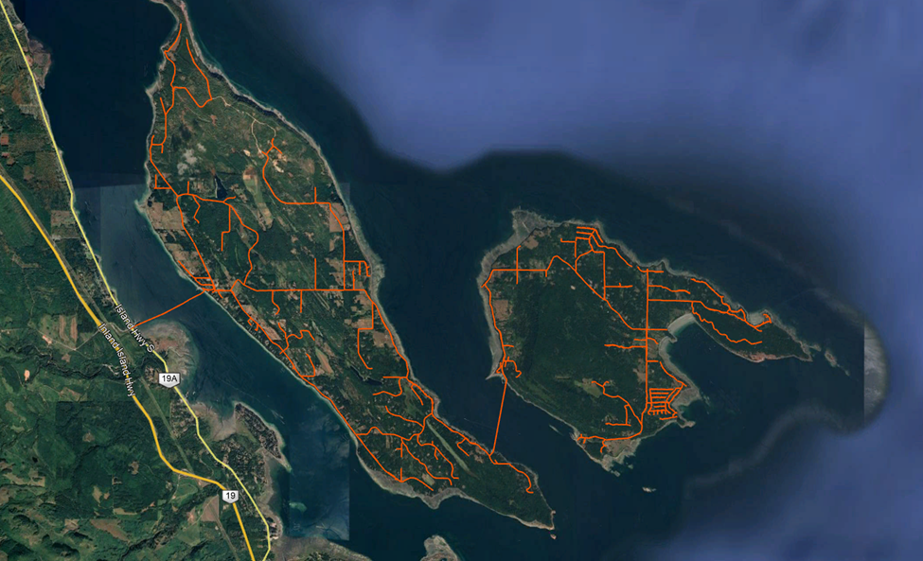
Legend
Underground Design
N
Hornby and Denman Underground Design

Hybrid
As mentioned above, the system does not require to be one or the other. Both an aerial and underground mixture can be used (hybrid). There are many factors that can contribute to the decision of what infrastructure is to be used in different scenarios. The factors can be cost, ground conditions, length of segment, last mile or transport, environmental impact etc. During the construction phase of this project, the builder will decide on a case by case depending on the mentioned factors.

Top Level Requirements
The fundamental aspect which network architecture follows must satisfy capacity, speed, reliability and availability. The Future State Network must be capable of offering a suite of products and services that address the needs of its customers and users within the network. In addition to services, users require scalable solution as their business needs grow. Users require services that are intelligent and can differentiate between best effort traffic, Voice over IP, Video, and critical business applications that are both reliable and dependable. The network must have the necessary redundancy and resiliency to ensure high availability, meaning that the system is available in every instance and instantly when the users need it.

- Bandwidth Capacity
In order to meet most funding programs, there are set speeds and bandwidth capacity that must be met. CRTC’s Broadband Fund for example require all access project (last-mile) have a minimum of 25/5 Mbps to be funded but the targeted universal service objective-level is 50/10 Mbps. Transport projects for new builds must offer a minimum capacity of 1 Gbps, and projects that would upgrade transport infrastructure must offer a minimum capacity of 10 Gbps, to support the speed and capacity levels set out in the universal service objective.
- Reliability and Availability
The system will need to provide industry standard levels of availability services uptime of 99.99% with a mean time to repair of 24 hours. (The network must be operation for a minimum five-year period following the project completion date. The system will require to have an overall design life of 30 years.)
- Cable Routing and Protection
The network routing needs to take into consideration the weather and terrain on the islands. The Comox Valley can regularly get up to 90km/h wind speeds during storms. Certain sections of both islands are steep and narrow for utility right of way. Redundancy of the network where it is possible should be applied to maintain availability. This system will be designed such that faults affecting one section of the network will not impair the operation of the rest of the system.
- Maintenance and Support
The proposed network must have acceptable level of service during network failures in the course of normal operations and unforeseen circumstances. These circumstances may include physical network failures, such as fibre cuts or equipment malfunctions, and natural disasters. The overall system design must consider the lack of technical expertise readily available on both Denman and Hornby Islands. Therefore, the system shall be designed with sufficient redundancy to minimize maintenance and maximize availability.

- Network Expansion Capability
The network must demonstrate the ability to meet or exceed the universal service objective of 50/10 Mbps. The network must have the ability to serve more customers and/or provide more extensive coverage following the project completion.

System Design
The foundation of the network design is built upon,10 Gbps fibre optic transport network inter-connecting all of the different community areas on both islands. This transport network is to be connected to the last mile aggregation points in each fibre distribution areas. Each access aggregation point is then connected to 1 Gbps access nodes in various spots around both islands to 100% feed every home in the region.
This design is not a static system and may require refinement through more detailed consultations with different service suppliers. The system designed is a modular chassis-based passive solution for the optical transport network, such that these electronics may be easily interchanged within the design.
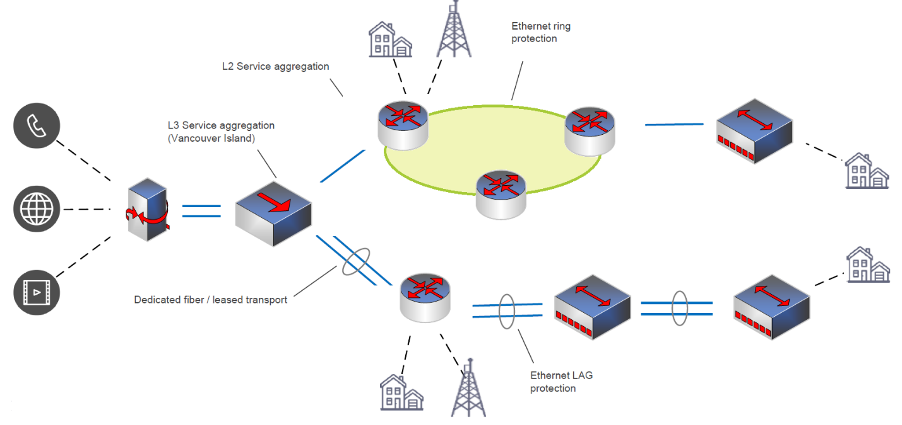
The fibre network design is based on providing connectivity to the facilities and generally follows the road shoulder of the road right of ways to be deployed in a manner that would maximize the ability to extend to residential and commercial customers. The fibre network is comprised of the backbone system, providing the main transport systems, and the distribution system, providing the connection to the individual properties.
The fibre network will be deployed with conduit, direct buried, shadow conduits or a hybrid method sizing and fibre counts that allow for growth of services and connections as required. The fibre route is proposed with adequate breakout points and room to accommodate the deployment of additional fibre branches as future needs increase. The fibre network would have adequate fibres to accommodate an aggregated fibre to the premise network, dedicated point to point connections and support carrier/service provider connections as required. The system will have capacity to enable island residents to take advantage of connectivity to support their internal services, both existing and planned.
The proposed infrastructure provides the HICEEC and DIRA committees with high level design and cost estimates. The fibre backbone was designed to accommodate connectivity to six fibre distribution hub (FDH) service areas on each island. The network will connect all the facilities on both islands and extend into the various commercial and residential areas. This would consist of a high-count fibre optic cable. Breakout locations would be provided that would interconnect to local distribution vaults and access fibres to the various premises.
The network will consist of the backbone and last mile.
The backbone consists of very large capacity trunks that connect to multiple fibre-optic lines capable of transmitting large amounts of data. It provides a path for the exchange of information that local or regional networks can connect with for long distance data transmission.
The last mile brings the connection to residents’ homes and small businesses within the internet service provider serving the area. Though all pieces of the broadband infrastructure are important, there is much focus on the availability (or lack thereof) of the last mile connectivity.
In this fibre optical network, the backbone will be the large capacity trunk fibre coming from Vancouver Island at Buckley Bay and the spurs to the C/O’s. The last mile represents the majority of this network connecting the businesses and residential buildings.
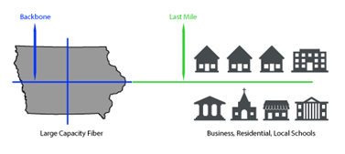

The Distribution fibre network will provide last mile connectivity from specific backbone locations to the various premises, whether they be residential or commercial. Construction cost estimates per meter are based on previous network design and installation experiences.
The internet service provider (ISP) of broadband service requires several levels of network electronics, servers, and software in order to operate. These various levels are responsible for access, routing, activation, monitoring, management, and security. The service network provides the customer premise with electronics that connect back to the core network electronics located in the central office’s (CO) network aggregation site. For the fibre network, there are two options as a deployment strategy, a Passive Optical Network (PON), or an Active Ethernet System.
The basic operation of this PON system is to deliver Internet broadband from the CO with the optical line terminal (OLT) device through the optical distribution network (ODN) with the splitter to the subscribers where the optical network terminals (ONT) are located.

Passive optical networks are fibre optic last mile technologies that are used in deploying FTTP architectures. They do not require any active element in between the Central office (CO) and the subscribers’ premises. PON technology enables the optimization of fibre optic networks to the last miles in that the number of fibre optic cores required to connect many last mile users are significantly reduced. This is made possible as a result of a passive optical fibre component called the splitter. The splitter has the capacity to split a single fibre into 4, 8, 16, 32, 64, 128, etc. depending on the PON technology. The system can provide end users with Gigabit interfaces and the ability to provide varying levels of speeds and levels of service. The system is capable of 10 Gigabit capacity on the fibre. PON systems are efficient at creating a large shared pool of bandwidth, provides a feasible upgrade plan, and is an excellent technology for addressing residential and small business services.
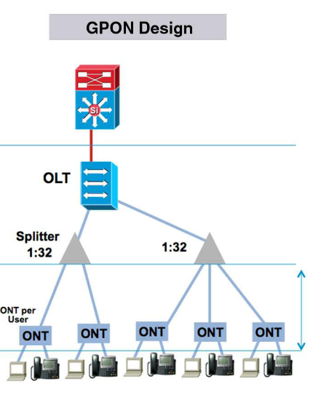
The main components of PON are classified into three main divisions;
The Optical Line Terminal (OLT): This is located at the central office of the Internet Service Provider (ISP) or at the main Network Operating Centre (NOC) of an organization. It connects the PON to the core network.
Optical Distribution Network (ODN): This consists of the fibre optic, fibre distribution and the splitters. The splitter has the ability to split a single fibre optic core into several cores to the Optical Network Terminal
Optical Network Terminal (ONT): This is a device that connects the consumer (the last mile) to the passive optical network (PON). It is located at or very close to the user’s location, depending on the FTTP configuration used.

The Active Ethernet System utilizes a dedicated fibre linking each premise to the aggregation site. The aggregation site has a fully redundant aggregation switch. This system can provide full symmetrical line rates in increments of 100 Megabits per second, 1 Gigabit per second, and 10 Gigabits per second. Generally, Active Ethernet Systems are deployed for commercial customers who require higher bandwidth than residential users. The customer premise electronics are generally higher in associated cost than PON.
Due to the low density and very limited number of high occupancy multi dwelling / business units with high occupancy on Hornby and Denman Islands, it is recommended that a Passive Optical Network architecture be utilized for the Hornby and Denman system requirements.
Below are graphic representations of the PON and Active Ethernet Systems
Attribute | G-PON | Active Ethernet
Type of Optical Distribution Network | Passive | Active
Capacity | 32+ users per passive tree
Reach | 20km (28db) from OLT | 10km (6db) from Active Node
Rates | Up to 2.4Gbps per PON | Up to 1.2Gbps per user
Bandwidth Efficiency | High | Low
Security | AES encryption | AES encryption
Scalability | Up to 32(64) users at 1.2(2.4) Gpbs on one PON tree and more users can be supported with more fibre and equipment | Higher capacities and more users can be supported with more equipment
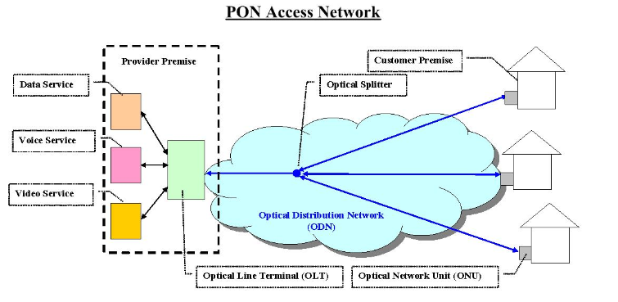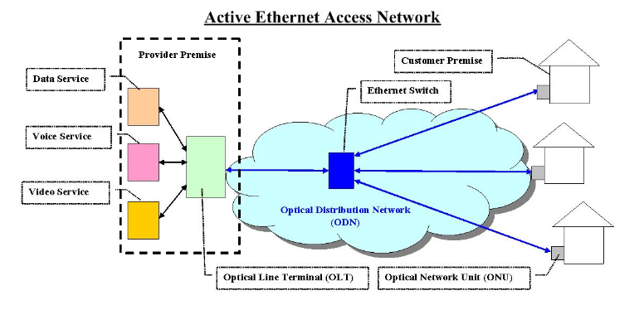
Network Management
Network operations are critical to any network deployment. Systems must be monitored and maintained in order to protect the investment and ensure its success. The deployment of a network will require an operations component that provides the following for the network and customers:
• Network and customer activations
• Adds, moves and changes to the infrastructure as well as to the customer services
• Capacity management
• Maintenance and repair activities
• Customer management including billing
• Wholesale and carrier management

There are two main aspects of the network that require network management; the fibre infrastructure network and the service electronics network.
Fibre Network
After the deployment of the network resource, technical support is required for the fibre network. Engineering design and fibre installation, maintenance, adds, moves and changes can be contracted out after fibre deployment which would not require full time resource. Construction resources can both be contracted or in-house. Records management of the design and permits would be in-house functions.
There are multiple companies providing contract services for the fibre network. The overall recommendation would be to contract the specific fibre engineering, installation, maintenance, and adds/moves and changes to a single outsourced company (turnkey). However, this can be accomplished through the manpower of a contract with an existing or new ISP.
Service Electronics Network
The deployment and ongoing support of the Service Electronics will include access transport and distribution gear, customer premise electronics, management and activation servers, and routers and firewalls. Each of these components require differing technology skill sets, as well as varying levels of these skill sets. With a 24/7 operational environment, there is a level of personnel requirements to manage, and maintain this portion of the network. The estimated staff requirements for the network to support this are provided in below.
Resource | Staff
24/7 Network Operators | 2-3
Network and Server Engineers | 1-2
Technicians | 1-2
Admin Staff/ Sales/ Payroll | 1-2
Total | 5-9

Some of these staff could serve dual purposes in addition to relying on vendors to supply support. The initial 6 months of operation could be done on a smaller scale.
A Network Operations Center (NOC) will be utilized to monitor and maintain the fibre optic system and its supporting equipment 365 days per day, 24 hours per day, 7 days per week as 365/24/7. This allows Mean-Time-to-Restore (MTTR)’s to be established with customers and carriers guaranteeing against failure. The NOC will also handle the management and provision of the fibre optic network connections and interconnections. The NOC will have monitoring system set in place to help identify anomalies, whether environmental, physical or electronic, and automatically initiate system alarms. Depending on the severity level of the issue the system will alert the staff that maintenance is required at that site is immediately or not and a work order is created to service the site. The location of the NOC for both islands is yet to be determined, all future NOC locations can be done remotely or local to the island. The selected ISP will run the NOC.

4.0 Maintenance

The network will require the following maintenance:
- BC One Call – responding to locate requests – 10 locate requests per year – email response
- BC One Call – painting the network to identify its location – 2 per year
- Undersea landings inspections – 1 inspection every year
- Repairs to the undersea network – possibly 1 every 30 years
- General inspections of the network – 1 inspection every year
- Emergency repairs on land network – possibly 1 per year
- Construction site supervision to protect the network around construction activity – 1 event every year
- Relocation of the network due to development and construction – 1 event every 10 years
- Equipment and software upgrades – 1 upgrade every 2 years
- Battery replacement – approximately every 7 years – there is possibly a battery backup unit in every home for the ONT – this will be a customer cost
- Addressing technical issues from customers – 1 per day in the first few years – dropping off to 1 per week on the mature network
- Backup power systems testing at the CO– 1 test per year
- Removal of graffiti from cabinets – 1 event every 3 years

The team of 2 technicians will be able to support the maintenance activities required to maintain a healthy network on both islands. There may be a need to bring in support labour in the event of an emergency outage. During the initial build out phase when there are many new customers, the workload on the technicians will be high, and the technicians may need an additional support person to help. In general, underground networks in a rural setting will see very little disruptive activity.

5.0 Project Permitting and Environmental Assessments

Land Based Network
For the land-based fibre optic builds, the only permitting body is the Ministry of Transportation (MoTi). The proposed primary running line for the project will be in the roadway shoulders. Denman and Hornby Islands are managed by the MoTi office in Courtenay. The application process involves submitting a detailed set of drawings as well as forms. An environmental assessment is generally not required. A traffic management plan will be required. MoTi typically prefers the alignment for utilities to be at the far edge of the right of way. However, that is not feasible on Denman and Hornby due to encroaching trees and other obstacles. It will require some continued discussions, negotiations and escalations to get the road shoulder alignment approved. There are many precedent projects in the province that have been built in the road shoulder. The MoTi office has been contacted to request approval for the alignment but to date, has not received any significant feedback from the request. The first step contact for MoTi is found below:
Brendan Kelly
Senior Development Services Officer
Ministry of Transportation and Infrastructure
Vancouver Island District
Phone: 250-334-6967
Office:
Ministry of Transportation and Infrastructure British Columbia
550 Comox Rd, Courtenay, BC V9N 3P6, BC
Phone: (250) 334-6951
There are several housing co-ops on the islands which will require approval from the co-op management. This can typically be accomplished with a simple document. Also, approval is required from individual homeowners, and again this can be accomplished with a simple document.
The project will require the approval from the Islands Trust and such approval is presently in place for both islands.
Islands Trust
Northern Team
(Denman, Gabriola, Gambier, Hornby, Lasqueti, Thetis, Ballenas-Winchelsea)
Tel: 250-247-2063
http://www.islandstrust.bc.ca/
It is important to also get the approval of the Comox Valley Regional District for the project.
The preliminary survey and design work that has been completed represents a 95% accurate overall system design and can be used to produce ACAD construction/permit drawings. There is 14 weeks of additional work required to produce a set of construction/permit drawings.

Undersea Network Sections
For the undersea section of the network, applications for line assignment are made through Front Counter BC (Farming, Natural Resources & Industry). There is a well-defined application process, which will require a detailed set of drawing, letters of support, environmental management plans and archeological assessments. There is an application fee of approximately $1000. There will also be an ongoing fee to lease the line assignment, which is very small and sustainable within the operational budget of the network. The application process for the undersea network will typically take 6 months.
The preliminary survey and design work that has been completed represents a 95% accurate overall system design and can be used to produce a set of ACAD construction/permit drawings. There is 2 additional weeks of work required to produce a set of construction/permit drawings.

6.0 Risk Assessment and Project Planning

The network design and implementation plan has considered various project risks and potential mitigation. Some of the potentially critical aspects are considered below. Those with potential impact to cost and schedule are identified and discussed herein.

Preliminary Risk Analysis Considerations
The main construction risk at present involves the Ministry of Transport and Infrastructure approval. There is some risk that MoTi could potentially deny the request to use the shoulder of the roadway on the islands. A Right-of-Way alignment must be negotiated with MoTi. It will be the most economical pathway for the deployment of an underground fibre optic network.
The key financial risk factor on the revenue side is the penetration rate of the market (ie. subscribers). The rate of market share growth cannot be known until the project is well underway and significant amounts of capital are expended. However, considering that there is presently no premium broadband service available on either island and that the communities have overwhelmingly endorsed a desire for quality, affordable connectivity, the risk of low market penetration is considered to be minimal.
A small factor affecting the penetration rate on Denman and Hornby Islands is the seasonal aspect of some residents and their subscription rate. The potential maximum number of subscribers as of today is approximately 1600 total on the two islands. The following table compares service penetration rates of 30% vs 60% vs 90% as well as an aggressive triple play model. In telecommunications, triple play service is the ability of a telecommunications operator to supply voice, data, and video applications all at once. A typical example of a triple-play proposal would include phone lines, a high-speed Internet connection, and television/video services over a broadband connection to residential and business customers. The challenges in offering triple play are mostly associated with determining the right business model, backend processes, customer care support, and economic environment, rather than technology.
Residential ISP | Take Rate
 | 30% | 60% | 90% | Aggressive Triple Play @ 90%
Average Monthly Billing | $70.00 | $70.00 | $70.00 | $110.00
Number of Subscriber | 480 | 960 | 1440 | 1440
Total Monthly Revenue | $33,600.00 | $67,200.00 | $100,800.00 | $158,400.00
Total Annual Revenue | $403,200.00 | $806,400.00 | $1,209,600.00 | $1,900,800.00
*The estimated cost to run this network annually is approximately $697,396.80, which means a take rate of a bit over 50% would be the break-even mark.
At the same price that subscribers are currently paying for marginal bandwidth, it is likely that most people will subscribe to the upgraded service. This indicates that this is a low risk element.
If the take rate is worse than expected, another source of revenue can be the invest interest of the use of network as a cellular network. During the planning phase, several splices and or vault locations allows the breakout of the network along the route for Tier 1 cellular companies to invest in providing coverage. This is another potential revenue stream to the system owner/operator.
The risk factors on the cost side include, costing of production and installation of the network interface unit (NIU), or control box, in the home, cost of building and installing the fibre network on both islands, and the required staffing levels. The costs of manufacturing and installing the control boxes and the FTTP network would be known before expending the capital required with proper design and project planning. These risk factors are manageable with proper contract ceilings, project planning, and other provisions to limit FTTP downside risks. Additionally, technology developments will tend to drive these costs downward, further limiting FTTP risks. Risk caused by not providing the level of service expected by the end users must be mitigated with the adequate staffing representatives. This is necessary to ensure excellent “word of mouth” advertising, which will be essential to maximizing market share early on during project roll out. However, it is noted that significantly increasing staffing levels can be costly. This risk can be limited by adding staff through outsourcing arrangements or temporary staffing for initial operations as opposed to adding full-time permanent staff.
Competitive risks from the technology standpoint do not appear to be significant at present. Below table shows the existing available service on both islands. While the current incumbent internet provider has existing fibre to the backbone, their infrastructure does not extend out to the “last mile” connects from the backbone to the end users. The last mile portion in this project represents approximately 92% of the total fibre network and would remain a technological advantage of the FTTP system over the existing copper. Existing satellite internet systems is currently another alternative option on both islands with major drawbacks. The upload and download speeds are about 50% of the CRTC prescribe rates at best and they are dependent on weather and location with regards to topographical and timber/foliage interferences.

Internet Service Providers (ISPs) Serving Denman and Hornby Islands
Carrier/ISP Name | Plan Name | Download Speed | Upload Speed | Data Plan | Cost per month | Notes
Xplornet | 25 GB | up to 5 Mbps | unstated | 25 GB | $59.99 | slows significantly if data plan is exceeded
 | unlimited 50 | up to 10 Mbps | unstated | 50 GB | $99.99 | slows significantly if data plan is exceeded
 | unlimited 100 | up to 10 Mbps | unstated | 100 GB | $119.99 | slows significantly if data plan is exceeded
 | unlimited 100 | up to 25 Mbps | unstated | 100 GB | $129.99 | slows significantly if data plan is exceeded
Telus | Internet 25 | up to 25 Mbps | 5 Mbps | “unlimited” | $70.00 for 2 yrs. then $80.00
 | Internet 75 | up to 75 Mbps* | 15 Mbps | 550 GB | $85
 | Legacy plans | existing plans | No data available | No data available | No data available
 | bonded pair | greater than 25Mbps | No data available | unknown | unknown | perhaps available if residence is within 500m of POP. Requires 2 land lines
Telus Mobility | Smarthub 100GB | up to 25 Mbps | up to 10 Mbps | 100 GB | $60 | +$10 per 5GB over
 | Smarthub 500GB | up to 25 Mbps | up to 10 Mbps | 500 GB | $75 | +$10 per 5GB over
 | Smarthub 1TB | up to 25 Mbps | up to 10 Mbps | 1 TB | $110 | +$10 per 5GB over
Lightspeed | Does not offer service on DI/HI. Not equipped for fibre optics
Rogers Rocket Hub | N/A |  |  |  |  | no longer available
Bell Link Hub | N/A |  |  |  |  | not available to HI/DI
Tether to cell phone | Tethering is the use of cell phone as a wireless modem to connect to the Internet from your computer. |  |  |  |  | Expensive if data usage is significant

Installation
There is always some risk associated with the installation of a fibre network. In order to mitigate risk and challenges during installation, the following should be addressed for any new fibre optical network during initial design stage:
- A clear understanding of the final design configuration of the network, and the final capacity requirements. This network architecture will determine the location of branching/splicing points, the configuration of the network distribution, the location of the different service area, the number passive cabinets etc. It is almost always more cost effective to install all future branching/splicing units during the initial installation than later in the life of the system.
- The design then needs to consider the initial requirements, and the most cost-effective expansion strategy as the system grows.
- Both the initial and final design configurations need to consider the interconnection points of the proposed system with either a local distribution network, or other operators’ systems at the end terminal locations, together with a robust business and administrative operating model.
- Accurate terrestrial data, and up to date geographic information system (GIS) mapping are then used to generate a “desktop” study to evaluate alternative network configurations. Key evaluation parameters are:
- Feasible Route - usually performed an assessment on the potential routes to determine the possible existing infrastructure or new infrastructure would be used.
- Network Reliability – an assessment of alternative routings (sometimes using alternative technologies) in the event of a fibre break.
- Maintenance Strategy – how to deal with both land and undersea technical failures. This includes estimates of the expected “mean time between failures,” access to both the land-based equipment and a strategy for dealing with undersea fibre breaks.
- Environmental Review and Permitting – this activity generates a list of all the reviews and permits that are required to install, commission, and operate the system. An estimate of the cost and scheduling implications is then assigned to each environmental review and permit application.
- Putting all the above considerations together to generate cost and schedule alternatives.
- The next stage is typically a detailed survey to verify the assumptions made in the desktop study and different ground conditions.
Taking these steps during the design stage will minimize unforeseen risk or challenges. For this project, a high-level design and site survey for Denman and Hornby Islands has been completed to reduce installation risk for this project. The next step is to further generate an engineering report (for construction) for the permit approvals, with further refined cost and schedule estimates.

System Operation and Maintenance Failures
The support and operation of a network of this size is not trivial and has its challenges. The provider partners in the consortium, if this option is selected, should have lengthy track records passing traffic throughout a region of this size. Establishing the structure in a collaborative and consultative manner will be the key to success of the consortium model.
A potential operating risk is not being able to deliver 24/7 customer service as required in the current digital world. Almost all service providers operate 24/7/365 today and have NOCs to support their systems. The key will be to develop well defined technical service documents, marketing service documents, master service agreements, and service level agreements and escalation policies for the network by drawing on the proven capabilities and contracts of the provider partners who have a track record of providing customer service support.
Having an active maintenance plan and a supporting NOC will help prevent any risk of a system fibre cut. In the event of a fibre optic cut, the network monitoring software signals the network operation center of the outage. The network monitoring staff alerts the operator of the section of outage and proceeds to follow the maintenance plan. The operator or technician then drives the fibre route to determine if a visible incident (such as road construction, fire or water main break) has caused the incident. If the incident can be located, an operator informs its splicers of the location and sends them out to repair the damaged fibre. If the location of the cut is not noticeable or found, technicians will test the fibre from the closest access location using specialized equipment (OTDR) to determine the approximate location.

Timely Project Completion
The project plan provided must be based on a sensible timescale that are typical for the industry, potential suppliers, and turnkey and service suppliers. The major area of risk to be considered is the interaction between the design, procurement/delivery, construction, installation, and the commissioning of the network. Depending on the type of network to be designed, each has its own set of risks.
The comprehensive summary project schedule shown below details the early preconstruction activities through to project completion. The schedule is based on a buried fibre build including 2 submarine crossings.
The schedule assumes that applications for senior government funding will be submitted during the first quarter of 2020. Upon submission of funding applications, there is an up-front delay of approximately 14 months minimum while the applications are reviewed and funding is put into place. The funding time frame is based upon actual dates experienced in a number of previous projects supported by government funding. The project schedule anticipates funding arrangements to be completed by June of 2021.
The overall FTTP construction period of approximately 27 months commences in June of 2021 and completes in November of 2023. The construction force is planned to be 3 crews working between the 2 islands.

The plan includes the completion of engineering and procurement functions in a timely manner to support all permitting and construction needs. It is scheduled that the networks will become available for communications on a progressive basis as the various areas are completed.
Within the overall schedule, the Vancouver Island backhaul is provided all the way back to downtown Vancouver.

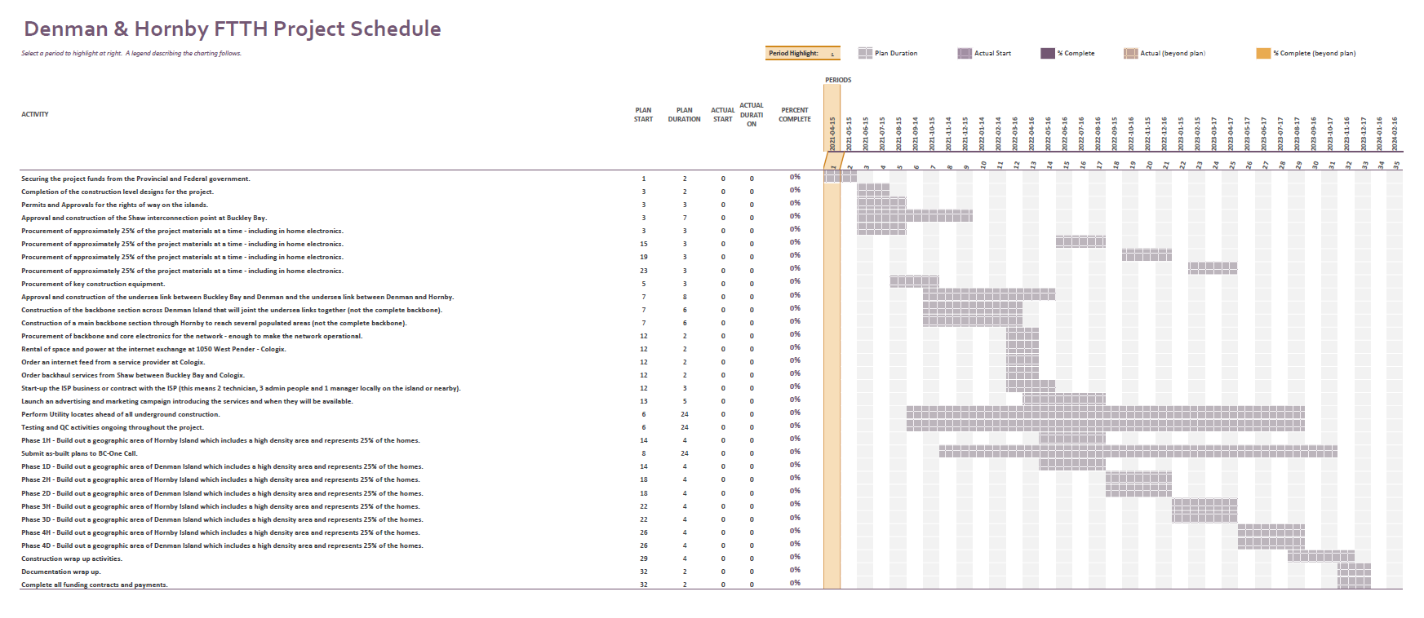
Denman & Hornby FTTH Project Schedule
Order: | Project Elements:
10 | Securing the project funds from the Provincial and Federal government.
20 | Completion of the construction level designs for the project.
30 | Permits and Approvals for the rights of way on the islands.
40 | Approval and construction of the Shaw interconnection point at Buckley Bay.
50 | Procurement of approximately 25% of the project materials at a time - including in home electronics.
55 | Procurement of approximately 25% of the project materials at a time - including in home electronics.
60 | Procurement of approximately 25% of the project materials at a time - including in home electronics.
65 | Procurement of approximately 25% of the project materials at a time - including in home electronics.
68 | Procurement of key construction equipment.
70 | Approval and construction of the undersea link between Buckley Bay and Denman and the undersea link between Denman and Hornby.
80 | Construction of the backbone section across Denman Island that will joint the undersea links together (not the complete backbone).
90 | Construction of a main backbone section through Hornby to reach several populated areas (not the complete backbone).
100 | Procurement of backbone and core electronics for the network - enough to make the network operational.
110 | Rental of space and power at the internet exchange at 1050 West Pender - Cologix.
120 | Order an internet feed from a service provider at Cologix.
130 | Order backhaul services from Shaw between Buckley Bay and Cologix.
140 | Start-up the ISP business or contract with the ISP (this means 2 technician, 3 admin people and 1 manager locally on the island or nearby).
150 | Launch an advertising and marketing campaign introducing the services and when they will be available.
155 | Perform Utility locates ahead of all underground construction.
157 | Testing and QC activities ongoing throughout the project.
160 | Phase 1H - Build out a geographic area of Hornby Island which includes a high density area and represents 25% of the homes.
165 | Submit as-built plans to BC-One Call.
170 | Phase 1D - Build out a geographic area of Denman Island which includes a high density area and represents 25% of the homes.
180 | Phase 2H - Build out a geographic area of Hornby Island which includes a high density area and represents 25% of the homes.
190 | Phase 2D - Build out a geographic area of Denman Island which includes a high density area and represents 25% of the homes.
200 | Phase 3H - Build out a geographic area of Hornby Island which includes a high density area and represents 25% of the homes.
210 | Phase 3D - Build out a geographic area of Denman Island which includes a high density area and represents 25% of the homes.
220 | Phase 4H - Build out a geographic area of Hornby Island which includes a high density area and represents 25% of the homes.
230 | Phase 4D - Build out a geographic area of Denman Island which includes a high density area and represents 25% of the homes.
240 | Construction wrap up activities.
250 | Documentation wrap up.
260 | Complete all funding contracts and payments.

Aerial Network
There is considerable concern over the amount of time required to implement the Denman and Hornby network on the existing aerial infrastructure and its potential impact on project costs and schedule. There are 2079 poles and 137kms of backbone aerial route involved in the aerial network over the 2 islands.
Typically, when an installer/operator endeavours to utilize the existing pole facilities for additional aerial installations, a special application (P408 application) for pole access agreements must be filed. In the case of Denman and Hornby, this application for pole use is to be filed with BC Hydro/Telus. The application is then received and managed by Telus/Inceptra. It is conceivable that such an application from a non-Telus applicant such as Denman/Hornby can be delayed indefinitely thereby delaying the project and consequently driving the costs up.
As examples of this situation, two network operators (CityWest and Columbia Basin Broadband Corp.) have existing P408 applications into Telus for larger projects for pole access agreements. Both parties have been waiting for over one year with almost no feedback or progress. It will not be acceptable to funding groups, communities and investors to move forward with this level of uncertainty. Also, there is great uncertainty on the cost for the make-ready work required to prepare the existing aerial infrastructure for the new cables to be added on. There is no recourse to accelerate the P408 process or to argue/negotiate the make-ready costs, other than to actively lobby the CRTC with potential associated delays. The overall cost to implement the Denman and Hornby network on the existing aerial infrastructure has the potential to be less costly than building the network underground. However, the overall project risk in terms of delay and cost does not justify the potential savings. Funding programs have deadlines for delivery which will likely not be achievable based on utilizing the aerial infrastructure.

Underground Network
There are time related risks in building underground telecom networks. The underground network will require approval from the Ministry of Transportation and Infrastructure (MOTI) which will take time. Historically, MOTI can be achieved in 3 to 6 months and there are channels and methods to escalate the approval process. The process of contacting the ministry for a preliminary approval in principal has already been initiated. Another risk in the underground network is the daily productivity rate for trenching/plowing/drilling the cable/conduit into the ground and that can vary greatly depending on ground conditions. There are some sections on both islands that have rocky conditions and other sections that have highly favorable conditions. The estimated average productivity is approximately 200 meters per day per crew and if concurrently running three crews, it will yield 600 meters per day for the complete network. These productivity numbers have been vetted by 3rd party contractors. Overall, the time risks to complete the underground build should be considered low risk and easily managed with many options for remedy if issues are encountered.
Mitigation of the overall project risk is to utilize well qualified and seasoned program and project management personnel who will ensure that all providers, resellers, and contractors are experienced in FTTP project works and operations. Further mitigation is achieved by ensuring rigorous, auditable, and enforceable master service and service level agreements with provider partners including performance metrics and performance milestones.

7.0 Cost Analysis

Construction Budget
The construction budget for this project is based on an underground build with the construction contracted out as a turnkey project is shown in the table below.
Summary Budget:
Construction Costs: | $5,722,974.77
Undersea Network Build: | $630,000.00
Hornby Island OSP materials: | $1,020,736.58
Hornby Island customer in building materials: | $430,677.20
Denman Island OSP materials: | $1,198,658.92
Denman Island customer in building materials: | $351,196.00
Total: | $9,354,243.48
Contingency %: | 10.00%
Contingency $: | $935,424.35
Total Budget: | $10,289,667.82

Operating Budget
The table below is the operational budget for the network based on a staff of 2 technicians, 1 manager and 3 admin. In the budget there are 2 vehicles for the technicians and all the appropriate tools as well as an office. This team will service both islands.
General Monthly Expenditure:
Description: | Monthly Cost:
Gateway connection | $8,000.00
One Call and Locates | $100.00
Maintenance and Repairs | $625.00
Office Space | $3,000.00
Utilities | $400.00
Vehicles and Tools | $2,000.00
Fuel | $600.00
Ferry Costs | $300.00
Additional Vehicle allowance | $400.00
New Equipment Accrual | $1,666.00
Insurance | $2,966.00
Software | $200.00
Staffing | $37,859.40
Total: | $58,116.40
Total Annual Budget: | $697,396.80

Revenue and Profit Details
The tables below show a conservative and an aggressive revenue model. The models are missing loan repayments, cost of capital and interest.
Conservative Revenue: |  |  | Aggressive Revenue:
Average Monthly Billing: | $70.00 |  | Average Monthly Billing: | $110.00
Number of Subscribers: | 1100 |  | Number of Subscribers: | 1400
Total Monthly Revenue: | $77,000.00 |  | Total Monthly Revenue: | $154,000.00
Total Annual Revenue: | $924,000.00 |  | Total Annual Revenue: | $1,848,000.00
Summary: |  |  | Summary:
Total monthly expenditure: | $58,116.40 |  | Total monthly expenditure: | $58,116.40
Total monthly revenue: | $77,000.00 |  | Total monthly revenue: | $154,000.00
Gross monthly profit: | $18,883.60 |  | Gross monthly profit: | $95,883.60
Gross annual profit: | $226,603.20 |  | Gross annual profit: | $1,150,603.20

8.0 Ownership Options

This section describes the four options considered for ownership of the FTTP fibre systems on each island. Their respective summary budgets are projected and discussed.
The four options are;
1.0 Builder/Owner/Operator
The builder/owner/operator is a company highly experienced in building/operating fibre networks and providing telecommunications services to customers. The company will build, operate and own the network.
2.0 Owner/Operator-Contracted out build cost
The Owner/Operator is a company experienced at owning/operating a fibre network but does not have the ability/structure to construct a network. The construction will therefore be contracted out.
3.0 The Owner is the Denman/Hornby Community Development Company
In this model, the Denman/Hornby broadband group (CDC – Community Development Company) is the owner of the network.
4.0 Telus is the Owner/Operator - Contracted out build cost.
As the Owner and Operator, Telus will contract out the construction work.

Option 1 - Builder/Owner/Operator
The builder/owner/operator is company highly experienced in building/operating fibre networks as well as providing telecommunications services to customers. In this model, the company will build, operator and the own the network. The company will fund 25% of the build cost, 100% of the in-building costs, and will provide the start-up funds for the operational (ISP) business that will run the network. The remaining build costs of 75% are covered by Federal and Provincial funding programs. The build is done at cost with no profit made on the construction of the network. The company invests $1,000,000 in cash and borrows the balance at favorable interest rates with a 25-year term. The loan is secured against the network asset. Higher loan amounts may be required to make this work. The lender is potentially the Comox Valley Regional District or possibly another institution. The three companies considering this opportunity are Canadian Fibre Optics, TeraSpan Networks Inc. and the former owners of Gwaii Communications. The opportunity offers the potential for a significant long-term recurring revenue stream. In this model the funding application is submitted by the company, with the full support of the Denman/Hornby Broadband group. In the below table a conservative revenue is based on 1,100 subscribers while an aggressive revenue is based on 1,400.

Builder/Owner/Operator Model - Summary Budget
Construction Cost: | $4,006,514
OSP Material Cost: | $2,219,396
Undersea Network Cost: | $630,000
Total: | $6,855,909
Total + 10% Contingency | $7,541,500
75% of costs cover by funding agencies: | $5,656,125
Balance funded by Owner: | $1,885,375
In building costs not covered by funding agencies: | $781,873
In building costs + 10% contingency | $860,061
ISP start-up costs: | $150,000
Total funds required by owner: | $2,895,436
Cash: | $1,000,000
Loan: | $1,895,436
Interest rate: | 5.00%
Term in years: | 5
Amortization period years: | 25
Monthly Payments: | $11,081
Sum of 300 payments: | $3,324,159
Total Interest: | $1,428,723
Conservative Revenue:
Gross monthly profit before loan payment: | $18,884
Gross monthly profit after loan payment: | $7,803
Gross annual profit after loan payment: | $93,637
Aggressive Revenue:
Gross monthly profit before loan payment: | $95,884
Gross monthly profit after loan payment: | $84,803
Gross annual profit after loan payment: | $1,017,637

Option 2 - Owner/Operator – Contracted out build cost
The Owner/Operator is a company that is experienced at owning/operating a fibre network, but does not have the ability/structure to construct a network and thus will contract out the construction. The company has the experience/infrastructure to provide telecommunications services to customers. The company will fund 25% of the build cost, 100% of the in-building costs, and will provide the start-up funds for the operational (ISP) business that will run the network. The remaining build costs of 75% are covered by Federal and Provincial funding programs. The build is done by an arms length contractor (who profits from the build). The company invests $1,000,000 in cash and borrows the balance at favorable interest rates and a 25-year term. Higher loan amounts may be required to make this work. The loan is secured against the network asset. The lender is potentially the Comox Valley Regional District or another institution. The opportunity offers the potential for a significant long-term recurring revenue stream. In this model the funding application is submitted by the company, with the full support of the Denman/Hornby Broadband group. The potential owner/operator (the company) may be a larger telecom company such as Shaw. In the below table a conservative revenue is based on 1,100 subscribers while an aggressive revenue is based on 1,400.

Owner/Operator Model - Contracted out construction - Summary Budget
Construction Cost: | $5,722,975
OSP Material Cost: | $2,219,396
Undersea Network Cost: | $630,000
Total: | $8,572,370
Total + 10% contingency | $9,429,607
75% of costs cover by funding agencies: | $7,072,205
Balance funded by Owner: | $2,357,402
In building costs not covered by funding agencies: | $781,873
In building costs + 10% contingency | $860,061
ISP start-up Costs: | $150,000
Total funds required by owner: | $3,367,462
Cash: | $1,000,000
Loan: | $2,367,462
Interest rate: | 5.00%
Term in years: | 5
Amortization period years: | 25
Monthly Payments: | $13,840
Sum of 300 payments: | $4,151,984
Total Interest: | $1,784,522
Conservative Revenue:
Gross monthly profit before loan payment: | $18,884
Gross monthly profit after loan payment: | $5,044
Gross annual profit after loan payment: | $60,524
Aggressive Revenue:
Gross monthly profit before loan payment: | $95,884
Gross monthly profit after loan payment: | $82,044
Gross annual profit after loan payment: | $984,524

Option 3 – The Owner is the Denman/Hornby Community Development Company
In this model, the Denman/Hornby broadband group (CDC – community development company) is the owner of the network. The construction of the network is contracted out as a turnkey project. An independent project manager is hired by the CDC to oversee construction of the network. The operation of the network is basically contracted out to an existing ISP who will white label their existing services as the Denman/Hornby brand. The CDC will need two well equipped technicians (with vehicles and tools) and a manager on a full-time basis on the islands as well as an office. The budget for this model will look very similar to Option 2, however the loan amount will likely be higher.

Option 4 – Telus is the Owner/Operator – Contracted out build cost
In this option, Telus will apply for the funds with support of the Denman/Hornby Broadband Group (CDC) and Telus will build out the network (most likely on the existing aerial infrastructure). Telus will execute the contribution agreement contracts directly with the funding agencies. Telus will contract out the network build and will upgrade the customers to fibre services as the network is built out. Telus has requested a specific amount of contribution in order to proceed with the build which exceeds the amount of funds that will be granted by the funding agencies. There is a gap of $306,250 which the CDC will need to fill. It may be possible to negotiate with Telus so that the CDC is not required to contribute any funds. In the table below 75% of the total build cost is shown as being covered by the funding agencies. Typically, the funding agencies will not cover the in-building costs (ineligible costs). There is not enough detail in the Telus proposal to know if there are ineligible costs within their “Total Build Cost” numbers.

Telus Model:
Denman Island:
Single family units: | 1043
Single family units adjusted: | 592
Single business units | 24
Single business units adjusted: | 24
Multi-dwelling units | 153
Multi-dwelling units adjusted: | 30
Total units: | 1220
Total units adjusted: | 646
Access requirements: | $5,502,000.00
Transport & inside plant: | $360,000.00
Total build cost: | $5,862,000.00
Contribution Requested: | $4,580,000.00
75% funding of the build cost: | $4,396,500.00
Short fall in funding vs Telus requested contribution: | $183,500.00
Hornby Island:
Single family units: | 1105
Single family units adjusted: | 560
Single business units | 39
Single business units adjusted: | 36
Multi-dwelling units | 45
Multi-dwelling units adjusted: | 45
Total units: | 1189
Total units adjusted: | 641
Access requirements: | $5,332,000.00
Transport & inside plant: | $371,000.00
Total build cost: | $5,703,000.00
Contribution Requested: | $4,400,000.00
75% funding of the above amount: | $4,277,250.00
Short fall in funding vs Telus requested contribution: | $122,750.00
Summary:
Total request from funding agencies: | $8,673,750.00
Total short fall: | $306,250.00

SUMMARY OF OWNERSHIP OPTIONS
The four options considered above will require community participation in varying degrees.
Options 1 and 4 require minimal community involvement. The community will participate in the planning and notification to island homeowners as the construction and network commissioning progresses. Depending upon the terms of contracts in Option 1, there is some potential for a higher degree of community activity than is anticipated in Option 4.
Options 2 and 3 will require a community management team of experienced personnel. The team personnel required will be knowledgeable in the areas of construction management; in the areas of optical fiber construction and commissioning including financial management. The team staffing level of Option 3 is higher than Option 2 as it requires the community development company to be fully mobilized in the areas of project, construction and financial management.
Note in the above options CDC project management cost are not included

9.0 Conclusions and Recommendations

A quality, low-maintenance, underground fibre optic network that would meet and exceed the bandwidth needs of the community for the foreseeable future, can be built on the Islands.
The network would serve every home/business on the islands with fibre optics (no wireless infrastructure). The network can supply internet, phone, TV and any other telecommunications services. It could be built for a total construction/installation budget of $10,289,668.
There is already good aerial infrastructure on the islands that could support an aerial fibre network. It is estimated that an aerial network would cost almost 50 percent less than a buried network. However, the risks of unmanageable delays and uncontrollable costs to gain access to more than 2000 poles, renders the aerial construction option unworkable for a non-Telus builder. Aerial infrastructure is an only viable, financially, for Telus.
In order to understand the viability of constructing and operating the preferred underground network, several business models were developed and tested. The models assumed that approximately 75% of the network construction costs will be paid by a combination of funding from the CRTC as well as from the Province of British Columbia. The remaining funds would come from whoever builds/owns and operates the network. The models anticipate that the owner would obtain some form of low-interest, long-term financing in order to make the business case more attractive. The testing found the models are attractive if the majority of the potential 1600 homes/businesses sign up for the new broadband service. However, if less than 1100 homes/businesses subscribe the business is at risk of losing money.
The construction and start-up of a broadband network service is a complicated, lengthy, and expensive project. In considering options to proceed, the community must ensure that in any ongoing joint venture with another owner, it has the managerial and financial skills to play a successful, central role.

