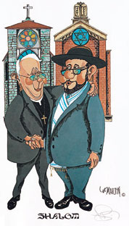 Procession of the Wedding Party
INTERFAITH – CATHOLIC and JEWISH
WEDDING CEREMONY RITUAL
- Welcome and Nuptial Blessing [M4]
- Invocation for the Bride and Groom
- Explanation of the Chuppah (if present) and Remembrance of Loved Ones
- Ceremony Readings [2]
(Hebrew Scriptures and New Testament)
Alternate Reading Selection (if preferred)
- Homily/Reflection (if desired)
- Intention and Consent
- Recitation of the Marriage Vows
- Blessing and Giving of the Rings
- Unity Ceremony
(Candle Lighting or Blending of Sand if desired)
- Blessing Over the Wine and
Jewish Wedding Blessings
- Closing Blessing - Declaration of Marriage
- Breaking of the Glass - Recessional

Cantor Neil A. Berris
70-11 Fairfield Way
Commack, NY 11725

Phone 631.553.2330
Email interclerg@aol.com
Web site http://www.interfaithclergynetwork.com

INTERFAITH CLERGY NETWORK
JEWISH LIFECYCLE SERVICES

