*Procession of the Wedding Party*

**INTERFAITH – *CHRISTIAN and JEWISH***

**WEDDING CEREMONY RITUAL**

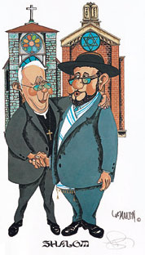

1. Welcome and Invocation
2. Explanation of the *Chuppah* and Remembrance of Loved Ones
3. Ceremony Readings

(Old [*Torah*] and New Testament)

Alternate Reading Selection *(if preferred)*

1. Homily/Reflection *(if desired)*
2. Intention / Consent / Vows of Marriage
3. Giving of the Rings
4. Unity Ceremony

*(Candle Lighting or Blending of Sand if desired)*

1. Blessing Over the Wine and

Jewish Wedding Blessings

1. Closing Blessing
2. Declaration of Marriage
3. Breaking of the Glass - *Recessional*

**Phone 631.553.2330**

**Email interclerg@aol.com**

**Web site** [**http://www.interfaithclergynetwork.com**](http://www.interfaithclergynetwork.com)

# *INTERFAITH CLERGY NETWORK*

JEWISH LIFECYCLE SERVICES

**Cantor Neil A. Berris**

**70-11 Fairfield Way**

**Commack, NY 11725**

