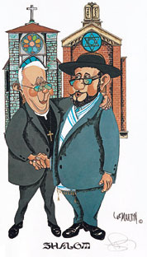 Procession of the Wedding Party
INTERFAITH – PROTESTANT/JEWISH
WEDDING CEREMONY RITUAL
- Welcome and Invocation (Minister)
- Explanation of the Chuppah and Remembrance of Loved Ones (Cantor)
- Readings from Scripture
(Torah and New Testament)
Alternate Reading Selection (if preferred)
- Homily/Sermon (if desired) (Minister)
- Recitation of the Wedding Vows and Blessing of the Rings (Minister)
- Giving of the Rings (Cantor)
- Acclamation and Marriage Blessing (Minister)
- Unity Ceremony (Candle or Sand if desired)
- Blessing Over the Wine and
Jewish Wedding Blessings (Cantor)
- Peace and Closing Benediction
- Breaking of the Glass (Cantor)
Recessional
Phone 631.553.2330
Fax 631.864.0122
E-mail interclerg@aol.com
Web site http://www.interfaithclergynetwork.com

INTERFAITH CLERGY NETWORK
JEWISH LIFECYCLE SERVICES

Cantor Neil A. Berris
1 Waner Street
Commack, NY 11725

