Processional of the Wedding Party to the Chuppah

- Circling of the Bride and Groom (if requested)
- Welcome and Opening Blessing
- Explanation of the Chuppah and
Remembrance of Loved Ones
- Ceremony Readings from the Tanach, (Torah)
and/or alternate selections (if requested)
- Blessing of the Wine
Hebrew text and translation
(First cup shared by the Groom and Bride)
- Recitation of Wedding Vows/Giving of the Rings
- Reading from the Ketubah
- Seven Wedding Blessings (or selections)
Hebrew text and translation
(Second cup shared by the Groom and Bride)
- Closing Benediction (Numbers 6:24-26)
- Pronouncement of Marriage
- Breaking of the Glass

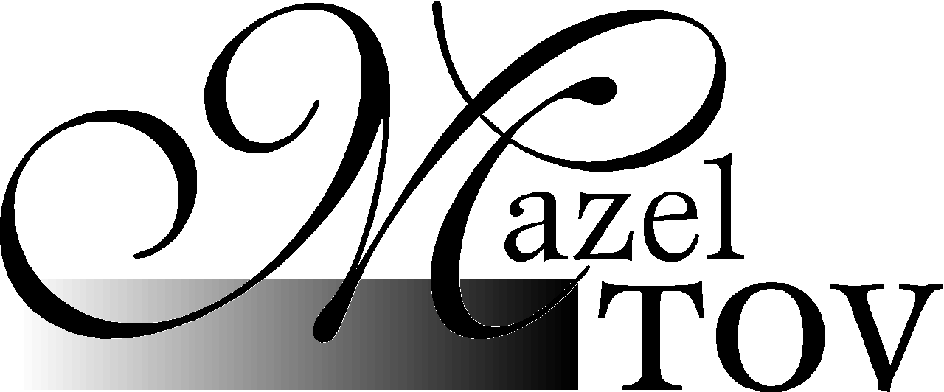!

Cantor Neil A. Berris
1 Waner Street
Commack, NY 11725

Phone 631.553.2330
Fax 631.864.0122
E-mail info@jewishlifecycleservices.com
Web site http://www.jewishlifecycleservices.com

JEWISH LIFECYCLE SERVICES
Traditional Jewish Wedding Ceremony Outline

