**Lost Woods of Ainotaria**

**Participation Rules**

* **General Terms**

1. **LARP** Abbreviation for Live Action Role Play, frequently used to refer to the event itself.
2. **OOP** Abbreviation for Out of Play. This is used to describe times and places that do not fall within the purview of the storyline of the LARP.
3. **OOC** Abbreviation for Out of Character. Typically used with behavior and interpersonal interactions and that don’t fall within the storyline of the LARP.
4. **IC** Abbreviation for In Character. Used to describe behavior and interpersonal interactions that align with the storyline of the LARP.

* **General Rules**

1. **Always be alert for a command to “hold”.** While attending the LARP, players may hear the call “Hold". When they do, it should be repeated loudly one (1) time by each player so that others can hear it, and all players should immediately stop in place until event staff can come assess the situation. Repeating the command has two purposes: It lets the staff know that players are following the guidelines, and it echoes through the play area so that everyone is aware.

“Hold” may be used by anyone who observes an unusually dangerous situation. It is only to be used when an individual is either injured, at serious risk of being harmed physically, or appears to be showing signs of a serious medical problem or unusually high mental distress. Medical attention may be necessary and this procedure limits the number of people in the immediate area, helping to avoid adding complications. Examples include someone having a seizure, suspected broken bones, or encountering potentially dangerous wildlife. Play will resume when a member of the administration announces “Play on”.

1. **Always strive to maintain a family-friendly enviroment.** We want our events to be a place where all ages of players can attend. Children will likely be present at each of our events. This means no discussions of mature themes, use of profane language, or lewd behavior will be permitted. When in doubt, aim for a “PG” environment and err on the side of caution.
2. **Remain IC while in the play area.** * As much as possible, any OOC behavior should take place in the OOP areas. The goal is to keep immersion in the game as much as possible.
3. **Keep modern technology exposure limited** while IC. If you feel you must have your devices on you while in the play area, keep it hidden and silenced. Ideally, we prefer you keep them in the OOP areas. If you must use them, remove yourself to the OOP area.
4. **No OOC harassment or discrimination** will be permitted. We will use the following definitions for these terms.

Harass: 1-to annoy persistently 2-to create an unpleasant or hostile situation for especially by uninvited and unwelcome verbal or physical conduct.

Discriminate: to make a difference in treatment or favor on a basis other than individual merit

You are free to exchange ideas, debate, and learn from each other in productive ways. You are free to discuss any family-friendly topic in a respectful manner, as long as you can maintain a calm tone of voice when doing so. If anyone expresses the desire to end the conversation, respect that decision. If at any time anyone feels they are witnessing harassment or discrimination, they should report to a member of the LARP staff and we will investigate.

1. **No pets will be allowed at any time on the property.** Genuine service animals are always welcome, and encouraged. Some working dogs will be permitted with prior written approval from a member of the LARP administrative staff. No exceptions will be made for emotional support animals or therapy animals. LARP staff is trained and fully versed in all applicable laws for service animals under **MO statute **209.204.** If it becomes apparent a participant is in violation of this law, they will be removed from the property immediately.**
2. **LARP staff may, at any time, require you to step away** to an OOP area or remove you from the property, altogether if it is found that you are unable to conduct yourself in an appropriate manner, are causing an unsafe environment, or are disruptive to the event.
3. **No alcohol, drugs, or other controlled substances permitted on the premises.**\* The use of alcohol and other controlled substances is not permitted at any of our events. Our staff has determined that it is unsafe to LARP while intoxicated. Furthermore, the consumption of these substances may cause discomfort among some members and parents of our community. Therefore, participants must refrain from the use of any such substances at our events.
4. **No non-LARP weapons, of any type, permitted in the play area.** LARP play is already an inherently dangerous activity. LARP weapons are designed to mitigate the danger as much as possible. With the level of activity and the length of the events, the presence of a non-LARP weapon poses too great a risk to have in the play area. Any other weapons must remain secured in OOP areas. Failure to abide by this rule will be grounds for immediate removal from the premises.
5. **Cannabis Use.** While we recognize that some people may use cannabis and its related products for medical purposes, it is also still heavily regulated. Outside of a legitimate, prescribed, medicinal use, cannabis and other products containing THC will fall under the same general rules as other controlled substances. If you use cannabis products for medicinal purposes, in accordance with state law, you may only do so in your vehicle. Inside a camping structure while around other campers is still considered public exposure, and is illegal. Therefore, no cannabis products may be used while anywhere outside of your own vehicle.
6. **Nicotine use.** The use of any visibly obvious nicotine products will be permitted in OOP areas only. This includes all types of tobacco products and electronic cigarettes/vape products.

In maintaining a family-friendly environment, any product that can have second-hand effects (cigarettes, vapes, etc.) must be used a minimum of 20 yards away from, and if possible, downwind from, others. Staff maintains the right to require any persons to move to a designated smoking area or stop if they are not within a designated smoking area.

Smokeless tobacco products may be used anywhere in OOP areas. However, spit must be contained either in a closed container or swallowed. Plugs/chew wads must be disposed of in a closed container.

The use of nicotine products that are not immediately obvious and have no risk of second-hand effects, such as nicotine patches, is permitted throughout the property.

1. **No glass or ceramic materials** will be permitted outside of OOP areas. They break too easily, presenting an unnecessary risk to others as well as the potential for unwanted debris, and should not be included in your character’s garb, costume, or other gear.

* **Clothing/Costume/Garb Guidelines**

1. **IC clothing should be believable**, if not historically accurate, for a medieval fantasy setting.
2. **Maintain a family friendly mindset with all clothing choices,** whether IC or OOC.
3. **Areas indicated by red in the attached image must be covered** as a minimum. This will help preserve the immersion for IC interaction, maintain a family-friendly environment for all participants, and facilitate safety.

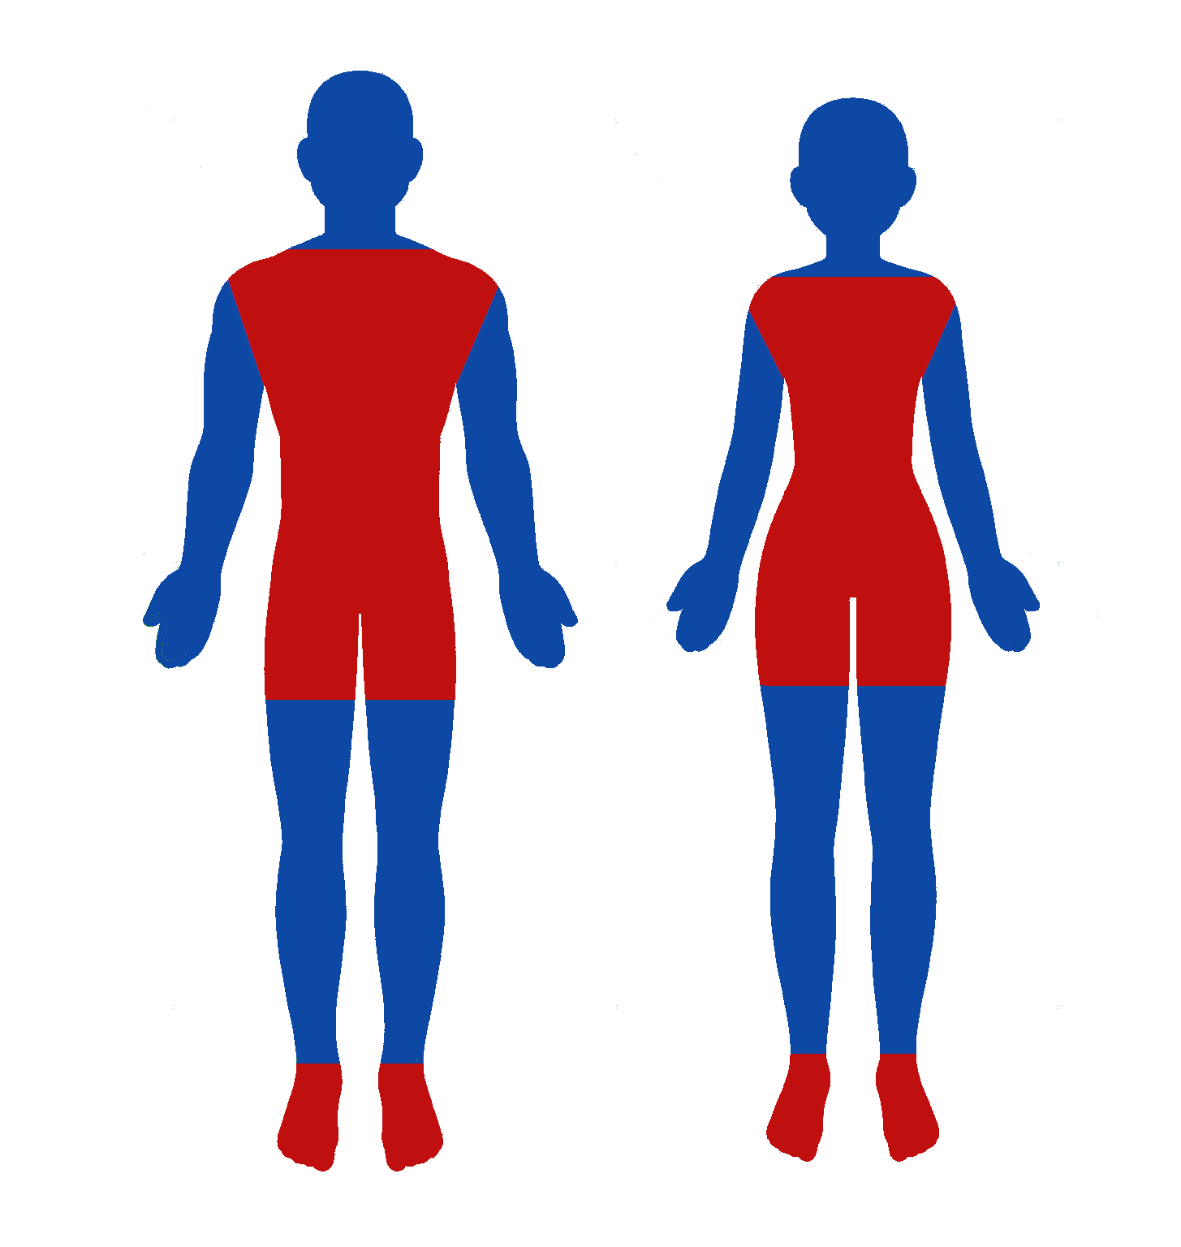

* **Campsite Rules**

1. **Clean and put away any food or food related wares immediately after using them.** As to not attract unwanted pests or vermin to your campsite.
2. **Fires must be watched at all times and extinguished entirely by persons 18 or older.** There will be a fire pit in most of the campsites. If you start a fire (18 or over) it is your responsibility to watch and entirely extinguish the fire using two buckets of water. If you need to transfer **Fire Watch and Extinguishing Duty** to someone else, it must be clearly communicated. “I am over 18 and accept responsibility of the fire.” This is to keep the land safe from wild fires.
3. **Clean your campsite at the end of the event.** Fully pack up campsites at the end of each event. It is our shared responsibility to keep our lands clean and free of garbage when we are finished. We want to leave our kingdom looking better than we found it so that the land baron will continue to let us grow and create new lands.

* **Offsite Events**

In the case of events happening at off-site locations when the Lost Woods of Ainotaria LARP group is participating as a 3rd party vendor, all applicable rules will still apply for any wishing to participate as part of the LARP group.

**\***Exceptions exist

Legal Name (print): _________________________________________________

Signature: _________________________________________________ Date: ____________________

Character Name: _________________________________________________