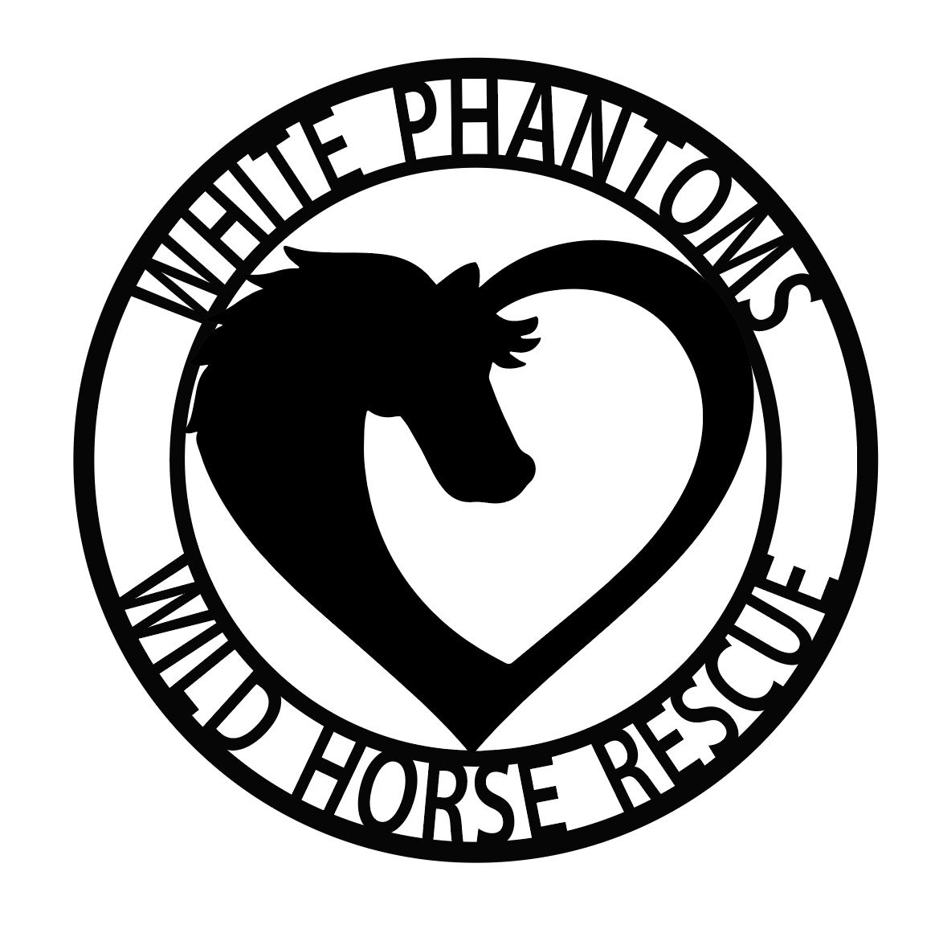
White Phantoms Wild Horse Rescue
515 S. Tonasket Ave Apt #1
Tonasket, WA 98855

[NAME]
[ADDRESS]
[CITY, STATE, ZIP]
[Phone]

[DATE]
RE: Gelding Amendment to Contract
Dear [Name of Adopter]:
You have adopted [HORSES NAME OR IDENTIFYING MARKS] from WPWHR (White Phantoms Wild Horse Rescue) with the understanding that there is a gelding amendment.
You agree to the following: (initial each item)
_____ 1. Said horse is being adopted with the requirement to GELD within 12 months of the adoption date if horse is under one year of age or within six (6) months if older than two years of age.
_____ 2. Gelding costs and risks are at YOUR expense.
_____ 3. You are required to send proof of gelding, with a veterinarian’s statement, to WPWHR within the timeframe listed above.
_____ 4. Horse may NOT be used for breeding whether planned, intentional or accidental. See Conditional Contract.
Please sign and date below. A copy of the signed addendum will need to be on file with the WPWHR before the colt/stallion is released.

SIGNED SIGNED
_________________________________ _______________________________________
Adopter White Phantoms Wild Horse Rescue

Conditional Contract
I, [name of adopter], understand that White Phantoms Wild Horse Rescue (hereinafter referred to as the “Rescue”) is requiring proof of gelding within a year for this adoption to be final. The [color] colt that I refer to as “[name]” will never be bred or used in a breeding program of any kind. This includes live cover, AI and/or pasture breeding. If I am unable to show proof of gelding in this time frame, I understand the Rescue has the right to pursue repossession of the horse including the costs associated with any medical care/procedures, transport fees and/or legal fees associated with recovering the colt. I also understand that if a signed copy of this Contract is not on file with the Rescue, they will not be able to release the colt into my custody.
I understand, and agree, to the above terms.
Signed: Signed:

______________________________________ _______________________________________
Adopter White Phantoms Wild Horse Rescue

_______________ ________________
Date Date

