Christmas

What will happen and what helps me



Christmas time can make us feel different. We may be excited, we may be overwhelmed, we may be happy, we may be anxious.

Lets think about what may happen.

Talk with a trusted adult to make Christmas as good a time as it can be for you and your friends and family.

The following pages may help you.

School breaks up in December for the Christmas holidays



You can use a countdown calendar to tell you when school finishes

Countdown to Christmas

| 27 | 26 | 25 | 24 | 23 | 22 | 21 |
| --- | --- | --- | --- | --- | --- | --- |
| 20 | 19 | 18 | 17 | 16 | 15 | 14 |
| 13 | 12 | 11 | 10 | 9 | 8 | 7 |
| 6 | 5 | 4 | 3 | 2 | 1 |  |

Countdown to Christmas Day

You may have an advent calendar that helps you countdown to Christmas Day



You may have a Christmas Tree at home and help to decorate it

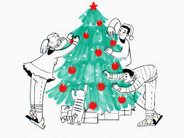

At Christmas time your routine may be different



It may help to have a calendar or diary to write down all the different things that will be happening.

Include:

Who you will see and where you will see them

Where you will go

What is happening during the day

What smells and foods will be available

If you are giving or receiving presents

And anything else that is happening.

You may see people that you don’t see very often.

Having pictures of these people to look at can help you feel more comfortable when you see them.



You may go to places that you are not familiar with.

You can use the internet to look at the places before you go there so you know what they look like



You can look at maps to see how you will get there

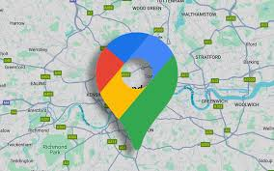

You can look at travel timetables if you are using public transport

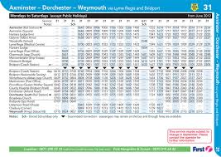

What happens at Christmas time?

You will receive presents and you will give presents



Other people will want to see you open your presents.

Some people are happy to open presents with other people around and some people like to open presents on their own, talk with your trusted adult about what you would like to do. They can explain to other people.

Maybe if you want to open the presents on your own, your trusted adult can take a photo of you with the present to show the person that gave you the present.

 

Friends and family may visit your home



You may want to spend a lot of time with family and friends or some time with family and friends.

Make sure you have a quiet place to go to if you need to.

Think of a signal you can give to your trusted adults so they know you need some quiet time in your quiet place.

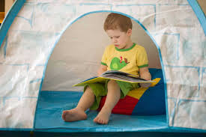

Things that may help you

Think of the things that help you feel regulated, some of them may be …

 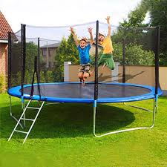 

  

  

Talk to your trusted adult to decide what will help you.

Friends and family may behave differently and do different things.

At Christmas people often celebrate.

Friends and family may be at home more than usual.

There may be loud and different music.

People often cook and eat different foods, there may be different smells in the home.

Adults may behave differently.

People may play games.

People watch different things on TV.

Think about how you will feel and talk with your trusted adult to make a plan to help you all have a good time at Christmas.

It helps to plan things in advance so everyone knows what helps. You can all help each other!!

Remember that it is OK to need and have quiet time! You can choose to go to your safe space.

Sometimes we know we need to do something that will overwhelm us, we can help ourselves by doing things that calm and regulate us so that we can tolerate more when we have to.