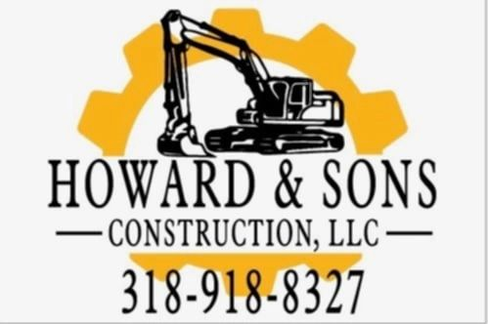  Howard & Sons Construction, LLC  333 Texas Street Ste. 1300  Shreveport, la 71101  (318) 918-8327  Email: contact@howard-sonsconstruction.com  Website: https://howard-sonsconstruction.com | CAPABILITIES STATEMENT  Howard & Sons Construction LLC is a Minority-Owned small business trusted and experienced construction firm committed to delivering high-quality construction, renovation, and infrastructure solutions. With a focus on excellence, safety, and efficiency, we provide a full range of construction services tailored to the needs of our clients in the commercial and residential sectors.
Core Competencies

- Commercial & Residential Construction
- Concrete & Masonry Work
- Site Development & Excavation
Past Performance  - Successfully completed concrete, demolition, and site preparation for residential and commercial developments  - Over 20 plus years of experience in the construction business |  | Differentiators  - Extensive industry experience and skilled workforce  - Commitment to safety, quality, and compliance  - Ability to handle projects of all sizes, from small renovations to large scale developments
Company Data  - UEI: E7SKFK5D1621  - CAGE: 9YFFS  - NACIS Codes:  238110: Concrete Contractor  238140: Masonry Contractor  238190: Foundation/Structure Contractor  237110: Water/Sewer Construction  236115: Home Construction  236118: Residential Remodeler  238350: Finish Carpentry  238910: Site Preparation |  | CONTACT INFORMATION  Adam Howard, Owner  Howard & Sons Construction, LLC  (318) 918-8327  Email: contact@howard-sonsconstruction.com  Website: https://howard-sonsconstruction.com

