Love
by Bill Judge

The corroded bell above the door tinkled as a bearded homeless man, wearing a camo jacket with his shirt half way out, pushed the steel framed glass door open, stepped through, looked up towards the register, vaguely smiled, and then turned left down the first aisle of the market on 71st Street.
A young, raven haired, pale skinned woman, in black skinny jeans and a large grey long sleeve athletic shirt that draped to her thighs, glanced up and said, “He’s here again.” She leaned with one arm on a register behind the checkout counter.
“Who?” Another woman with black lipstick asked. Dressed in an extra long seaweed green sweatshirt and dull yellow spandex leggings, she stood in front of the counter. Her eyes were heavy with black, grey and white makeup. Her hair was cut short, shot straight out and was all white though she was young.
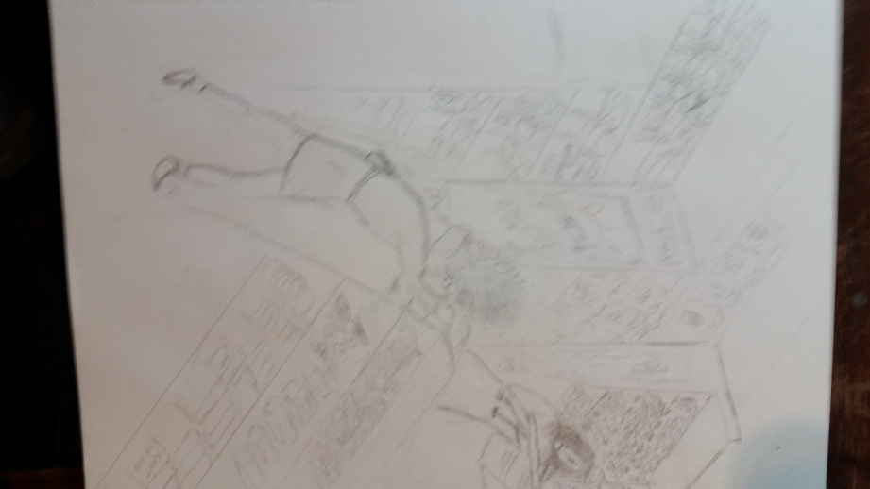
“Him,” the woman behind the counter barely lifted a hand. She pointed to the back of the store and nodded her head in roughly the same direction. Her lip curled.
The customer turned around and saw the man. “Oh yeah. Hmmmm. A bum.” She turned back. “Don’t change the subject.”
“I’m not changing the subject.”
“You are. Don’t let him hit you like that, Juney. “
“I know. I know,” Juney Bee said as she held a frozen orange juice tube on her cheek. “It’s no big deal.”
“No big deal,” Bin’s voice rose an octave. “He’s going to really hurt you one day.”
“But, he wouldn’t hurt me, Bin. He just got angry.”
“What do you mean, he wouldn’t hurt you. He did hurt you. So, yes, he would really hurt you,” Bin answered, “and maybe next time, he’ll send you to the hospital.”
Juney shook her head. “It’s my fault. I made him mad.”

“What do you mean it’s your fault? No, it’s never your fault.” Bin adjusted her stance. “What’d you do, steal his freaking car? That tripped out, ticket machine. He thinks he’s so cool in that piece of,” she paused for effect, “junk.”
Juney giggled. “NO.” She used the other hand to hold the cold plastic orange tube to her bruise. The sleeve of her shirt slid down and exposed a bruise on her forearm.
“Where’d you get that?”
“Get what?”
“That bruise on your arm.” Bin leaned forward and took Juney’s hand. “Let me see.”
“It’s nothing. I tripped and fell.”
“Yeah you tripped. You liar. You’ve got more of these. Let me see.” Bin tried to push up the sleeve of the shirt past Juney’s bicep but could only get it less than half way up. “There is another one.”
“Stop it. Of course there is. I fell, like I said.”
“I bet there’s even more.” Like a flash, she leaned over the counter with her feet off the floor and grabbed Juney Bee’s jersey and lifted it to show some of her stomach.
“Bin! You’re crazy. Quit it!” Juney Bee jerked away and exposed her back which did have some dark bruising. “There’s that bum. Stop it!”
“But you got more of them.”
“I told you I fell.”
“Right. Where?” Bin maneuvered back onto the floor and stared at her friend.
Juney set down the orange juice container, pulled down her jersey and straightened herself. She didn’t say anything.
“Where? You don’t know where? How could you not know where?”
“Huh?” Juney picked up the frozen orange juice and pressed it against her face. “What do you want?”
“Where were you?”
“Oh, yeah. Uh, my grandma’s.” Juney said and then looked away at the front door.
“Your grandma lives here in the city? You never told me that.”
“We haven’t known each other very long.”
“Where?”
“What’s with all the questions?”
“I just didn’t know you had anybody here in the city,” Bin said in a conciliatory tone. “Why don’t you live with her instead of your boyfriend?”
“Really?” Juney raised the timbre of her voice and her eyebrows. “You got to ask that?”
“I’m just curious.”
Through one squinting eye, Juney answered, “Sure, okay. I’ll tell you. Though not sure why you need to know. It’s Rosemont.”
“Rosemont? That’s pretty big. I haven’t been there in a while. Where in Rosemont?”
“Westminister.”
“Westminister, huh? What’s the address?”
Juney shook her head. “I don’t know.”
“What do you mean, you don’t know? How can you go to her house and not know the address?”
“Oh, I meant, I don’t remember, or I forgot just this second. Geez, Bin.” She dropped the orange to the counter next to her, picked up and drank from a coffee cup that had sat for thirty minutes. Closing her eyes, she let the cup rest against her lips and swallowed. She didn’t move the cup.
Bin stared at her, annoyed.
Juney seemed to delight in that and she waited and then drank again. She set the cup down and let out a long sigh and then smiled. “Fifteen twenty two.”
“I’m checking,” Bin typed the address into her phone.
“You don’t trust me?”
“No, Juney Bee, not this time,” she said as she waited for the search to end. They both looked at her phone. “Okay, there’s a house there.”
“I told you.” She picked up the orange juice and laid it against the bruise on her face.
“But it’s not a two story. So what stairs did you fall down?”
“Oh my goodness,” but Juney didn’t answer. She pretended to look for the bum in the back of the store. Then she really looked for him. He was standing in front of the pet food, reading some box.
“What stairs did you fall down,” Bin repeated.
“Huh? Oh yeah, her basement stairs. She has a basement. She needed something from the basement. Some preservatives or something that she made. I said I’d get them and I fell.”
“Some preservatives or something?”
“Yeah, preservatives. You know Grandmas and preservatives.”
Bin shrugged. “I’m done, Juney Bee. You’re lying. But if you want to get beat up, that’s your own business.”
“No, I’m not. She has a peach tree in back.”
“Sure, Juney, they all have peach trees. Tell me what you want about all the Grandmas in Rosemont.” Bin placed a hand on the counter. “But let’s get back to the bruise under your eye.”
“What about it?” She asked and then held her breath as she turned the orange juice container around and then held it against her face.
“Why did he hit you?”
“I don’t want to talk about it.” She heaved.
“Why did he hit you?” Bin asked again, leaning in.
Juney took a deep breath. “Geez. Okay, okay. I told him I couldn’t go with him. I had to work.”
“You told him you couldn’t go with him. You had to work. And for that he beat you?”
“No. It’s not like that. For one thing, he didn’t beat me. For another, well.” She looked down at the floor. “He really wanted me, you know? He wanted me.” She pleaded with Bin to understand. “And I had to work. And I told him no.”
“So? You told him no. And he’s the only guy that’s ever been told no? He can’t hold out until you’re not working?”
“You don’t understand.”
“I think I do.”
“He really wants me.”
“Girrrrrl.” Bin rolled her eyes. “He’s just another guy.”
“No, he’s not.” Juney jerked her head up. “Great, now the homeless guy needs to dirty up the restroom. Why can’t they just buy stuff and get out of here? Disgusting.” She leaned against the locked cigarette case. “Now I’ll have to clean the men’s room.”
Bin looked over her shoulder and saw that there was nothing to see and turned back. “So the guy needs to go. Better here than outside.”
“I don’t need to clean the alley.”
“Grrrosss, now that’s disgusting.” Bin said, making a face. Jiggling her head side to side as if to rid the image, she drew a deep breath. “Now back to you. You need to break up with Two Fer.”
“Two By.”
“Uh?”
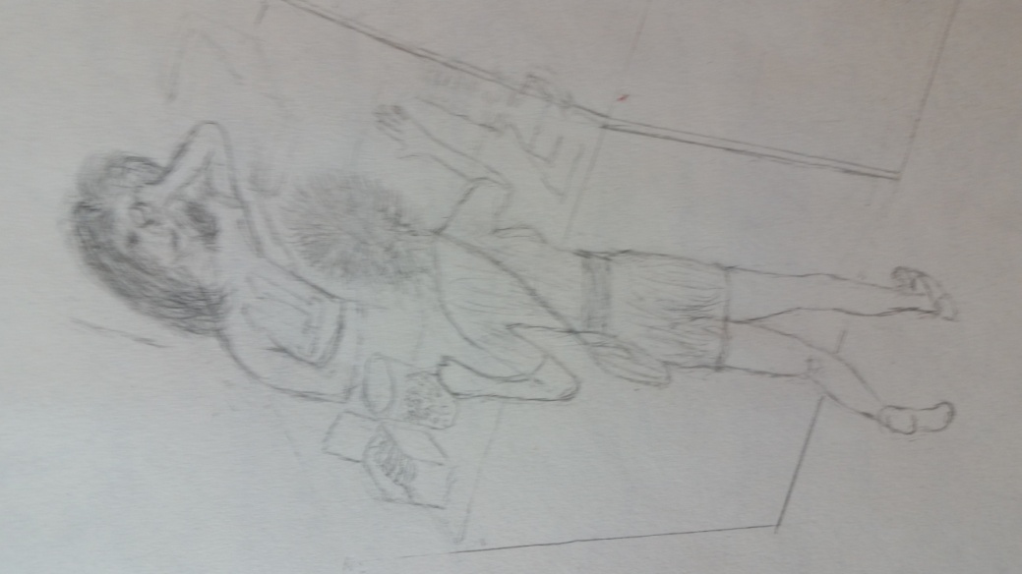
“It’s Two By, not Two Fer, and it’s not that easy. That’s why I, that’s why he,” Juney stopped.
“Oh, so that’s really why you got hit?” Her voice went up a notch. “He thought you were breaking up.”
“Kind of, I think. I don’t know. I guess so. He wasn’t happy.”
“Were you,” Bin’s eyes flashed towards her, “breaking up?”
“I don’t know.”
“You should, you know.” Bin said and then she heard a slight shuffle and a whisper behind her. Snapping her head around, she simultaneously side stepped away from the counter. But she realized in an instant she had no need to bother. It was the bum. Except when she looked in his eyes, they were green like shimmering emeralds. They were deep, too. As deep as the oceans. Palm trees, the islands, the oceans. She caught the spark of his eyes as he looked away and then down. She tried to look again and catch his attention but he wouldn’t look up.
“Excusez-moi,” he said very softly and musically. His voice reminded Bin of a brook running in the country though she had never been in the suburbs, much less the country. She had lived her entire seventeen years in the city. The closest sound to a babbling brook she had ever heard was the big fountain in the city’s largest park. She realized she had never really listened to the music in the fountain. She hadn’t known it ever existed. She hadn’t thought to think it could ever exist. She looked again at the man next to her. His thick dark hair, streaked with grey, ran over his ratty Army camouflage overcoat. His coat was too warm to wear in the late July weather, but maybe at night it was needed on the streets.
She tried to return to the images of the oceans, the palm trees, the emeralds but they flew away as soon as he reached into his pocket. His beard was as thick and as black as a Sicilian mobster’s though she was sure he wasn’t a mobster. He placed a small Slim Jim and a dollar on the counter.
Juney sneered without looking at him and rang it up on the register. “That’ll be ninety five cents, big spender.” She laughed and looked at Bin to join in but Bin shook her head and looked away. Something about the bum was very different now.
He pointed at the dollar.
Juney picked it up with two fingers in an exaggerated movement like it was diseased and she finalized the purchase. She dug out a nickel and stripped off the receipt. She laid them on the counter in front of the man. “I’m sure you’ll need these.”
“Merci,” he said.
“Sure, whatever.”
He reached into his pocket and placed a figurine on the counter. He pushed a piece of paper underneath it. With a bow of his head, he turned and walked with a limp out of the store.
A couple of customers entered.
He had left a multi-colored origami. Bin picked it up. “How beautiful,” she exclaimed as she whisked it through the air in front of her. “It’s a butterfly. Do you see how magnificent it is?”
“The guy gives me the creeps.”
“What do you mean?”
“He never speaks any English but I think he knows English.”
“Really? He’s been here before?”
“Yeah, and he gives me those things. Always butterflies or insects or whatever they are.”
Bin lifted it up again. “It could be worth something.”
“From a bum? Yeah. Sure.” She exaggerated her words.
“Look at these colors. What’s it made of, I wonder? The colors are brilliant and you can see right through it. Almost like glass.” She held it up. “It’s not paper, you know.”
“I’m not interested. He’s gross.”
“What’s the slip of paper say?”
“I don’t know. I never touch them.”
“You have others?”
“Yes. Several.”
“Let’s see them.”
“I throw them away.”
“You throw them away? You don’t have any or you have several?”
“I, well, I did throw them away but someone fishes them out of the trash again. Here. In this box. There’s a couple.”
“He sounded French, you know. I’m taking French. Let’s see the paper he left.”
“He’s not French. He’s a bum.” Juney handed her the slip.
“Amour.” Bin held the paper so they both could see. “Amour,” she repeated. “World? The world? No, no, that’s not it. NOOOO! Oh my God! Love, that’s what he’s saying. He’s telling you, I love you, isn’t that delicious?” She giggled.
“Oh God, why me?” Juney reddened in the face.
“I think it’s cute.”
“You would.”
“What’s one of the others say? Let’s see one of the figures.”
“Here you go. I’m going to end up hating you, you know.”
“Another butterfly. It’s different but made from the same stuff. It really is quite beautiful. Do you have another one of those slips of paper?”
Juney reached into the box and pulled out a note and handed it to her.
Bin held it out but couldn’t pronounce the strange lettering “Любовь”. “I wonder what it means.”
“Love,” a heavy set woman said with a thick Eastern European accent. She had just walked up without warning. She plopped a gallon of milk and a small plastic canister of coffee on the counter. “It’s ‘lyu-BOV’. Easy.” She looked over at Bin. “You have Russian boyfriend, eh?”
Bin blushed and shook her head.
“Yah, maybe not you but he wants you.” She smiled, paid and left. “He loves you, he do.”
Juney watched her leave and waited for the bell to ring as the door closed. “The old lady knows what she’s talking about. That bum is creepy.”
“He didn’t leave it for me. Now, show me another. First, French, then Russian. What else do you have?”
“Here’s an easy one. “ Juney didn’t even hand the next note over to her friend. She just held it out and showed it. “Amor.”
“Love, again,” they both said at once and laughed. “Spanish.”
“He’s consistent, I’ll say that,” Bin said.
“Here’s another note and one of his thingeys.” She placed them both on the counter.
Bin marveled at the figurine. “I wonder if it can fly.”
“Don’t be silly.”
“No, really. I wonder if I tossed it to you, if it could really fly. It looks like it could. They both do. I bet it could.”
“Now that would be crazy.”
“Yes it would, but let’s see.”
Bin stepped back into the aisles. “Are you ready?”
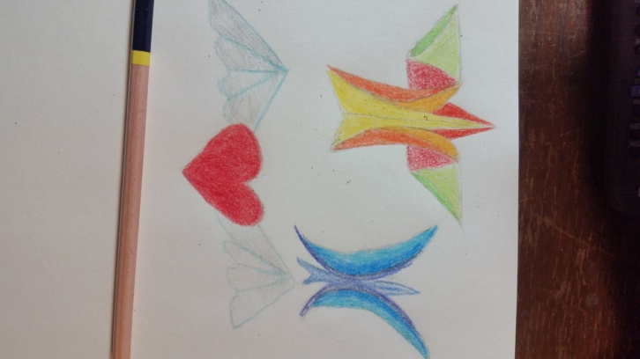
“You are insane,” Juney snickered but she kept her eyes on her friend’s hand. “Ready.”
“Alright, here goes,” Bin tossed the figurine into the air like a glider and it flew! Its little wings fluttered just like a butterfly. It lifted and bobbed so slightly, just enough to keep it aloft. It hovered ever so briefly as if anticipating Juney’s next move. She held her hands out.
“Oh my gosh, Bin. Oh my gosh. It’s unbelievable.” The figurine made a quick halting curve and landed gently into her open palms. Juney’s mouth was wide open. “It’s fantastic.”
“It’s freaking unbelievable! It really is! I can’t believe my own eyes.” Bin looked around the store for the bum, knowing he had left. There was another customer walking up the aisle with a newspaper and a twelve pack of beer.
The bell on the door rang. Juney glanced over and saw a woman. Sighing, she turned towards the beer man.
He placed his stuff on the counter with a clank. “Marlboro Hard?” He grunted.
“Red or black.”
“Black.”
“Got ‘em,” Juney said.
“Give me two.” He coughed.
Juney fished out two packs of cigarettes and rang up the items and closed out the customer. They both waited until he left.
“So what did the note say for this one?” Bin asked, holding up the flying origami.
“I don’t know if the note is related to it. They are all mixed up.”
“You’re not very organized.”
“Hey, now, you’re not all that,” Juney started to say.
“I’m just teasing. What’s it say?”
“See for yourself.” Juney handed her the next slip.
The woman walked up to counter with a bag of chips and a soda.
Bin stood to the side and read the note out loud, “Pagmamahal.”
The woman looked at them both and smiled.
“What’s it mean?” Bin asked.
“I don’t know,” Juney replied. She scanned the woman’s items.
“Love,” the woman said.
“What?” Juney asked, as if she didn’t hear but she had heard her perfectly well.
“It means, love, in Tagalog.”
“What’s Tagalog?”
“The Filipino language. It’s where I come from.”
“Uh, thanks.” Juney checked her out and they turned their attention to the notes and the figurines.
“That’s weird.”
“Yeah, that’s really strange.”
“Another note.”
“Okay,” Juney reached into the box and pulled another note and origami out. She swept the other notes and figurines into the box. She slid the new note and a figurine to Bin and then looked over Bin’s shoulder. “Can I help you?” It was the man who bought the cigarettes.
Bin picked up the figurine and then looked at the guy.
“Forgot the cigarettes.”
“I thought I put them in the bag.”
“No, they weren’t in there.”
Juney frowned.
Bin tried to decipher the note.
The man looked at Juney.
Nobody moved.
“Well, can you look by the register? Maybe you left them there?”
“Sure, I guess.”
“I don’t know what this is,” Bin said, speaking to Juney. “Libe. Maybe life. Maybe he wrote ‘life’ this time and broke the streak. But it doesn’t make sense.”
The man glanced down and said, ‘leeb.’ That’s German. It means love.”
“What do you know? Juney said. “They’re here.” She picked up the cigarettes from behind the register. “How did they fall behind there?” She looked at the ad that was butted up to the register on one side and the case on the other. “It’s impossible.”
The man looked up from the note.
With a puzzled look, Juney gave him the packs. “I’m really sorry, mister. I don’t know how it happened. I could have sworn I put them in your bag.”
“It’s alright.” He waved her off. “Thanks.” He looked at the note, gave a quick smile and turned away.
They both watched him leave.
“Did you hear what he said?” Bin asked.
“No, what?”
Bin held the slip of paper up, “The note. It’s pronounced ‘leeb’ and it means, wait for it.”
“Love.”
“How did you guess?”
“This is getting really crazy,” Juney exclaimed.
“Yeah, four notes, four ‘loves’. We’re talking a serious crush.”
“And he’s so old and gross.”
Bin thought about the grey in his hair but then the music in his voice and the sparkle in his eyes. “Maybe. I don’t know. I mean, I know he’s supposed to look old. But how old is he, really?”
“You’re so weird, Bin. He’s a bum. There’s no point in thinking about how old he is.”
“I’m just saying. He might not be old.”
“Well, he and I are never going to, you know.”
“No,” Bin laughed, “no, that’s not what I meant. I just meant, there’s something different about him.”
“Well, you’re still weird and he’s still really weird.”
“Okay, you know what else is strange. Those notes. That’s three different people and three different languages.”
“Five languages.”
Bin paused. “Yeah, right. What I meant was, that’s three people and they each read a different language to us. I mean, they come into this store and they tell us what the notes say. What are the odds of that? How is that possible?”
“True. I don’t know.” Juney looked around, thoughtfully. “I do know I packed those cigarettes. It’s too weird to think about.”
They both stood silent.
“Look, I got to go, you take care of yourself. And you know what I mean. Love you, girlfriend.” Bin reached out for a hug and bent over the counter. “You call me if he so much as raises his voice to order takeout.”
“I will. Love you, too.” They wrapped arms around each other and kissed each other’s cheek.
“Keep those things. Those butterflies. No. Wait. Those angels. I know it’s crazy but you keep them. You never know when you’ll need a little love.”
Juney smiled and waved goodbye. She left her shift and took the subway back to Two By’s tiny flat, back to their flat. No, back to her flat. She paid the rent, the utilities and all of the groceries, practically everything. With the money from her job and savings and with some of the inheritance money from her grandmother.
She ate, showered, and went to sleep on the twin bed. He didn’t come back during the night. She had gotten used to it.
She woke up late the next morning and looked through the apps on her phone. She had no real friends. Well, there was Bin but she had just seen her the day before.
She had left her parents during the holidays in her junior year of high school. Some of the kids thought she was cool to drop out and leave but then they quit talking to her when they went back to school after the break. They didn’t think about her during the summer so she got no messages, no Snapchats. She didn’t do Facebook. She looked out the window one more time.
She sunk into the broken old couch. There was nothing on her phone. There was nothing in the apartment that appealed to her. Not a thing.
By late afternoon, she wrote a note to tell Two By that she had to work again. She had the night shift from five to one and then she had close up alone. She’d be late. Slipping on a jacket and the strap of her oversized purse, she took the subway to midtown.
With no ballgames, there were no people to speak of either on the train or in the store - just an occasional milk, beer or wine buyer. And, of course, lottery tickets. She leaned against the cigarette case and managed to rest a hip on the register counter.
The wall clock read eleven thirty five. She yawned. Rubbing at her eyes, she reached down and picked up the box of origami figures. She flicked one with her finger.
She didn’t hear the bell ring. Thinking back, she knew that for a fact. She wondered if it would have helped or if it would have killed her if she had. The next thing she knew, some man in a black ski mask stood in front of her with a large pistol. She dropped the box.
He aimed the gun right at her. His eyes were like two ice cubes full of hate except they weren’t two ice cubes. She looked deep into those eyes. Before he even said a word, she knew him but she couldn’t move.
“Open the register and get me the money,” he growled.
She knew him before he spoke. Now she really knew him. She still couldn’t move. He had betrayed her. He had betrayed every inch of her soul and body. She had given up every inch to live in a hovel with a grifter. She had even written him a note.
“The money! Are you as stupid as you are ugly?”
Oh my God, why couldn’t she move? She just wanted to kill him. She wished she had a gun but she had nothing. She had betrayal. She had hurt. She had tears welling and burning the edges of her eyes but she had no weapon. How could he do this to her? How could he hit her one night and then beat her another night and then another and then he come in and aim a gun at her and rob her? How?
“Get the freaking money or I’ll blow your stupid head off!” He yelled.
She had barely turned when she heard the bell. Later, she would remember she did hear it that time for sure. She remembered how strangely nice it sounded. And then everything happened all so fast.
“What was that?” Two By yelled as he swiveled his upper body toward the door. There was a bearded man in an Army fatigue. “You came at the exact wrong time.”
“No. I’m pretty sure I came at the right time,” the bearded man answered.
Juney recognized the bum, her bum, but didn’t recognize his voice because he had spoken English for the first time and his voice was other worldly.
It reminded her of one of her mom’s wind chimes hanging off the back porch but the notes were indescribable. Where a chime’s notes were pleasant but random, his voice had a rhythm, a pattern, and alternating chords with a melody playing over the top. Not being a music major, she couldn’t describe it any better than that.
Her bum gave her a quick look and somehow she understood what he meant. He placed words in her head somehow. Grabbing her purse, she snuck away from behind the counter and had just begun to cross the area in front when Two By heard her. She wasn’t far enough. She was only ten feet from him.
“Where are you going?”
“To get the money.” She lied and she could tell he almost shot her right there. Money or no money.
“Get back and get the money, dumbchucks.”
Crash! The bum knocked over a display. Two By had no choice but to turn his way.
“Run!” The bum called out as he stepped forward.
She couldn’t run to the front door. She did not dare run to the back door. It was locked. Picturing herself running to the back, she knew she’d struggle against it and he’d shoot the bum and then her.
But the storage room had a door that opened inward. She wondered about that and had been told it was easier to roll the big bulky supplies in when the door swung in. They never locked that door and, best yet, it locked on the inside with a cotter pin.
Her brain was firing like a sparkler but her feet didn’t.
BAM! The gun blasted. The bum was knocked backward and his chest blew open in a big splash of red. “Run!” He yelled one last time before Two By stood over him and shot him again.
The unseen chains dropped around her feet. She ran towards the back and slammed the heavy planked door of the storage room shut. She set the pin and stood away from it. She had no idea if Two By could shoot through it. She waited. And then waited some more.
The police eventually found her.
A group of detectives and cops gathered around her, peppered her with questions and she told them what she knew, except for Two By. She told them about the robbery and the shooting but she didn’t identify Two By. She vaguely thought she would be in danger if he knew she had identified him in the robbery and the shooting.
After being questioned, she was finally told that the robber had fled but there had been a fatality. One of the detectives led her to the body.
“Do you recognize this man?”
She swallowed hard and her head swam from the slimy red and the smell of death and copper. “No.”
“I’m sorry if all the blood upsets you,” another detective said. “We can’t cover him up until the coroner and photographers get here.”
They didn’t lead her away from the body so she knew they weren’t really sorry. They were trying to frazzle her. But it didn’t work.
“Do you know his name?”
She stared at his face, at the tiny little smile that seemed to form on the corners of his mouth. Years later, she could still remember how he looked so peaceful, even happy. She was positive of that. She didn’t understand how that was possible given his violent and sudden death.
“Are you sure?” The detective asked.
Juney returned her gaze to him. “No, other than what I told you. He was a bum who would come in and buy little things.”
“How do you know he was a bum?”
She didn’t answer right away and then she said, “I guess I don’t know that. I just assumed that.”
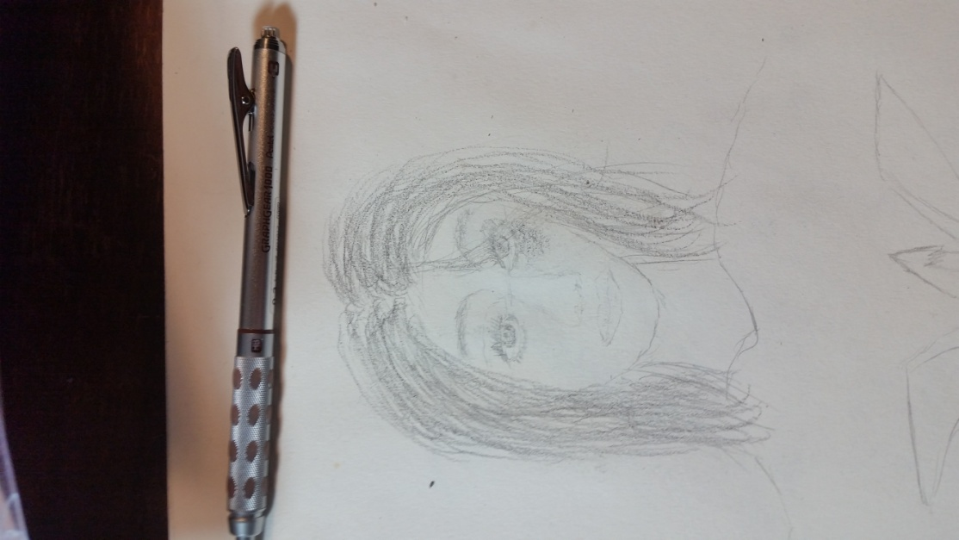
“Why?”
“Why?”
“Yes, why?”
“Well, look at him.”
The cop shrugged. “So?”
“He never had any money.”
“He didn’t?”
“No,” she said. But then she added, “He had money but only enough to pay for Slim Jims, things like that.”
“Really?”
“Yes.”
“He never bought more than that?”
“No.”
“How much would you say he had on him tonight?”
“I really don’t know.””
“Just a guess.”
He was toying with her and she had no idea why. “I don’t know. Five bucks?” She answered.
“Did he rob the store?”
“No,” she frowned.
“Well, he had over fifteen hundred on him. New wallet. No license. No cards. Just cash. How’s that happen?”
Juney said nothing.
“No idea?”
She shook her head.
“Nobody got into the register?”
“Not while I was here.”
“Can you open it for us?”
“Sure.”
They walked up front. She opened it.
“Any money missing?”

She looked at the drawer. “I don’t know. I don’t think so. But I couldn’t say if there’s a couple of twenties missing or something.”
“I’m not talking about twenties. I’m talking fifteen hundred.”
“No, we don’t take in but about a couple of hundred at most at night.”
Another detective broke in.
“Did you know the gun man?”
Ah, there was the question. She asked, “Who?”
“The shooter?”
“No.”
She could feel the eyes of the other detectives on her. Somehow, she knew they didn’t believe her. To help keep her story straight, she reminded herself that she really didn’t know Two By. She knew his real name but that didn’t mean she knew him. She shared an apartment with him but that didn’t mean she knew him. She slept with him but that didn’t mean she knew him. He had pointed a gun at her. No, she didn’t really know him. She thought of all the ways she didn’t know him.
“You’re sure about that?”
“Yes.”
“We called the owner.”
She didn’t say anything.
“Can you stay until he comes?”
She nodded.
Nobody asked if she was thirsty. Nobody asked if she was hungry. Nobody asked if she was tired. Sitting on the stool next to the register, she held her head up with one hand and tried to sleep but she couldn’t. Mr. Nguyen, the owner, came in around three in the morning. He sent her home. None of the police objected.
But she didn’t go back to the apartment. Instead, she found a reasonable hotel and checked in and slept past noon. Given that she would owe two days’ stay, she took her time and showered. She bought toiletries from a kiosk in the lobby and freshened up.
Lying back on the bed, she thought about her options. The apartment was out, forever. So was her job at the store. She couldn’t go back to anything that Two By knew. Her friendship with Bin was iffy. She didn’t know if Two By knew her or not. She liked Bin but not enough, or maybe, too much to put her in danger.
Working through the desk downstairs, she ordered delivery and ate a salad and wings. She saved some for later. She watched TV and thought and hated her thoughts. She didn’t want to go home. All the love had run out for her there.
If she went back, everybody would think she was a loser. Her friends. But then she thought, what friends? She didn’t have any friends that followed up on her. The teachers and school admins? Nobody asked about her. They didn’t care. She had dropped out. Her relatives? They never called her at all. She was just a footnote in the family tree. Her mom and dad? They would probably be the most disappointed. Once she left, she should stay gone. They hadn’t called her.
But, she thought, to be fair, they couldn’t call her. She had bought a burner phone just so they couldn’t call her. She really didn’t know if they had tried or not.
She took a cab to a store and bought some underwear, tees, shorts and a lightweight backpack. She added chips, a couple of apples and bananas.
Later that evening, she tried to sleep after watching the news and a late movie. The bum didn’t make any noise on the evening or the late news. There were too many murders for a bum’s murder to matter. Bin had called a dozen times and texted more than that but Juney didn’t want to reply. Everything was too hot, too mixed up.
All she could think about all night was Two By pointing the gun at her. The bum giving himself up for her. His chest exploding in blood. Bin. Her mom. Her hometown. She was a loser. She didn’t get any sleep.
The next morning she showered and changed clothes. She stuffed the dirty laundry in a plastic grocery bag and then into her back pack. She slipped on her light jacket, despite the warming day. Loser that she was, she knew what she had to do.
She taxied to the bus depot and bought a ticket home. Not to her home she reminded herself, but to her parents’ home. She didn’t see how it could ever be her home again. Not after leaving like she did.
She remembered a line from a poem somewhere that said, “Home is the place where, when you have to go there, they have to take you in.” She had to go there.
Entering the terminal, she found her bus and boarded and then found a seat in one of the middle rows, alone by a window. She slipped her hands into the empty pockets of her jacket and slumped down to sleep. She felt the bus back up and then roll out of the terminal. Even though she had a five hour trip ahead of her, she set the alarm on her phone.
Juney woke up three hours later as the bus bounced along the interstate. She had no one sitting in the seat next to her. Reaching into her backpack, she pulled out a bag of chips and an apple and munched while she watched the trees and the signs and the buildings flash by.
Finished with the apple and chips, she shoved the core into the chip bag and then shoved the chip bag into a side pocket of her backpack. She hoped against hope that she would remember it when she got off the bus but there were so many things to think about. Her mom. Her dad. Her loser life.
No friends. Nobody to love or love back. Except maybe Bin. Bin was a friend but she had to cut her loose. It was too dangerous now that she had the One Big Enemy. A murderer who would have murdered her except for the bum.
Out of all of the guys in the world, she picked him and that showed just what a loser she was. She wanted someone different from her hometown. Someone with steel. Someone who wouldn’t just put up with what life tried to shove at him but would shove back twice as hard. He was tough and mean and he was everything she looked for. And then she realized what that really meant when she looked down the barrel of his gun. She had asked to be killed. Bin tried to warn her and she didn’t listen.
Slumping in her seat again, she stuck her right hand in her jacket. There was something in the pocket. She pulled it out. It was the origami that flew two days before. She lifted it up and let the sun catch the colors. Bin was right. It wasn’t paper and it wasn’t plastic. Juney reached in again and hoped she’d pull out a little slip of paper with the word love even if she couldn’t read the language. But there was no paper.
Her cell rang and, desperate for some good news, she fished it out of her jeans’ back pocket. It was Bin. She hesitated. She didn’t want to put Bin in danger but, was she in any more danger if she answered and didn’t tell her where she was? She answered.
“Juney! Where are you, girl? I’ve been calling you forever. Check your texts.”
“I know, Bin, I know. I’ve been hiding.”
“Juney, you don’t have to hide no more. I got him.”
“What do you mean, you got him? You got who, Bin?” Her heart raced. She hadn’t told anybody about Two By so she had no idea how Bin would know anything.
“Two By. I turned him in.”
“You turned him in. Two By? To who?”
“The screws.”
“You did? Did you tell them about me?”
“No, I didn’t tell them about you!”
Relieved, Juney asked, “But how did you know?”
“I saw him, Juney. I saw him leave your store that night. The night he shot the bum. I didn’t see you but I saw him and I saw the bum. I’ve been scared for you.”
“I was in the back.”
“I didn’t see you. I’ve been really scared.”
“It’s okay. I’m fine.”
“You can go home. Where are you?”
“I can’t go back. They’ll get me, too, Bin,” Juney whispered.
“No, they won’t. They won’t get you. They don’t even know you know him.”
“They’ll know I was his girlfriend.”
“His girlfriend?” For the first time, she laughed. “His girlfriend, girl. You weren’t his girlfriend. No more than the girl he was staying with when they caught him. You are off the hook. They don’t know nothing about you.”
“He was with another girl?”
“Where you think he was when he wasn’t with you? Church?”
“I guess I didn’t know.”
“I tried to tell you that he’s a player. You’re in the big leagues.”
Juney slumped further as she held the phone in her right hand and looked vacantly out the window. Bin’s call brought her up but then she crashed back down. She was a loser.
Her left hand slid into the other jacket pocket. She felt a folded piece of paper. Pulling it out, she told Bin, “I’ll call you back.”
“Where are you?”
“I’ll call you back, Bin.”
She unfolded the sheet of paper and saw that it was a child’s drawing of a broken heart that looked like it had been stitched. She slid the phone into her pocket. She smiled and held the paper so the window’s sunlight shone through it. The stitching was really a bunch of letters. She looked closer. The letters were words. It said,
“Love in any language is all we have to hold our hearts together”
She knew her both of her pockets had been empty. She was absolutely certain. And yet she now had the origami that flew and a new message. A message that she knew was meant just for her and she knew who gave it to her. But how? Her heart felt light, as light as the gold that glittered around the edges of the heart.
The bus slowed down and she looked out of the window and into the late afternoon. It was her stop. Her town. She had no idea how she would get to her parents’ house. It didn’t matter anymore. It was only few miles away from town. She could walk it.
She slid to the center aisle and made her way to the front. No one else had stopped for the town. She thanked the bus driver for an easy ride with a big smile on her face. Five hours ago she wouldn’t have thanked anybody for anything. She stepped down one, two, three stairs and landed on the concrete walkway.
Hitching her backpack, she never looked up until her bus roared away. She moved back. Then, out of the corner of her eye, she saw a long haired, bearded man near the back of the bus, looking straight ahead. She looked over at him. Juney knew it couldn’t possibly be him. He had a hard guitar case standing upright next to him. She looked after the bus until it was a few blocks away and then felt for the paper in her pocket. It was still there.
“Juney! Juney! Over here!”
Her mom called for her as she stood across the street. How could that be?
Her dad was right behind her mom on her shoulder.
Juney ran across. Her mother met her in the middle of the street. They hugged and kissed. They pulled away.
“How did you know?”
“We had a text.”
They hugged again.
©2019 Bill Judge

