**Frequently Asked Questions**

**The Songbird or 2Lakes’ Cottage**

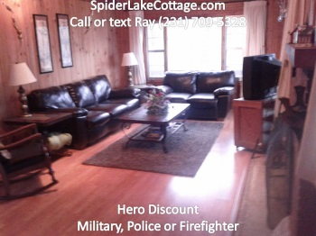 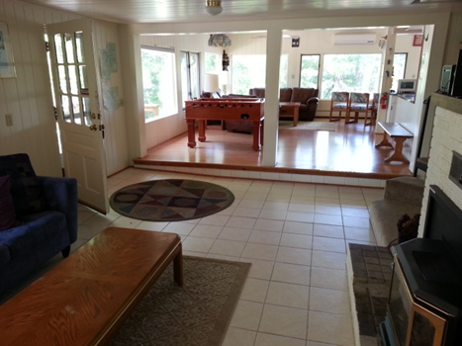

**Webpage** [**SpiderLakeCottage.com**](http://www.spiderlakecottage.com/)

**Ray contact info; 231.709.5328, call or text**

**Email;** [**spiderlakecottage@gmail.com**](mailto:spiderlakecottage@gmail.com)

**How big are the cottages? How many people can it handle?**

* **Songbird:** This cottage hosts 14 persons. It is lovely knotty pine, six bedroom,7th sleeping area with a bunk bed and double pullout, 2 full bathroom home, 2500 + square feet, Air Conditioned, three decks, 2 covered, 2 docks, swim raft, beaches, fire ring, free rowboat, kayaks and a pontoon are available for rent, hot tub large windows, Foosball, Ping pong, corn hole toss that sits only 45 feet from 270 frontage feet of beautiful lake front on Spider Lake.
* **2Lake:** This cottage hosts 14 persons. Of the two cottages we own, 2Lakes, this is our deluxe cottage; It is spacious, six bedroom,7th sleeping area with a double pullout, 2 full bathroom home, 2500 + square feet, Air Conditioned, three decks, 2 covered, 2 docks, 2 beaches, fire ring free rowboat, kayaks and a pontoon are available, hot tub, Foosball, Ping pong, corn hole toss, large new windows that sits on two different lakes with over 2200 lake front lake frontage from the full recreational Spider Lake and Bass Lake a fishing lake.

**Can you describe the cottage a little more?** Listen to the Loons in the morning and evenings...it’s fun, beautiful, and romantic -- a HOT TUB, kayaks, pontoon boat are available and free row boat at both cottages.

* **Songbird Cottage:** There is a ping pong table, corn hole game, foosball table, 2 SMART TVs one with DVD, WIFI, and two swim areas, two docks, a swim raft and fire ring. Outside you get a large outside deck for grilling and two additional decks and one wrap around, the other a covered area. There are two docks, two swim areas. This is a fun cottage in a quiet cove that opens into the main part of the lake. Its sits on scenic, private lake shore on over three acres of wooded setting, privacy is assured. The cottage is all knotty pine, fully AC, large 2500 plus, a full bathroom upstairs, two bedrooms upstairs 2 King beds, with living room, sofas chairs, fireplace and WIFI, TV, 12 seat dining table, Foosball Table, kitchen, and upper deck. Downstairs is another very large full bathroom, four downstairs bedrooms 1 king, 2 queens and 2 twin beds; these rooms are very quiet and sleeping is wonderful on quality mattresses. The large 7th sleeping area combines a living room with a bunk bed, double pullout couch and another sofa and SMART TV/DVD, more furniture and an additional reading room with lots of books. This property is very socially interactive with the boats going through the channel and people waving and having fun.
* **2Lakes Cottage:** This cottage has views that will knock your socks off. Its very open on the main floor, guests have named it the gathering room. But the cottage and grounds are big and spacious so everyone can find their spot for privacy. There is a ping pong table, corn hole game, foosball table, 1 SMART TV one with DVD, WIFI, and two swim areas, two docks, a swim raft and fire ring. Fishermen love this cottage because of the two lakes, Bass Lake is under-fished and Spider Lake is huge. The front porch is gigantic and it’s a favorite hangout. In the back, you get a large outside deck for grilling and a third deck down at the Bass Lake beach. This is a fun cottage in a quiet cove that opens into the main part of the lake. Its sits on scenic, private lake shore on over three acres of wooded setting, privacy is assured. Read about the rooms and beds below.

**What kind of beds and how are each cottage situated?**

**The Songbird Cottage**

* **Upper level**
* 1st Bedroom, Main Floor, King, King Koil, comfy
* 2nd Bedroom, Main Floor, King, King Koil, comfy
* **Lower level**
* 3rd Bedroom, King, King Koil, comfy, cooler in summer but there is AC if you want it
* 4th Bedroom, Queen, King Koil, comfy, cool in summer but there is AC if you want it
* 5th Bedroom, Queen, King Koil,, cooler in summer but there is AC if you want it
* 6th Bedroom, 2 twin beds, cooler in summer but there is AC if you want it
* 7th sleeping area is a 2nd living room with a queen pullout and bunk bed

**2Lakes Cottage**

* **Upper level**
* 1st Bedroom, Main Floor, King, comfy
* 2nd Bedroom, Main Floor, Queen, firm mattress
* **Lower level**
* 3rd Bedroom, King, King Koil, comfy, cooler in summer
* **Loft; the loft has irregular rooms and lower ceilings in the kids room**
* 4th Bedroom, Queen, King Koil, comfy
* 5th Bedroom, Queen, King Koil, comfy
* 6th Bedroom, 4 twin beds, kids room
* 7th sleeping area is the fireplace room with a double pullout.

**Can you tell me a little bit about yourself?**

* I enjoy talking to my guests. I'm a retired U.S. Army officer (2006) with multiple tours in Iraq and Afghanistan. It is now my mission and passion to provide your family and excellent, fun and safe vacation rental experience at an affordable price. I pride myself in giving good service, almost always greeting you; explain the home, the area and then providing 24/7 phone service and assistance if needed. If there is anything you need, please let me know ahead of time, that way I can try and make it happen. While I do not provide a concierge service, please ask. I enjoy sharing my inside knowledge of Traverse City, Leelanau Peninsula and the region, there is a ton of things to do. We know that by providing the best equipment, location and vacation experience, our guests will create memories that will last a life time and keep coming back for more fun. Seeing smiling faces, hearing the great stores and seeing the family picture is a part I enjoy the most.

**What is Grandma Authority?** Grandmas are the clever ladies with tennis shoes who spend hours planning the trip so that your family is strong and loving. Grandmas have the authority during the vacation to confiscate all electronic devices and handout fishing poles as a substitute. No further explanations are necessary.

**Who stays at the Spider Lake Cottages and why?**

* Anyone that is a decent person/family, there is no creed, religion, culture, sex or color we don’t like and we routinely host guests from Europe, the Middle East, Africa, all over the U.S. Everyone flocks to the Traverse City region to get rest, relaxation, hit the wine tours, microbrewery, swim, events, Cherry Festival, Movie Festival, etc. We had many combat veterans, police, fire-fighters, Olympians, the first American to win the last leg of the Tour of France, directors from one of the movies Batman, artists, musicians, families, lovers, doctors, lawyers, grandmas, kids… basically the most amazing groups of people and we are constantly impressed. Some of my best friends were former guests and we stay in touch. We all agree, the cottages and beautiful area that so powerfully affected me while deployed to Iraq and Afghanistan, will affect you too. You will find a place of healing and beauty that is almost indescribable.

**Have you ever had problems with the renters or property as a vacation rental?**

* Let me explain the difference between a guest that legitimately complains and a guest that willingly deceives/disrespects/damages/condescending and is mean towards the owners or workers. A guest who legitimately complains because the hot tub was left cloudy or a blender piece was missing or the cleaning was not up to our professional standard is correct to point that out. We are fast to fix those concerns if the guest lets us know within the first hour inspection of their arrival as part of their check-in. Rarely, do we ever get unreasonable and mean guests. Sometimes, a guest accident happens and the property unintentionally gets damaged because a giant 6”5 15 year old teenager, full or energy, crushes something, then sheepishly gets up and says, “oops, sorry Grandma”. Parents who tell me something gets got broke get the fast discount repair. Deceitful guests, who hide it, get charged the full price….The guest below refused to leave so we melted him!
* 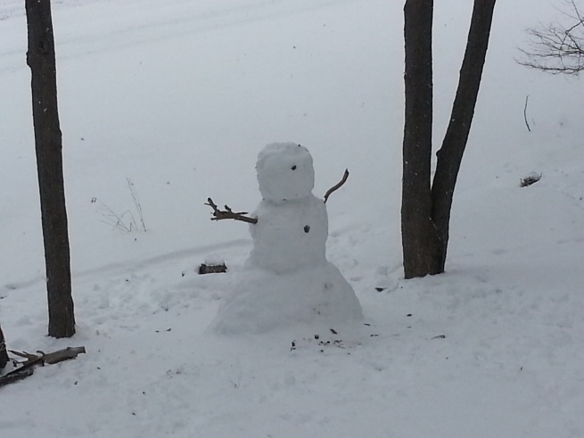

**What parking is available?**

* **Songbird Cottage** The property has limited parking usually 5 cars. If you have more please ask. We do not permit RVs, tents or trailers without written permission from the owner. Just ask, thank you.
* **2Lakes Cottage** The property very good parking, usually 7 cars or more. If you have more please ask. We do not permit RVs, tents or trailers without written permission from the owner. Just ask, thank you.

**What kind of BBCUE grill do you have? What kind of grill does the cottage have and do you provide fuel?**

* **For Both Songbird and 2Lakes Cottages**. We provide the same top notch Weber grill, Genesis 310. It has lots of grilling area so it can handle a large group. We provide one bottle of propane for one stay. It is a Weber, three burner grill, and each burner unit individually lights, you set it on start, press and hold in each burner control while pressing the ignition button. It’s a good quality grill. We do not permit charcoal due to the fire hazard unless you have the owner’s written permission. There is a separate grilling area for your chefs to have lots of fun. We do expect you to clean your messy grill, dispose of the grease in the grease pan in the garbage and put the cover back on or get a reasonable fine. Please do not remove the grill from the fire safe grilling area.

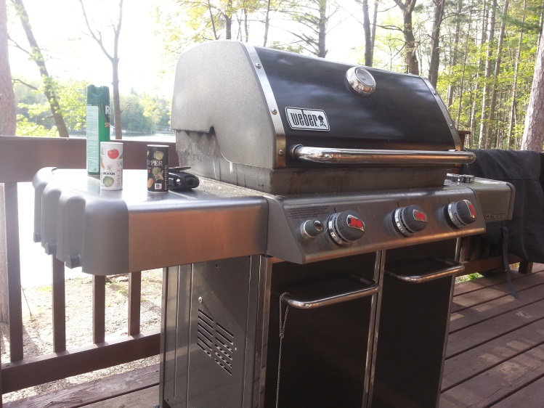

**What is the Lake Description?** Spider and Bass Lake are Glacial Lakes, spring fed, no rivers or streams flow into them. They are very clean, sandy, swimming, boating, full recreational lake. Both cottages are nestled in a quiet cove off Spider Lake where there is tubing, jet-skiing, sailing, kayaking, swimming and two private beaches. You will enjoy great swimming with many sandy islands on which to picnic. Spider Lake teems with bass, bluegill, perch, pike, and crappie contained within 27 miles of shoreline. Bass Lake is the fisher's secret fishing lake and is perfect for swimming and peaceful row boating. Most of our serious guests who are fishermen demand to stay at 2Lakes because it is on two lakes, 800 feet of Spider Lake frontage and 1600 frontage on Bass Lake. The Songbird has a respectable 270 ft of lake frontage with beaches.



**Is Spider Lake a full recreational lake? Can you swim in it? Is there Lake Itch?**

Spider Lake; Spider lake is a glacially formed Lake of 27 miles of lake front, sandy and is totally spring fed, the comes up from well spring in spots throughout the lake, there are no rivers or streams leading into Spider Lake to contaminate it so it is very clear, clear and pure Michigan. Swimming is excellent. There has never been any lake itch in the past. The lake is full recreational; meaning skiing, tubing, jet skis and pontoon cruising is excellent. There are five islands on the lake, three are Public Island, one is especially popular and called Party Island, or Sandy Island or Island number 3 where everyone gathers to swim, fish, socialize. The water is warm from Jun to late Sep for swimming. Memorial Day swimming is authorized by 12 year old boys and girls.

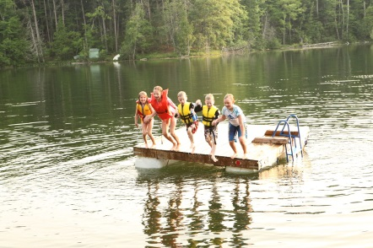

**What is the beach like at the cottage?** Because the lake is a natural glacially formed lake, it’s mostly sandy and not rocky or weedy around the cottage beaches. Our beach is gently sloping with no drop-offs; we groom the beaches with both an aqua blaster and Lake Rake. We also bring in extra sand for the beach just to build it up more for the kids to play in. You can swim anywhere on the property and we have a swim raft, 2 docks at each cottage.

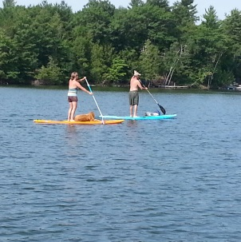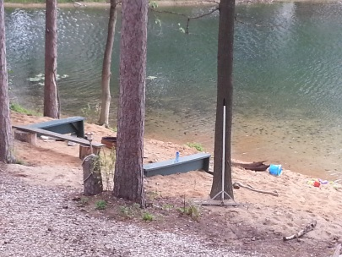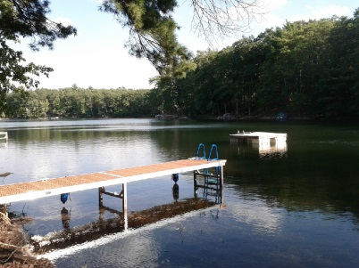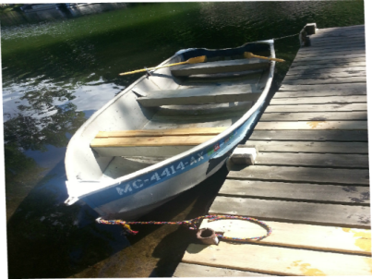

**What are the lake rules?** Spider Lake is a self-regulated lake so everyone can enjoy it better.

* From sunrise to 1130am, the whole lake is no wake for kayakers, canoeing, swimmers, paddle boarders, Buddhist monks and sun worshipers.
* From 1130am to 730pm, its full throttle, skiing and tubing. If you ski or tube it is COUNTER clockwise to pull. Then it calms down again at 730pm to dusk to no wake.
* You will greatly appreciate this, this is the only lake in Northern Michigan that does this and it is totally self-managed and guess what? Everyone pretty much follows the rules and loves it.
* Stay at least 100 feet away from the Loons. I wrote a song for the Loons called “Boat kill Loon Meat Sold Here.”

**What is the fishing like on Spider Lake?**

Spider Lake is one of seven fishing tournament lakes in the area. Also, if you want to fly fish, the Boardman River is only 3 miles from the cottage and Ray knows all the secret fishing spots. Plenty of fish species; several Bass, large mouth, small mouth, rock; perch, crappie, walleye, pike, sunfish and sunfish.

The property is a combination of woods and sunny yard; if you want to catch some rays you can.

Two docks, to fish from, or Moore your boat, tie your boat and all boats tight to the dock with at least two bumpers. Bumpers are not provided.

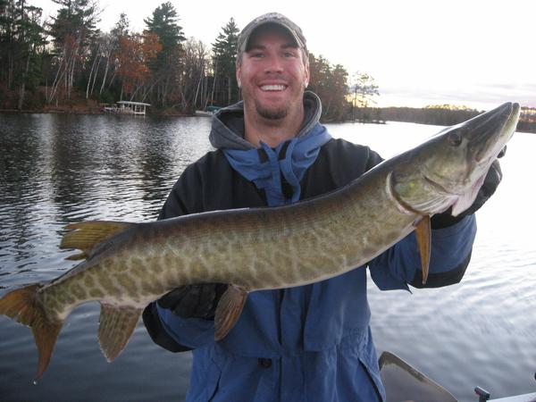

**What is the difference between 2Lakes Cottage and the Songbird Cottage.**

* We have two properties available to rent, 2Lakes and the Songbird at spiderlakecottage.com so take look, both are approximately equal in amenities, also in house size. 2Lakes is like sitting on top of the Grand Canyon, the Songbird is like being at the base of the Grand Canyon, its perspective. 2Lakes has a road between it and the 800ft of privately owned beach and lake front on Spider Lake, however, it has 1600 feet of lake front on the under fished Bass Lake with a another private beach. This makes for magnificent views and fresh lake breeze. The 2Lakes property is super private. It also has almost four acres. The Songbird is private but you can see the across the lake to the neighbors. 2Lakes has THREE full bathrooms versus TWO at the Songbird. 2Lakes has a spiral staircase to the upstairs the Songbird has regular stairs. 2Lakes loft bedroom are cozy and have irregular shapes, lower ceiling yet one room designated the kids room comes with four twins, while the Songbird has more regular sized rooms and the 7th sleeping area/2nd living room has a double pullout and a bunk bed and extra couch. The Songbird is 45 feet from Spider lake, 2Lakes is 75 feet off the back porch to Bass Lake and 150 feet from the front porch to Spider Lake. 60% of families choose 2Lakes, the Songbird has its own loyal tribe of followers too. 2Lakes kitchen table is smaller but you have a pullup table, a picnic table on the back porch and a table on a covered front porch. Songbird has a corporate dining table with plugs and seating for 12. Both have place setting for 14 or more. It really comes down to your own personal preference. It is easy to keep an eye on young children around the water at the Songbird cottage because you are closer to them from the cottage to the lake. I like both of them, I spend most of my time at 2Lakes in the winter but in the summer at the Songbird because it’s great to play guitar there. Sorry, we are not handicapped equipped or allergy free.

**How long does it take before this “healing place” kicks in?**

* When you open your eyes and mind, it happens the moment you arrive. I can often see it in our guest’s eyes. My theory is, if your mind is troubled, it can take 24-48 hours, usually a person doing corporate attorney work is troubled! However, once you relax your mind, the effects of the Great Up North take hold quickly. We suggest you actively go out and “discover the place to sit” on the property, try by one the lake. I don’t meditate but I do things that make me feel at peace and that are good for me, like playing guitar with my jam buddies and drinking mead. I also like to get up early before everyone else, listen to the loons and play guitar. I will take your concerns seriously, but please take these comments seriously too - *you are coming from a crazy fast paced environment, now it time to slow down and find your place to heal, love and enjoy your family because that why you came here.*

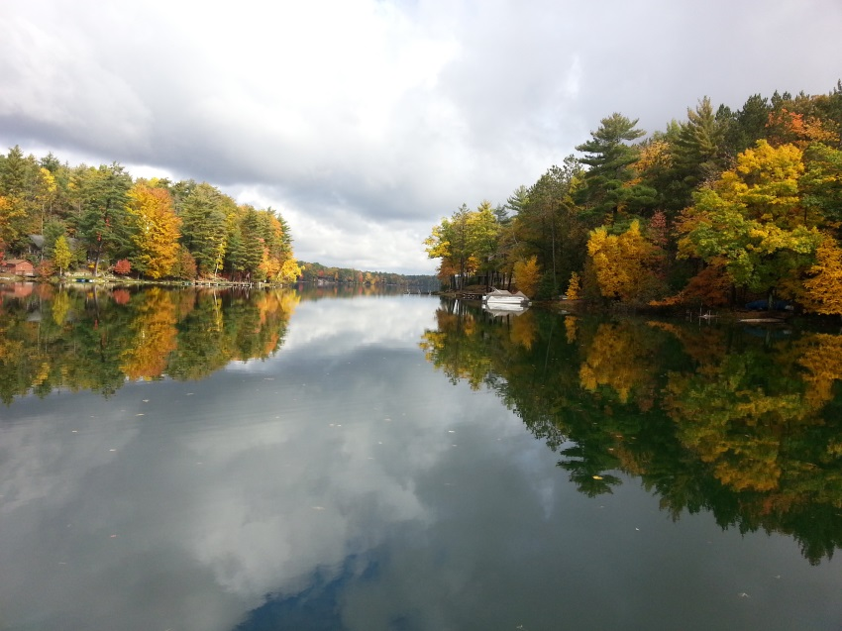

**Can we bring a RV or setup tents?** We do charge an additional fee for these requests which must be made in writing in the contract but we almost always honor those requests.

**Is the internet fast? I work on the internet so it’s important to me.** We have Charter broadband and it routinely runs Netflicks, music and everything else that a large group uses it for without issues.

**How far is it from Traverse City?** Traverse City is only 10-15 minutes away. Its close but you are also able to keep your privacy and Up North feel without all the craziness of down town with people crawling all over you.

**What is your pet policy?**  We like dogs, please bring them, why leave them in a kennel to get kennel cough and make them feel like they were abandoned? You will feel bad and so will they because they are simple and loyal creatures that only love. It’s cheaper to pay a small pet fee to us instead of you and your friend going through all the stress of a kennel. Please bring a crate for when you leave the cottage, place your friend on a leash outside and pick up your pet waste.

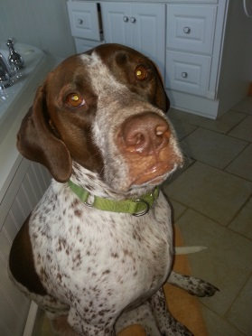

This our dog, Crazy Hank, an escape and con-artist who loves to go out hunting for unsuspecting tourists to give him a ride around in a car until we are called to come pick him up. Loves anyone from New York, Ohio, Indiana, Illinois, basically anyone and everyone. If you see him, just wave and pass by, he comes home faster.

**There is a ping pong table and Foosball table at both cottages.** Usually there are balls available but sometimes they disappear after a guest so we request our guests to bring a foosball and ping pong ball with them.

**What amenities are at the cottages?**

* **Songbird Cottage**: We have a seven person Nordic Hot Tub Warrior XL and WIFI. Two SMART TVs with one DVD player, board games, Full Kitchen, large Refrigerators, Pots, Pans, and cooking utensils. Fully furnished with bedding, (you bring the towels, Three large decks, 1.5 are covered - to sit and watch the wildlife or entertain, Outside is a Weber grill, plenty of quality chairs and tables. A fire-ring with benches for GHOST STORIES, there are two docks, 1 beaches and 2 swim areas and 1 raft. Each cottage has a free rowboat. The kayaks and pontoon boats are available at an inexpensive price for our guests only. All swimming and boat use at your own risk.
* **2Lakes Cottage:** We have a seven person Nordic Hot Tub Warrior XL and WIFI. 1 SMART TV/DVD at 2Lakes. A Full Kitchen, large Refrigerators, Pots, Pans, and cooking utensils, Fully furnished with bedding, (you bring the towels, Three large decks, 1 giant covered deck- to sit and watch the wildlife or entertain, Outside is a Weber grill, plenty of quality chairs and tables. A fire-ring with benches for GHOST STORIES, there are two lakes, 2 docks, beaches and a swim raft. Each cottage has a free rowboat. The kayaks and pontoon boats are available at an inexpensive price for our guests only. All swimming and boat use at your own risk.

**Do you provide life jackets for adults and children?**

* We provide lifejackets for the purpose of the boating activity if you rent a boat for adults. We urge you to provide lifejackets for children and do not provide lifejackets for children because they often need special fitting. Its much safer for families to purchase a life jacket for their children then risk an ill-fitting life jacket. If you do not rent a boat, please bring your own life jackets. Always place life jackets back in the boat securely.

**What is the reservation and cancellation policy?**

We advertise on several websites so third party policies apply individually, please refer to those for specifics. To reserve a cottage full payment is due the day of the booking with a signed contract, minimum 25 years of age. Cancellations are non-refundable 180 days from the date of arrival.

**What are the rates for rental?**

* We advertise on several websites so third party charges and fees are different and apply.
* The rates change based on the season.
* Our pricing depends on how many total guests over the entire rental period. Additional people over 14 are charged and must provide their own linens and blankets and sleeping pads.
* In the off season we rent for 2 night minimum.
* In the summer, rent for 7 days, SA to SA minimum. In general, we are $1,000 less then our competitors yet offer better locations, quality cottages and more amenities; hence, we stay fully booked.
* A weekly pontoon rental is required if you book a week in the summer.
* Infants and children are counted as people too, they produce a lot of waste!
* Pets are charged a $250 pet fee, maximum 2 pets. If you have a special situation please ask me.

**Will you hold the cottage while I check with my family members?**

Yes, we will hold the cottage with a payment but no without a payment. If you are sure you want the cottage, we have a $500 Peace of Mind reservation, nonrefundable, 10 day hold fee, which is credited to the balance. The 10 days allows you time to complete the contract and send in the complete payment. If you change your mind in the 10 days you forfeit the $500 dollars and the reservation is cancelled.

**Do you take credit cards and checks?**

We accept credit cards Master Card, VISA, Discover, Paypal and American Express. We charge an additional fee of 3% to use a credit card. We accept checks also and they are free. You may send either a scanned copy of the front and back of the check by email or a photo copy of the signed contract. If you make a payment using a credit card, then you may also send the contract and payments by snail mail.

**Can you let us see the property before we rent it?** Unfortunately, we do not permit this ever. Due to the abundance of scams, cons and our security concerns for our currents guests we do not show the property. Instead, we will provide volumes of pictures, descriptions and guest reviews so that you may feel comfortable as a guest. Our exterior electronic security will alert us to violators.

**How do I get the property address and key?**

Once an initial payment is made, we will provide the address and entry code to get into the property by email.

**Can you describe the Pontoon boats and policy?**

We combine older quality pontoon boats with newer Honda engines that we rent only to our guests at a much lower price than the boat rentals. We keep them in good operational care. On the 24ft pontoon, 40hp Honda our seating is soft and comfy for grandma and the pregnant spouse. Each pontoon has a Bimini cover, lifejackets and ladder and anchor. Our 21ft pontoon is a fish and cruise with a 15hp Honda. These engines are well maintained, highly fuel efficient and extremely reliable. You will not use much fuel because of the efficiency of the engines but it depends on how you drive too. For only the 24ft pontoon, we will provide you with a tube, bridle and rope. Please do not use your own equipment, we do not permit that. They require marine grade fuel with no oil. The guest is responsible to purchase marine grade from us or purchase it themselves Courtades Trading Post 233 High Lake Road, Traverse City, MI 49696 prior to departing. We provide a five gallon gas can. Swim and boat at your own risk.

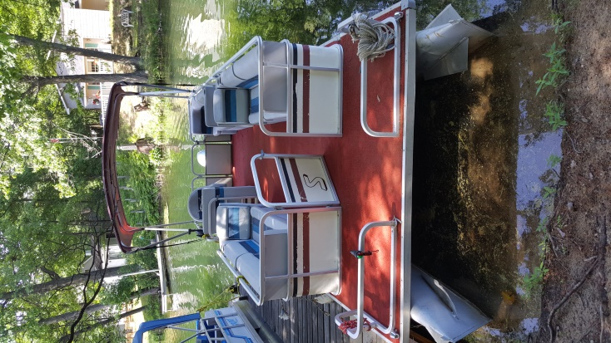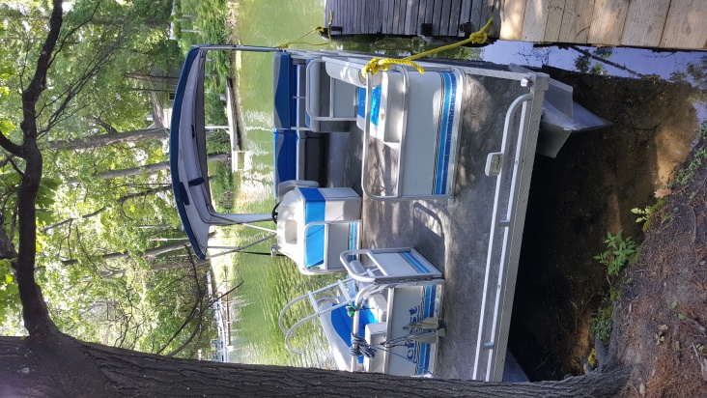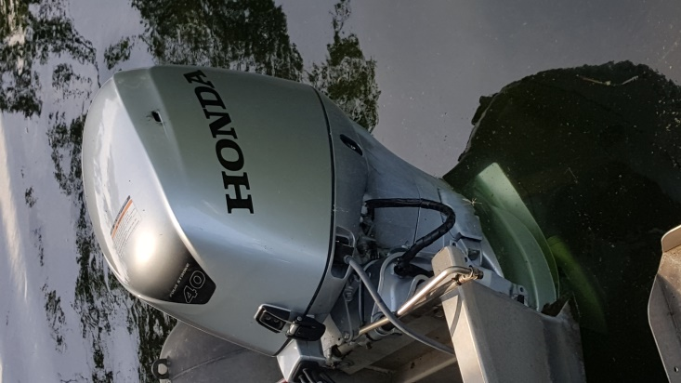

**What is the reason the pontoon boat is required to book a reservation for the peak summer prior to 1 Jun?**

A weekly pontoon rental is required if you would like to reserve one or our cottages from Memorial Weekend, Labor Day Weekend and from 2nd week in Jun to Labor Day Weekend. Other dates are only encouraged. The reason we do this is because we have invested $35,000 to provide these awesome pontoon boats for our guests while keeping the prices low. All our guests who stayed with us greatly appreciated the pontoon boats as they add a HUGE fun aspect to their stay on the lake. Unlike boat rentals that charge three times our rates, drop off a beat-up boat, abandon you until pickup time at the launch, possibly leave you in the middle of the lake if it breaks down without rescue, we don’t do that. We are there to help no matter what. You won’t have the headache of coordinating a drop off time, deciding when to go on the pontoon or when to take it back, where to get fuel or a tube, ladder or paying way too much for your pontoon boat.

**How do we check in, what are the procedures?** We require the contracted person to arrive the day of check in between 3-5pm, present a valid government ID and complete the arrival inspection. You may delegate this in writing however you are still responsible for everything regardless of who checks in first. The person checking in must provide a valid ID, be 25 years old and sign is responsible for you and themselves for all guests and the arrival inspection. This insures that everything is working and anything that is not working is identified and repairs are either done on the spot or planned. Unfortunately, we cannot permit entry without the check in process completed or full payments received in advance.

**How do I coordinate before the trip?** It’s important for you to relay all important questions as the groups’ single point of contact to me. We will do our best to provide you the information needed.

**Do you have any suggestions for families that don’t get together too often?** Yes, be nice and guard your mouth. Friendly family friction is normal but when it turns ugly, take a walk then apologize before the sun goes down. Also, everyone is different, plan to go in five directions, and don’t try to force everyone in one direction.

**There is a ping pong table and Foosball table at both cottages.** Usually there are balls available but sometimes they disappear after a guest so we need our guests to bring a foosball and ping pong ball with them just in case.

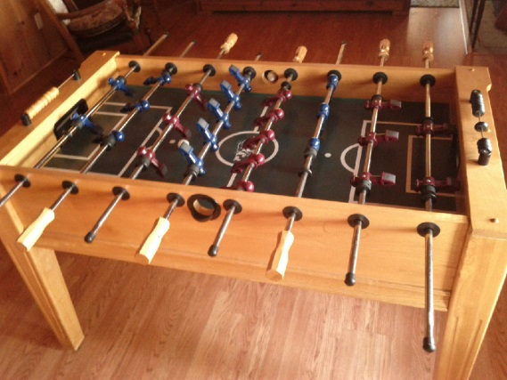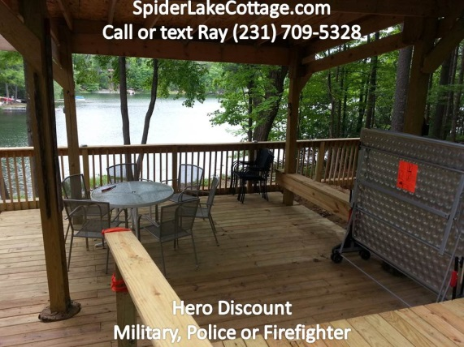

**What is the kayak rental policy? How many kayaks are available?**

Normally, we have three kayaks available at each property for rent. We only charge $25 per kayak per week with paddle and vests included. Most of the kayak income goes to charities; both school snacks for the kindergarteners and to put military dependent children through Camp Hayo Went who have either lost a parent or have a severely wounded parent as result of combat. Out in town, you will pay $125 per week or more per kayak. We only charge a basic minimum so we can keep buying replacement equipment and keep our guests happy! You can drop cash in the cash box or pay online at <http://www.spiderlakecottage.com> or just call me and we can charge your credit card.

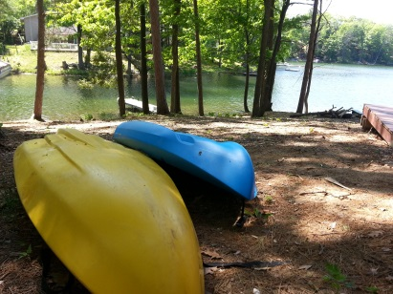

**How is the cottage heated and Air Conditioned?** 2Lakes is air conditioned on the main floor. Songbird has central AC. Both are heated centrally. There are also fans in both cottages.

**Does the cottage have a yard for our games?**

Our Yard is large, gently sloping to setup your games; we provide corn holes, ping pong table, foosball table, and basketball hoop. It’s a combination of woods, beaches, docks and water on 3.5 acres. The picture below is about a quarter of the yard by the beach.

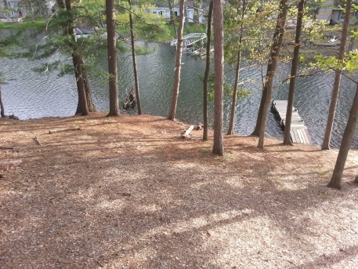

**Is there a fire pit on the property? Do you have wood available?**

We have a large fire pit with benches and have wood available. Please check the fire pit in the daytime so you know where it is and prepare it BEFORE dark. You will need flashlights to get down to it as we respect the great outdoors and do no pollute with flood lights, how else will you see our wonderful Milky Way galaxy or the Northern Lights? Also, bring drums, shakers, guitars and get a drum circle going. We have three benches around a fire pit on the property. You can purchase wood from us or out in town. Winter fire pit are also the best. You can purchase bundles of firewood from us, we deliver and stack bundles, you may use them as you need them and pay each time with the cash box or pay online at <http://www.spiderlakecottage.com> or just call me and we can charge your credit card.

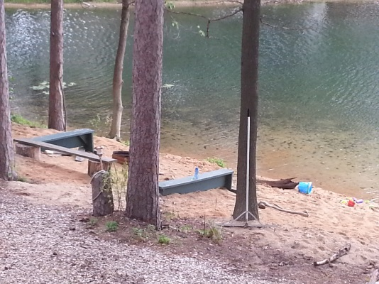

**How do you maintain the landscape?** We mostly let Mother Nature do the work with native species, plants, trees and grass. We have found over time, that natural landscape supports the environment the best, it also brings in the wildlife and doesn’t pollute the lakes with fertilizers. We usually only do a leaf cleanup around certain areas just before Memorial Weekend and cut the grass every two weeks or as needed. We periodically rake the beaches, keep it sanded and rake around the fire pit area. Please don’t expect a highly groomed landscape that you will find at the Wolf Lodge, this is an Up North cottage that is well maintained. At Songbird we use woodchips too, they are really nice to walk on.

**What do you provide in the kitchen?**

At 2Lakes, the kitchen has all the basics plus more; pots, pans, blender, crock pot, lots of utensils, plates, bowls, glasses, wine glasses, double sink, stove and oven, very large refrigerator, toaster, microwave, CD and radio player, coffee maker. It is not an Italian kitchen with Chef Vacation-n-echelli items, we go to Meijers every year and restock. Songbird kitchen has everything 2Lakes has but no blender. We provide dishwashing soap and dishwasher soap. We provide a basic supply of paper products and then the guest must purchase their own. We do not provide condiments or coffee and filters. Here are some pictures too, at the time of the pictures my spouse was restocking to 14 sets which are not shown.

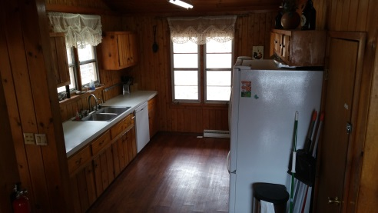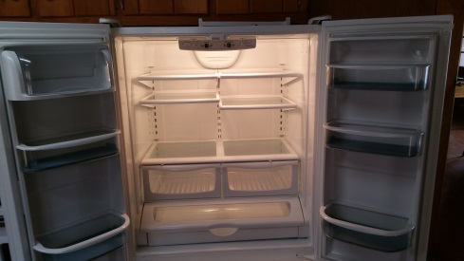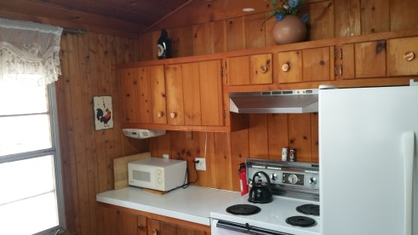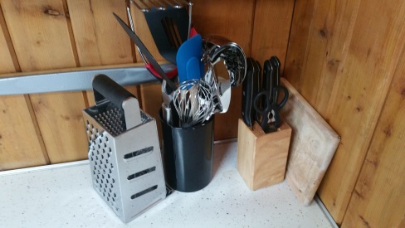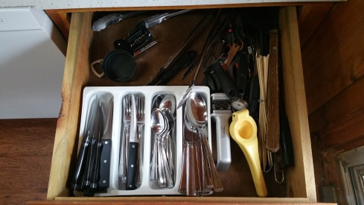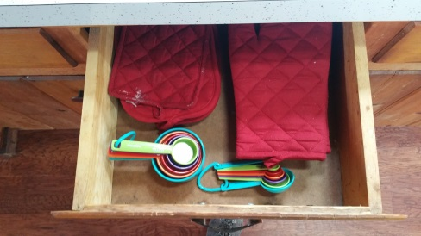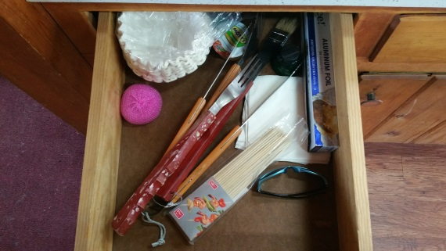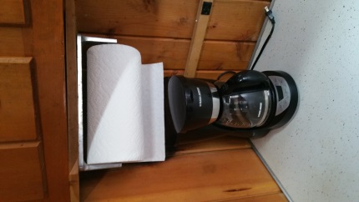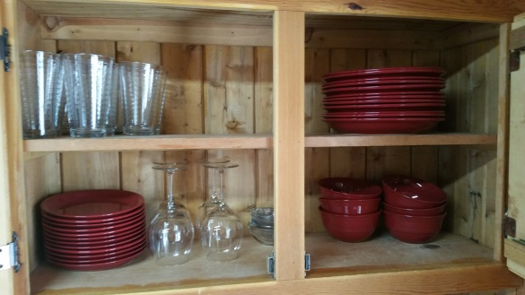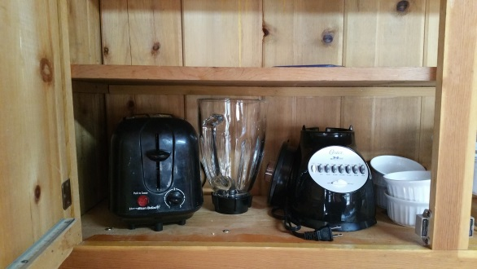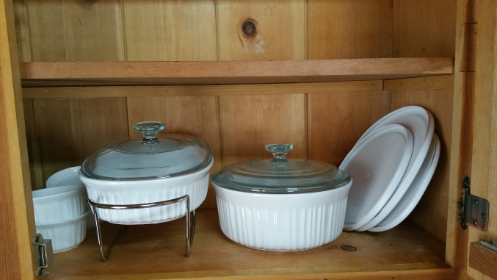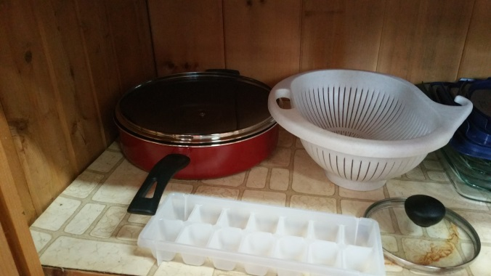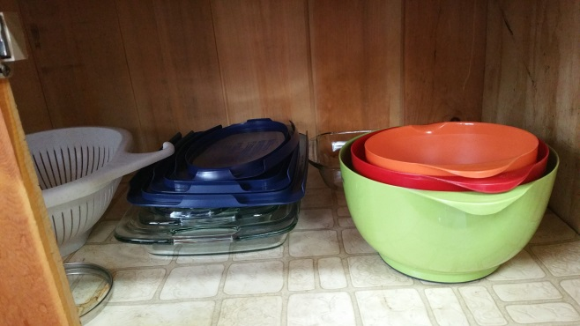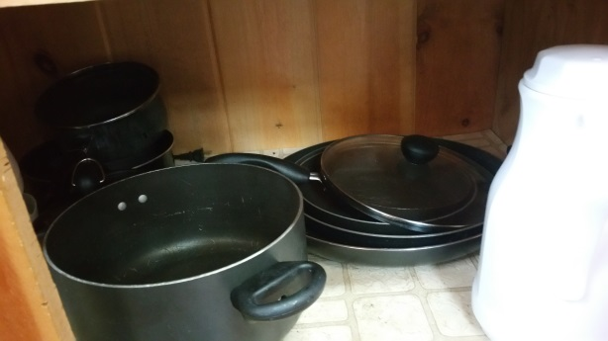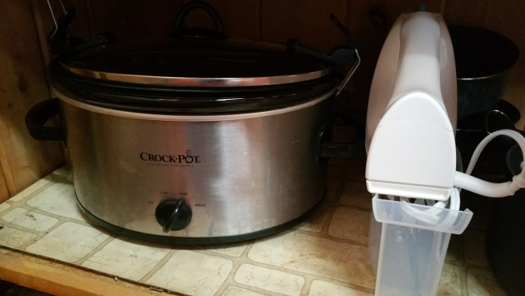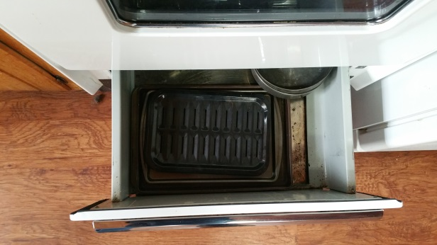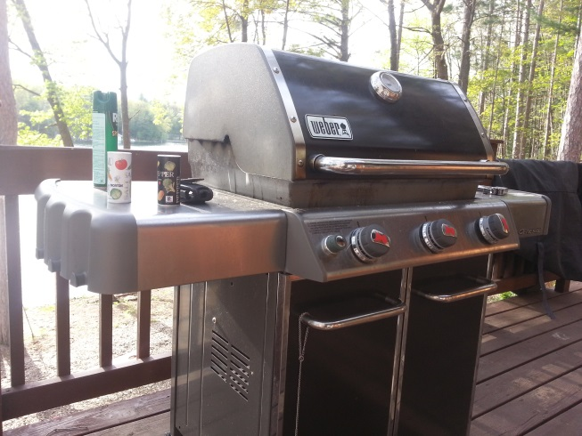

**Do you provide Linens, bedding, towels and soaps?**

We provide linens and bedding for each bed. If an additional guest is purchased beyond our bed space, the guest is responsible to provide linens, bedding and air mattress. The guests must provide their own towels, hand soap and laundry soap. We do not make the beds up but place the bedding and linens on the bed, this way our guests know that the items are clean.

**Do you provide maintenance and repair?**

We provide ourselves in keeping our cottage in good operational condition. We are both owners and managers of our cottage so there is pride there. If something does go wrong, I’m always available to fix it 24/7 or get schedule a professional if needed. I don’t provide concierge service, sorry. I try and provide great communication to answer all their questions at any time, please ask.

**In the winter is there any snowmobiling in the area and rentals?**

We have the snowmobile trails in both the front and back yards with direct access to the VASA trails. We are actually on the trail between Peegeos Pizza and Ranch Rudolf. You will hear caravans of snowmobiles in the day and evening of people having fun. Blue Sky rentals is one of the many rentals in the area.

**What kind of hot tub is it and how many people can fit in it**? It is a Nordic hot tub for water spa therapy and treatment. Its round and can fit 7 people.

**Do you provide free tourist advice and suggestions?**

We pride ourselves in providing great free insider tourist advice for any venue or experience to our guests. We have no problems sharing that advice but the best advice, trips, secret fishing spots, events, people, musicians, kayak launches, restaurants and beautiful spots are kept locked in the advice vault only for our guests. Much of what I suggest is on our website <http://www.spiderlakecottage.com>

**What is the closest place to buy groceries and a fishing license and bait?**

Getting Groceries - Olson’s @ 3 mile and Hammond Rd. - Fishing supplies at Roy’s Grocery and Hardware @ 3 mile and Hammond Rd

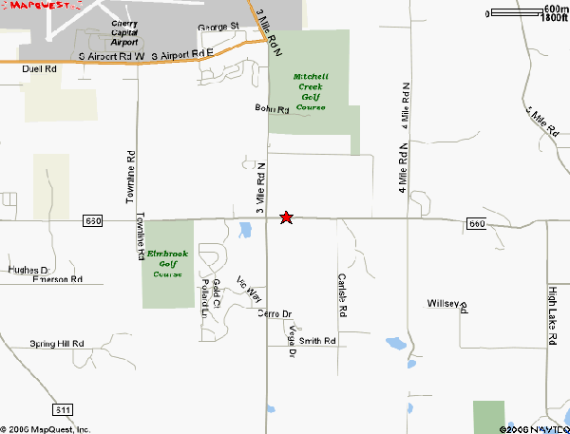

**What items would you suggest we bring**? Check out our website, I usually update that first too. Suggested Things to Bring: GUITARS! bug spray, drums, shakers, musical instruments! Artistic supplies! Cell phone (no phone in cottage) - a USB or HDMI cord to hook up TV to computer, Bath/Beach Towels - TWO bathing suits, one for the lake, one for the hot tub, paper products, dish washing soap, laundry detergent - Bar soap or body soap - Mosquito Bug repellent - Kids life jackets (we provide adult and recommend you specially fit your child) - Sun Block - Hats - Snorkel, fins and face mask - Swim goggles - swim shoes - sandals - hiking shoes - A good novel - Your favorite DVD movies - Bicycle and helmet - Fishing poles and tackle - Binoculars  - Sand toys for kids - Camera - Deck of cards (we have lots of board games) -  paper plates, plastic (knives, forks, spoons) napkins (dishes/silverware provided but you will tire of washing) - Kleenex tissues - napkins - paper towels - Extra Toilet Paper - Baby wipes - Spices - Prescription medicines - First Aid Kit - bee bite kit.

**What basic products do you provide for your guests?**

A basic issue of garbage bags, toilet paper and paper towels. The WIFI free, corn-hole game or bean bag toss,  Ping Pong table, paddle and balls, bed linens, Foosball table, ping pong table, hot tub, lots of kitchen items, coffee makers, crock pot, plates etc, lots of old fashioned board games, books and more books, row boat, kayaks, pontoon boat, one propane bottle per stay, ghost stories (ask me about John Thomas....), lots of fish...we are your personal guide for the area too. A 5 gal gas tank to refill the pontoon boat with Marine grade gas. Soft-soap in every bathroom and kitchen, dishwasher soap, dishwashing soap.

**What things do you not provide?**

Towels, food, Laundry soap, Coffee and coffee filters, Condiments, basic issue of garbage bags and paper products, we do not provide those items for the entire stay. Baby Crib or baby chair, children life jackets, cable TV, a phone, pingpong balls, Foosballs, fishing gear, bikes, water toys, we don't provide free kayaks or pontoon boats.

**2Lakes Cottage**

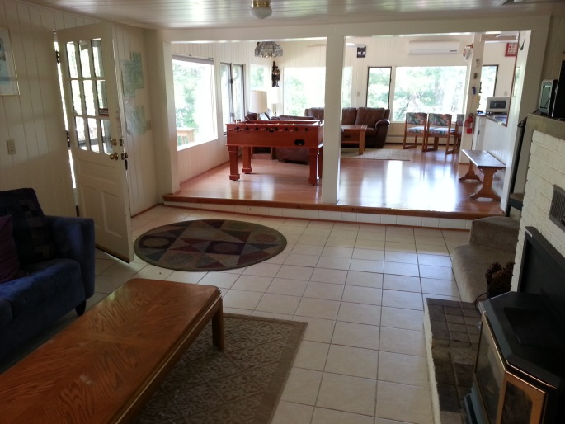

**Webpage** [**SpiderLakeCottage.com**](http://www.spiderlakecottage.com/)

**Ray contact info; 231.709.5328, call or text**

**Email;** [**spiderlakecottage@gmail.com**](mailto:spiderlakecottage@gmail.com)

**How big is your cottage? How many people can it handle?**

This is our premium cottage of the two we own and manage. It is big and it base rent sleeps 14 with a maximum capacity to 20. This lovely cottage has six bedroom, 3 full bathrooms, 7th sleeping area, 2500 + square feet. Come enjoy the summer fun, weekly rentals in the summer only please, Gorgeous changing fall colors! This lovely, six bedroom,7th sleeping area, home, 2500 square feet, Air Conditioned, with large windows sits on a hill surrounded by water on TWO lakes (Spider and Bass Lakes). The master bedroom (550 square feet) has cathedral ceilings and huge windows, as do all the rooms in the home which overlooks the sparkling lakes and scenic view. King bed with pillow top, top of the line bed. You feel like you are on your own island - but it’s an isthmus. You enjoy over 2200 feet of private (not shared) scenic lake shore on over three acres of wooded setting, privacy is assured. Listen to the Loons in the morning and evenings...its fun, beautiful, romantic -- a HOT TUB, kayaks, pontoon boat are available and free row boat and more! Giant covered front deck for everyone and two big decks in the back and on Bass Lake side. There are two beaches, one on Bass Lake the other on Spider Lake.

**What kind of beds and how are they situated?**

**Main level**

1 -Master Bedroom, Main Floor, full bathroom, King, King Koil, comfy

2- Bedroom, next to bathroom, Main Floor, Queen, firm

**Lower Level**

3 Master Bedroom, lower level, full bathroom, Queen, King Koil, comfy, cooler in

**Loft level these rooms are cozy and there is a spiral staircase going up. Not a place for toddlers.**

4 Bedroom, upper level, Queen, King Koil, comfy, usually kids and teenager room lower ceiling

5 Bedroom, upper level Queen, King Koil, comfy upstairs, smaller room

6 Bedroom, two long twins, King Koil, two regular twins, smaller room

7the sleeping area, double pullout, reading room

**What is the Lake Description?** This is a Glacial Lake, clean, sandy, swimming, boating, full recreational. It is nestled in a quiet cove off Spider lake where there is tubing, jet-skiing, sailing, and two private beaches. You will enjoy great swimming with many sandy islands on which to picnic. Spider Lake teems with bass, bluegill, perch, pike, and crappie contained within 29 miles of shoreline. Bass Lake is the fisher's secret fishing lake and is perfect for swimming and peaceful row boating. Most of our serious guests who are fishermen demand to stay at 2Lakes.

**What is the difference between 2Lakes Cottage and the Songbird Cottage.** We have two properties available to rent, 2Lakes and the Songbird at spiderlakecottage.com so take look, both about equal in house size and amenities. 2Lakes is like sitting on top of the Grand Canyon, the Songbird is like being at the base of the Grand Canyon, its perspective. 2Lakes has a road between it and Spider Lake, however, it has 1600 feet of lake front on the under fished Bass Lake and 800 frontage feet is on Spider Lake which makes for magnificent views and fresh lake breeze. The 2Lakes property is super private. It also has almost four acres. The Songbird is private but you can see the across the lake the neighbors. 2Lakes has THREE full bathrooms versus TWO at the Songbird. 2Lakes has a spiral staircase to the upstairs. 2Lakes loft three rooms are cozy but have a kids room with four twins, while the Songbird has more regular sized rooms and the 7th sleeping area/2nd living room has a queen pullout and a bunk bed. The Songbird is 45 feet from Spider lake, 2Lakes is 75 feet off the back porch to Bass Lake and 150 feet from the front porch to Spider Lake. 60% of families choose 2Lakes, the Songbird has its own loyal tribe of followers too. 2Lakes kitchen table is smaller but you have a pullup table, a picnic table on the back porch and a table on the front porch. Songbird has a corporate dining table with plugs and seating for 12. Both have place setting for 16 or more. It really comes down to your own personal preference. It is easy to keep an eye on young children around the water at the Songbird cottage you are closer to them from the cottage to the lake. Sorry, we are not handicapped equipped. I like both of them, I spend most of my time at 2Lakes in the winter but in the summer at the Songbird because its great to play guitar there.

**What parking is available?** The property has plenty of parking for our guests. If you have a boat trailer we can show you some great spots to put it on the south circle drive. Also, we suggest you park all cars on the lower levels so you can enjoy the views.

**Is the internet fast? I work on the internet so its important to me.** We have 60mbps broadband Charter and it routinely runs Netflicks, music and everything else that a large group uses it for without issues.

We had many IT folks who were always working online while at the cottage so it does work for workers.

**What kind of BBCUE grill do you have? What kind of grill does the cottage have and do you provide fuel?** We provide a top notch Weber grill, Genesis 310, lots of grilling area so it can handle a large group. We provide one bottle of propane for the stay. It is a Weber, three burner grill, very good quality grill. We do not permit charcoal due to the fire hazard unless you have the owner’s written permission. There is a separate grilling area for your chefs to have lots of fun. We do expect you to clean your messy grill, dispose of the grease in the grease pan in the garbage and put the cover back on or get a reasonable fine. Please do not remove the grill from the fire safe grilling area. The grill below is the one at the Songbird cottage but 2Lakes has the same one but copper colored.

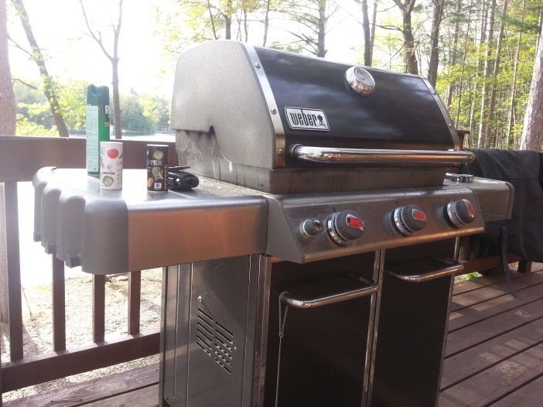

**Can you tell me a little bit about yourself?**

Oh yes, I love to talk to my guests. I'm a retired U.S. Army officer (2006) with multiple tours in Iraq and Afghanistan. It is now my mission and passion to provide your family and excellent, fun and safe vacation rental experience at an affordable price. I pride myself in giving good service, almost always greeting you; explain the home, the area and then providing 24/7 phone service and assistance if needed. If there is ANYTHING you need, please let me know ahead of time, that way I can try and make it happen. I enjoy sharing my inside knowledge of Traverse City, Leelanau Peninsula and the region, there is a ton of things to do. We know that by providing the best equipment, location and vacation experience, our guests will create memories that will last a life time and keep coming back for more fun. Seeing smiling faces, hearing the great stores and seeing the family pictures are the part I most enjoy.

**Who stay at the Spider Lake Cottages and why?** Anyone that is a decent person/family, there is no creed, religion, culture, sex or color we don’t like and we routinely host guests from Europe, the Middle East, Africa, all over the U.S. Everyone flocks to the Traverse City region to get rest, relaxation, hit the wine tours, microbrewery, swim, events, Cherry Festival, Movie Festival, etc. We have had MANY combat veterans, police, fire-fighters, Olympians, the first American to win the last leg of the Tour of France, directors from one of the movies Batman, artists, musicians, families, lovers, doctors, lawyers, grandmas, kids… basically the most amazing groups of people and we are constantly impressed. Some of my best friends were former guests and we stay in touch. We all agree, the same thing that so powerfully affected me while deployed to Iraq and Afghanistan, affect you and them too, to find a place of healing and beauty that is almost indescribable.

**Has anyone ever damaged the property?** Let me explain the difference between a guest that legitimately complains and a guest that willingly deceives/disrespects/damages/condescending and mean to workers. A guest who legitimately complains because the hot tub was left cloudy or it was not up to standard for cleaning is right and correct. We act fast to fix those concerns if the guest lets us know within the first two hours or arrival. Rarely, do we ever get unreasonable and mean guest. Sometimes, a guest accident happens and the property unintentionally get damaged because a giant 6”5 15 year old teenager, full or energy, crushes something, then sheepishly gets up and says, “oops”. Parents who tell me get the fast discount repair, guests who hide it, get charged the full price…. The guest below refused to leave so we melted him with a hose!

**How long does it take before this “healing place” kicks in?** When you open your eyes and mind. It varies but usually 24 hours; for grandmas, it’s immediate. First, you have to actively go out and “find the place to sit”. I don’t meditate but I do things that make me feel at peace and are good for me, like get up early before everyone else, listen to the loons and play guitar. My theory is, that the more high functioning you are, the higher in the management pyramid you are, the longer it will take you to shed the “I see a problem, I must fix a problem now syndrome.” I will take your complaints and concerns seriously, but please take this seriously too. You are coming from a crazy fast paced environment, now it time to slow down and find your place to heal, love and enjoy your family because that why you came here. If you are an attorney, expect it to take 72 hours to find your place, but you will get there!

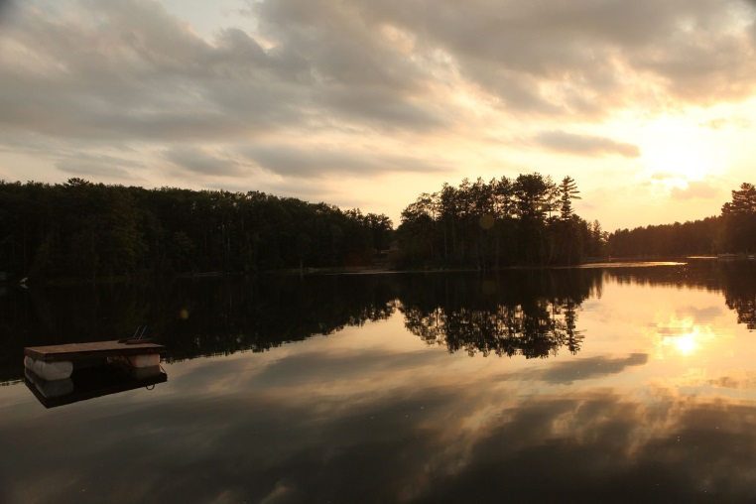

**Can we bring a RV or setup tents?** We do charge an additional fee for these requests which must be made in writing in the contract but we almost always honor those requests.

**How far is it from Traverse City?** Traverse City is only 10 minutes away, close by but you are able to keep your privacy and Up North feel without being in town with people crawling all over you.

**What is your pet policy?**  We like dogs, please bring them, why leave them in a kennel to get kennel cough and make them feel like they were abandoned? You will feel bad and so will they. It’s cheaper to pay a small pet fee to us instead of you and your friend going through all that stress. Please bring a crate for when you leave the cottage to make your doggie comfy.

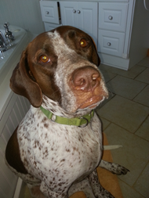

**My parents are disabled and it’s difficult for them to walk. Are there lots of steps to the lake at either cottage?**

**2Lakes Cottage:** We always try and create a suitable environment for our guests. The walk down to Bass lake is gentle and about 100 feet. The walk to Spider Lake is also gentle and about 200 feet, they can use the 8 steps or take the gentle slope down. The entrance to the cottage is about five steps up. Disabled folks can stay in two bedrooms on the main floor next the restrooms so its not a problem. There is only one small step up on the main floor.

**Songbird Cottage:** There are two ways to get to the lake one you go down about 6-8 steps and walk 45 feet. The other way is no steps around the cottage to the water about 200 feet. Going down to the lower level is about 10 steps, it’s easy.

**What amenities are at the cottage?**

7 person Nordic Hot Tub, BOSE Acoustic Wave Radio, WIFI, DVD, flat screen TV, board games, Full Kitchen, large Refrigerator, a small refrigerator, Pots, Pans, and cooking utensils, Fully furnished with bedding, Three large decks - to sit and watch the wildlife or entertain, Outside is a Weber grill, plenty of quality chairs and an three foot tables, fire-ring with benches for GHOST STORIES, there are two docks, beach, swim raft on Spider Lake, 800 frontage footage, Bass Lake has 1600 lake frontage so you have your choice of where to hang out. here is plenty of parking, all boat use at your own risk, The rowboat is FREE and kayaks and pontoon boats are available at an inexpensive price for our guests only. You cannot get a better experience, SpiderLakeCottage. com. It’s a great cottage, spacious, privacy, boating, games, and Traverse City is 10 minutes away.

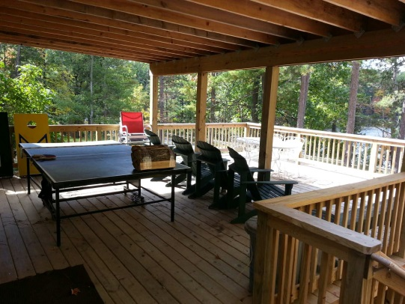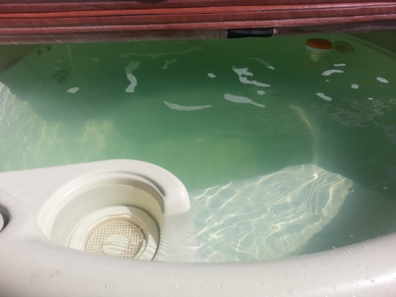

**There is a ping pong table and Foosball table at both cottages.** Usually there are balls available but sometimes they disappear after a guest so we need our guests to bring a foosball and ping pong ball with them.

**Is Spider Lake a full recreational lake? Can you swim in it? Is there Lake Itch?**

Spider Lake; Spider lake is a glacially formed Lake of 27 miles of lake front, sandy and is TOTALLY spring fed, the comes up from well spring in spots throughout the lake, there are no rivers or streams leading into Spider Lake to contaminate it so it is very clear, clear and pure Michigan. Swimming is excellent. There has never been any lake itch. The lake is full recreational; meaning skiing, tubing, jet skis and pontoon cruising is excellent. There are five islands on the lake, three are Public Island, one is especially popular and called Party Island, or Sandy Island or Island number 3 where everyone gathers to swim fish and socialize. **Swimming,** The water is warm from Jun to late Sep for swimming. Memorial Day swimming is authorized by 12 year old boys and young girls who want to be boys and silly old men who still think they are still boys.



**What is the beach like at the cottage?** Because the lake is a natural glacially formed lake, it’s mostly sandy and not rocky or weedy around the cottage beaches. Both of the beaches are gently sloping with no drop-offs; we groom the beaches with both an aqua blaster and Lake Rake. Most guests swim the Spider Lake beach, but Bass Lake is actually cleaner, the sand stops 20 feet out then it gets soft on Bass Lake. We also bring in extra sand for the beach just to build it up more for the kids to play in. You can swim anywhere on the property and we have a swim raft and dock both Bass Lake and Spider Lake. There is over 2200 feet of Lake Front on two different lakes on this property.

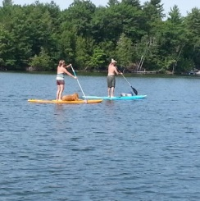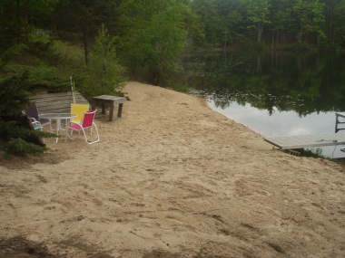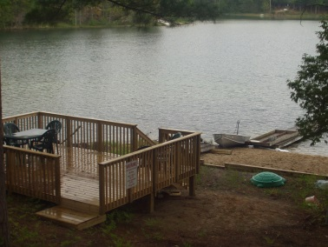

**What are the lake rules?** Spider Lake is a self-regulated lake so everyone can enjoy it better. So, from sunrise to 1130am, the whole lake is no wake for kayakers, canoeing, swimmers, paddle boarders, Buddhist monks and sun worshipers. From 1130am to 730pm, its full throttle, skiing and tubing. If you ski or tube it is COUNTER clockwise to pull. Then it calms down again at 730pm to dusk to no wake. You will greatly appreciate this, this is the only lake in Northern Michigan that does this and it is totally self-managed and guesses what? Everyone follows the rules and loves it. If nasty weather is coming, go ahead and open it up to get home, everyone understands.

**What is the fishing like on Spider Lake?**

Spider Lake is one of seven fishing tournament lakes in the area. Bass Lake is under fished so the bass get plentiful and big. Fishermen love to stay at this cottage. Also, if you want to fly fish, the Boardman River is only 3 miles from the cottage and Ray knows all the secret fishing spots. Plenty of fish species; several Bass, large mouth, small mouth, rock; perch, crappie, walleye, pike, sunfish and sunfish.

The property is a combination of woods and sunny yard; if you want to catch some rays you can.

Two docks, to fish from, or tie off your boat. Please tie your boat and all boats tight to the dock with at least two bumpers. Bumpers are not provided for boats you bring.



**What is the reservation and cancellation policy?**

To reserve, the day of the booking half the rent is due, the remaining balance is due 90 days prior to arrival, signed contract. Cancellation Policy; within 90 days of arrival date the guest forfeits total sum.

**What are the rates for rental? For current prices please check www.spiderlakecottage.com** Peak and nonpeak? These rates are subject to change without notice.

Rates and Policy The rates change so check our webpage for the updated rates. On average, we are about $1,000 less than our competitors with better locations, cottages and amenities, hence, we stay fully booked.

* A weekly pontoon rental is required if you would like to reserve one or our cottages in the summer peak season.

** RV and tents require written approval and modest charges

**Will you hold the cottage while I check with my family members?**

Yes, we will hold the cottage with a payment. If you are sure you want the cottage, we have a Peace of Mind reservation, 10 day hold fee, nonrefundable, that is credited to the balance. The 10 days allows you time to complete the contract and send in the initial payment. If you change your mind in the 10 days you forfeit the $250 dollars and the reservation is cancelled.

**Do you take credit cards and checks?**

We accept credit cards Master Card, VISA, Discover and American Express. We charge an additional fee of 3% to use a credit card. We accept checks also and they are free. You may send either a scanned copy of the front and back of the check by email or a photo copy of the signed contract. If you make a payment using a credit card, then you may also send the contract and payments by snail mail.

**Can you let us see the property before we rent it?**

Unfortunately, we do not permit this ever. Due to security concerns for our guests, our property and disturbances, we forbid previews. Instead, we will provide volumes of pictures, descriptions and guest reviews so that you may feel comfortable as a guest. Our security will alert us to violators.

**How do I get the property address and key?**

Once an initial payment is made, we will provide the address and entry code to get into the property by email. I use emails with a calendar to contact and keep folks updated.

**Can you describe the Pontoon boats and policy?**

We combine older quality pontoon boats with newer engines that we rent only to our guests for a low price. We keep them in good operational care. Our seating is soft and comfy for grandma and the pregnant spouse. Each pontoon has a Bimini cover, lifejackets and ladder and anchor. Our engines are powerful and new Honda 40hp, 2013, 4 strokes, that are very quiet, highly fuel efficient and extremely reliable. You will not use much fuel because of the efficiency of the engines but it depends on how you drive too. You can tube with the pontoon boats or just cruise and talk and have fun. They require marine grade fuel with no oil. The guest can purchase marine grade from from us or purchase it themselves Courtades Trading Post 233 High Lake Road, Traverse City, MI 49696 . We provide a five gallon gas can. The contract has the complete description of polices.

**What is the reason the pontoon boat is required to book a reservation for the peak summer prior to 1 Jun?**

A weekly pontoon rental is required if you would like to reserve one or our cottages prior to 1 Jun for the peak summer season. After 1 Jun a pontoon rental is only encouraged. The reason we do this is because we have invested $40,000 to provide these awesome pontoon boats for our guests while keeping the prices low. All our guests who stayed with us greatly appreciated the pontoon boats as they add a HUGE fun aspect to their stay. Unlike boat rentals that charge three times our rates, drop off a beat-up boat, abandon you until pickup time at the launch, possibly leave you in the middle of the lake if it breaks down without rescue, we don’t do that. We are there to help no matter what. You won’t have the headache of coordinating a drop off time, deciding when to go on the pontoon or when to take it back, where to get fuel or a tube, ladder or paying way too much for your pontoon boat.

**Is there a fire pit on the property? Do you have wood available?**

We have a large fire pit with benches and have wood available. Please check the fire pit in the daytime so you know where it is and prepare it BEFORE dark. You will need flashlights to get down to it as we respect the great outdoors and do no pollute with flood lights, how else will you see our wonderful Milky Way galaxy or the Northern Lights? Also, bring drums, shakers, guitars and get a drum circle going. We have three benches around a fire pit on the property. You can purchase wood from us or out in town. Winter fire pit are also the best. You can purchase bundles of firewood from us, we deliver and stack bundles, you may use them as you need them and pay each time you use them conveniently do it online at <http://www.spiderlakecottage.com/services.html> or just call me and we can charge your credit card.

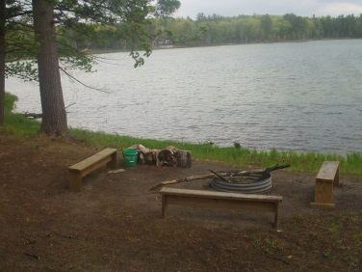

**What is the kayak rental policy? How many kayaks are available?**

Normally, we have two kayaks available at each property for rent. We only charge $25 per kayak per week with paddle and vests included. Out in town, you will pay $125 per week or more. We only charge a basic minimum so we can keep buying replacement equipment and keep our guests happy! If you need more, we can provide up to four or five, let us know 72 hours in advance or as early as possible and we should be able to bring them out for you. You must pay prior to us delivering it and you can conveniently do it online at <http://www.spiderlakecottage.com/services.html> or just call me and we can charge your credit card.

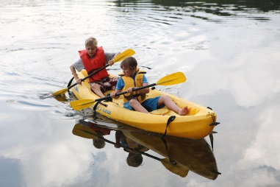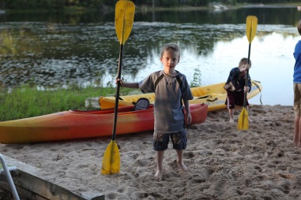

**Do you provide life jackets for adults and children?** We provide lifejackets for the purpose of the boating activity if you rent a boat for adults. We do not provide lifejackets for children because they often need special fitting and it is much safer for families to purchase a life jacket for their children then risk an ill-fitting life jacket. If you do not rent a boat, please bring your own life jackets. Always place life jackets back in the boat securely.

**Does the cottage have a yard for our games?**

Our Yard is large, gently sloping to setup your games; we provide corn holes, ping pong table, foosball table, and basketball hoop. It’s a combination of woods, beaches, docks and water on 3.5 acres. The picture below is about a quarter of the yard by the beach.

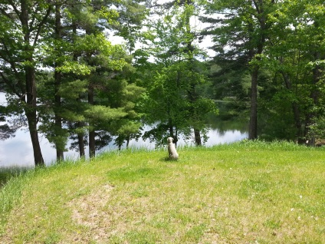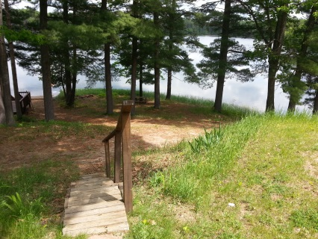

**How do you maintain the landscape?** We mostly let Mother Nature do the work with native species, plants, trees and grass. We have found over time, that natural landscape supports the environment the best, it also brings in the wildlife and doesn’t pollute the lakes with fertilizers. We usually only do a leaf cleanup around certain areas just before Memorial Weekend and cut the grass every two weeks or as needed. We periodically rake the beaches, keep it sanded and rake around the fire pit area. Please don’t expect a highly groomed landscape that you will find at the Wolf Lodge, this is an Up North cottage that is well maintained.

**What do you provide in the cottage kitchens?**

The kitchen has all the basics plus more; pots, pans, blender, six quart crock pot, lots of utensils, plates, bowls, glasses, wine glasses, double sink, stove and two ovens, very large refrigerator, a small refrigerator for beverages, toaster, microwave, CD and radio player, coffee maker. We provide dishwashing soap and dishwasher soap. We provide a basic supply of paper products and then the guest must purchase their own. We do not provide condiments or coffee and filters. There plates and utensils for up to 16 people. My spouse restocks the kitchens every season. It’s not an Italian kitchen but it covers most every base for your stay. If in doubt bring some of your own favorite items.

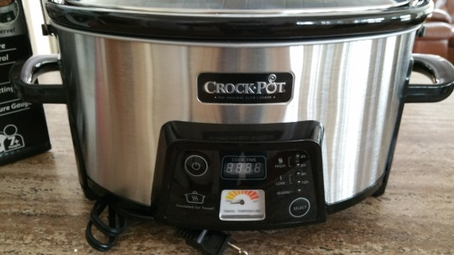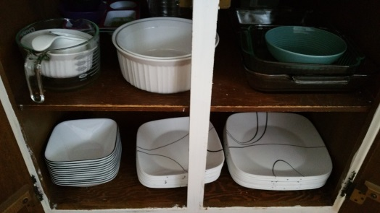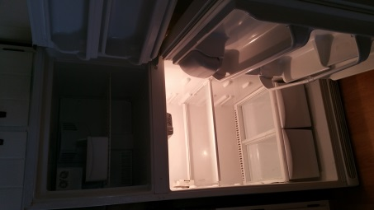

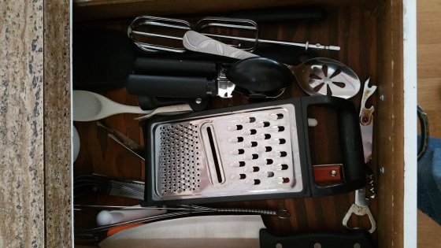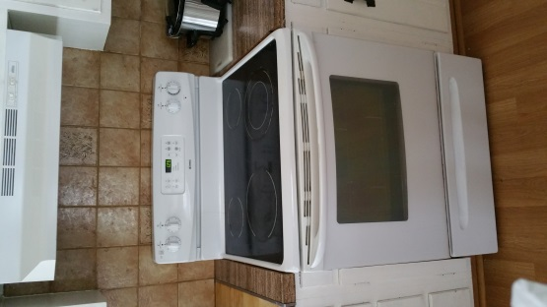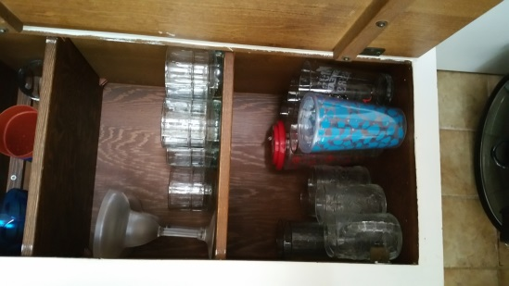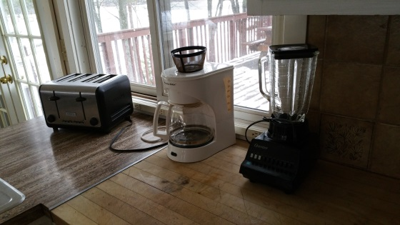

**Do you provide Linens, bedding, towels and soaps?**

Linens and Bedding. We provide linens and bedding for each bed and if the guest requests linen for the pullout at least 72 hours prior to their arrival we will provide it for the pullout also. The guests must provide their own towels, hand towels , hand soap and laundry soap. We do not make the beds up but place the bedding and linens on the bed, this way our guests know that the items are clean.

**What kind of hot tub are there and how many people can fit in it?** It is a Nordic hot tub for water spa therapy and treatment. Its round and can fit 7 normal people or 14 adults (LOL my Marine Corps humor keeps slipping out!)

**Do you provide maintenance and repair?**

We provide ourselves in keeping our cottage in good operational condition. We are both owners and managers of our cottage so there is pride there. If something does go wrong, I’m always available to fix it 24/7 or get a professional in there ASAP if needed. I do not provide concierge service. I try and meet my guests to check them in, then, we both inspect the property and I will try and fix anything on the spot. I try and provide great communication to answer all their questions at any time, just ask.

**In the winter is there any snowmobiling in the area and rentals?**

We have the snowmobile trails in both the front and back yards with direct access to the VASA trails. We are actually on the trail between Peegeos Pizza and Ranch Rudolf. You will hear caravans of snowmobiles in the day and evening of people having fun. Blue Sky rentals is one of the many rentals in the area.

**We have heard that 2Lakes is haunted? Is that true?** Of course not, that is ridiculous; however, at night we have an old Indian shape shifter in the area so make sure you get the fire-pit setup in the daylight. It’s so scary when John Thomas the shape shifter shows up, he never hurts anyone but you can hear him creeping about. Bring your bongos, guitars and drums; he especially likes it when the ladies sing to him.

**How is the cottage heated and Air Conditioned?** It is headed by an oil furnace and a heat pump. The heat pump also provides AC to the main floor but not the upstairs. The lower level stays cool regardless. We do have several fans. There is a gas fireplace for use from Labor Day to Memorial Day, for the rest of the time we turn it off and make folks hit the fire ring!

**What do I do if there is an emergency?**

Call 911. Let the police and fire help out. There is a large hospital in Traverse City called Munson Hospital. Also, once you are in a safe place, please contact me and let me know too.

**Do you provide free tourist advice and suggestions?**

We pride ourselves in providing ONLY our guests great free insider tourist advice for any venue or experience. We have no problems sharing that advice but the best advice, trips, secret fishing spots, events, people, musicians, kayak launches, restaurants and beautiful spots are kept locked in the advice vault ONLY for our guests. Much of what I suggest is on our website <http://www.spiderlakecottage.com>

**What is the closest place to buy groceries and a fishing license and bait?**

Getting Groceries - Olson’s @ 3 mile and Hammond Rd. - Fishing supplies at Roy’s Grocery and Hardware @ 3 mile and Hammond Rd



**What items would you suggest we bring?**

Paper towels

Extra Foosball and ping pong ball (usually we have them but sometimes they disappear so we ask guests to bring an extra one just in case)

Napkins

Toilet paper

Basic seasonings

Cooking oil

paper plates, plastic (knives, forks, spoons) napkins

Laundry soap

Bath towels

Baby crib, chair, baby gate

Extra linens: sheets, bath towels, kitchen towels

[Toiletries](http://www.ebay.com/sch/Health-Beauty-/26395/i.html?_nkw=travel+size+toiletries): shampoo, conditioner, soap

Fishing poles

[Coffee filters](http://www.ebay.com/sch/Coffee-Tea-Makers-/38250/i.html?_from=R40&_nkw=coffee+filters)

[Corkscrew](http://www.ebay.com/sch/Corkscrews-/11635/i.html?_from=R40&_nkw=corkscrew)

Extra Pillows

Garbage bags

Matches or a lighter

Phone, camera, and laptop chargers

Specialty kitchen gadgets

All-purpose cleaner

[First aid kit](http://www.ebay.com/sch/Health-Care-/67588/i.html?_from=R40&_nkw=first+aid+kit)

Bee bite kit, Benidril, Epipen

Safety gear

Phone charger

Hiking back packs for the dunes

Water bottles

HDMI cable to hookup to TV

Ice, and large ice chest

musical instruments! GUITARS! drums shakers,

bug spray

TWO bathing suits, one for the lake, one for the hot tub, Mosquito Bug repellent –

Kids life jackets (we provide adult and recommend you specially fit your child) –

Sun Block –

Hats –

Snorkel, fins and face mask –

Swim goggles –

swim shoes –

sandals - hiking shoes –

A good novel –

Your favorite DVD movies –

Bicycle and helmet –

Fishing poles and tackle –

Binoculars  -

Sand toys for kids - Deck of cards

Your favorite board games -

Kleenex tissues –

prescription medicines –

buy firewood up here its illegal to transport in Michigan; big fines

**What basic products do you provide for your guests?**

A basic issue of garbage bags, toilet paper and paper towels. The WIFI free, corn-hole game or bean bag toss,  Ping Pong table, paddle and balls, bed linens, Foosball table, ping pong table, hot tub, lots of kitchen items, coffee makers, 8 qt crock pot, plates etc, lots of old fashioned board games, books and more books, row boat, kayaks, pontoon boat, one propane bottle per stay, ghost stories (ask me about John Thomas....), lots of fish...we are your personal guide for the area too. A 5 gal gas tank to refill the pontoon boat with Marine grade gas. We will retrieve a boat if there is a problem, causes for issues are assessed. Soft-soap in every bathroom and kitchen, dishwasher soap, dishwashing soap.

**What things do you not provide?**

Laundry soap, Coffee and coffee filters, Condiments, Bath towels Beyond the basic issue of garbage bags and paper products, we do not provide those items for the entire stay. Baby Crib or baby chair, children life jackets, cable TV, a phone, ping pong balls, Foosballs, towels, fishing gear, bikes, water toys, we don't provide free kayaks or pontoon boats. We do not provide concierge service but we do provide 24/7 repairs. We make every reasonable attempt to get out there fast, priority goes to electric, water and heat. If it a guest is responsible for the issue than a $50 service charge plus $25 per hour and parts are assessed.

**Once I get to the property should inspect it?**

Yes, please conduct a quick 10 minute arrival check in at or between 3-5pm and report anything broken or mission within one hour so we can repair it and know you didn’t do it. Occasionally, we will miss something, we overlook it or a guest avoids telling us something was damaged. We don’t want to charge you for something you did not do. For the pontoon, we provide the option for you to get a quick pontoon safety and operations check ride. Please text or call upon arrival and departure.

**What are your house rules?**

* Please don’t conduct either illegal or business activities
* Due to a fire hazard, we don’t permit fireworks or flammables, Tike torches
* We are a family place and don’t permit house parties; weddings, etc., all guests that stay there must be contracted guests.
* Please no smoking inside the house, take a smoke on the porch and dispose of the butts properly.
* Please wash your body and suits before entering hot tub; never go from lake to hot tub
* Keep hot tub covered when not in use; put 1 oz. of chlorine in tub daily
* All boats, tie it tight to the dock with at least two bumpers
* Use the designated fire pit for campfires, no burning outside it due to ordinance restrictions
* Rowboat; Pull it up and flip it over so if doesn’t fill with rain on departure
* Playing music in the day is ok, but after 9pm please take it inside and turn it down.
* Please do not move furniture around or take it apart either insider or outside
* Please keep your dog on a lease and crate them when left alone
* In peak season, Check in 3pm and Check Out 10am times are firm
* In nonpeak season, Check in 3pm and Check Out 10am can be adjusted with written owner approval
* Upon arrival within 1 hours, conduct an inspection for damage and send Ray text/call 231.709.5328

**What is an acceptable amount of sand in the hot tub, I don’t want to be charged for it?** Good question Kelly! A small amount, it hides in the pipes. Here is a picture of a typical amount that is acceptable. We provide a water wand to our guests to remove excessive sand. We also leave a tub to wash feet and a screener with chemicals out.

. WeWe We provide 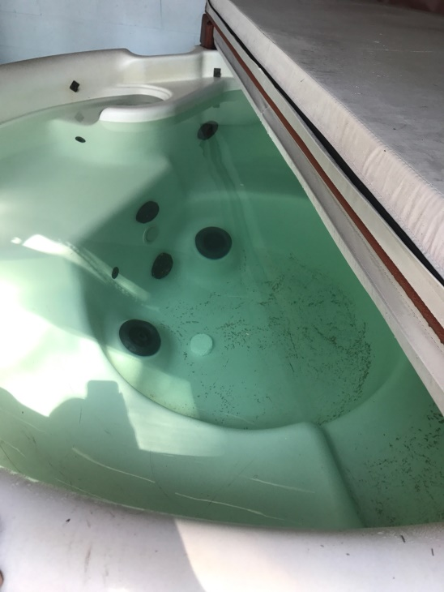

**Why do I have to pay the cleaning and maintenance fee when the departure procedures?** After each stay, a 4-5 person team works to deep clean, this is not something our guests can do, we conduct inspections, maintenance and yard work over a 4-5 hour period. Your cleaning and maintenance fee covers *only a portion of the funds we expend to create a clean and well organized cottage.*  I’m sure you understand that large groups in large cottages like ours mean a higher volume and frequency of areas to clean and maintain. These departure procedures are to both help owners and our guests to achieve a clean and well organized place - so we do not discount this fee.

**What is the departure procedure?**

* Please place all trash in the trash cans at the end of the drive way near the road for a Monday pickup.
* Please compact your trash. You get two trash cans. Any trash left behind outside of the containers is charged the extra disposal fee.
* Please give the inside a good sweep to get rid of the sand, you do not have to mop.
* Wipe all surfaces in the kitchens and bathrooms.
* Wash and put away all dishes, pot and pans.
* Please clean the oven if you made it messy.
* Please place all dirty linens/sheets on or by the washer, but not the not mattress cover/pillows/comforter unless they need replacing or cleaning.
* Bag and remove food items; if you want to leave unopened food or alcoholic beverages, we will take them and give them out to our hard working helpers.
* For the Hot tub, please remove the sand from the hot tub, fill it up, shock it with 1 oz. of chlorine, place cover on it. A trashed hot tub costs 450 gal of water, $50 chemicals and 4-5 hours of manual labor so it costs you $200. Usually little kids are the culprits so lay the rules down, we don’t’ want you to pay that expense either!
* Place corn holes by the lower level door with tossing bags.
* Put the ping pong table in the up position and place cover on it; put paddles and balls in holder
* Stack outside chairs and pickup any loose trash
* Clean the Weber grill, empty the grease tray and wipe it down if you made it messy
* All boats, tie it tight to the dock with at least two bumpers
* Rowboat; pull it up and flip it over so if doesn’t fill with rain on departure
* Places all pontoon vests, ladder, tube, ropes, bridle, back into the pontoon boats storage
* Sweep the pontoon boat, fill the gas tank, leave boat key in the pontoon boat.
* Place the kayaks upside down, paddles underneath the boats
* In the summer, spring, fall, close all windows, turn off AC, and turn off heat, place key in lockbox
* In the winter, close all windows and lock all doors, turn heat to 55 degrees, place key in lockbox. Text me upon departure, let me know if you have any suggestions to improve your future stay or if anything is broken/damaged or needs to be replaced. Thank you and drive safe!

**Ray 231.709.5328, call/text, Web** [**SpiderLakeCottage.com**](http://www.spiderlakecottage.com/)**, Email** [**spiderlakecottage@gmail.com**](mailto:spiderlakecottage@gmail.com)

**Hot Tub Instructions “at own your risk”**

**INSTRUCTIONS AND WARNINGS FOR USING THE HOT TUB**

The Hot Tub is provided for your use and the water has been treated to ensure it is correctly balanced. If used following these instructions, there should be no need for additional maintenance visits. Hot tubs pose similar risks to swimming pools, as well as having their own dangers. Here are some **hot tub safety rules** that everyone should be aware of before using the tub.

* The tub is to be used responsibly and is not to be used as a substitute wading pool by children. Allowing children to jump or dive into the water is not permitted under any circumstances. Children must not use the spa unsupervised at any time.
* Only clean swimwear may be worn in the tub as the chemicals in the water will remove the colored dyes found in ordinary clothing, causing them to leach into the water and turn it cloudy. If you go from the lake to the hot tub, it trashes the water and damages the filter. You will be charged $200 for 450 gal refill, $50 chemicals, a new filter and four hours of maintenance.
* Please shower before using the tub to remove make-up, sun-screen, insect repellent or any other oil-based products. Use two suits, one for the lake, one for the hot tub.
* It is recommended that you have someone in the hot tub with you. If you choose to ignore this advice and elect to use the tub alone, make sure a responsible person inside the cottage is aware that you are in the tub and how long you have been in.
* Do not use the hot tub if you have a medical condition without discussing it with your doctor first; your doctor may advise you about specific temperature settings, how long it is safe to stay in, and any warning signs that you may be in trouble. Do not use a hot tub if you are taking any medication that makes you drowsy or affects your circulation; if necessary, check with your doctor. Pregnant women and the elderly should also consult their doctor before using a hot tub.
* Do not use the hot tub if you are under the influence of alcohol or drugs as your judgment will be impaired and you could become unconscious and drown.
* Be aware of the amount of time you have been in the tub. Soaking in the warm water can raise your body temperature to dangerous levels. 15-minutes in water no warmer than 104 degrees Fahrenheit is considered safe; if you want to use the tub for a longer period, take a break. Soaking in the warm water can dehydrate you, which could lead to nausea, dizziness, or fainting. Take breaks from the hot tub and drink water before getting back in.
* Please use plastic glasses if taking a drink into the tub. Do not take beer bottles near the spa
* No smoking is permitted in or around the tub.
* People with cuts or external infections should not use the tub.
* Be sure to check the temperature of the water before you enter the tub.
* Be sure to replace the cover on the tub whenever the tub is not in use.

Overuse or abuse will also cause the tub water to turn cloudy and will render the tub unusable. Every day, put in one tablespoon or two of chlorine. If this occurs the owners are to be notified immediately as the tub will almost certainly have to be emptied and refilled, which will deny you the use of the tub for at least 24-hours. Any abuse of the tub will result in a charge on your damage deposit. The owners take no responsibility for skin conditions that may arise from using the spa when the water is cloudy or smelling unpleasant.