**IDAHO STATE CHAMPIONSHIP 2019**

**STAGE 1 BAY ONE**

Rifle

1 2 3

Shotgun Pistol

1 2 3



* 

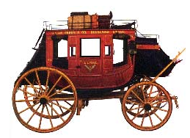 

A B C

10 Pistol – Holstered

10 Rifle - Staged safely

4+ Shotgun- in hands with buttstock against shoulder

Shooter starts at A. **Under supervision of the timer operator, shooter may load up to 2 rounds in the shotgun.**

To start the timer say, “Throw down the strong box.”

At A, with shotgun engage the targets in front of you until down

From B, through stagecoach door, with Rifle, engage the targets as follows 2-2-1-3-2 or 2,2,3,1,2 and repeat. (Two shots on the middle target, one shot on each outside target, then one shot on the middle target and repeat.)

From C, at horses in front of the stagecoach, with Pistols, engage the targets with the rifle instructions