**IDAHO STATE CHAMPIONSHIP 2018**

**STAGE ONE BAY ONE**

R2

R1

* 
* 

P2 S S S S

P1

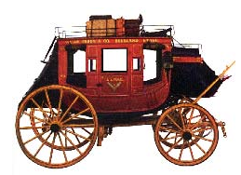 

A B C

10 Pistol – Holstered

10 Rifle - Staged safely

4+ Shotgun- Staged safely

Shooter starts at A or C (Stage will be shot left to right or right to left.) . Hands on Hat.

To start the timer say **“We deal in lead , friend. ”**

At A, with Pistols engage targets with five rounds on P1, **then alternate the next five rounds beginning on P2.**

From B, through stagecoach door, with Rifle, follow pistol instructions.

From C, horses in front of the stagecoach, with shotgun, engage targets until down.