**IDAHO STATE CHAMPIONSHIP 2018**

**STAGE TWO BAY ONE**

R2

R1

* 
* 

P2 S S S S

P1

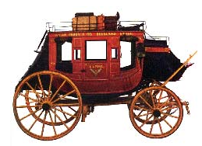 

A B C

10 Pistol – Holstered

10 Rifle - Staged safely

4+ Shotgun- Staged safely

Shooter starts at B, stagecoach door, Rifle in hands.

To start the timer say **“Throw down that strong box!”**

With rifle, through the stagecoach door, engage targets as follows:

**R1, R2, R1, R2, R2, R1, R2, R2, R2, R1.**

From A, the back of the stagecoach, with Pistols, follow rifle instructions.

From C, horses in front of the stagecoach, with shotgun, engage targets until down.