**IDAHO STATE CHAMPIONSHIP** **2018**

**STAGE THREE BAY TWO**

* 

1. 21

4

4

3

2

* 

Rifle

3

2

111

4 4

* 

3 3

Shotgun 2 Pistols 2 Shotgun

1

* 11
* 

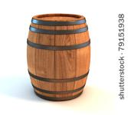  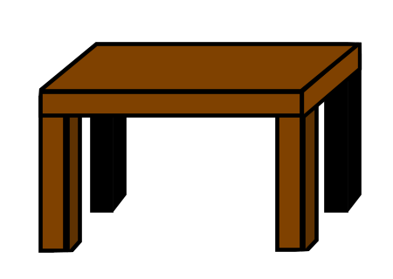  

10 Pistol – Holstered

10 Rifle - Staged safely

4+ Shotgun- Staged safely

**Shooter starts at fence**, hands at low surrender.

To start the timer say **“Baby sister, I was born game.”**

With Rifle, **engage R1 twice**, then sweep either side (R2-R4) for the first 5 rounds. Then **engage R1 twice** and sweep the other side (R2-R4) for 2nd 5 rounds.

Also from fence, with pistols engage the pistol targets using rifle instructions.

Move to either barrel, and engage the four shotgun targets until down.