IDAHO STATE CHAMPIONSHIP 2018
SALOON STAGE 8

Rifle

1 3
R/P 2 Pistol

1 3

2

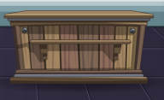
D C 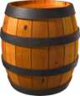
10 Pistol- Holstered B A
10 Rifle – Staged safely
4+ Shotgun – Staged safely

Shooter starts at A, right barrel, Hands on pistols.
To start the timer say “All I wanted was a drink and a bed.”
At the beep; with Pistols engage P1-P3, starting on either end, in a continuous Nevada sweep DOUBLE TAPPING THE CENTER TARGET . ( 1-2-2-3-2-2-1-2-2-3)
Move to B, with Rifle follow Pistol instructions.
Move to C, with Shotgun engage the two targets in front of you.
Move to D, with Shotgun engage the two remaining shotgun targets.

