**IDAHO STATE CHAMPIONSHIP** **2019**

**STAGE 2 BAY TWO**

Rifle

4

2

111

3

Pistol

1 2 3 4 Shotgun

1. 2

1

* 21
* 

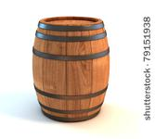 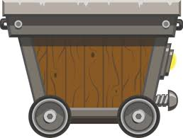 

B A C

10 Pistol – Holstered

10 Rifle - staged safely

6+ Shotgun- Staged safely

Shooter starts at A, hands above head.

To start the timer, say “This is my claim”

With Pistols, engage the targets as follows 1-2-3-4-3-3-3-2-2-1 (Tadpole Tap)

Move to B and with the rifle engage the rifle targets using pistol instructions.

Move to C and engage the six shotgun targets until down.