**IDAHO STATE CHAMPIONSHIP 2019**

**STAGE 7 BAY ONE**



* 

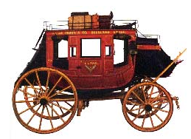 

A B C

10 Pistol – Holstered

10 Rifle - in hands

4+ Shotgun- Staged safely

Shooter starts at B with Rifle in hands.

To start the timer say, “They just robbed the stage!”

At B the stage coach door engage the targets as follows 1-1-2-2-3-3-2-1-2-3

From A, the rear of the stage coach, engage the shotgun targets until down.

Then from C, at horses in front of the stagecoach, with Pistols, engage the targets with the rifle instructions