**IDAHO STATE CHAMPIONSHIP** **2019**

**STAGE 8 BAY TWO**

Rifle

4

2

111

3

Pistol

1 2 3 4 Shotgun

* 11
* 

1. 21

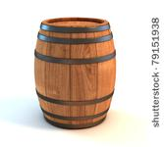  

A B C

10 Pistol – Holstered

10 Rifle - staged safely

4+ Shotgun- Staged safely

Shooter starts at A or C, gun in hands.

To start the timer, say “You won’t get my gold!”

From A engage the rifle targets as follows 1-2-2-3-3-2-2-3-3-4.

From C with shotgun engage any **four** shotgun targets until down.

From B engage the pistol targets with the rifle instructions.

Stage will be shot right to left or left to right.