**[OFFICESUBLETNY](https://officesubletny.com/" \o "Officesubletny)**

126 5th Ave, New York

|

[212 242 6700](tel:2122426700)

VIEW EVERY SINGLE NYC OFFICE SUBLET  
THIS SITE IS STILL UNDER CONSTRUCTION

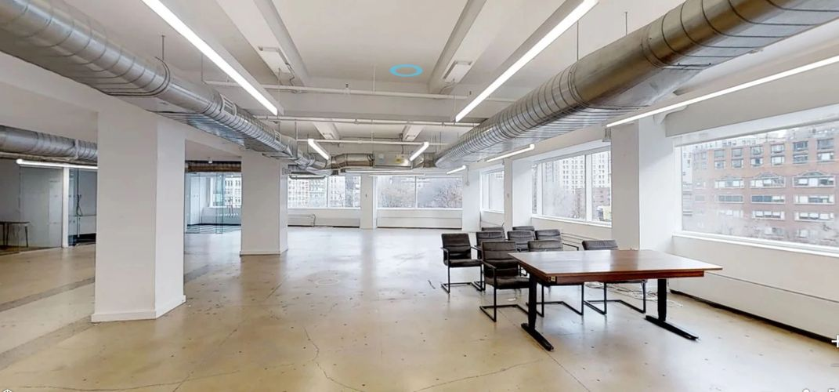

CHELSEA SUBLETS- MAY 1,2019

|  |  |  |  |  |  |  |
| --- | --- | --- | --- | --- | --- | --- |
| 55 Fifth Ave | | P 16 |  | 4,300 |  | 75.00/mg |
| 55 Fifth Ave | | P 18 |  | 2,300 |  | 85.00/mg |
| 155 W 23rd St | | E 8 |  | 6,933 |  | Withheld |
| 121 E 24th St | | P 9 |  | 1,000 |  | 66.00/fs |
| 34 W 27th St | | P 4 |  | 1,500 |  | 47.00/mg |
| 150 W 30th St | | P 13 |  | 1,800 |  | 48.00/mg |
| 31 E 32nd St | | P 7 |  | 2,500-3,000 | | 48.00-57.60/fs |
| 345 E 37th St | | P 3 |  | 2,500 |  | 42.00/+elec |
| 1140 Broadway | | E 11 |  | 8,711 |  | 65.00/mg |
| 80-90 Eighth Ave | | P 9 |  | 2,050 |  | 65.00/+elec |
| 275 Fifth Ave | | E 2 |  | 1,856-2,300/1,856 ofc | | 58.00-63.00/mg |
| 27 Union Sq W | | P 2 |  | 2,000 |  | 65.00/fs |
| 154 W 14th St | | P 7 |  | 3,197 |  | Withheld |
| 1-5 W 19th St | | P 5 |  | 7,000 |  | Withheld |
| 36-38 E 20th St | | P 5 |  | 4,125 |  | Withheld |
| 45 E 20th St | | E 9 |  | 5,000 |  | Withheld |
| 515 W 20th St | | P 6 |  | 5,042 |  | Withheld |
| 19 W 21st St | | P 5 |  | 1,700 |  | Withheld |
| 19 W 21st St | | P 9 |  | 250-1,250 |  | Withheld |
| 30 W 21st St | | P 6 |  | 5,361 |  | Withheld |
| 45-51 W 21st St | | P 3 |  | 3,400 |  | Withheld |
| 48 W 21st St | | P 12 |  | 1,000 |  | Withheld |
| 54 W 21st St | | P 6 |  | 6,750 |  | Withheld |
| 54 W 21st St | | P 10 |  | 1,600 |  | Withheld |
| 16 W 22nd St | | P 2 |  | 3,721 |  | Withheld |
| 150 W 22nd St | | E 10 |  | 6,900 |  | Withheld |
| 115 E 23rd St | | E 2 |  | 6,140 |  | Withheld |
| 22 W 23rd St | | E 5 |  | 2,800 |  | Withheld |
| 23 W 23rd St | | E 2 |  | 1,958 |  | Withheld |
| 23 W 23rd St | | E 3 |  | 1,958 |  | Withheld |
| 23 W 23rd St | | E 4 |  | 1,958 |  | Withheld |
| 26 W 23rd St | | P 5 |  | 3,147 |  | Withheld |
| 26 W 23rd St | | P 6 |  | 3,147 |  | Withheld |
| 19-21 W 24th St | | E 5 |  | 5,418 |  | Withheld |
| 43 W 24th St | | P 12 |  | 2,175 |  | Withheld |
| 41 W 25th St | | E 3 |  | 5,412 |  | Withheld |
| 125 W 25th St | | P 4 |  | 4,250 |  | Withheld |
| 147 W 25th St | | E 12 |  | 3,800 |  | Withheld |
| 150 W 25th St | | P 6 |  | 5,200 |  | Withheld |
| 151 W 25th St | | E 11 |  | 6,500 |  | Withheld |
| 521-531 W 25th St | | P 3 |  | 2,000 |  | Withheld |
| 122 W 26th St | | P 2 |  | 2,000-4,000 | | Withheld |
| 127 W 26th St | | P 5 |  | 2,233 |  | Withheld |
| 13-15 W 27th St | | E 2 |  | 5,909 |  | Withheld |
| 13-15 W 27th St | | E 3 |  | 5,909 |  | Withheld |
| 49-55 W 27th St | | E 8 |  | 8,800 |  | Withheld |
| 115-117 W 27th St | | P 6 |  | 5,000 |  | Withheld |
| 115-117 W 27th St | | P 10 |  | 1,500 |  | Withheld |
| 153 W 27th St | | P 12 |  | 2,315 |  | Withheld |
| 3 E 28th St | | E 2 |  | 5,575 |  | Withheld |
| 430 E 29th St | | P 11 |  | 8,351 |  | Withheld |
| 135-139 W 29th St | | P 4 |  | 4,000 |  | Withheld |
| 135-139 W 29th St | | P 4 |  | 1,400 |  | Withheld |
| 143 W 29th St | | P 2 |  | 1,300 |  | Withheld |
| 210 W 29th St | | E 4 |  | 2,300 |  | Withheld |
| 210 W 29th St | | E 9 |  | 2,300 |  | Withheld |
| 242 W 30th St | | E 2 |  | 8,000 |  | Withheld |
| 12 E 33rd St | | E 6 |  | 3,000 |  | Withheld |
| 9 E 37th St | | E 12 |  | 5,000 |  | Withheld |
| 14 E 38th St | | E 12 |  | 5,233 |  | Withheld |
| 915 Broadway | | E MEZZ |  | 3,708 |  | Withheld |
| 1133 Broadway | | P 2 |  | 1,290 |  | Withheld |
| 1133 Broadway | | P 4 |  | 4,500 |  | Withheld |
| 1178 Broadway | | P 3 |  | 1,000-2,616 | | Withheld |
| 1182-1184 Broadway | | P 3 |  | 1,700 |  | Withheld |
| 1214-1216 Broadway | | P 3 |  | 4,500-8,000 | | Withheld |
| 1214-1216 Broadway | | P 4 |  | 4,500-8,000 | | Withheld |
| 322-326 Eighth Ave | | P 3 |  | 4,908-9,583 | | Withheld |
| 322-326 Eighth Ave | | P 18 |  | 6,750 |  | Withheld |
| 119 Fifth Ave | | E 6 |  | 8,750 |  | Withheld |
| 156 Fifth Ave | | P 11 |  | 3,000-6,000 | | Withheld |
| 245 Fifth Ave | | P 11 |  | 3,272 |  | Withheld |
| 335-339 Fifth Ave | | P 5 |  | 1,200 |  | Withheld |
| 389 Fifth Ave | | P 4 |  | 2,759 |  | Withheld |
| 192 Lexington Ave | | P 12 |  | 2,616 |  | Withheld |
| 205 Lexington Ave | | E 15 |  | 5,967 |  | Withheld |
| 152-156 Madison Ave | | E 5 |  | 1,500-5,000 | | Withheld |
| 2 Park Ave |  | P 3 |  | 7,788 |  | Withheld |
| 2 Park Ave |  | P 3 |  | 3,376 |  | Withheld |
| 2 Park Ave |  | P 3 |  | 5,212-11,779 | | Withheld |
| 3 Park Ave |  | E 22 |  | 5,000-22,722 | | Withheld |
| 215 Park Ave S | | P 17 |  | 5,378 |  | Withheld |
| 257 Park Ave S | | P 3 |  | 4,856 |  | Withheld |
| 270 Park Ave S | | P MEZZ |  | 2,281 |  | Withheld |
| 381 Park Ave S | | P 10 |  | 4,727 |  | Withheld |
| 419 Park Ave S | | P 18 |  | 7,525 |  | Withheld |
| 432 Park Ave S | | E 15 |  | 9,800 |  | Withheld |
| 475 Park Ave S | | P 9 |  | 3,170 |  | Withheld |
| 352 Seventh Ave | | P 6 |  | 1,876 |  | Withheld |