OFFICESUBLETNY
126 5th Ave, New York
|
212 242 6700

VIEW EVERY SINGLE NYC OFFICE SUBLET
THIS SITE IS STILL UNDER CONSTRUCTION
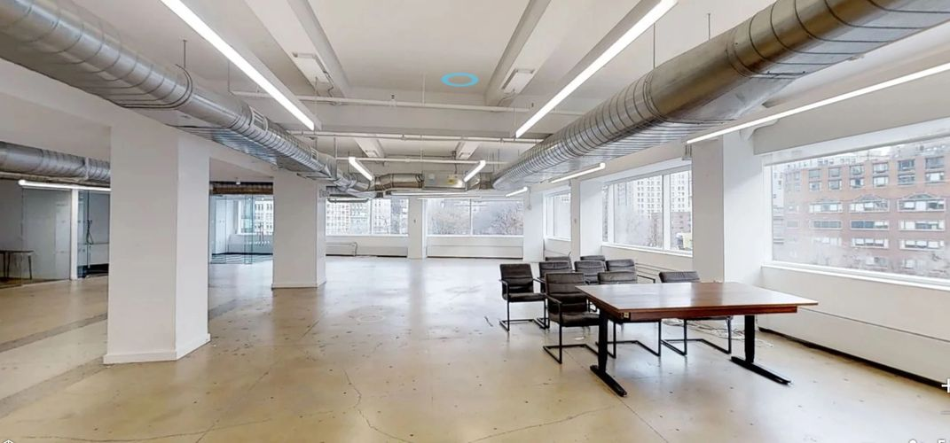

CHELSEA SUBLETS- July 1,2019
55 Fifth Ave | P 16 |  | 4,300 |  | 72.00/mg
261 Fifth Ave | P 9 |  | 6,541 |  | 53.00/+e&c
155 W 23rd St | E 8 |  | 6,933 |  | Withheld
55 Fifth Ave | P 18 |  | 2,516 |  | Withheld
220 Fifth Ave | P 3 |  | 2,200 |  | Withheld
261 Fifth Ave | P 16 |  | 4,710 |  | Withheld
45 E 20th St | P 9 |  | 5,000 |  | 60.00/fs
121 E 24th St | P 9 |  | 1,000 |  | 66.00/fs
147 W 25th St | P 10 |  | 3,800 |  | 55.00/+util
153 W 27th St | P 2 |  | 1,550 |  | 50.00/+elec
242 W 27th St | P 3 |  | 1,400 |  | 54.00/+util
150 W 28th St | P 5 |  | 1,800 |  | 33.32/n
115 W 29th St | P 7 |  | 3,650 |  | 45.00-46.00/+e&c
31 E 32nd St | P 7 |  | 2,500 |  | 48.00-62.40/mg
345 E 37th St | P 3 |  | 2,500 |  | 42.00/+elec
1140 Broadway | E 11 |  | 6,500-8,711 |  | 65.00/mg
80-90 Eighth Ave | P 9 |  | 2,050 |  | 56.00/+elec
275 Fifth Ave | E 2 |  | 1,856-2,300/1,856 ofc |  | 58.00-63.00/mg
192 Lexington Ave | P 12 |  | 2,616 |  | 42.00/fs
333 Park Ave S | P 5 |  | 2,300 |  | 54.00/fs
419 Park Ave S | P 4 |  | 2,360 |  | 56.52/mg
27 Union Sq W | P 2 |  | 2,000 |  | 71.00/fs
405 W 14th St | P 2 |  | 2,350 |  | Withheld
414 W 14th St | E 2 |  | 9,140 |  | Withheld
412 W 15th St | E 9 |  | 8,367 |  | Withheld
29 W 17th St | P 10 |  | 2,500 |  | Withheld
7 W 18th St | E 4 |  | 5,377 |  | Withheld
1-5 W 19th St | P 5 |  | 7,000 |  | Withheld
36-38 E 20th St | E 4 |  | 4,700 |  | Withheld
36-38 W 20th St | P 9 |  | 5,255 |  | Withheld
515 W 20th St | P 6 |  | 5,042 |  | Withheld
35 E 21st St | P 6 |  | 5,685 |  | Withheld
35 E 21st St | P 7 |  | 5,685 |  | Withheld
35 E 21st St | P 8 |  | 5,685 |  | Withheld
19 W 21st St | P 5 |  | 1,700 |  | Withheld
19 W 21st St | P 9 |  | 250-1,250 |  | Withheld
30 W 21st St | P 6 |  | 5,361 |  | Withheld
45-51 W 21st St | P 3 |  | 3,400 |  | Withheld
54 W 21st St | P 6 |  | 1,446 |  | Withheld
54 W 21st St | P 6 |  | 6,750 |  | Withheld
16 W 22nd St | P 2 |  | 3,721 |  | Withheld
150 W 22nd St | E 10 |  | 6,900 |  | Withheld
36 E 23rd St | P 9 |  | 1,200 |  | Withheld
115 E 23rd St | E 2 |  | 6,140 |  | Withheld
26 W 23rd St | P 5 |  | 3,147 |  | Withheld
26 W 23rd St | P 6 |  | 3,147 |  | Withheld
36 W 25th St | P 3 |  | 2,850 |  | Withheld
147 W 25th St | E 12 |  | 3,800 |  | Withheld
150 W 25th St | P 6 |  | 5,000 |  | Withheld
150 W 25th St | P 6 |  | 1,220 |  | Withheld

