**[OFFICESUBLETNY](https://officesubletny.com/" \o "Officesubletny)**

126 5th Ave, New York

|

[212 242 6700](tel:2122426700)

VIEW EVERY SINGLE NYC OFFICE SUBLET  
THIS SITE IS STILL UNDER CONSTRUCTION

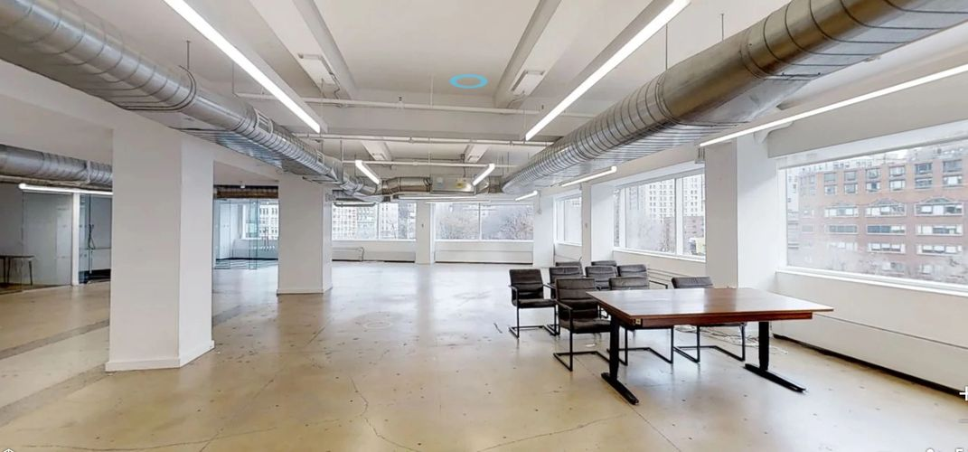

FINANCIAL DISTRICT SUBLETS- JULY 1,2019

|  |  |  |  |  |  |  |
| --- | --- | --- | --- | --- | --- | --- |
| 17 State St | | P 19 |  | 6,325 |  | Withheld |
| One World Trade Center | | P 58 |  | 7,000-26,292 | | Withheld |
| 75 Broad St | | P 3 |  | 500 |  | Withheld |
| 75 Broad St | | P 6 |  | 9,429 |  | Withheld |
| 75 Broad St | | P 22 |  | 7,124 |  | Withheld |
| 75 Broad St | | P 25 |  | 4,177 |  | Withheld |
| 233 Broadway | | P 17 |  | 9,102 |  | Withheld |
| 233 Broadway | | P 23 |  | 132 |  | Withheld |
| 120 Wall St | | E 29 |  | 8,788 |  | Withheld |
| 16 Beaver St | | E 2 |  | 2,750 |  | 27.00/mg |
| 16 Beaver St | | E 3 |  | 2,750 |  | 32.00/mg |
| 16 Beaver St | | E 4 |  | 2,750 |  | 25.00/mg |
| 30 Broad St | | P 4 |  | 150 |  | 13.33/mg |
| 29 Broadway | | P 18 |  | 4,354 |  | 45.00/mg |
| 160 Broadway | | P 10 |  | 400 |  | 60.00/mg |
| 225 Broadway | | P 21 |  | 450 |  | 60.00/fs |
| 225 Broadway | | P 29 |  | 4,118 |  | 40.00-50.00/mg |
| 305 Broadway | | P 11 |  | 5,500 |  | 45.00/mg |
| 325-333 Broadway | | P LL |  | 1,400 |  | 105.00/+util |
| 325-333 Broadway | | P GRND |  | 1,600 |  | 105.00/+util |
| 401 Broadway | | P 8 |  | 2,725 |  | 56.00/mg |
| 401 Broadway | | P 9 |  | 650 |  | 80.00-82.00/mg |
| 35-37 E Broadway | | P 4 |  | 1,400 |  | 55.71/mg |
| 35-37 E Broadway | | P 4 |  | 1,400 |  | 57.43/mg |
| 7 Division St | | P 6 |  | 600-1,400 |  | 42.00/mg |
| 64 Fulton St | | P 3 |  | 720 |  | 47.91/fs |
| 64 Fulton St | | P 3 |  | 200 |  | 75.00/fs |
| 111 John St | | P 4 |  | 300-400 |  | 40.00-45.00/fs |
| 111 John St | | P 18 |  | 300 |  | 57.00/mg |
| 80 Nassau St | | P GRND |  | 847 |  | 141.68/mg |
| 132 Nassau St | | P 6 |  | 3,144 |  | 33.00/+elec |
| 11 Park Pl |  | P 8 |  | 2,652 |  | 37.10/mg |
| 20 Vesey St | | P 9 |  | 500 |  | 96.00/fs |
| 20 Vesey St | | P 9 |  | 250 |  | 120.00/fs |
| 20 Vesey St | | P 9 |  | 250 |  | 120.00/fs |
| 89 Walker St | | P 2 |  | 600 |  | 62.00/mg |
| 100 Wall St | | P 7 |  | 8,332 |  | 50.00/+elec |
| 17 Battery Pl | | P 6 |  | 8,035 |  | Withheld |
| 60 Broad St | | P GRND |  | 4,074 |  | Withheld |
| 80 Broad St | | P 7 |  | 4,850 |  | Withheld |
| 26 Broadway | | P 9 |  | 860 |  | Withheld |
| 26 Broadway | | P 22 |  | 7,127 |  | Withheld |
| 26 Broadway | | E 23 |  | 7,330 |  | Withheld |
| 26 Broadway | | E 24 |  | 7,330 |  | Withheld |
| 45 Broadway | | P 3 |  | 9,756 |  | Withheld |
| 45 Broadway | | P 18 |  | 1,000 |  | Withheld |
| 55 Broadway | | E 18 |  | 2,000-10,370 | | Withheld |
| 61 Broadway | | P 10 |  | 3,725 |  | Withheld |
| 61 Broadway | | P 27 |  | 1,450 |  | Withheld |
| 65 Broadway | | P 16 |  | 1,500 |  | Withheld |
| 100 Broadway | | E 9 |  | 5,000-17,625 | | Withheld |
| 111 Broadway | | P 10 |  | 9,311 |  | Withheld |
| 111 Broadway | | P 12 |  | 2,764 |  | Withheld |
| 291 Broadway | | P 8 |  | 100-500 |  | Withheld |
| 299 Broadway | | P 14 |  | 1,787 |  | Withheld |
| 299 Broadway | | P 15 |  | 5,104 |  | Withheld |
| 11-15 E Broadway | | E 5 |  | 1,750-3,648 | | Withheld |
| 168 Canal St | | P 3 |  | 569-2,862 |  | Withheld |
| 86 Chambers St | | P 2 |  | 2,028 |  | Withheld |
| 40 Exchange Pl | | P 3 |  | 4,554 |  | Withheld |
| 40 Exchange Pl | | P 13 |  | 1,250 |  | Withheld |
| 40 Exchange Pl | | P 15 |  | 5,725 |  | Withheld |
| 40 Exchange Pl | | P 16 |  | 120-1,600 |  | Withheld |
| 5 Hanover Sq | | P 2 |  | 9,750 |  | Withheld |
| 5 Hanover Sq | | P 19 |  | 4,970 |  | Withheld |
| 5 Hanover Sq | | P 21 |  | 2,910 |  | Withheld |
| 96-104 Lafayette St | | P GRND |  | 1,653 div |  | Withheld |
| 28 Liberty St | | P 30 |  | 8,599 |  | Withheld |
| 75 Maiden Ln | | P 5 |  | 1,256 |  | Withheld |
| 80 Maiden Ln | | P 5 |  | 4,201 |  | Withheld |
| 80 Maiden Ln | | P 10 |  | 1,851 |  | Withheld |
| 375 Pearl St | | P 2 |  | 2,305 |  | Withheld |
| 375 Pearl St | | P 13 |  | 8,247 |  | Withheld |
| 80 Pine St |  | P 1 |  | 2,929 |  | Withheld |
| 88 Pine St |  | P 22 |  | 2,244 |  | Withheld |
| 88 Pine St |  | P 23 |  | 6,760 |  | Withheld |
| 40 Rector St | | P 10 |  | 100-2,500 |  | Withheld |
| One State Street Plz | | P GRND |  | 3,580 |  | Withheld |
| 2 Wall St |  | P 3 |  | 200 |  | Withheld |
| 2 Wall St |  | P 3 |  | 200 |  | Withheld |
| 2 Wall St |  | P 3 |  | 175 |  | Withheld |
| 2 Wall St |  | P 5 |  | 500 |  | Withheld |
| 2 Wall St |  | P 5 |  | 500 |  | Withheld |
| 14 Wall St |  | P 16 |  | 9,506 |  | Withheld |
| 40 Wall St |  | E 29 |  | 550-13,600 | | Withheld |
| 44 Wall St |  | P 5 |  | 3,131 |  | Withheld |
| 100 Wall St | | P 5 |  | 4,071 |  | Withheld |
| 100 Wall St | | P 14 |  | 2,871 |  | Withheld |
| 77 Water St | | P 2 |  | 3,409-12,204 | | Withheld |
| 199 Water St | | E 17 |  | 10,000-35,995 | | Withheld |
| 33 Whitehall St | | P 14 |  | 8,514 |  | Withheld |
| 123 William St | | P 19 |  | 3,750 |  | Withheld |
| 123 William St | | P 26 |  | 8,293 |  | Withheld |