OFFICESUBLETNY
126 5th Ave, New York
|
212 242 6700

VIEW EVERY SINGLE NYC OFFICE SUBLET
THIS SITE IS STILL UNDER CONSTRUCTION
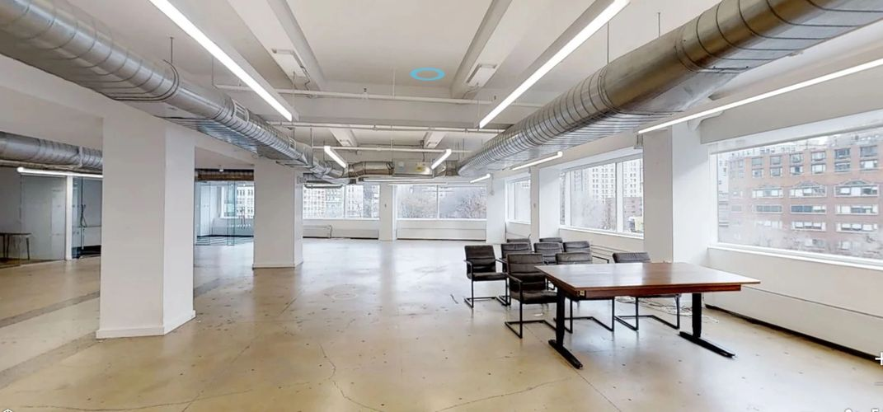

DONWTOWN SUBLETS- MAY 1,2019

17 State St |  | P 19 |  | 6,325
75 Broad St |  | P 6 |  | 9,429
75 Broad St |  | P 25 |  | 4,177
233 Broadway |  | P 17 |  | 9,102
120 Wall St |  | E 29 |  | 8,788
16 Beaver St |  | E 2 |  | 2,750
16 Beaver St |  | E 3 |  | 2,750
16 Beaver St |  | E 4 |  | 2,750
35-37 E Broadway |  | P 4 |  | 1,400
196 Canal St |  | P 6 |  | 1,341
132 Nassau St |  | P 6 |  | 3,144
120-124 Walker St |  | P 3 |  | 4,000
17 Battery Pl |  | P 6 |  | 8,035
60 Broad St |  | P 36 |  | 7,102
80 Broad St |  | P 7 |  | 4,850
25 Broadway |  | P 10 |  | 1,202
26 Broadway |  | E 23 |  | 7,330
26 Broadway |  | E 24 |  | 7,330
29 Broadway |  | P 28 |  | 5,675
32 Broadway |  | P 12 |  | 3,500
42 Broadway |  | P 19 |  | 2,350
45 Broadway |  | P 3 |  | 9,756
55 Broadway |  | P 8 |  | 5,000-10,557
55 Broadway |  | P 20 |  | 3,406
61 Broadway |  | P 27 |  | 1,450
100 Broadway |  | P 9 |  | 9,280-17,625
111 Broadway |  | P 10 |  | 9,311
111 Broadway |  | P 12 |  | 2,764
299 Broadway |  | P 14 |  | 1,787
299 Broadway |  | P 15 |  | 5,104
408-410 Broadway |  | P 3 |  | 3,993
408-410 Broadway |  | P 4 |  | 2,890
264 Canal St |  | P 5 |  | 1,975
1 N End Ave |  | P 9 |  | 7,710
40 Exchange Pl |  | P 3 |  | 4,554
40 Exchange Pl |  | P 15 |  | 5,725
40 Exchange Pl |  | P 16 |  | 120-1,600
5 Hanover Sq |  | P 19 |  | 4,970
28 Liberty St |  | P 30 |  | 8,599
75 Maiden Ln |  | P 5 |  | 1,256
80 Maiden Ln |  | P 10 |  | 1,851
88 Pine St |  | P 23 |  | 6,760
40 Wall St |  | P 60 |  | 6,191
44 Wall St |  | P 5 |  | 3,131
100 Wall St |  | P 5 |  | 4,071
100 Wall St |  | P 14 |  | 2,871
77 Water St |  | P 2 |  | 3,409-12,204
33 Whitehall St |  | P 14 |  | 8,514

