OFFICESUBLETNY
126 5th Ave, New York
|
212 242 6700

VIEW EVERY SINGLE NYC OFFICE SUBLET
THIS SITE IS STILL UNDER CONSTRUCTION
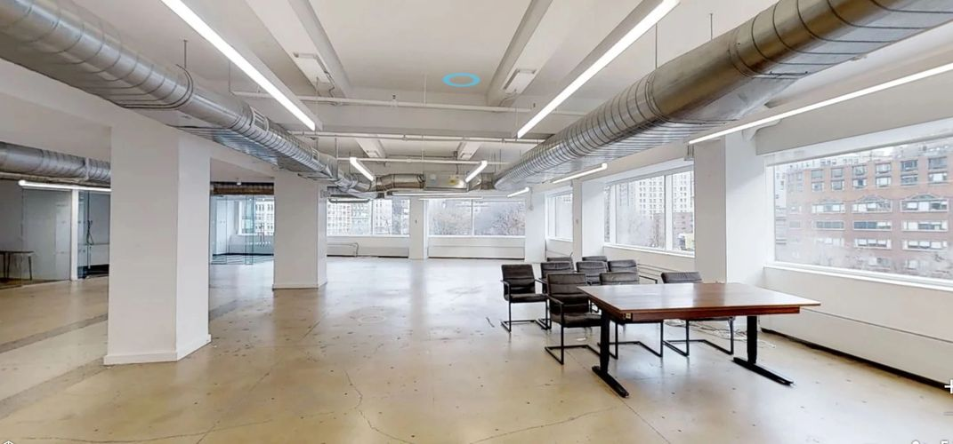

Garment Center Sublets- MAY 1,2019

110 W 40th St |  | P 25 |  | 2,731 |  | 60.00/mg
8 W 36th St |  | E 5 |  | 3,460 |  | 45.00/mg
1441 Broadway |  | P 17 |  | 4,500-7,000 |  | 53.00/fs
1001 6th Ave |  | P 7 |  | 4,500 |  | 58.00/mg
1001 6th Ave |  | P 18 |  | 5,315 |  | 53.00/mg
1001 6th Ave |  | P 24 |  | 5,000 |  | 60.00/fs
115-125 W 30th St |  | P 4 |  | 1,047 |  | 48.00/fs
243 W 30th St |  | P 4 |  | 1,650 |  | 39.00/+util
22 W 32nd St |  | E 9 |  | 7,000 |  | 55.00/nnn
10 W 33rd St |  | P 6 |  | 1,366 |  | 55.00/mg
147 W 35th St |  | P 14 |  | 1,300 |  | 46.00/mg
260 W 35th St |  | P 3 |  | 1,000 |  | 42.00/mg
260 W 35th St |  | P 13 |  | 1,750-3,500 |  | 44.57/mg
11 W 36th St |  | P GRND |  | 2,000 |  | 90.76/nnn
34 W 36th St |  | E 5 |  | 1,600 |  | 44.00/mg
34 W 36th St |  | E 6 |  | 1,600 |  | 44.00/mg
35 W 36th St |  | P 3 |  | 3,430 |  | 47.50/mg
237 W 37th St |  | P 14 |  | 3,500 |  | 49.00/mg
265-269 W 37th St |  | P 18 |  | 1,300 |  | 49.00/+u&ch
29 W 38th St |  | P 16 |  | 3,200 |  | 35.00/mg
57 W 38th St |  | P 6 |  | 1,370 |  | 42.00/+elec
250 W 40th St |  | P 12 |  | 4,000 |  | 40.00/mg
264 W 40th St |  | P 5 |  | 200-1,200 |  | 40.00/nnn
535 Eighth Ave |  | P GRND |  | 3,540 |  | 119.00/mg
463 Seventh Ave |  | P 16 |  | 2,756 |  | 55.00/mg
406-408 8th Ave |  | P 1 |  | 1,300 |  | Withheld
575 8th Ave |  | P 8 |  | 7,562 |  | Withheld
575 8th Ave |  | P 14 |  | 3,000 div |  | Withheld
29 W 30th St |  | E 2 |  | 6,800 |  | Withheld
115-125 W 30th St |  | P 2 |  | 3,450 |  | Withheld
18 W 33rd St |  | P 2 |  | 100-2,800 |  | Withheld
32-34 W 34th St |  | P GRND |  | 1,750 |  | Withheld
29 W 35th St |  | P 6 |  | 4,100 |  | Withheld
29 W 35th St |  | E 10 |  | 7,800 |  | Withheld
223-225 W 35th St |  | P 16 |  | 100-2,000 |  | Withheld
237 W 35th St |  | E 16 |  | 5,318 |  | Withheld
247 W 35th St |  | P 6 |  | 500-2,000 |  | Withheld
315 W 36th St |  | P 9 |  | 1,432 |  | Withheld
218 W 37th St |  | E 5 |  | 2,566 div |  | Withheld
252-258 W 37th St |  | E 11 |  | 9,500 |  | Withheld
252-258 W 37th St |  | E PENT |  | 5,500 |  | Withheld
8 W 38th St |  | P 2 |  | 3,560 |  | Withheld
60-64 W 38th St |  | P 6 |  | 2,085 |  | Withheld
256 W 38th St |  | E 8 |  | 8,610 |  | Withheld
32 W 39th St |  | E 8 |  | 5,400 |  | Withheld
37 W 39th St |  | E 2 |  | 4,000 |  | Withheld
231-249 W 39th St |  | P 7 |  | 2,200 |  | Withheld
234 W 39th St |  | E 9 |  | 8,257 |  | Withheld
260 W 39th St |  | P 1 |  | 2,800 |  | Withheld
260 W 39th St |  | P MEZZ |  | 1,500 |  | Withheld
260 W 39th St |  | P 17 |  | 3,600 |  | Withheld
104 W 40th St |  | P 10 |  | 4,662 |  | Withheld
130 W 42nd St |  | P 3 |  | 1,085 |  | Withheld
1359 Broadway |  | P 22 |  | 6,009 |  | Withheld
1384 Broadway |  | P 8 |  | 1,000 |  | Withheld
1385 Broadway |  | P 7 |  | 7,050 |  | Withheld
1385 Broadway |  | P 10 |  | 8,327 |  | Withheld
1385 Broadway |  | P 22 |  | 1,800 |  | Withheld
1407 Broadway |  | P 34 |  | 1,064 |  | Withheld
1450 Broadway |  | P 6 |  | 3,094 |  | Withheld
1450 Broadway |  | P 7 |  | 5,395 |  | Withheld
5 Bryant Park |  | E 29 |  | 7,558 |  | Withheld
520 Eighth Ave |  | P 12 |  | 5,200 |  | Withheld
350 Fifth Ave |  | P 42 |  | 4,338 |  | Withheld
350 Fifth Ave |  | P 47 |  | 2,776 |  | Withheld
350 Fifth Ave |  | P 48 |  | 4,033 |  | Withheld
350 Fifth Ave |  | P 67 |  | 3,223 |  | Withheld
350 Fifth Ave |  | P 69 |  | 5,240 |  | Withheld
350 Fifth Ave |  | P 72 |  | 2,488 |  | Withheld
350 Fifth Ave |  | P 77 |  | 5,669 |  | Withheld
350 Fifth Ave |  | P 77 |  | 4,328 |  | Withheld
366 Fifth Ave |  | P GRND |  | 1,792 |  | Withheld
1 Penn Plz |  | P 22 |  | 9,786 |  | Withheld
1 Penn Plz |  | P 24 |  | 1,366 |  | Withheld
1 Penn Plz |  | P 25 |  | 6,305 |  | Withheld
1 Penn Plz |  | P 45 |  | 2,000-3,000 |  | Withheld
1 Penn Plz |  | P 51 |  | 6,939 |  | Withheld
450 Seventh Ave |  | P 26 |  | 1,691 |  | Withheld
525 Seventh Ave |  | P 19 |  | 6,419 |  | Withheld
530 Seventh Ave |  | P 5 |  | 1,700 |  | Withheld
530 Seventh Ave |  | P 11 |  | 3,600 |  | Withheld
7 Times Sq |  | P 43 |  | 3,367 |  | Withheld

