**[OFFICESUBLETNY](https://officesubletny.com/" \o "Officesubletny)**

126 5th Ave, New York

|

[212 242 6700](tel:2122426700)

VIEW EVERY SINGLE NYC OFFICE SUBLET

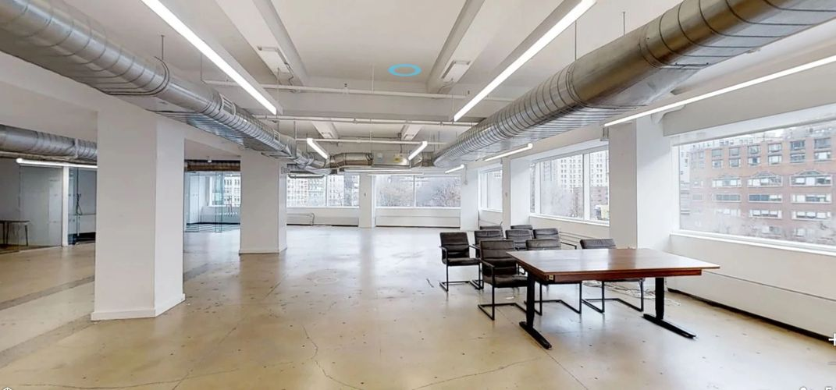

Soho Tribeca Sublets- JULY 1,2019

|  |  |  |  |  |  |  |
| --- | --- | --- | --- | --- | --- | --- |
| 21 University Pl | | P 1 |  | 4,100 |  | Withheld |
| 95 2nd Ave | | P 1 |  | 1,500 |  | 128.00/nnn |
| 126 E 7th St | | E GRND |  | 1,800 |  | 86.67/mg |
| 24 Avenue A | | P GRND |  | 400 |  | 136.86/mg |
| 115 Avenue A | | P 1 |  | 500 |  | 172.80/+util |
| 9-11 Avenue B | | P 1 |  | 1,000 |  | 96.00/nnn |
| 145 Avenue of the Americas | | P 6 |  | 3,500 |  | 45.00/fs |
| 72 Bedford St | | P 1 |  | 800 |  | 225.00/mg |
| 253 Bleecker St | | E 1 |  | 620 |  | 305.81/mg |
| 351 Bleecker St | | P GRND |  | 350 |  | 274.00/mg |
| 134 Bowery | | P 4 |  | 1,000 |  | 40.00/tbd |
| 263 Bowery | | P GRND |  | 1,800 |  | 86.00-88.00/mg |
| 483-485 Broadway | | P 5 |  | 4,000-12,700 | | 48.00/mg |
| 550 Broadway | | E 4 |  | 3,500 |  | 57.00/+elec |
| 520 Broome St | | P 1 |  | 4,000 |  | 80.00/+util |
| 95-99 Canal St | | P 3 |  | 900 |  | 56.00-57.00/mg |
| 123 Essex St | | P 2 |  | 1,464 |  | 69.00/+util |
| 78 Forsyth St | | P 1 |  | 320 |  | 112.00/mg |
| 187-195 W Fourth St | | P GRND |  | 600 |  | 154.21/nnn |
| 104-110 Greene St | | P 11 |  | 772 |  | 81.61/mg |
| 99 Hudson St | | P 8 |  | 4,000 |  | 52.50/mg |
| 201-203 Lafayette St | | P 3 |  | 1,200 |  | 48.00-50.00/mg |
| 166 Mercer St | | P 2 |  | 3,500 |  | 65.00/fs |
| 227-233 Mulberry St | | P GRND |  | 2,350 |  | 142.00/mg |
| 170 Rivington St | | P 1 |  | 600 |  | 76.00/mg |
| 174 Rivington St | | P GRND |  | 800 |  | 79.50/nnn |
| 9 Saint Marks Pl | | P 1 |  | 2,000 |  | 138.00/mg |
| 57 Seventh Ave S | | E LL |  | 372 |  | 99.40/mg |
| 57 Seventh Ave S | | P GRND |  | 473 |  | 99.40/mg |
| 116 Suffolk St | | P 1 |  | 4,000 |  | 36.00/nnn |
| 156-158 Sullivan St | | P GRND |  | 500 |  | 144.00/mg |
| 14-16 E 4th St | | P 4 |  | 1,500 |  | Withheld |
| 57-59 E 11th St | | P 2 |  | 4,461 |  | Withheld |
| 57-59 E 11th St | | P 3 |  | 4,461 |  | Withheld |
| 57-59 E 11th St | | P 4 |  | 4,461 |  | Withheld |
| 57-59 E 11th St | | P 5 |  | 4,461 |  | Withheld |
| 57-59 E 11th St | | P 6 |  | 4,461 |  | Withheld |
| 57-59 E 11th St | | P 7 |  | 4,461 |  | Withheld |
| 57-59 E 11th St | | P 8 |  | 4,461 |  | Withheld |
| 57-59 E 11th St | | P 9 |  | 4,461 |  | Withheld |
| 57-59 E 11th St | | P 10 |  | 4,461 |  | Withheld |
| 57-59 E 11th St | | P PENT |  | 1,477 |  | Withheld |
| 36 E 12th St | | E 3 |  | 5,150 |  | Withheld |
| 97 Allen St |  | P GRND |  | 1,200 |  | Withheld |
| 32 Avenue of the Americas | | P 4 |  | 39,954 |  | Withheld |
| 32 Avenue of the Americas | | P 8 |  | 19,673 |  | Withheld |
| 32 Avenue of the Americas | | P 17 |  | 4,861 |  | Withheld |
| 101 Avenue of the Americas | | E 8 |  | 15,599 div |  | Withheld |
| 396 Avenue Of The Americ… | | E LL |  | 3,640 |  | Withheld |
| 396 Avenue Of The Americ… | | E 1 |  | 3,640 |  | Withheld |
| 396 Avenue Of The Americ… | | E 2 |  | 3,640 |  | Withheld |
| 65 Bleecker St | | E 13 |  | 9,310 |  | Withheld |
| 382-384 Bleecker St | | P LL |  | 335 |  | Withheld |
| 382-384 Bleecker St | | P 1 |  | 1,040 |  | Withheld |
| 390 Bleecker St | | P BSMT |  | 300 |  | Withheld |
| 390 Bleecker St | | E 1 |  | 600 |  | Withheld |
| 135 Bowery | | E 2 |  | 3,464 |  | Withheld |
| 135 Bowery | | P 5 |  | 849 |  | Withheld |
| 425 Broadway | | P GRND |  | 2,500 |  | Withheld |
| 444 Broadway | | E 3 |  | 8,425 |  | Withheld |
| 449 Broadway | | E 3 |  | 6,370 |  | Withheld |
| 462 Broadway | | P LL |  | 5,000 |  | Withheld |
| 462 Broadway | | P GRND |  | 8,300 |  | Withheld |
| 494 Broadway | | P 2 |  | 2,979 |  | Withheld |
| 514-516 Broadway | | P GRND |  | 7,000 |  | Withheld |
| 520 Broadway | | E 9 |  | 5,500 |  | Withheld |
| 535 Broadway | | E LL |  | 2,335 |  | Withheld |
| 535 Broadway | | E GRND |  | 2,350 |  | Withheld |
| 568-578 Broadway | | P 6 |  | 6,498 |  | Withheld |
| 583-587 Broadway | | P LL |  | 6,003 |  | Withheld |
| 583-587 Broadway | | P GRND |  | 6,807 |  | Withheld |
| 584-590 Broadway | | P 8 |  | 6,419 |  | Withheld |
| 594 Broadway | | P 6 |  | 200-600 |  | Withheld |
| 594 Broadway | | P 7 |  | 1,108 |  | Withheld |
| 594 Broadway | | P 11 |  | 1,340 |  | Withheld |
| 598 Broadway | | P 2 |  | 100-500 |  | Withheld |
| 606 Broadway | | P 2 |  | 5,200 |  | Withheld |
| 611 Broadway | | P 5 |  | 425 |  | Withheld |
| 636 Broadway | | E 3 |  | 10,000 |  | Withheld |
| 636 Broadway | | P 7 |  | 2,700 |  | Withheld |
| 678 Broadway | | E 5 |  | 4,200 |  | Withheld |
| 757-769 Broadway | | P LL |  | 2,650 |  | Withheld |
| 757-769 Broadway | | P GRND |  | 7,550 |  | Withheld |
| 757-769 Broadway | | P MEZZ |  | 1,400 |  | Withheld |
| 412 W Broadway | | P GRND |  | 560 |  | Withheld |
| 412 W Broadway | | P MEZZ |  | 280 |  | Withheld |
| 412 W Broadway | | P 2 |  | 560 |  | Withheld |
| 420-422 W Broadway | | P BSMT |  | 1,200 |  | Withheld |
| 420-422 W Broadway | | P GRND |  | 1,400 |  | Withheld |
| 436-442 W Broadway | | P GRND |  | 200 |  | Withheld |
| 372 Broome St | | P LL |  | 2,500 |  | Withheld |
| 243 Canal St | | E 6 |  | 4,950 |  | Withheld |
| 41-43 Carmine St | | P LL |  | 1,000 |  | Withheld |
| 41-43 Carmine St | | P GRND |  | 1,100 |  | Withheld |
| 32 Cooper Sq | | E 2 |  | 3,100 |  | Withheld |
| 34-36 Cooper Sq | | P 5 |  | 2,890 |  | Withheld |
| 100 Crosby St | | P 5 |  | 1,836 |  | Withheld |
| 2 Gansevoort St | | P CNCR |  | 7,489 |  | Withheld |
| 2 Gansevoort St | | P 1 |  | 4,734 |  | Withheld |
| 2 Gansevoort St | | E 8 |  | 23,000 |  | Withheld |
|  |  |  |  |  |  |  |
| 82-100 Gansevoort St | | P 1 |  | 5,125 |  | Withheld |
| 95 Grand St | | P 2 |  | 1,400 |  | Withheld |
| 176-180 Grand St | | P 6 |  | 2,182 |  | Withheld |
| 197-201 Grand St | | P 3 |  | 5,300 |  | Withheld |
| 77 Greene St | | E GRND |  | 2,200 |  | Withheld |
| 81 Greene St | | E 2 |  | 1,800 |  | Withheld |
| 92-94 Greene St | | P LL |  | 1,600 |  | Withheld |
| 92-94 Greene St | | P GRND |  | 1,667 |  | Withheld |
| 129-131 Greene St | | P BSMT |  | 4,100 |  | Withheld |
| 129-131 Greene St | | P GRND |  | 4,100 |  | Withheld |
| 60 Hudson St | | P 12 |  | 5,574 |  | Withheld |
| 122 Hudson St | | P 5 |  | 2,205 |  | Withheld |
| 325 Hudson St | | P 10 |  | 11,243 |  | Withheld |
| 325 Hudson St | | P 10 |  | 8,167 |  | Withheld |
| 330 Hudson St | | P LL |  | 1,219 |  | Withheld |
| 330 Hudson St | | P GRND |  | 12,108 |  | Withheld |
| 330 Hudson St | | E 15 |  | 17,175 |  | Withheld |
| 375 Hudson St | | E 2 |  | 63,763 |  | Withheld |
| 375 Hudson St | | E 3 |  | 71,192 |  | Withheld |
| 375 Hudson St | | E 4 |  | 71,192 |  | Withheld |
| 375 Hudson St | | E 5 |  | 71,192 |  | Withheld |
| 395 Hudson St | | P 7 |  | 11,101 |  | Withheld |
| 435 Hudson St | | P 7 |  | 11,310 |  | Withheld |
| 281-283 Lafayette St | | P GRND |  | 1,600 |  | Withheld |
| 400 Lafayette St | | E 2 |  | 3,813 |  | Withheld |
| 400 Lafayette St | | P 3 |  | 3,813 |  | Withheld |
| 400 Lafayette St | | E 4 |  | 27,269 |  | Withheld |
| 113-115 Mercer St | | P GRND |  | 1,650 |  | Withheld |
| 65 N Moore St | | P 2 |  | 3,291 |  | Withheld |
| 95 Morton St | | P 3 |  | 16,362 |  | Withheld |
| 96 Morton St | | E 5 |  | 14,000 |  | Withheld |
| 7-11 Prince St | | P LL |  | 435 |  | Withheld |
| 7-11 Prince St | | P LL |  | 841 |  | Withheld |
| 7-11 Prince St | | P GRND |  | 711 |  | Withheld |
| 7-11 Prince St | | P GRND |  | 966 |  | Withheld |
| 26 Prince St | | P 1 |  | 600 |  | Withheld |
| 47 Prince St | | E BSMT |  | 1,908 |  | Withheld |
| 47 Prince St | | E GRND |  | 1,907 |  | Withheld |
| 47 Prince St | | E MEZZ |  | 588 |  | Withheld |
| 92 Prince St | | E GRND |  | 2,521 |  | Withheld |
| 92 Prince St | | E 2 |  | 1,720 |  | Withheld |
| 116 Prince St | | P 1 |  | 1,250 |  | Withheld |
| 103 Saint Marks Pl | | P GRND |  | 100-400 |  | Withheld |
| 96 Spring St | | E 7 |  | 7,415 |  | Withheld |
| 96 Spring St | | E 8 |  | 7,321 |  | Withheld |
| 155 Spring St | | P 4 |  | 4,529 |  | Withheld |
| 55 Third Ave | | P LL |  | 2,119 |  | Withheld |
| 55 Third Ave | | P GRND |  | 3,150 |  | Withheld |
| 40-42 Thompson St | | E 2 |  | 5,193 |  | Withheld |
| 40-42 Thompson St | | E 3 |  | 4,476 |  | Withheld |